1. **Request access through Account Requests using the following steps:**

* Start MARS <http://mars.web.boeing.com/>
* Click ‘Request/Manage Accounts’
* Enter the user’s BEMSID
* Click ‘Submit’
* Click 'Request Accounts'
* Click ‘Request Application Access’
* Click ‘Enovia’
* Select the EBOM Disclosure Level(s) that apply
* Select any additional access rights if applicable (e.g. access to military drawings – REDARS only or 787 access rights – PSDS only).
* Select the person(s) that should be notified when the request is processed
* Click ‘Continue’
* Review the contents of the request
* Click ‘Finish’ to complete the request
* You will be notified via email after the approving manager approves or rejects the request and the request has completed processing

1. **Once approved, search for DEEM in your Windows search bar**

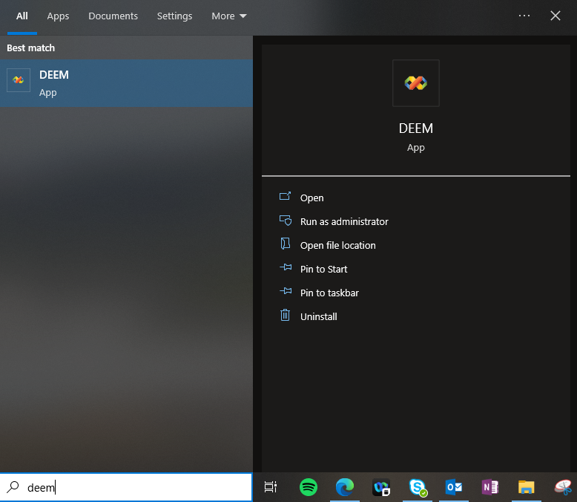

1. **DEEM will be slow but will look like the below when running**



1. **Select Boeing Commercial Airplanes**

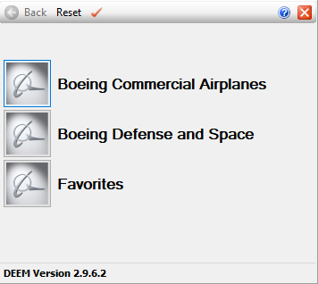

1. **Select any of the following options, but I chose 777**

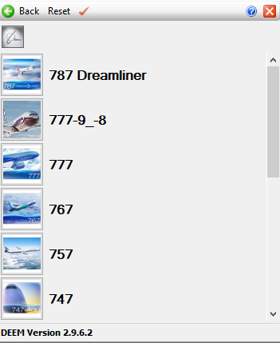

1. **Select Enovia LCA**

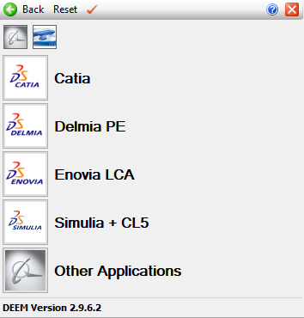

1. **Right click on the yellow icon, and select Cerate Favorite to This Button**

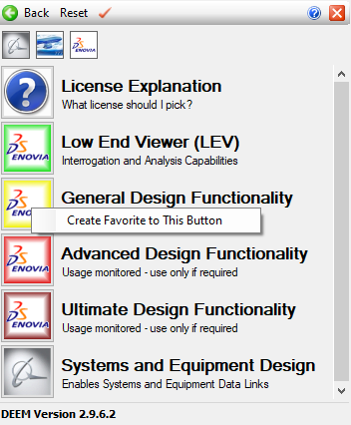

1. **Select General Design Functionality**

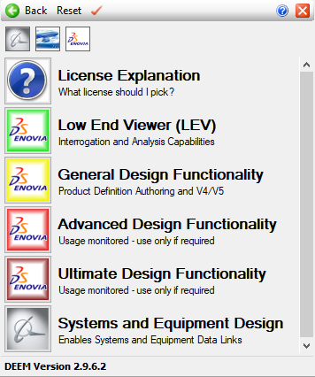

1. **Locate your stduserid (listed in Account Requests)** <https://infosec.web.boeing.com/Search/ISFindit.aspx?aId=1>

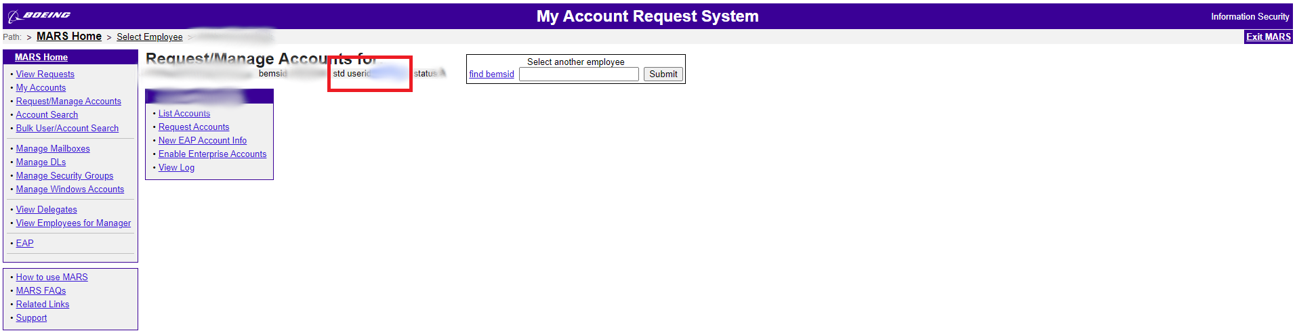

1. **Log on to Enovia using your stduserid and set up a password**

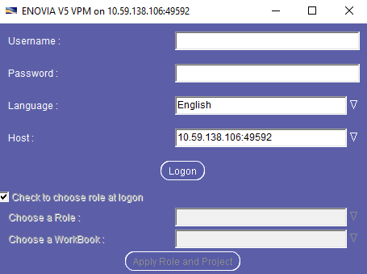

1. **The program will run and look like the below when ready to use**

