1. **Search Software Express Puget Sound in your Windows Search Bar**

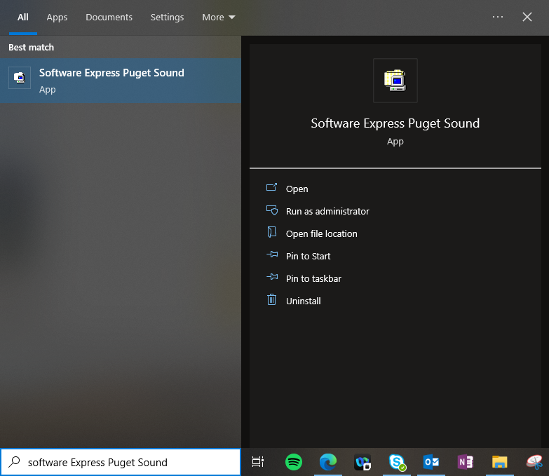

1. **Search IVT in the top right Software Express Search Bar**

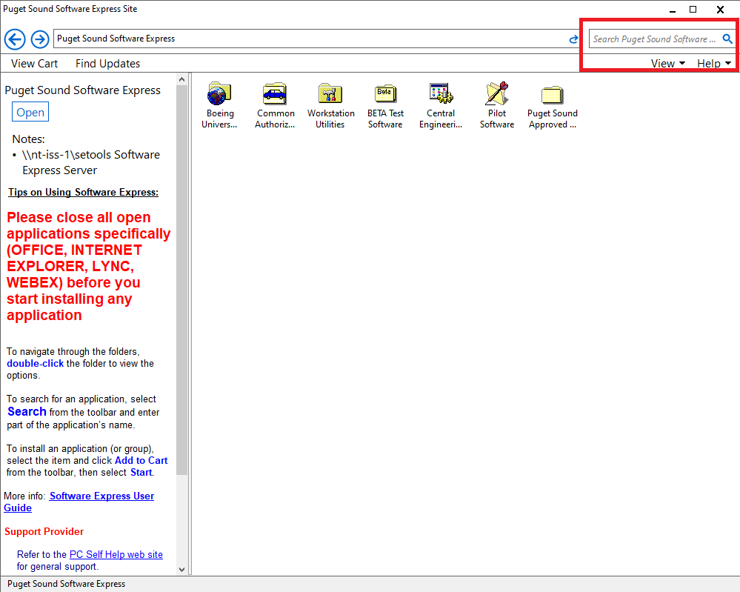

1. **Install IVT**

