1. **Navigate to STAR under the tab “Tools” on the webpage**

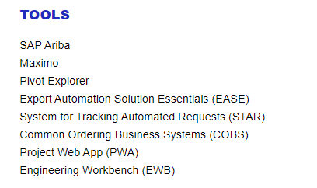

1. **Select “Initiate Request for Yourself”**

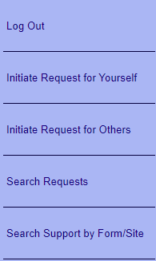

1. **Verify the employee and manager information before selecting “Next”**

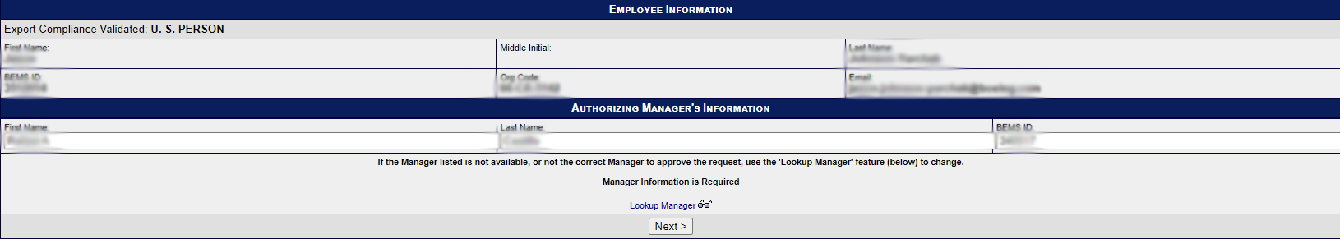

1. **Select “Mastercam” from the STAR Forms List before choosing “Next”**

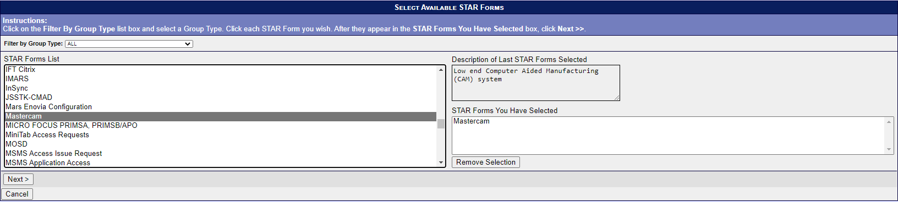

1. **Input asset tag, business justification, and NC programming use before choosing “Next”**

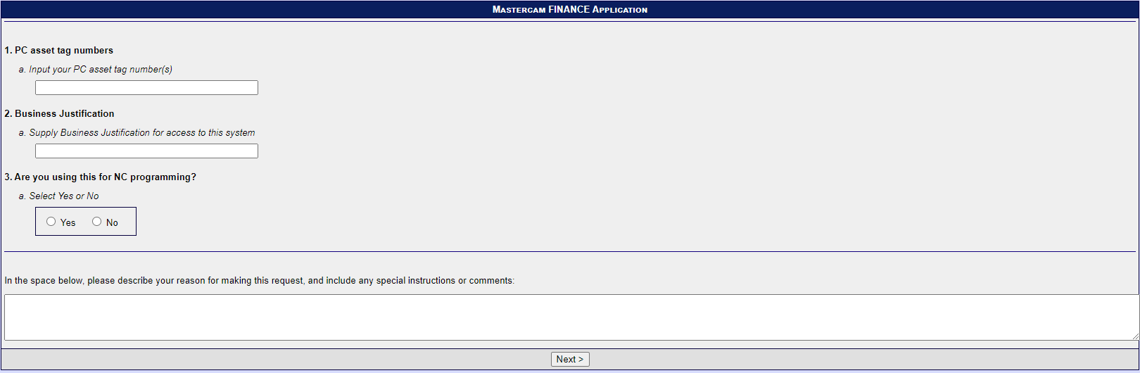

1. **Verify your request and then select “Review & Finish”**

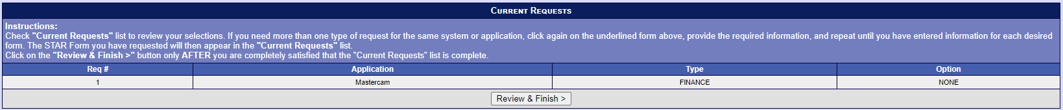

1. **The following email will confirm your approval:**

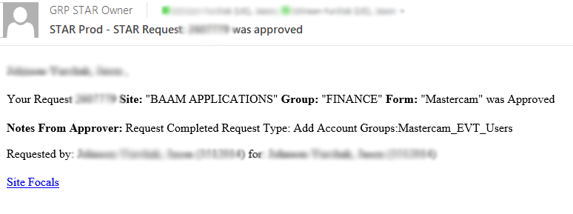

1. **Search Software Express Puget Sound in your Windows Search Bar**

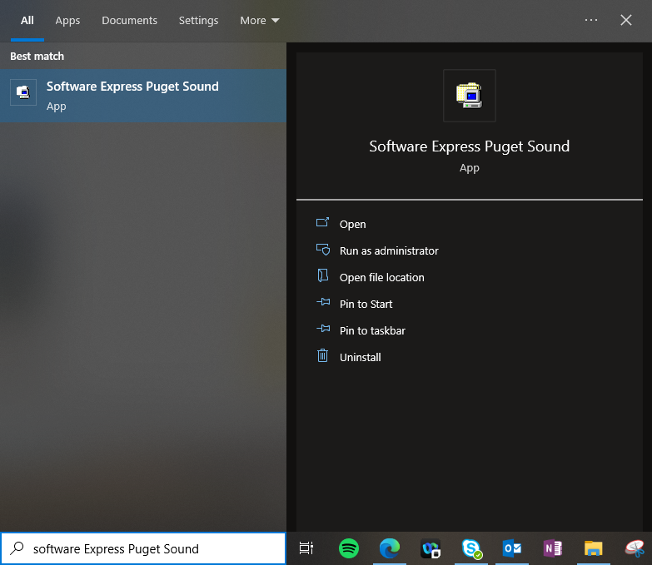

1. **Search Mastercam in the top right Software Express Search Bar**

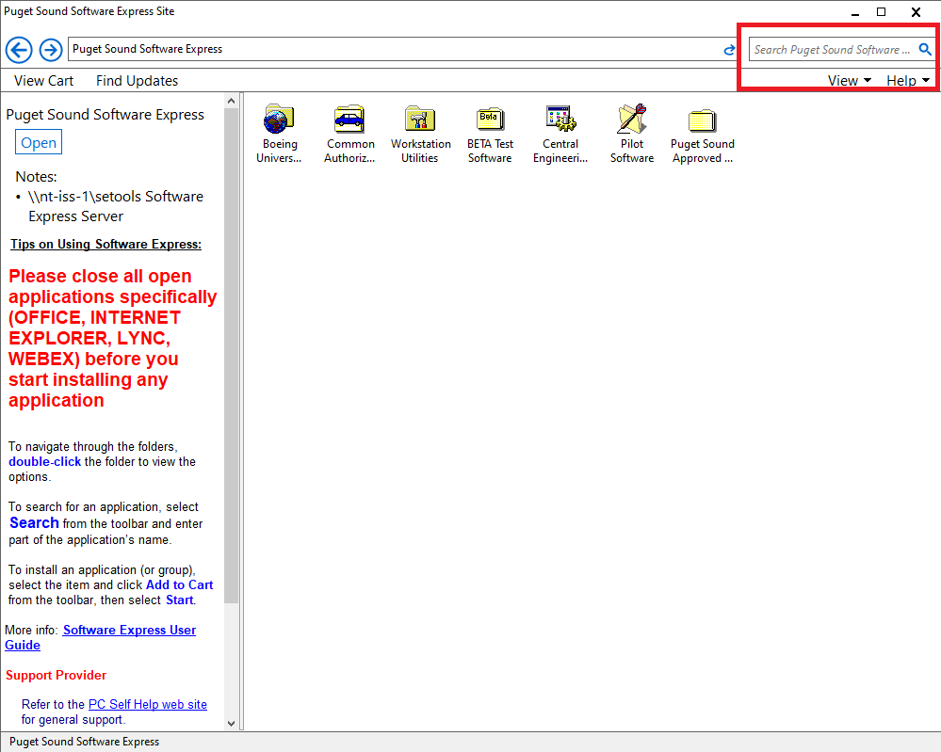

1. **Install the most recent version of Mastercam**

