**Requesting a Maximo Account:**

* Access the following map to see who your assigned focal is: <http://site-support.web.boeing.com/Maximo/focal_map.asp>
* If attempting to request access by yourself, you will be met with this message:

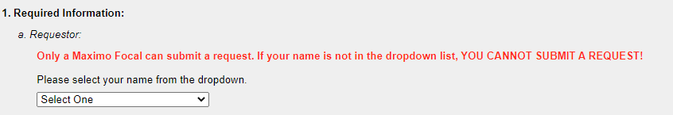

* Send them an email requesting Maximo access

**Accessing Maximo:**

* Maximo can be accessed using your username () and password ()