1. **Email Mollie K. Vigil (**[**mollie.k.vigil@boeing.com**](mailto:mollie.k.vigil@boeing.com)**) or Andrea L. Garretson (**[**andrea.l.garretson@boeing.com**](mailto:andrea.l.garretson@boeing.com)**) for approval**
2. **Once approval is confirmed by Mollie or Andrea, access the “Projects” page**

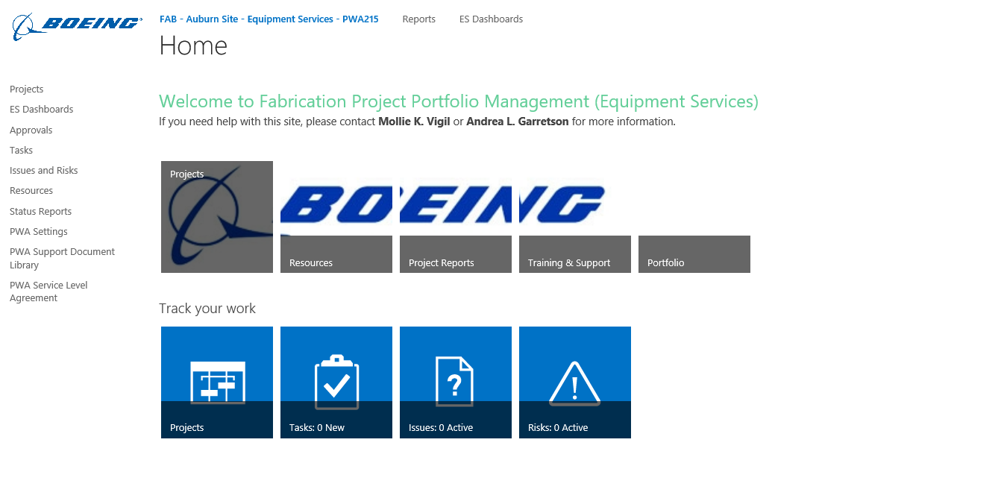

1. **Filter your Equipment Engineers or Project Managers by “Owner”**

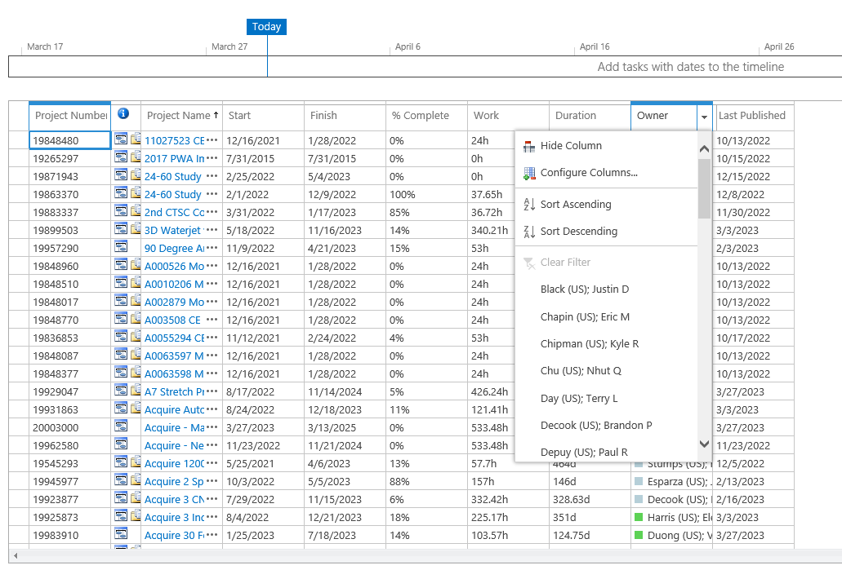

1. **Track projects using their “Project Number” and inspect completion**

