1. **Search Software Express Puget Sound in your Windows Search Bar**

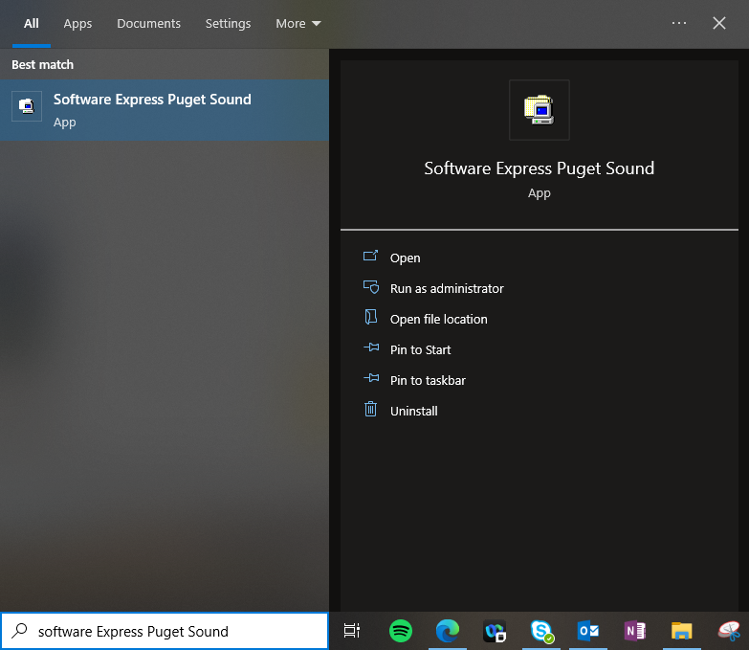

1. **Search “Quick Response” in the top right Software Express Search Bar**

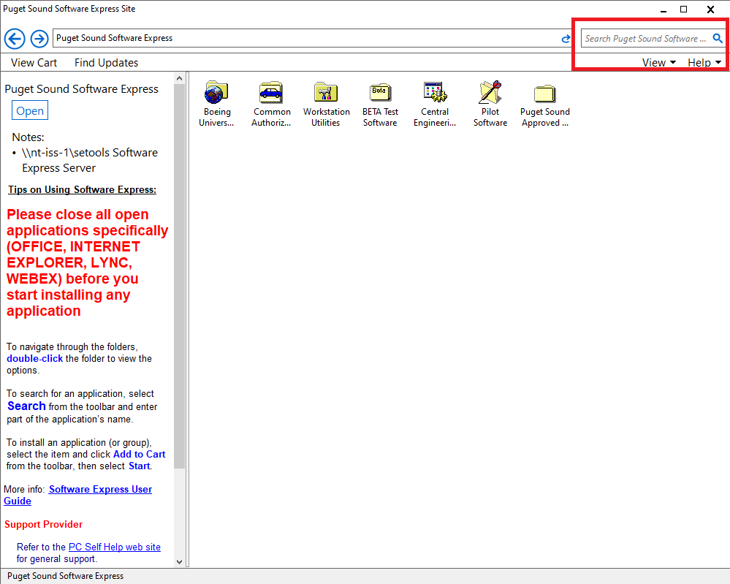

1. **Install Quick Response DataBase Office 2019**

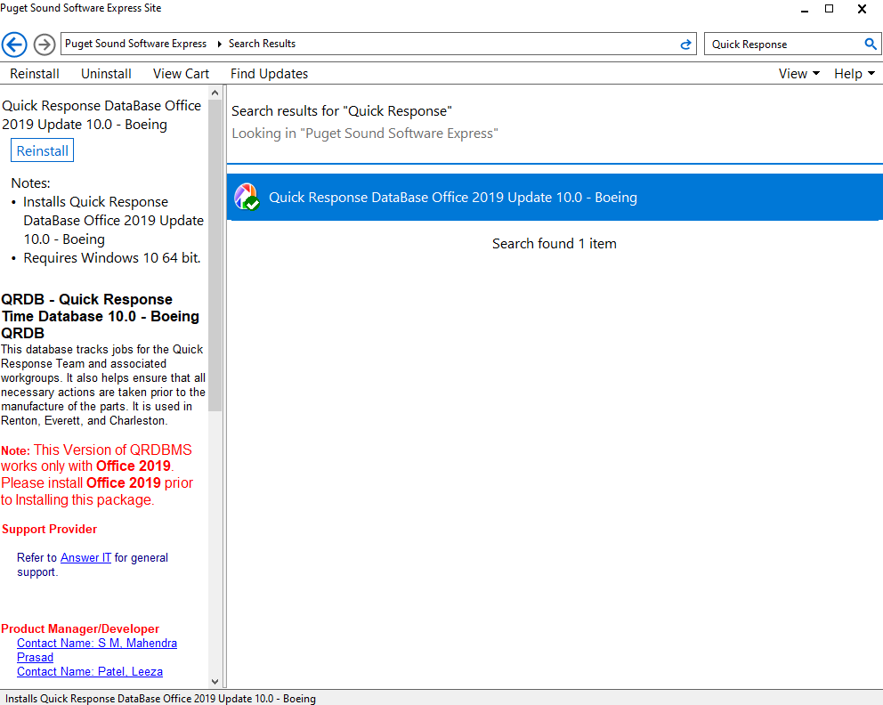

1. **Email Jarett Krieg (**[**Jarett.e.krieg@boeing.com**](mailto:Jarett.e.krieg@boeing.com)**) to request a new account or provide alternative installation instructions if Software Express does not work**