1. **Search Software Express Puget Sound in your Windows Search Bar**

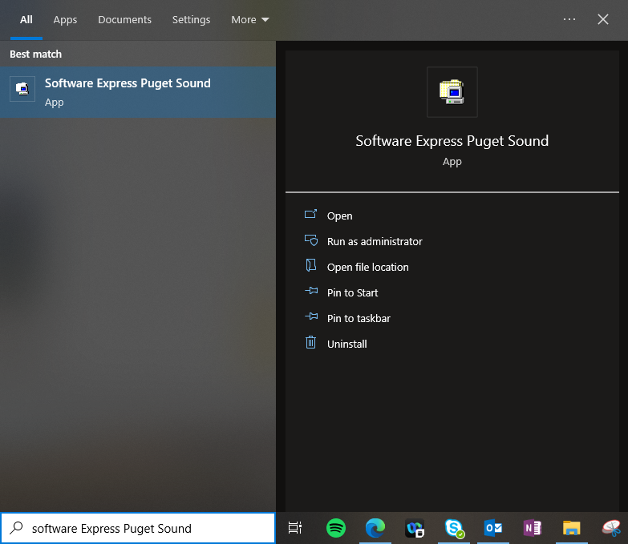

1. **Search Slicer in the top right Software Express Search Bar**

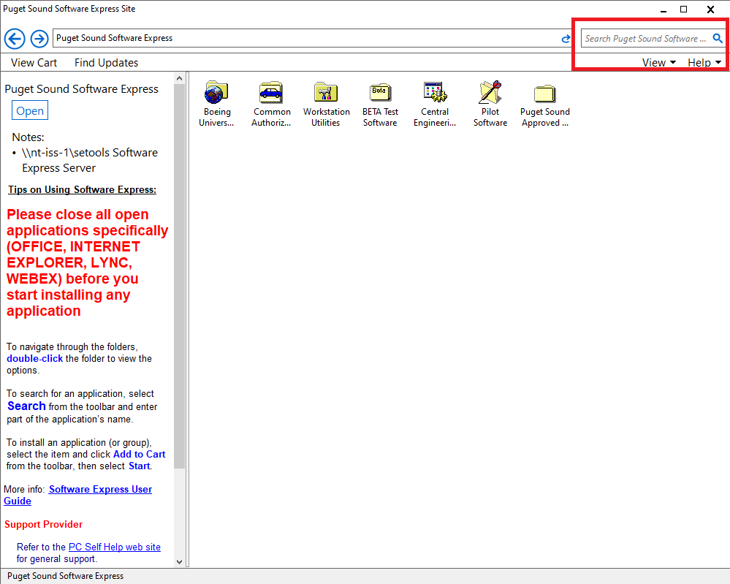

1. **Install the latest version of Slicer**

