Jason Yu, Kyle Franseen, Shadi Fadaee

CS 171: Visualization

Project Proposal

BACKGROUND AND MOTIVATION

We plan to develop an interactive visualization of the sales data for key music formats (CD, cassette, vinyl, download single, paid subscriptions, etc.) in the United States over the years. We think it would be interesting to explore how music consumption has changed from generation to generation and how evolving music format technologies have influenced that. Lastly, with many business articles reporting that the music industry is in decline, it would also be interesting to verify if this is the case or not based on trends and patterns in the dataset.

PROJECT OBJECTIVES

The primary questions we are trying to answer with our visualization are:

* How has the popularity of various music formats changed throughout the years?
* Have overall sales in music been decreasing gradually over time?
* Have new and evolving music format technologies hurt or helped music sales?

What we would like to learn is if any trends or patterns exist in the music sales dataset. In particular, the things we would like to accomplish include:

* ranking the various music formats to find out which ones dominated during different time intervals
* finding the peaks and valleys in music sales over time
* discovering when formats increased and decreased in popularity
* finding the greatest changes in sales throughout each year
* discovering any resurgences of older music formats (e.g. vinyl, cassette)

The benefits include:

* being able to compare sales between various music formats over time
* being able to compare sale dollar values accounting and not accounting for inflation
* being able to compare sales between music format types (physical, digital, streaming)
* being able to compare music sales between different time intervals

DATA

The United States music sales dataset comes from the Recording Industry Association of America (RIAA) Shipment Database. The database is accessible through the following login page: <https://www.riaa.com/keystatistics.php?content_selector=riaa-shipment-database-log-in>. The RIAA has provided us access to their database for academic use. The database provides an option to export the dataset as an Excel spreadsheet, which is how we are collecting the data.

DATA PROCESSING

We do not expect to do substantial data cleanup. We plan to save the Excel spreadsheet exported from the RIAA database as CSV files and process the data using the D3 CSV API. The dataset includes year-end sales statistics from 1973 to 2014 for the recorded music industry in the United States. The statistics comprise of both the number of units and dollar values sold (in millions) for key music formats (CD, cassette, vinyl, download single, paid subscriptions, etc.).

The quantities we plan to derive from the number of units and dollar values data include:

* the cumulative amounts over a specified time interval
* the aggregate amounts of physical, digital, and streaming format types
* the changes in amounts over each year
* the differences in amounts between two specified time intervals

We plan to implement data processing by using the D3 CSV API to parse the CSV files and create an array of JavaScript object containing the following fields:

* formatName (CD, cassette, vinyl, download single, paid subscriptions, etc.)
* formatType (physical, digital, streaming)
* year
* metricType (units sold, dollar values sold, dollar values adjusted for inflation sold)
* metricValue

VISUALIZATION

The visualization will comprise of multiple coordinated charts that link together so that when a user interacts with one of the views, the others dynamically update through animated transitions. We will display the music sales data using line, stacked area, and bar charts. Please refer to the sketches below.

On the top of the visualization is the toggle control for the metric type (units sold, dollar values sold, dollar values adjusted for inflation sold) encoding of all the charts. To the right of the Metric Type Control is the Aggregate Formats Control that toggles aggregation of the sales data by format type (physical, digital, streaming).

On the left side of the visualization is the Overview Chart. This area chart shows the total sales of all music formats for each year over the entire time interval of the dataset 1973 to 2014. A user can brush this chart to select a time interval to focus on through context zooming. The Primary and Secondary Focused Charts below the Overview Chart display the sales of the various music formats in the selected time intervals. The Chart View Controls above the Primary Focused Chart toggle between the different view types of the focused charts, which are line, stacked area, or derived data (i.e. the change in sales over each year by either percentage or actual value) charts. The slider controls to the left of the focused charts allow the user to rescale the vertical axis of the chart in a nonlinear fashion.

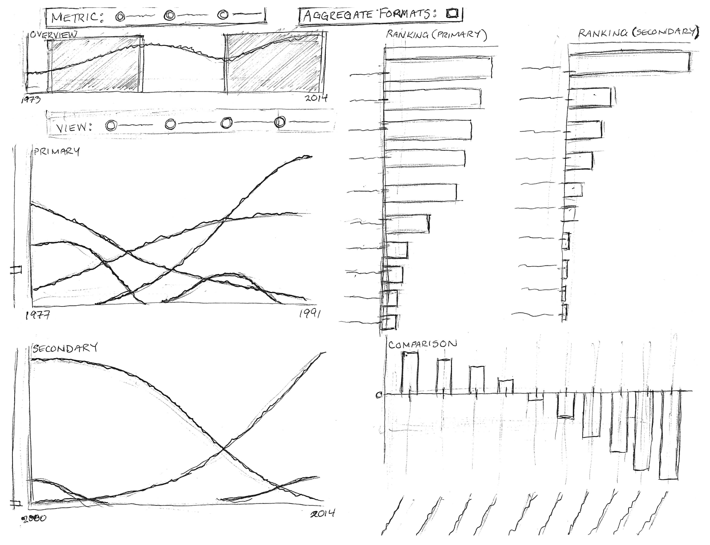

On the right side of the visualization are the Primary and Secondary Ranking Charts. These sorted bar charts show the rankings of the cumulative sales for each music format over the selected time interval. Under the ranking charts is the Comparison Chart that displays the difference in sales for each music format between the secondary and primary time interval selections.

The user can hover over the bars to highlight a particular music format of interest and fade the other music formats in both ranking charts as well as the focused charts. The user can do the same thing by hovering over the lines in the focused charts. The user can also click on a music format label in the ranking charts to toggle filtering of a format of interest in the focused charts.

MUST-HAVE FEATURES

The must-have features of the visualization include:

1. toggling the displayed sale metric data (units, dollar values, dollar values adjusted for inflation) through selection
2. focusing on the sales of a specified time interval through brushing and context zooming
3. ranking the sales of each music format through sorting
4. viewing the changes in sales for each music format over time through sliding of the brushed selection
5. highlighting and fading of music formats through mouse hovering
6. focusing on the sales of a subset of music formats through filtering
7. comparing sales between different time intervals through multiple brush selections

OPTIONAL FEATURES

The optional features of the visualization include:

1. aggregating sales by format type (physical, digital, streaming)
2. toggling between displaying raw sales data and derived data, which is the change in sales over each year by either percentage or actual value
3. toggling between a line chart and stacked area chart
4. rescaling the vertical axis of the focused chart in a nonlinear fashion

PROJECT SCHEDULE

The following project schedule lists the objectives for each week leading up to the final project deadline and the team member(s) responsible.

### Objectives for 4/10/2015

1. dataset parsed and processed into JavaScript objects [Jason]
2. an initial HTML layout file with chart control elements and stubbed out placeholders for each chart []
3. an initial focused chart displaying the number of units sold for each music format for the entire time interval of the dataset 1973 to 2014 [Jason]
4. an initial ranking bar chart displaying the total units sold from 1973 to 2014 for each music format sorted in descending order []
5. an initial outline version of the Process Book []

### Objectives for 4/17/2015 (MILESTONE 1 DUE)

1. the focused chart displaying either units sold, dollar values sold, or dollar values adjusted for inflation sold through toggle control [Jason]
2. the ranking bar chart displaying either units sold, dollar values sold, or dollar values adjusted for inflation sold through toggle control []
3. an overview chart with the focused chart displaying the sales of a specified time interval through brushing and context zooming [Jason]
4. the ranking bar chart displaying the cumulative sales of each music format for the time interval specified by the brush selection []
5. HTML layout file with chart controls bound and focused & ranking charts added []
6. an updated version of the Process Book []

### Objectives for 4/24/2015 (PROJECT REVIEW WITH TF)

1. the focused chart highlighting a music format of interest and fading the other music formats through hovering [Jason]
2. the ranking bar chart highlighting a music format of interest and fading the other music formats through hovering []
3. the focused chart displaying a subset of music formats through filter controls [Jason]
4. the ranking bar chart displaying a subset of music formats using opacity highlighting/fading through filter controls []
5. the overview chart allowing for a second brush selection [Jason]
6. another focused chart displaying the sales for the second brush selection interval [Jason]
7. another ranking bar chart displaying the sales for the second brush selection interval []
8. the comparison bar chart displaying the differences in sales between the two brush selection intervals []
9. an initial version of Project Website []

### Objectives for 5/5/2015 (FINAL PROJECT DUE)

1. the focused chart displaying the aggregate values of each format type (physical, digital, streaming) through aggregation controls [Jason]
2. the bar chart displaying the aggregate values of each format type (physical, digital, streaming) through aggregation controls []
3. the focused chart displaying a line or stacked area chart through toggle control [Jason]
4. the focused chart displaying raw sales data or derived data through toggle control [Jason]
5. the vertical axis of the focused chart rescaling in a nonlinear fashion [Jason]
6. the final version of the Process Book []
7. the final version of the Project Website and Screencast []
8. README file []