Faculty of Engineering, Natural and Medical Sciences

Department of Information Technologies



Software Project Management
Gdje Izlazimo ( gdje-izlazimo.ba )

Student 1: Alexander Jason Kaiser
Student 2: Petar Pržulj

Date of submission: 1.3.2026

Table of contents
Product Vision 4
Vision 5
Target Group 5
Needs 5
Product 5
Business Goals 5
Product Roadmap 7
Product Backlog / User Stories 8
EPIC 1: User Account & Authentication 8
User Story 1 – User Registration 8
User Story 2 – User Login 8
User Story 3 – User Logout 9
User Story 4 – View My Account Page 9
User Story 5 – Edit Personal Information 9
EPIC 2: Venue Discovery & Search 10
User Story 6 – View Venue List 10
User Story 7 – Search Venues 10
User Story 8 – Filter Venues 10
User Story 9 – View Venue Details 11
User Story 10 – Favorite Venues 11
User Story 11 – Location-Based Venue Suggestions 11
EPIC 3: Reservation Management (Users) 12
User Story 12 – Make a Reservation 12
User Story 13 – View My Reservations 12
User Story 14 – Cancel Reservation 12
User Story 15 – Edit Reservation 13
EPIC 4: Venue Partner Management 14
User Story 16 – Venue Registration 14
User Story 17 – Venue Dashboard 14
User Story 18 – Approve or Reject Reservations 14
EPIC 5: Notifications & Recommendations 15
User Story 19 – Reservation Notifications 15
User Story 20 – Venue Recommendations 15
EPIC 6: Monetization & Promotions 16
User Story 21 – Promote Venue 16
User Story 22 – Premium Subscription 16
EPIC 7: Admin Management 17
User Story 23 – Admin Login 17
User Story 24 – Approve Venues 17
User Story 25 – View Platform Metrics 17
NON-FUNCTIONAL REQUIREMENTS 18
User Story 26 – Performance 18
User Story 27 – Security 18
User Story 28 – Availability 18
Product Backlog Explanation 19
Product Backlog Estimation 24
Estimation Technique Used 24
Why Story Points? 24
Fibonacci Scale 24
Planning Poker Process 24
Wireframes 26
Different Methodology and Method Approach 40

Product Vision

Vision
For young people and students who want to easily discover cool places to hang out and make quick reservations, but get frustrated juggling Instagram, messages, and phone calls. The Gdje Izlazimo App Is a web app that helps them find venues they like, book a spot in seconds, and helps venues easily manage reservations. Unlike messaging venues individually or scrolling through multiple apps Our product brings discovery, booking, and reservation management together in one simple, fun experience

Target Group
The product targets young adults, students, and teenagers in urban areas who are socially active and tech-savvy. It is designed for people aged 16–30 who want to easily discover bars, cafes, restaurants, and event venues, as well as for venues and small businesses that need a simple and efficient way to manage reservations.

Needs
Users often struggle to find venues that match their preferences and face slow, fragmented reservation processes through Instagram, Viber, or phone calls. Venues, on the other hand, lack a simple system to track bookings and manage guests efficiently. Gdje Izlazimo solves these problems by allowing users to quickly find and reserve spots while providing venues with an easy-to-use reservation management system, simplifying social planning and enhancing the overall experience for everyone.

Product
Gdje Izlazimo is a mobile app that connects users with venues for discovery and instant reservation. It stands out by combining venue discovery, booking, and reservation management in a single platform, offering personalized recommendations based on user preferences and location. The app is feasible to develop using standard mobile frameworks and a cloud-based backend to support seamless reservation management for both users and venues.

Business Goals
The app aims to increase adoption and engagement among young urban users while attracting venues to adopt the platform for more efficient reservation management. By offering premium features such as analytics and promotional tools for venues, the product can generate revenue and establish itself as the go-to app for social outings. Over time, the platform can scale to additional cities and entertainment sectors, creating a strong presence in the local market and building a loyal user base.

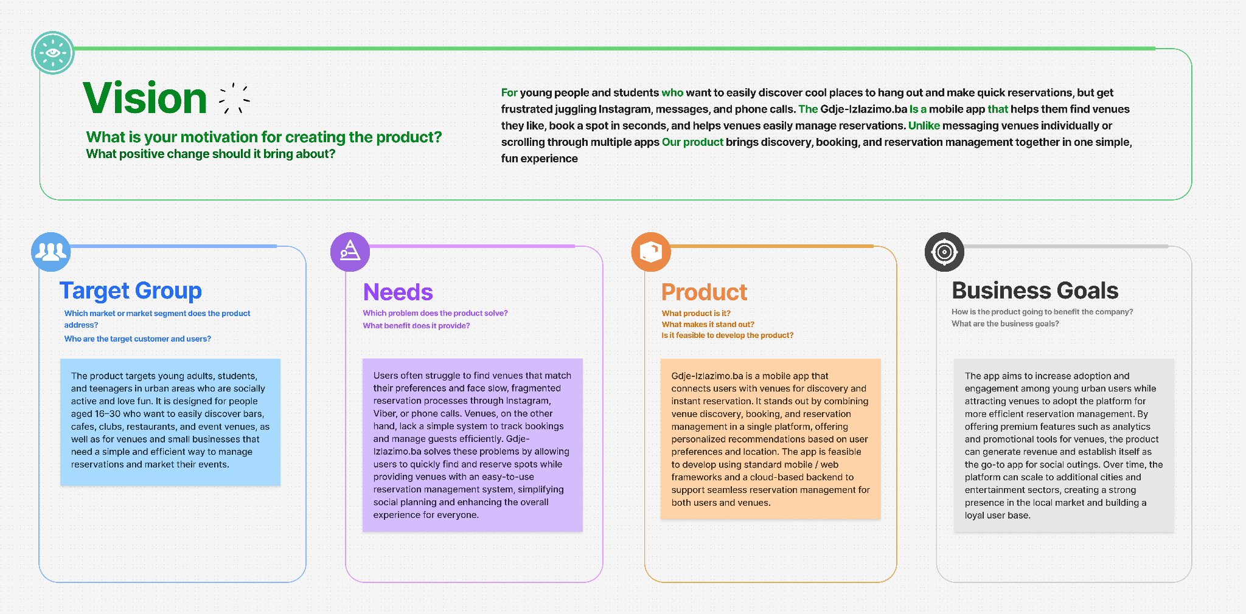

Product Roadmap

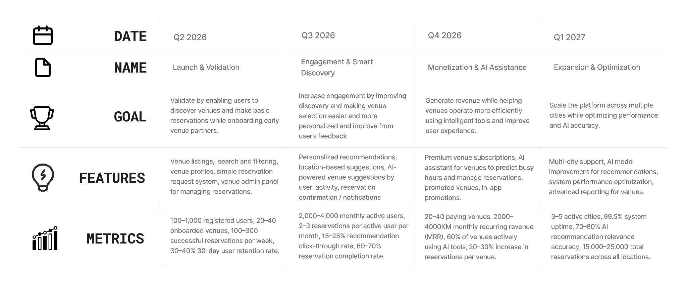

Product Backlog / User Stories

EPIC 1: User Account & Authentication

User Story 1 – User Registration
As a new user, I want to register an account so that I can use the application and make reservations.
Acceptance Criteria:
- A “Register” button is displayed on the home page and login page.
- When the user clicks the “Register” button, the system redirects them to the registration page.
- The registration page contains input fields for first name, last name, email address, password, and confirm password.
- All input fields are mandatory.
- The system checks if the email address already exists in the database.
- The password must contain at least 8 characters.
- If registration is successful, the user is automatically logged in and redirected to the home page.
- If any field is empty, an error message “All fields are required” is displayed.
- If the email already exists, an error message “Email already registered” is displayed.

User Story 2 – User Login
As a registered user, I want to log into the application so that I can access my account and features.
Acceptance Criteria:
- A “Login” button is visible on the home page and registration page.
- When the user clicks the “Login” button, they are redirected to the login page.
- The login page contains email and password input fields and a login button.
- Both fields are required to submit the form.
- The system verifies the email and password with the database.
- If credentials are correct, the user is redirected to the home page.
- If credentials are incorrect, an alert message “Wrong email address or password” is displayed.
- If fields are empty, an error message “Enter user data” is displayed.

User Story 3 – User Logout
As a logged-in user, I want to log out so that my account remains secure.
Acceptance Criteria:
- A “Logout” option is available in the My Account dropdown menu.
- When the user clicks “Logout,” the system terminates the active session.
- The user is redirected to the home page.
- After logout, protected pages cannot be accessed without logging in again.

User Story 4 – View My Account Page
As a logged-in user, I want to view my account page so that I can see my personal information.
Acceptance Criteria:
- The “My Account” button is visible in the navigation bar when the user is logged in.
- Clicking the button redirects the user to the My Account page.
- The page displays the user’s name, email, and account options.
- If the user is not logged in, access to the page is denied.

User Story 5 – Edit Personal Information
As a logged-in user, I want to edit my personal information so that my account details stay up to date.
Acceptance Criteria:
- An “Edit personal information” option is visible on the My Account page.
- Clicking the option opens a pop-up with editable fields for name, email, and password.
- Fields are prefilled with existing user data.
- If the user saves valid changes, a success message “Successfully saved changes” is displayed.
- If a field is left empty, an error message “No fields can be empty” is shown.
- If no changes are made, a message “No changes were made” is displayed.

EPIC 2: Venue Discovery & Search

User Story 6 – View Venue List
As a user, I want to view a list of venues so that I can discover places to go out.
Acceptance Criteria:
- The venue list is accessible from the home page.
- Each venue displays name, image, category, and location.
- The list loads automatically when the page is opened.
- If no venues exist, a message “No venues available” is displayed.

User Story 7 – Search Venues
As a user, I want to search venues by name so that I can quickly find a specific place.
Acceptance Criteria:
- A search input is displayed above the venue list.
- The user can type a venue name and submit the search.
- The system displays matching venues.
- If no results are found, a message “No matching venues found” is displayed.

User Story 8 – Filter Venues
As a user, I want to filter venues by category and location so that I can find relevant venues.
Acceptance Criteria:
- Filter options are visible on the venue list page.
- Users can select one or multiple filters.
- The venue list updates according to selected filters.
- A “Reset filters” option clears all selections.

User Story 9 – View Venue Details
As a user, I want to view venue details so that I can decide whether to make a reservation.
Acceptance Criteria:
- Clicking on a venue opens the venue details page.
- The page shows description, images, address, opening hours, and capacity.
- A “Reserve” button is displayed on the page.

User Story 10 – Favorite Venues
As a logged-in user, I want to save venues as favorites so that I can quickly access places I like.
Acceptance Criteria:
- A “Add to Favorites” button is displayed on each venue details page.
- The button is visible only to logged-in users.
- When the user clicks the button, the venue is saved to the user’s favorites list.
- A confirmation message “Venue added to favorites” is displayed.
- A “My Favorites” section is available in the My Account page.
- The favorites list displays the venue name, image, and location.
- The user can remove a venue from favorites by clicking a “Remove” button.
- After removal, a confirmation message “Venue removed from favorites” is displayed.

User Story 11 – Location-Based Venue Suggestions
As a user, I want to see venues near my location so that I can easily find nearby places to go out.
Acceptance Criteria:
- The system requests permission to access the user’s location.
- If permission is granted, nearby venues are displayed on the home page.
- Venues are sorted by distance from the user.
- If location access is denied, the system displays venues based on a default city.
- The user can manually change the city at any time.

EPIC 3: Reservation Management (Users)

User Story 12 – Make a Reservation
As a logged-in user, I want to make a reservation so that I can secure a spot at a venue.
Acceptance Criteria:
- Only logged-in users can access the reservation form.
- The form includes date, time, and number of people.
- All fields must be filled in.
- After submission, the reservation request is sent to the venue.
- A confirmation message is displayed to the user.

User Story 13 – View My Reservations
As a user, I want to view my reservations so that I can track my bookings.
Acceptance Criteria:
- A “My Reservations” section exists in the My Account page.
- The list shows upcoming and past reservations.
- Each reservation displays venue name, date, time, and status.

User Story 14 – Cancel Reservation
As a user, I want to cancel a reservation so that I can change my plans.
Acceptance Criteria:
- A “Cancel” button is available for upcoming reservations.
- Clicking the button prompts a confirmation dialog.
- Once confirmed, the reservation status changes to canceled.
- A success message is displayed.

User Story 15 – Edit Reservation
As a logged-in user, I want to edit my reservation so that I can adjust my plans if needed.
Acceptance Criteria:
- An “Edit” button is available for upcoming reservations.
- Clicking the button opens an editable reservation form.
- The form allows changing date, time, and number of people.
- All fields must be filled before saving changes.
- When changes are saved successfully, a message “Reservation updated successfully” is displayed.
- If the user tries to save without making changes, a message “No changes were made” is displayed.
- If the selected time or date is unavailable, an error message is shown.

EPIC 4: Venue Partner Management

User Story 16 – Venue Registration
As a venue owner, I want to register my venue so that I can receive reservations.
Acceptance Criteria:
- A “Register Venue” option is available.
- The form includes venue name, address, category, and contact details.
- All fields are mandatory.
- After submission, the venue status is set to “Pending approval.”

User Story 17 – Venue Dashboard
As a venue owner, I want to access a dashboard so that I can manage reservations.
Acceptance Criteria:
- Only approved venues can access the dashboard.
- The dashboard displays upcoming reservations.
- Reservation status is clearly visible.

User Story 18 – Approve or Reject Reservations
As a venue owner, I want to approve or reject reservations so that I can manage capacity.
Acceptance Criteria:
- Each reservation has “Approve” and “Reject” buttons.
- Clicking a button updates the reservation status.
- The user receives a notification about the decision.

EPIC 5: Notifications & Recommendations

User Story 19 – Reservation Notifications
As a user, I want to receive notifications so that I know the status of my reservations.
Acceptance Criteria:
- Notifications are sent when reservations are approved, rejected, or canceled.
- Notifications appear inside the application.
- Each notification contains reservation details.

User Story 20 – Venue Recommendations
As a user, I want to receive venue recommendations so that I can discover places I like.
Acceptance Criteria:
- Recommendations are based on user activity and location.
- Recommended venues are shown on the home page.
- Recommendations update over time.

EPIC 6: Monetization & Promotions

User Story 21 – Promote Venue
As a venue owner, I want to promote my venue so that it gains more visibility.
Acceptance Criteria:
- A promotion option exists in the venue dashboard.
- Promoted venues appear higher in search results.
- Promotion duration is selectable.

User Story 22 – Premium Subscription
As a venue owner, I want to subscribe to a premium plan so that I can access advanced tools.
Acceptance Criteria:
- Subscription plans are clearly displayed.
- Payment is required to activate premium features.
- Subscription status is visible in the dashboard.

EPIC 7: Admin Management

User Story 23 – Admin Login
As an admin, I want to log in so that I can manage the platform.
Acceptance Criteria:
- Admin login page is separate from user login.
- Only admin credentials allow access.
- Successful login redirects to the admin dashboard.

User Story 24 – Approve Venues

As an admin, I want to approve venues so that only valid venues are listed.
Acceptance Criteria:
- Pending venues are listed in the admin dashboard.
- Admin can approve or reject venues.
- Venue owners receive a notification.

User Story 25 – View Platform Metrics
As an admin, I want to view platform metrics so that I can monitor performance.
Acceptance Criteria:
- Metrics include users, venues, and reservations.
- Data updates automatically.
- Metrics are displayed visually.

NON-FUNCTIONAL REQUIREMENTS

User Story 26 – Performance
As a user, I want the application pages to load in under 3 seconds so that I do not waste time waiting.
Acceptance Criteria:
- Pages load in under 3 seconds in 90% of tests.
- Performance is tested under at least 1,000 concurrent users.

User Story 27 – Security
As a user, I want my personal data to be secure so that my privacy is protected.
Acceptance Criteria:
- Passwords are encrypted in the database.
- Secure authentication mechanisms are implemented.
- Unauthorized access attempts are blocked.

User Story 28 – Availability
As a user, I want the system to be available at all times so that I can access it whenever needed.
Acceptance Criteria:
- System uptime is at least 99.5%.
- Downtime incidents are logged and monitored.

Product Backlog Explanation

The product backlog for Gdje Izlazimo was ordered using the Business Value × User Impact (BV×UI) prioritization technique, as presented in SPM – Lab 8
Each user story was evaluated based on the benefit it brings to the business and the value it delivers to users. Stories with the highest combined score were placed at the top of the backlog, ensuring that core platform functionality and MVP-critical features are delivered first, followed by experience enhancements and engagement features, while monetization and advanced analyticsare intentionally deferred.

Below we provided the Tables based on 4 Priorities:

1 ) Must Have

2 ) Should Have

3 ) Could Have

4 ) Won’t Have

Why Must have?
Without these stories:
- Users cannot register or log in
- Venues cannot exist
- Reservations cannot be made
- Platform cannot function as a marketplace

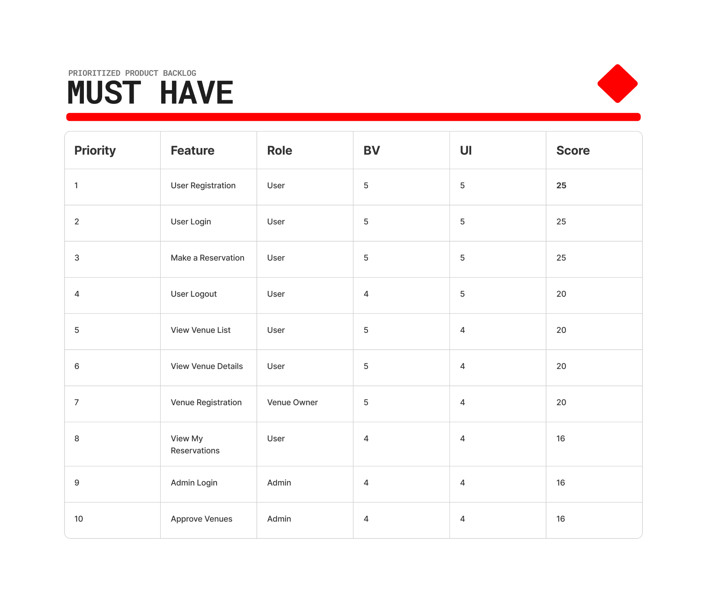

Why Should have?
The system still works without them, but:
- UX is significantly improved
- User retention increases
- Operational efficiency improves

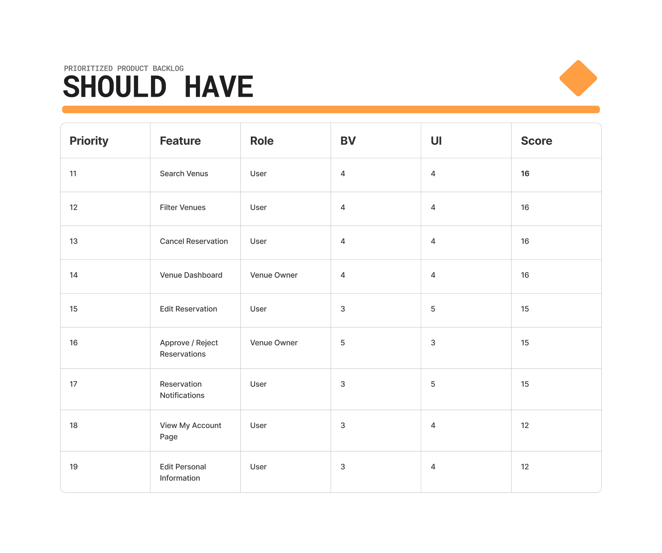

Why Could have?
They:
- Increase engagement
- Improve personalization
- Are not critical for MVP success
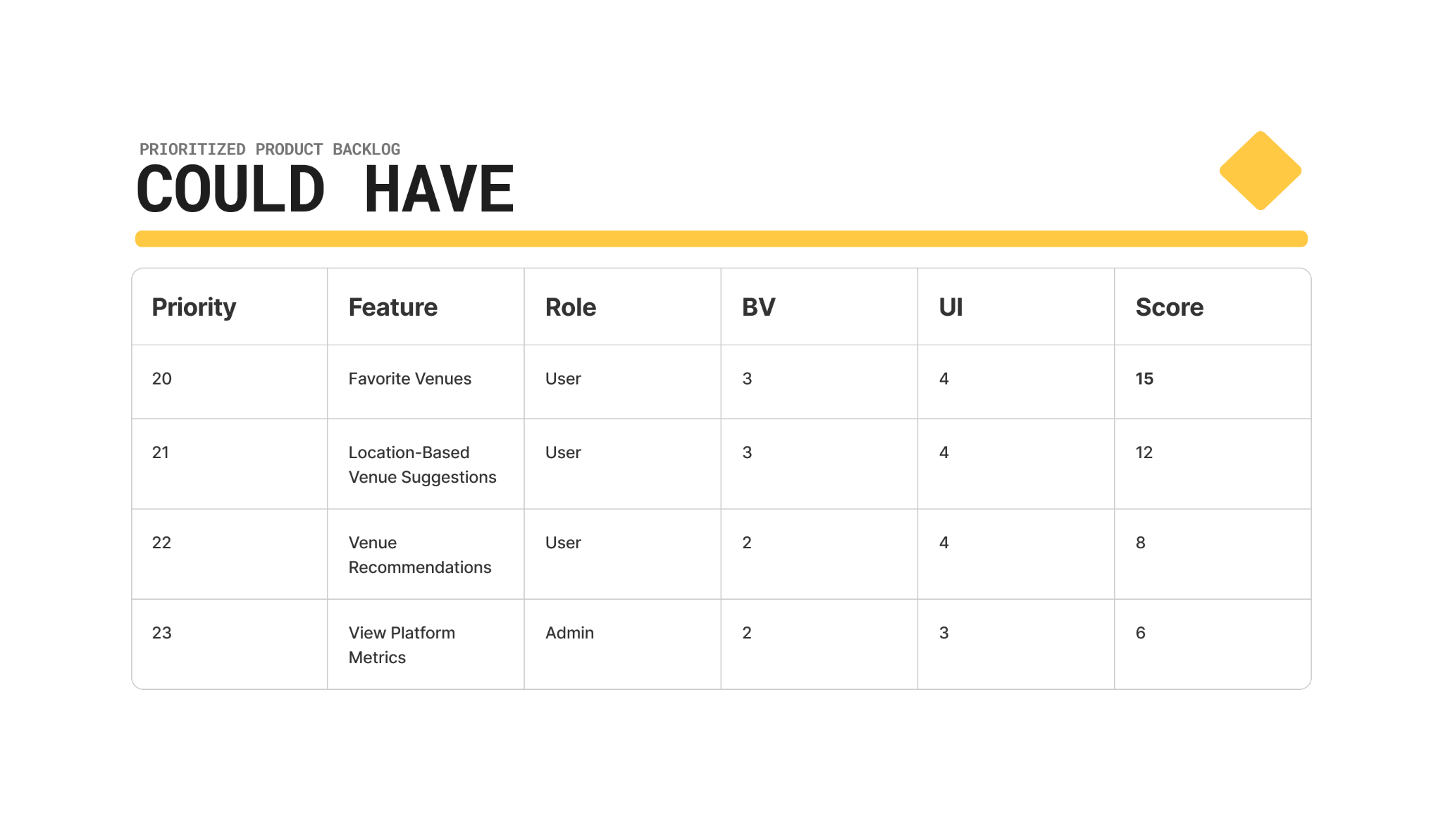

Why Won’t have?
These features are excluded for now because::
- They do not affect core MVP functionality or user flow
- They rely on a larger, stable user base before becoming valuable
- They introduce complexity or monetization that is premature at this stage

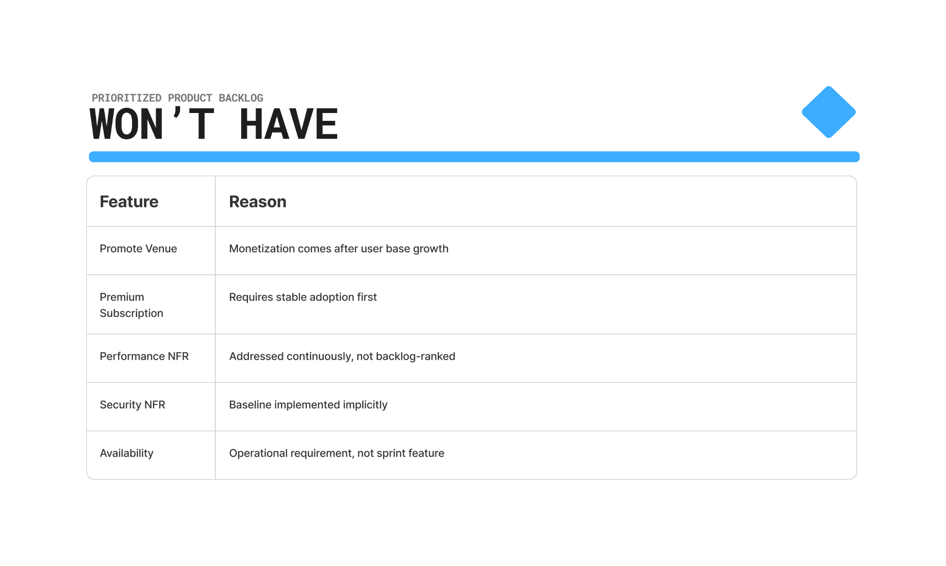

Product Backlog Estimation

Estimation Technique Used
The backlog items for Gdje Izlazimo were estimated using Story Points and Planning Poker, based on SPM – Lab 10.

Why Story Points?
Story points measure:
- Complexity, Amount of work, Technical risk
They avoid fixed time pressure, allow relative comparison of stories, and support sprint planning through team velocity.

Fibonacci Scale
The team used the Fibonacci scale: 1, 2, 3, 5, 8, 13, which reflects increasing uncertainty for larger tasks.

Planning Poker Process
Estimation was done using Planning Poker:
- Product Owner presents the story.
- Team briefly discusses functionality, complexity, and risks.
- Members pick story point cards individually.
- Cards are revealed at once.
- Differences are discussed until consensus is reached.
The final agreed number becomes the story point estimate.
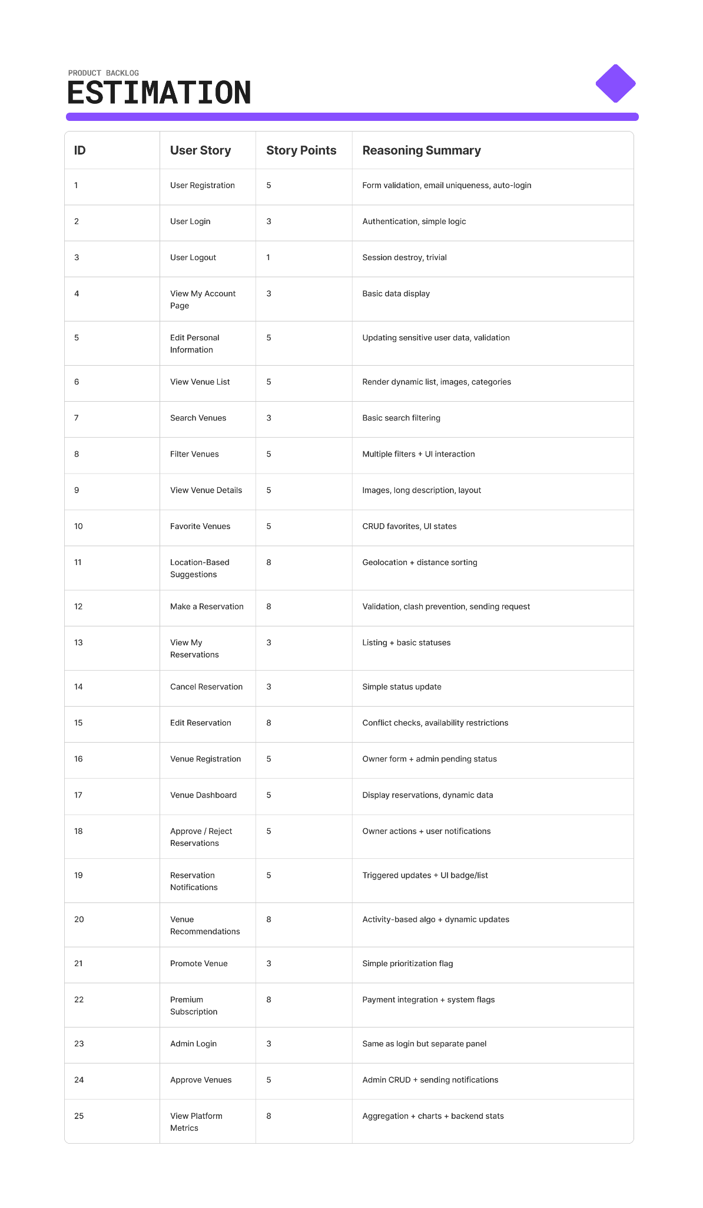

Wireframes

Home

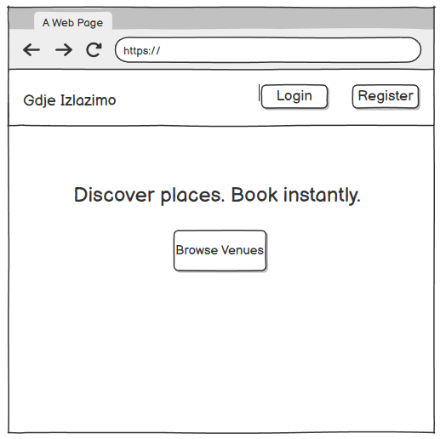

Login

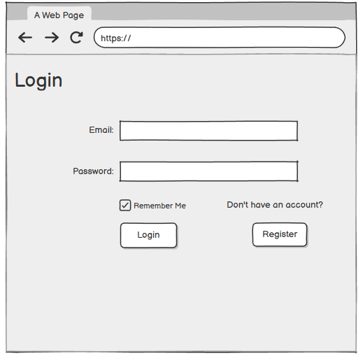

Register

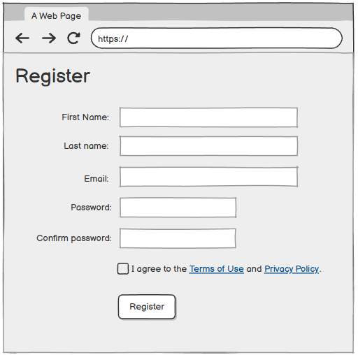

Browse Venues

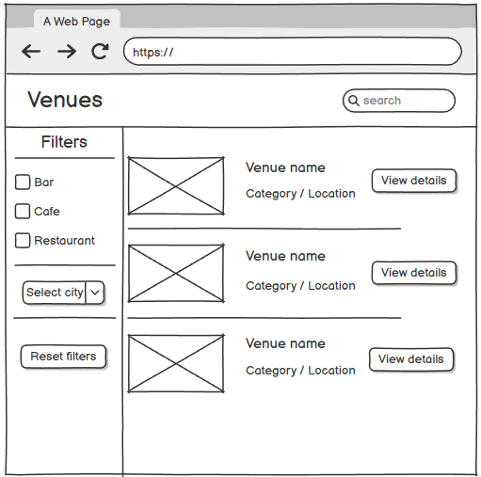

Venue Details

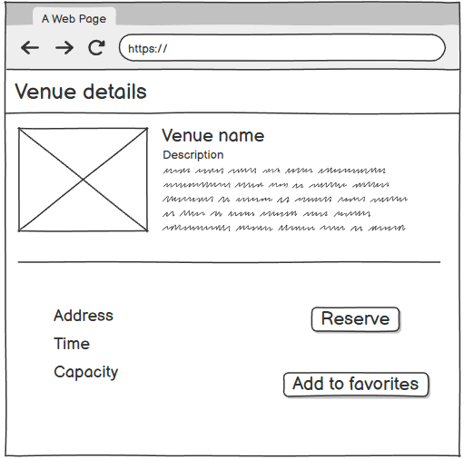

Make a Reservation

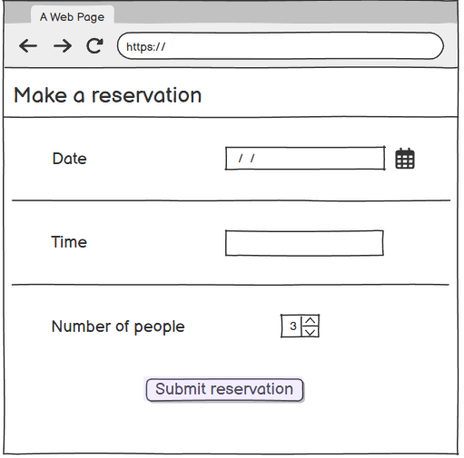

My Reservations

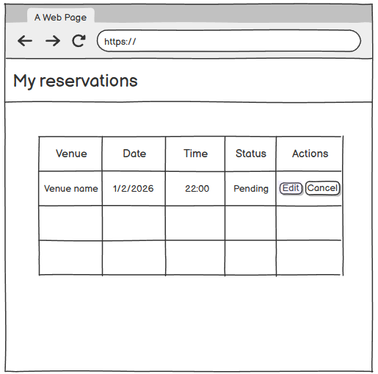

Edit Reservation

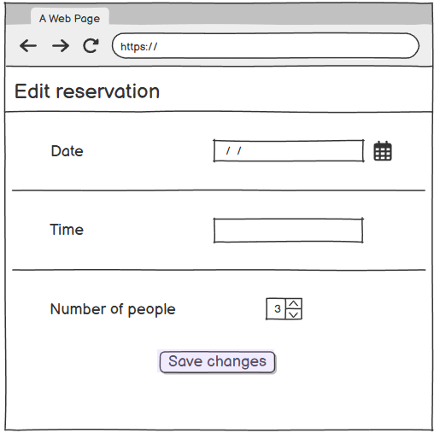

My Account

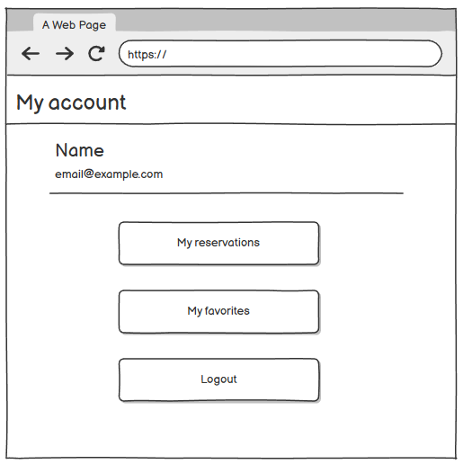

My Favorites

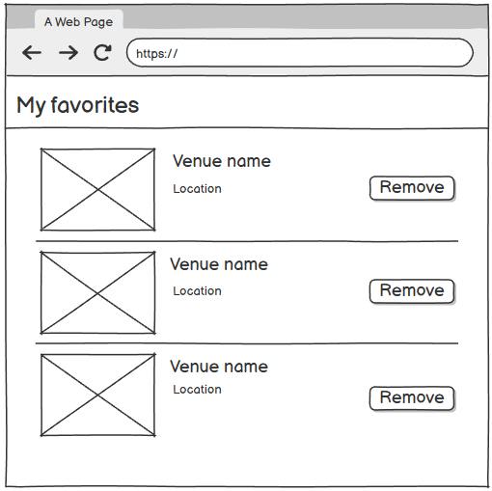

Register Venue

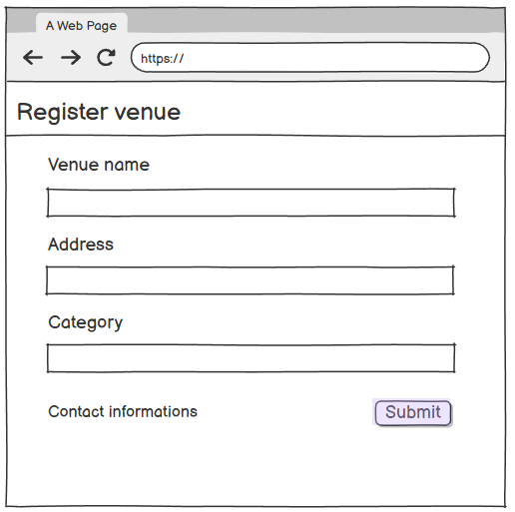

Venue Dashboard

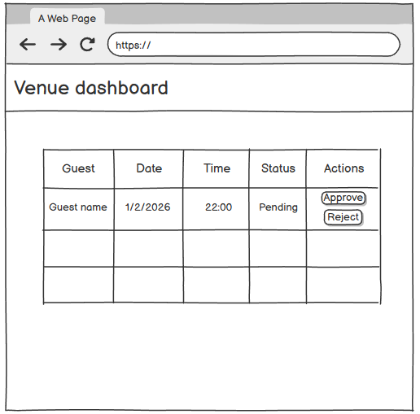

Admin Login

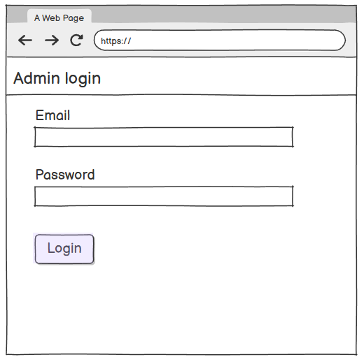

Admin Dashboard

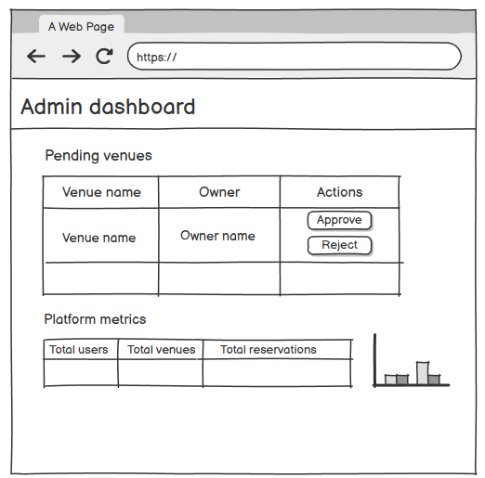

Different Methodology and Method Approach

In the main project, the Waterfall methodology was selected as the primary development
approach for the Gdje Izlazimo application due to its structured nature and clear
documentation requirements. However, if a different methodology were to be applied, this
project could also be approached using the Agile methodology, specifically the Scrum
method.

Applying Agile (Scrum) to the Gdje Izlazimo Project

The purpose of the Gdje Izlazimo project is to provide a platform that enables young users
to discover venues and make reservations easily, while allowing venue owners and
administrators to manage reservations efficiently. The project vision emphasizes user
experience, fast feedback, and continuous improvement—areas where Agile Scrum
performs particularly well.

Using Scrum, the project would be developed iteratively through short development cycles
called sprints, typically lasting 2–3 weeks. Instead of completing all requirements upfront,
the team would prioritize the product backlog and deliver a working increment of the
system at the end of each sprint.

At the start of the project, high-priority user stories such as User Registration, Venue List,
and Make Reservation would be placed in early sprints, forming a Minimum Viable Product
(MVP). Feedback from users and stakeholders would then be collected during Sprint
Reviews, allowing the team to refine features such as search filters, favorites, and
recommendations in subsequent iterations.

The Scrum roles would be clearly defined:
- Product Owner: responsible for managing and prioritizing the product backlog
- Scrum Master: ensures Scrum practices are followed and removes obstacles
- Development Team: designs, implements, and tests the application

Scrum ceremonies such as Sprint Planning, Daily Stand-ups, Sprint Reviews, and
Retrospectives would promote transparency, adaptability, and continuous improvement
throughout development.

Comparison: Waterfall vs Agile (Scrum)

Waterfall offers clear structure and strong documentation but lacks flexibility and delays
feedback. Agile Scrum allows continuous feedback and adaptability but requires strong
stakeholder involvement and provides less formal documentation.

Conclusion

Although Agile Scrum would be highly suitable for Gdje Izlazimo due to its focus on user
experience and adaptability, the Waterfall methodology remains more appropriate for this
academic project because of its structured phases and documentation requirements. In a
real-world environment, Agile Scrum would likely be the preferred methodology.

