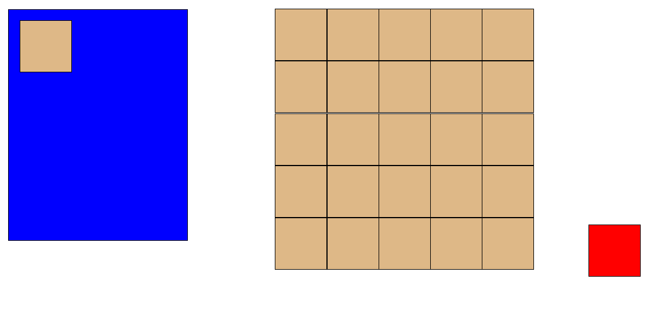
Backpacker screenshot

Link to repo: https://github.com/jasonkang990/Backpacker

