jQuery Knob
Nice, downward compatible, touchable, jQuery dial.
* implemented interactions : mouse click and wheel mouse, keyboard (on focus) and fingers (touch events)

× Disable display input
data-width="100"
data-displayInput=false

× 'cursor' mode
data-width="150"
data-cursor=true
data-thickness=.3
data-fgColor="#222222"

× Display previous value
data-displayPrevious=true
data-min="-100"

× Angle offset
data-angleOffset=90
data-linecap=round

× Angle offset and arc
data-fgColor="#66CC66"
data-angleOffset=-125
data-angleArc=250
data-rotation=anticlockwise

× 4-digit, step 0.1
data-step=".1"
data-min="-10000"
data-max="10000"
value="0"
data-displayPrevious=true

× Overloaded 'draw' method

data-width="75"
data-fgColor="#ffec03"
data-skin="tron"
data-thickness=".2"
data-displayPrevious=true

data-width="150"
data-fgColor="#ffec03"
data-skin="tron"
data-thickness=".2"
data-displayPrevious=true

data-width="150"
data-fgColor="#C0ffff"
data-skin="tron"
data-thickness=".1"
data-angleOffset="180"

× Responsive
data-width="80%"
Current div width is 30% of window width.
Knob width is 80% of current div.
Knob width is 80% of 30% of window width.
Test resizing window.

× Superpose (clock)

× Readonly
readonly (or data-readOnly=true)
data-thickness=".4"
data-fgColor="chartreuse"

× Dynamic
data-width="200"
data-width="50"
data-cursor=true

× Infinite || iPod click wheel

data-width="150"
data-cursor=true
data-thickness=".5"
data-fgColor="#AAAAAA"
data-bgColor="#FFFFFF"
data-displayInput="false"
+ some code

0
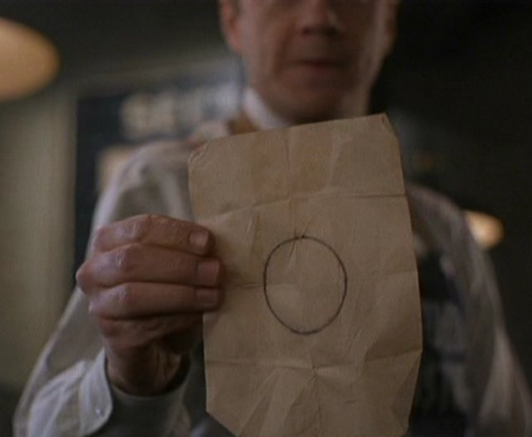
jQuery Knob is © 2012 Anthony Terrien - MIT License

