jQuery Knob

Nice, downward compatible, touchable, jQuery dial. Flattr this

\* implemented interactions : mouse click and wheel mouse, keyboard (on focus) and fingers (touch events)

× Disable display input

data-width="100"  
data-displayInput=false

× 'cursor' mode

data-width="150"  
data-cursor=true  
data-thickness=.3  
data-fgColor="#222222"

× Display previous value

data-displayPrevious=true  
data-min="-100"

× Angle offset

data-angleOffset=90  
data-linecap=round

× Angle offset and arc

data-fgColor="#66CC66"  
data-angleOffset=-125  
data-angleArc=250  
data-rotation=anticlockwise

× 4-digit, step 0.1

data-step=".1"  
data-min="-10000"  
data-max="10000"  
value="0"  
data-displayPrevious=true

× Overloaded 'draw' method

data-width="75"  
 data-fgColor="#ffec03"  
 data-skin="tron"  
 data-thickness=".2"  
 data-displayPrevious=true

data-width="150"  
 data-fgColor="#ffec03"  
 data-skin="tron"  
 data-thickness=".2"  
 data-displayPrevious=true

data-width="150"  
 data-fgColor="#C0ffff"  
 data-skin="tron"  
 data-thickness=".1"  
 data-angleOffset="180"

× Responsive

data-width="80%"

*Current div width is 30% of window width.*

*Knob width is 80% of current div.*

*Knob width is 80% of 30% of window width.*

*Test resizing window.*

× Superpose (clock)

× Readonly

readonly (or data-readOnly=true)  
data-thickness=".4"  
data-fgColor="chartreuse"

× Dynamic

data-width="200"

data-width="50"  
data-cursor=true

× Infinite || iPod click wheel

data-width="150"  
data-cursor=true  
data-thickness=".5"  
data-fgColor="#AAAAAA"  
data-bgColor="#FFFFFF"  
data-displayInput="false"  
+ some code

0

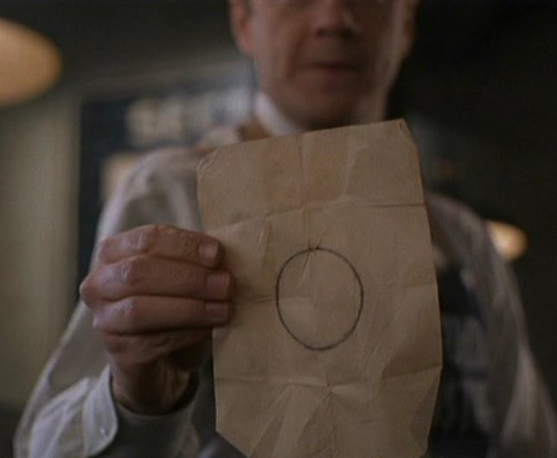

jQuery Knob is © 2012 Anthony Terrien - MIT License