**Alibaba Cloud IoT Platform**

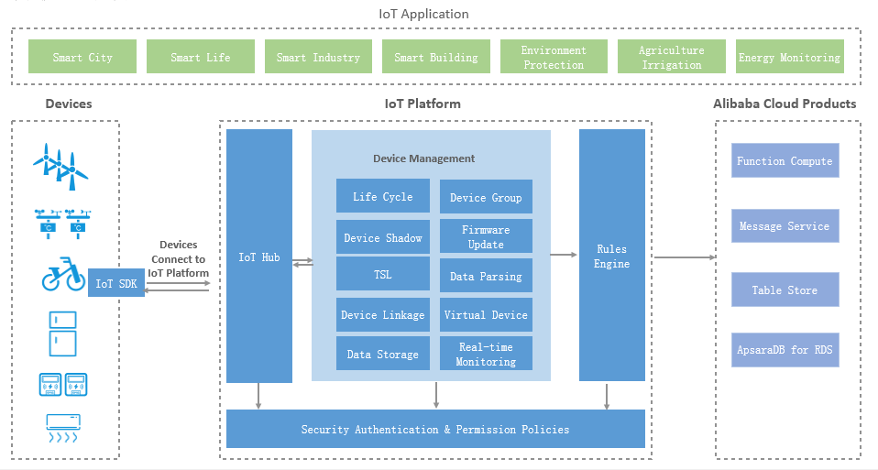

(1) Products/services (2) The Sector they serve (3) Features (4) Benefits/Advantages (5) Market Prospect / Market Share

Alibaba Cloud IoT Platform provide a stable communication way to IoT companies to communicate with their devices.

Features:

* IoT devices can access Alibaba IoT Platform by using different networks, platforms, providers and regions such as 3G, 4G, Lora, NB-IoT, MQTT, HTTP, etc
* provides multiple security features to secure devices

Eg. Provide a unique certificate to each device, support TLS transmission to protect data.

* Provides IoT devices management,

Eg. Lifecycle Management, Device Permissions, Supports Management Tags, Device Relationships, etc

* Contain a rules engine that allow you to integrate with other Alibaba Cloud services and business systems

Advantages:

* Support hundreds of millions of devices communicate with the IoT platform at the same time anywhere and any protocol.
* Encrypted communication that can ensure data will not be