1. **(i)** The most computationally efficient way to evaluate the function f(x) = 2x6 – 3x4 +4x2 -3 is by first calculating x2, say x2= x2. This number can then be multiplied by itself to yield x4 and x6.

**(ii)** The maximum range for a short signed integer in C is -2147483648 to 2147483647 (although this can depend on which machine you are using, compiler, etc.). So, for the input integers f(11,28) the integer and double results match because the calculated value of the polynomial f(11,28)< 2147483647. However, in the polynomial function f(x) = 2x6 – 3x4 +4x2 -3 is calculated by first calculating x2. Even if x2>2147483647, the number is capped at 2147483647, and one then has the potential to obtain negative results, as in the output file (these are marked in **bold**).

**(ii)** Algorithm: To check if a number n is prime, one is only required to check if the division of n by the integers from 2 to sqrt(n) results in another integer. 0 and 1 are not prime and 2 is prime by definition.

**Output of Program:**

f (11) = 3499680 (int), 3.49968e+006 (double). Prime: **1** (1 true, 0 false)

f (28) = 961939773 (int), 9.6194e+008 (double). Prime: **0** (1 true, 0 false)

f (45) = **-584631712** (int), 1.65952e+010 (double). Prime: **0** (1 true, 0 false)

f (397) = **-361058976** (int), 7.83013e+015 (double). Prime: **1** (1 true, 0 false)

f (677) = **-402784224** (int), 1.92558e+017 (double). Prime: **1** (1 true, 0 false)

f (951) = **-129610176** (int), 1.47949e+018 (double). Prime: **0** (1 true, 0 false)

f (2552) = **-2071637763** (int), 5.52477e+020 (double). Prime: **0** (1 true, 0 false)

f (6447) = 879593088 (int), 1.43607e+023 (double). Prime: **0** (1 true, 0 false)

f (6449) = 1282775424 (int), 1.43875e+023 (double). Prime: **1** (1 true, 0 false)

f (7411) = 1689934176 (int), 3.31353e+023 (double). Prime: **1** (1 true, 0 false)

f (7412) = 1747996477 (int), 3.31621e+023 (double). Prime: **0** (1 true, 0 false)

1. We know that the molecular weight of water is 18.0106 g/mol. If we have only 10,000 molecules of water, then the total mass of the system is:

0.018 kg X 10E4/6.023E23 = 2.99E-22 kg

From this, we can solve for L given the proper densities of 1000 and 100 kg/m3:

L = (2.99E-22/100)1/3 =14.4 nm

L = (2.99E-22/1000)1/3=6.7 nm

The length L only grows as the cube root of the density, so you would increase L by a factor of (10)1/3.

1. a)

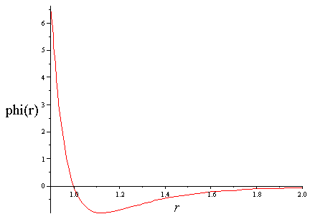

For:

$$ϕ\left(r\right)=0, r=1$$

For:

$$\frac{∂ϕ(r)}{∂r}=-\frac{48}{r^{13}}+\frac{24}{r^{7}}=0, r=2^{1/6}=1.122$$

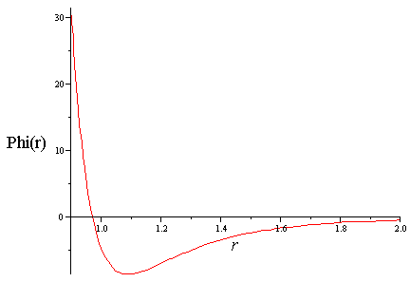

For:

$$ϕ\left(r\right)=0, r=0.971$$

For:

$$\frac{∂ϕ}{∂r}=-\frac{291.12}{r^{13}}+\frac{173.40}{r^{7}}, r=1.09$$

1. The scale:

$k=\frac{k_{b}{ϵ_{LJ}}^{1/2}}{{m_{LJ}}^{1/2}{σ_{LJ}}^{2}}$

Has the units of W/m-K.