1. See written attachment.

a)

See attachment for derivation.

b)

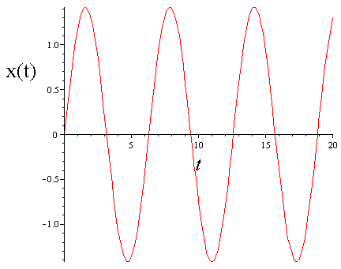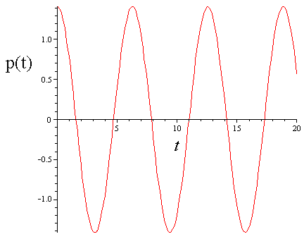

The Kinetic Energy $KE∝{p(t)}^{2}$ and $PE∝{x(t)}^{2}$. So, since both the position and momentum are varying trigonometrically, the total energy $H=KE+PE$ =1=constant. The total energy of the system is conserved, but the momentum fluctuates. This is because KE is constantly being exchanged with PE as the mass oscillates (and these quantities are exactly 90 degrees out of phase with each other).

c) For the linear spring case, there are two characteristic frequencies in the system, which is $f=2π s$ (a period of oscillation for the mass motion) and $f=π s$ which is the frequency of oscillation of Potential and Kinetic energy fluctuations. So, a good choice for a time step might be $dt≪π s$. Below are plots of x(t), p(t), and the KE(t) and PE(t) using an integration dt=0.2:

D:\Classes\CMU\Molecular Simulation\HW2\Q2\partb_x(t)_p(t).epsD:\Classes\CMU\Molecular Simulation\HW2\Q2\partb_KE(t)_PE(t).eps

This appears to be an adequate integration of the trajectory. The total energy is conserved as $\frac{U_{RMS}}{U_{tot}}=0.0036$, where URMS is the RMS fluctuation of the numerically evolved trajectory from the exact analytical solution (Utot=1). We can decrease this value by using a smaller dt. Below is a plot of Utot(t)-1:

D:\Classes\CMU\Molecular Simulation\HW2\Q2\partb_Utot(t).eps

Below is a plot of the evolved trajectory x(t) plotted onto the potential energy :

D:\Classes\CMU\Molecular Simulation\HW2\Q2\partb_PE(x).eps

One can see that the trajectory spends a great deal of time near the largest values of $U\left(±\sqrt{2}\right)=1.$ This is seen clearly in the below plot:

D:\Classes\CMU\Molecular Simulation\HW2\Q2\partb_PDF(x).eps

Which shows a histogram (normalized) of the potential function PDF(U(x)). This is reasonable, since when the potential energy is large the Kinetic Energy is very low and the mass is not moving very fast. The above plot is asymmetric because of the finite integration time.

d) To use different total energies U= 1+0.25 ,1+1, 1+ 2, one should use $p\left(0\right)=\sqrt{0.5},\sqrt{2}, \sqrt{4}$ since U(x=0)=1.

For the case $p\left(0\right)=\sqrt{0.5}$ and dt=0.2 (same as c) ), the energy is only conserved to $\frac{U_{RMS}}{U_{tot}}=0.0396$  
, which may or may not be sufficient, but is certainly worse than case c). To improve, use dt=0.02 and energy is conserved to $\frac{U_{RMS}}{U_{tot}}=0.00037$. Below are plots:

D:\Classes\CMU\Molecular Simulation\HW2\Q2\partc_x(t)_p(t)_05.eps

D:\Classes\CMU\Molecular Simulation\HW2\Q2\partc_PE(x)_05.epsD:\Classes\CMU\Molecular Simulation\HW2\Q2\partc_PDF(x)_05.eps

One sees that the mass oscillates between 2 energy minima before it reaches 2 potential energy maxima (where the kinetic energy is 0), before turning around. The plot on the right is a histogram of the mass’s position x(t), PDF(x). This shows that the particle spends most of it’s time near potential energy maxima, which is consistent with what was seen in c). For this case, the mass spends most of its time near x=0.

For the case $p\left(0\right)=\sqrt{1}$ and dt=0.02, energy is conserved to $\frac{U_{RMS}}{U_{tot}}=0.00049$  
. Below are plots:

D:\Classes\CMU\Molecular Simulation\HW2\Q2\partc_x(t)_p(t)_1.eps

D:\Classes\CMU\Molecular Simulation\HW2\Q2\partc_PE(x)_1.epsD:\Classes\CMU\Molecular Simulation\HW2\Q2\partc_PDF(x)_1.eps

Here again the mass spends most of its time near potential energy maxima, but here the particle has more kinetic energy, and spends less time near x=0. The particle can also access larger absolute values of x (where the potential energy is large) since it has more initial kinetic energy p2(0).

For the case and dt=0.02, energy is conserved to   
. Below are plots:

D:\Classes\CMU\Molecular Simulation\HW2\Q2\partc_x(t)_p(t)_2.eps

D:\Classes\CMU\Molecular Simulation\HW2\Q2\partc_PE(x)_2.epsD:\Classes\CMU\Molecular Simulation\HW2\Q2\partc_PDF(x)_2.eps

Once more, the particle has more initial kinetic energy and can access even larger absolute values of x. Also, the particle spends less time near x=0 and more time near the large potential energy regions of large absolute x.

The more interesting case might be when the initial position x(0)=+-1 (global potential energy minima) and p2(0)<1, so that the mass gets stuck in one of the potential wells. Since the initial kinetic energy is less than the energy difference between the bottom of the well and the local maxima at x(0), the particle remains near x=1 and can’t access the full energy surface:

D:\Classes\CMU\Molecular Simulation\HW2\Q2\partc_PDF(x)_x1_05.eps