3)

The below plot shows the Potential, Kinetic, and Total energies as functions of time. The PE and KE are (nearly) perfectly anti-correlated. That is, when the KE is decreasing, the PE is increasing and vice versa.

D:\Classes\CMU\Molecular Simulation\HW2\Q3\PEKETE(t).eps

The total energy is conserved to within 10E-04 (RMS fluctuation).

D:\Classes\CMU\Molecular Simulation\HW2\Q3\TE(t).eps

The rms fluctuations in the total energy is 2.0573e-004. Using a time step of dt=0.0005 the rms fluctuations are 1.4474e-005, which is consistent with energy conservation increasing with decreasing dt.

D:\Classes\CMU\Molecular Simulation\HW2\Q3\p_i(t).eps

Above is a plot of the 3 components of the momentum, showing that they are conserved within 10E-14.

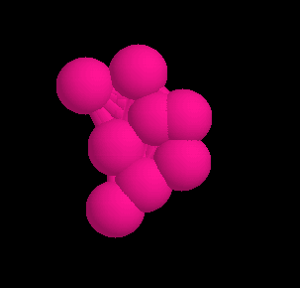

Above is a snapshot of the 10 atom nanoparticle after the time varying potential and kinetic energy have reached a steady state.

D:\Classes\CMU\Molecular Simulation\HW2\Q3\KE_quench(t).eps

The above plot shows the kinetic energy KE(t) as the system of N=8 particles is quenched using eta=0.02. The time step dt=0.002 and the simulation was run for 20,000 time steps. The parameter eta removes KE from the system until the structure is quenched.

D:\Classes\CMU\Molecular Simulation\HW2\Q3\KE_quench(t,eta).eps

Above is a plot for N=10, dt=0.002, and total time 20,000. The quench parameter eta controls how fast KE is removed from the system.

D:\Classes\CMU\Molecular Simulation\HW2\Q3\PE_atom(t).eps

Here is the Potential Energy per atom of the quenched structures. There are varying potential energy minima as the number of atoms N is varied.