Below are plots of the running average of the potential energy <U> as it evolves with the number of MC steps. One sees that for a proper choice of δ, where xtrial = x + (rand() – ½)δ, the integrated MC value of <U> comes within < 10% of the exact integral value (labeled in blue in each plot, see attached paper). Each trial was tested with difference initial conditions xi, which was varied between xi = $±\frac{1}{2}{<x^{2}>}^{1/2}$, which was calculated exactly (see attached paper). The results below do not depend on these initial conditions. The simulations were all run for 50,000 MC steps. The acceptance rate is reported, which for the best runs was near %50.

Beta = 0.1, delta = 25.0, (Uexact/<U>-1) = -5%, acceptance rate = 40.3%

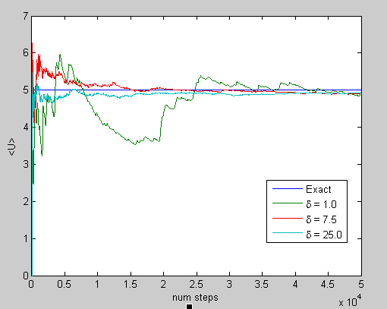

Beta = 1.0, delta = 5.0, (Uexact/<U>-1) = +4.1%, acceptance rate = 55.7%

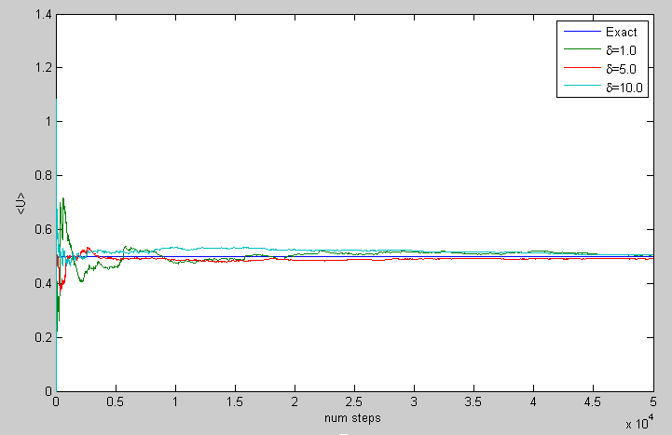

Beta = 5.0, delta = 2.0, (Uexact/<U>-1) = +2%, acceptance rate = 59.6%

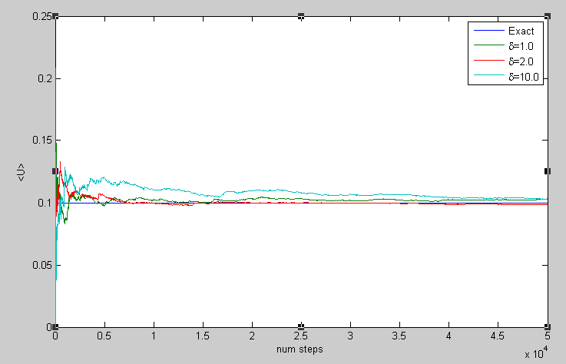

Beta = 10.0, delta = 2.5, (Uexact/<U>-1) = +2.5%, acceptance rate = 41.3%

