Below are plots of the running average of the potential energy <U> as it evolves with the number of MC steps. One sees that for a proper choice of δ, where xtrial = x + (rand() – ½)δ, the integrated MC value of <U> comes within < 10% of the exact integral value (labeled in blue in each plot, see attached paper). Also, the <x2> also comes within <10% for each run, but the most accurate value for both <U> and <x2> are not always calculated from the same delta. This seems reasonable, since both quantities (for this potential) give completely different integrals, and are not just a simple factor of 2 different (as in the harmonic potential). Each trial was tested with difference initial conditions xi, which was varied between xi = $±\frac{1}{2}{<x^{2}>}^{1/2}$. The results below do not depend on these initial conditions. The simulations were all run for 100,000 MC steps. The acceptance rate is reported, which for the best runs was close to %50.

Beta = 0.1, delta = 20.0, (Uexact/<U>-1) = +0.5%, (x2exact/<x2>-1) =+30.1% acceptance rate = 51.8%

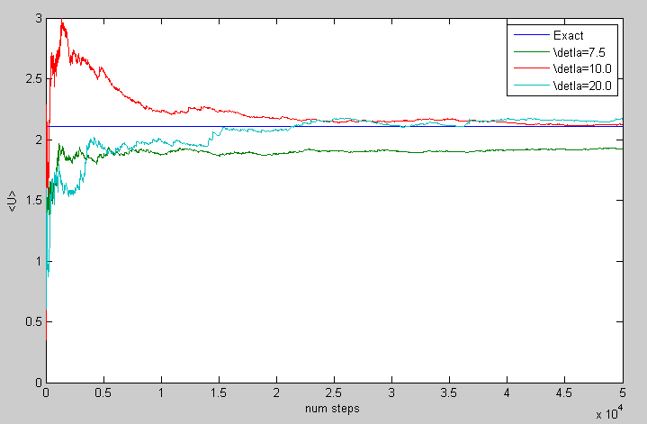

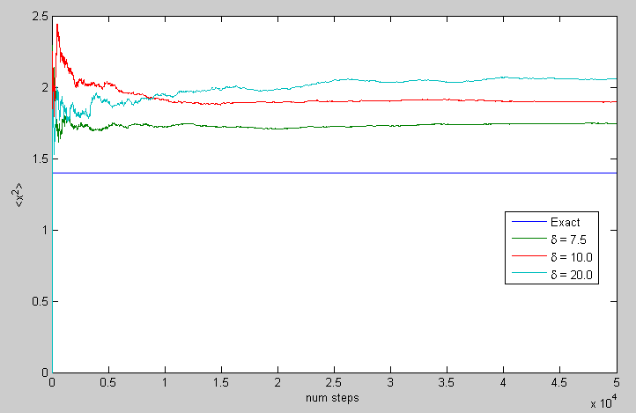

One sees that (from the average value of x2) the particle explores both sides of the potential well and does not get caught in either. This is because the temperature is high enough (small beta) such that the average thermal energy is sufficient to overcome the local potential maximum at x=0.

Beta = 1.0, delta = 5.0, (Uexact/<U>-1) = +1.4%, (x2exact/<x2>-1) =+5.1% acceptance rate = 57.55%

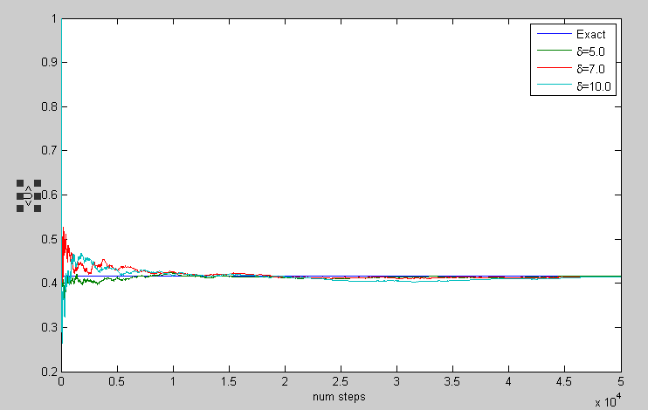

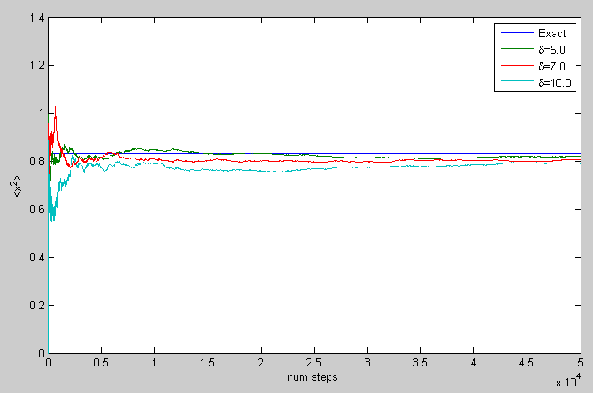

Beta = 5.0, delta = 1.0, (Uexact/<U>-1) =-+4.2%, (x2exact/<x2>-1) =-5.4% acceptance rate = 49.8%

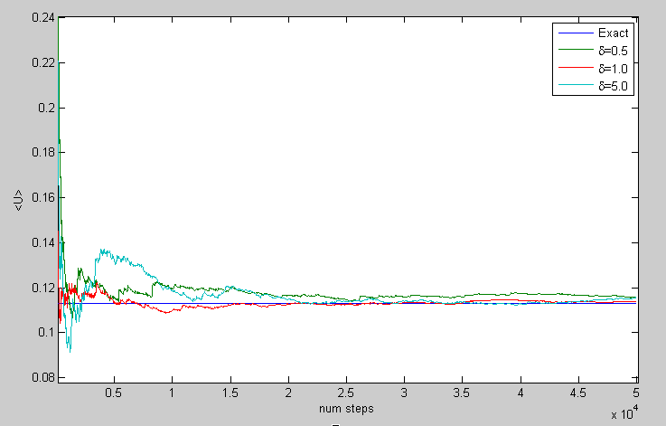

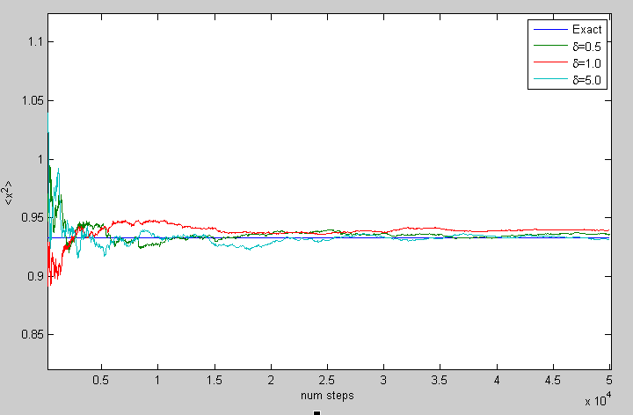

In the below plot, one can see for the successful run at delta=1.0, the particle periodically gets caught in both wells, but is able to explore both sides of the potential well.

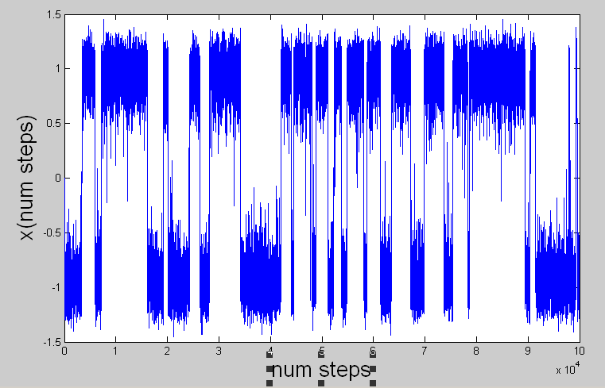

Beta = 10.0, delta = 1.0, (Uexact/<U>-1) = +3.7%, (x2exact/<x2>-1) = +2.4%, acceptance rate = 40.1%

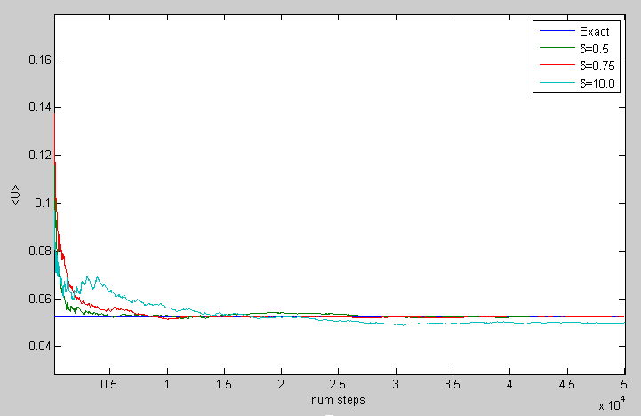

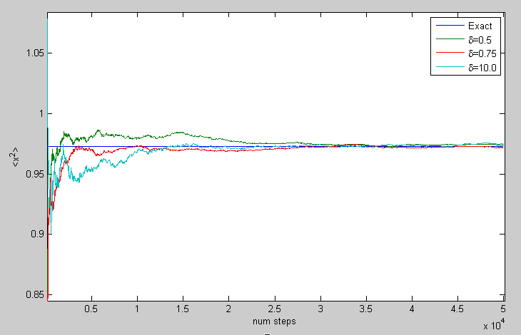

Below is a plot of the x position as a function of trial step number. For the successful run above, the particle was never able to make it out of the left well into the right. This is because the energy required to do so is very rare at such a low temperature (large beta). One can also see (although this is a very small effect) that the particle is biased to move in the direction towards the origin since the potential is “softer” in that direction (energy change per unit length is less).

