1)

a) This exercise was basically done in HW3. The below plot shows the density (in kg/m^3) as a function of (non-dimensionalized) pressure for two different Tau=0.5,0.05. The value of L=7.5 (LJ units) gives (approximately) 0 pressure.

The system was determined to be equilibrated when the running average of T (Trunavg) and P (Prunavg) reached a steady state. The below plot shows that this occurs after about 10,000 LJ steps (dt=0.002). After this the system shows normal fluctuations given by NVT ensemble. Below, tau=0.05.

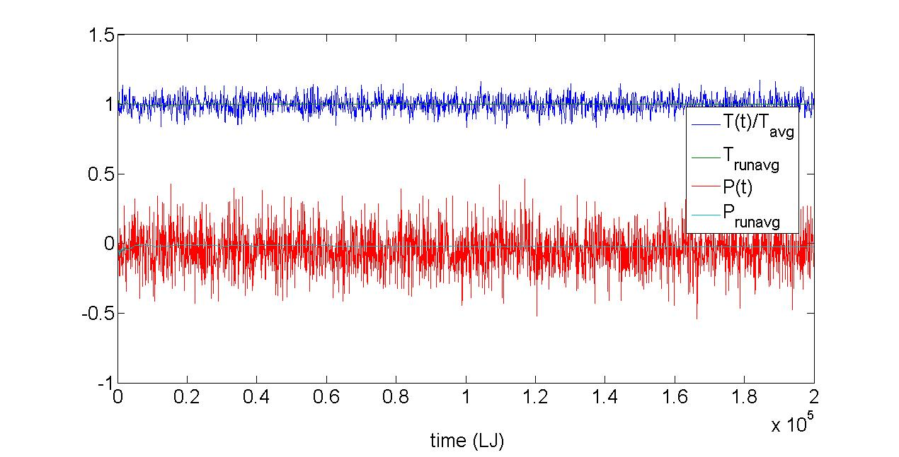

b)

Data from the above simulation can be used to estimate the constant volume specific heat. After the LJ time of 10,000, the fluctuations in the total energy can be used to estimate c,v by the relation given in the homework handout. Below is a plot of the estimate c,v for 3 different tau_T:

One sees that the value of c,v does not depend strongly on tau_T.

2)

a) The MC runs were run for various values of delta=0.1,0.5,1.0 at beta=0.8267 (100 K) for 250,000 MC steps. The value of L chosen for the MC simulation was the same as that determined from the MD simulations above, L=7.5. A similar plot was made for density as a function of pressure, showing a 0 pressure value for L~7.5.

A similar procedure was used as in 1b) to determine when the system was equilibrated. The pressure was tracked during the MC simulation, and when the average of that pressure became steady state the system was deemed to be in equilibrium. This time varied depending on the choice of delta. For example, it took approximately 100,000 MC steps to equilibrate using delta-1.0, while a value of delta=5.0 never equilibrated over the entire 250,000 step run. Below is a plot of the potential energy U as a function of MC steps:

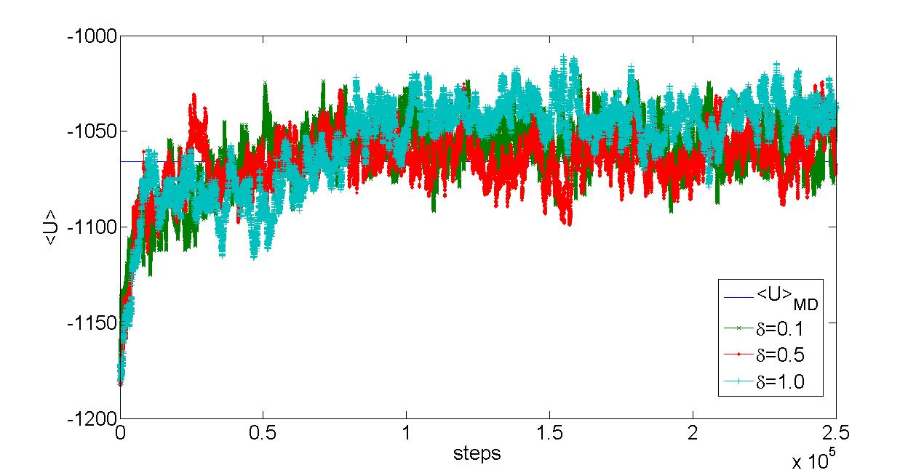

One sees that for the values of delta listed (delta=0.1,0.5,1.0), the average value is converging close to that value measured in the MD simulation for tau_T=0.05. Below is a plot of the specific heat c,v measured for three value of delta=0.1,0.5,1.0:

One can see that the value of c,v depends quite strongly on the choice of delta, even though all choices of delta converged to the MD value for <U> shown in the previous plot. This discrepancy is basically contained in the potential energy fluctuations, measured in <(U-<U>)^2>. The values of delta-0.1,0.5 allow for much smaller energy fluctuations (<(U-<U>)^2>~3.3E-40 J^2), while delta=1.0 gives <(U-<U>)^2>~6.4E-40 J^2. The cvalue of delta=1.0 also gives c,v to within 1-5% of the values calculated from the MD simulations for any tau_T.

In calculating the specific heat c,v, capturing the correct energy fluctuations is key. In MC simulations, these fluctuations depend strongly on the choice of the search parameter delta. While average quantities like <U> do not depend strongly on delta, the fluctuations can (and do). In MD, the choice of tau_T does not significantly affect the results, at least within an order of magnitude of the choice. Fluctuations in MD are also less dependent on the parameter tau_T, presumably because the nature of MD is to capture the system fluctuations in a Newtonian framework. Still, MC simulations (on this particular system) are able to run at (basically) O(n) scaling without any modifications to the code. Because of that, many simulations (and many long simulations) can be run. However, the sensitivity of the system fluctuations to delta seems to indicate that MD is a better choice for calculating c,v.