**1)**

Below is a plot of the transition rate Kab estimated from harmonic approximation for various values of beta (various temperatures). As expected, smaller beta (larger T) gives a larger rate constant, indicating that transitions are more likely for larger T. The curve follows a simple exponential Boltzmann type function. Note, I did not plot this function from 0.01< beta< 100 because the function changes too much over this range. The calculations of the harmonic rate constant are on the attached written paper.

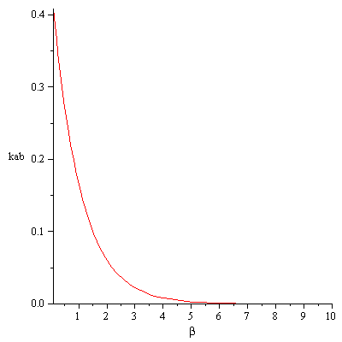

Below is a plot of the harmonic potential approximation (with curvature k=8.0 from the exact potential). One can see that near the local maximum at U(x=0)=1.0 the harmonic potential overestimates the energy required for a particle to reach x=0.

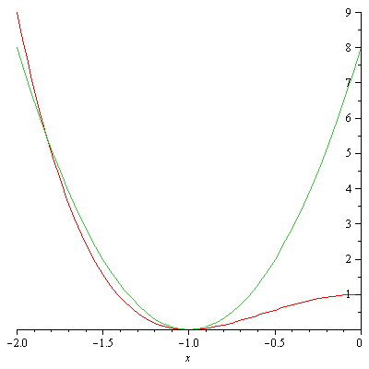

**2)**

Below are plots of the rate constant Kab estimated from various MC runs compared with the harmonic approximation and also the exact value of Kab measured by calculating the value of the delta function numerically using Simpson’s rule. Listed for each data series is a different choice of the MC step size delta. The plot is the value of Kab as a function of the bin size epsilon. For each value of delta a percent accept is reported, which is the percentage of accepted moves compared to the total number of moves which are either accepted or rejected, but not because x_trial>xstar+epsilon/2. Also reported is the “%outside”, which is percent of total trial moves which have x_trial>xstar+epsilon/2. One would think (intuitively) that this “%outside” should be small. However, I don’t see any clear convergence for these calculations as a function of “%outside”. If one uses the metric %acc~0.5 to choose an appropriate value of delta, then that gives one answer for Kab which seems converged for the choice of epsilon. However, other values of delta give completely different values for Kab, which also seems to be converged for various values of epsilon. Also, the harmonic approximation (in this case) should be underestimating the value of the rate constant since it overestimates the value of the energy U(x) at large beta, which is explained in a section below.

**Beta=0.01**

If we look at larger values of beta, the calculated Kab from MC is actually lower than the harmonic approximation, and is again dependent on the choice of delta. This is inconsistent with the exact calculation of Kab:

**Beta=0.1**

**Beta=1.0**

By the time you get to beta=10.0, you have to use 10E08 number of trial moves, and even then you can only get statistically significant results (numbin~100) by using epsilon>=0.01:

**Beta=10.0**

These results for beta=10.0 seem a little bit better converged with respect to both delta and epsilon. For the case beta=100.0, I never observe any points falling into a bin of size epsilon=0.1.

**Beta=100.0**

The harmonic approximation at beta=100.0 is Kab=1.67E-44, which is the same (within significant figures) to the exact Kab=1.67E-44. The value of Kab is essentially 0 at this temperature, and no data was available from MC to compare.

**Harmonic and Exact**

Below is a plot of the comparison of Kab using the harmonic approximation and also the “exact” numerical value using the exact potential U(x) and Simpson’s rule. Also plotted are the average values of Kab calculated from MC above, using the average across the various values of delta, and reported errors as standard deviations from those averages:

One sees that the harmonic approximation underestimates Kab, but the two Kab (harmonic and exact) converge for large beta. One also sees that MC consistently underestimates Kab, and the errors are quite large (of order %50 of the value of Kab itself).

Below is a plot of the relative difference between harmonic and exact, (exact-harmonic)/exact, which shows the same behavior as the above plot:

One sees at a value of beta=1.0 that the harmonic approximation actually overestimates Kab, which is explained below.

**Harmonic Approximation**

The problem is that the harmonic approximations still assumes the value of U*(x=0)=1.0, which is the exact value of the energy barrier. This is much less than what one would use if they extrapolated the harmonic potential UH(x)=k(x+1)^2, which has UH(x=0)=8.0. In TST, we assume in both the harmonic and exact case that the value of U*(x=0)=1.0, which provides some type of mixing between the harmonic approximation to the potential form, and the actual value of the energy at the barrier. Below are a series of plots showing the normalization factor:

$$\int_{-∞}^{0}{\exp\left(-U\left(x\right)β\right)dx}$$

From:

$$kab=\frac{\exp\left(-U^{*}β\right)}{\int_{-∞}^{0}{\exp\left(-U\left(x\right)β\right)dx}}$$

For both the harmonic and exact cases:

Beta=0.01 beta=0.1

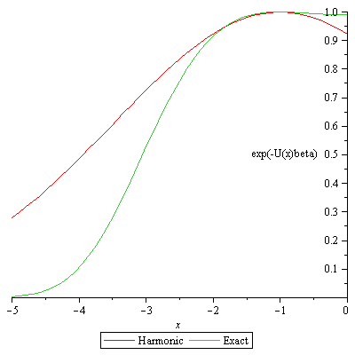    
beta=1.0 beta=10.0

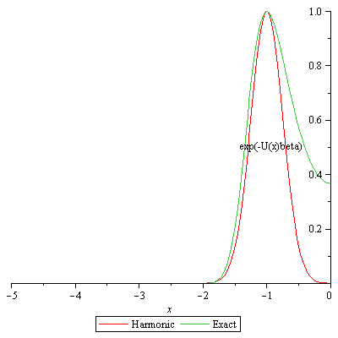 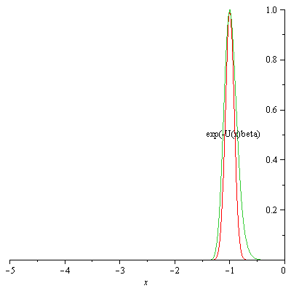

Beta=100.0

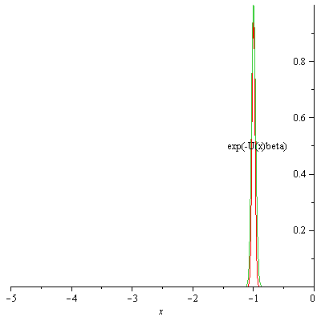

One can see for large beta that these two normalization factors converge to each other for large beta. One see at small value of beta that the normalization factor for the exact case (area under the curve) is smaller than the harmonic case, which explains why the harmonic approximation underestimates the rate constant for small beta. This result still does not explain the MC results, which seem to show the opposite trend (MC rate constant consistently smaller than harmonic case). Also, the MC results differ from the exact case by several factors, which again I cannot explain.