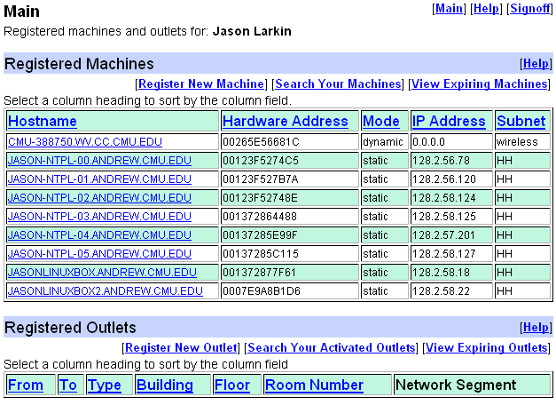

All 6 are in that Master’s student room. I would suggest using the “JASON-NTPL-05” machine for now, since we are using the first 5 off and on. The password and usernames are:

User: “Jason”

Pw: “1636l208”

That’s a lower-case “L” in the password.