**Project Title:** Atomistic Modeling of Large Unit Cell Crystals for Thermoelectric Energy Generation

**Research Team:**

Graduate Student: Jason Larkin, Mechanical Engineering  
Faculty Advisor: Associate Professor Alan McGaughey, Mechanical Engineering  
Affiliated Faculty: Visiting Professor Wissam Al-Saidi, Department of Chemical and Petroleum Engineering, University of Pittsburgh

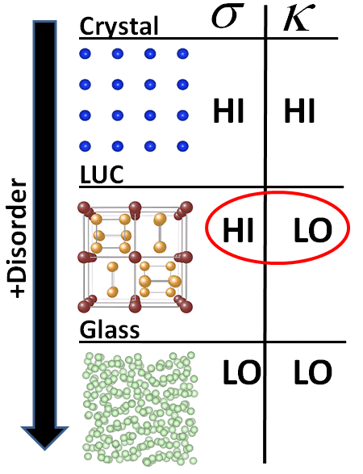**Project Description:** *The objective of this project is to build a robust, accurate, and efficient computational framework for predicting the thermal conductivity of large unit cell crystalline solids for improving the efficiency of thermoelectric energy generation.*

Thermoelectric energy generation - the transformation of waste heat into useful electricity - is a promising source of sustainable energy [1]. Thermoelectric materials directly convert temperature differences into electric voltage as a result of their intrinsic (atomic-level) electronic and thermal properties. The performance of a thermoelectric device can be quantified through the *thermoelectric figure of merit*, ***ZT* = $\frac{S^{2}σ}{κ}T$** , where *T* is the average device temperature, *S* is the Seebeck coefficient (the ratio of the induced thermoelectric voltage to the applied temperature difference), $σ$ is the electrical conductivity, and $κ$ is the *thermal conductivity*. For thermoelectric devices to be competitive with traditional power generation cycles requires *ZT* > 3 [2]. Achieving this performance is challenging because the electrical and thermal properties in *ZT* are coupled in the majority of materials [1,2]. The ideal thermoelectric can be thought of as an “electron-crystal/ phonon-glass” (high $σ$, low $κ$) (see Figure 1). An emerging area of study in thermoelectric power generation is the use of large unit cell (LUC) crystals [1].

Figure 1: LUC crystals can maximize *ZT*.

Large unit cell crystals have an ordered (crystalline) structure, but the basic building block (*unit cell*) of the crystal has a large number of distinct atoms (Figure 1) [4-6]. They are effectively disordered over length scales on the order of the atomic spacing and their thermal conductivities can be as low as a glass [4-6]. The key advantage of LUC materials is that they are still ordered from the standpoint of electrons, which results in large $σ$ and *ZT*. Thus, LUC crystals are “electron-crystal/phonon-glass” materials. Current LUC crystals have *ZT*<3 [4-6] and more research is required to improve their thermoelectric performance.

The LUC crystals to be studied here are skutterudites [4] and Zintl compounds [6]. Both of these LUC crystals have $ZT<0.3$, but experimental measurements show intriguing potential for improved thermoelectric efficiency [4-6]. Identifying design strategies for improving skutterudite and Zintl compound *ZT* requires detailed atomistic analyses. The necessary computational tools and resources are available in my research group, the Nanoscale Transport Phenomena Laboratory (NTPL) [7, 8]. Classical simulations will be used in preliminary testing to study the structural features of LUC crystals that lead to low $κ$ (***Objective 1***) [7,8]. These medium-accuracy classical simulation results will then be used to design computationally-intensive *ab initio* (quantum mechanical) simulations, which have high accuracy (***Objective 2***) [10]. From these *ab initio* simulations, structural features that lead to low $κ$ will be identified with high accuracy to improve *ZT*. The *ab initio* simulation results will be validated against limited experimental data [4-6], and used to provide guidance to the experimental community working on these exciting materials. These objectives can be used iteratively, with data from real experiments, to efficiently search the LUC design space. ***Ab-initio simulations can predict large unit cell materials with even lower thermal conductivities, and thus increase ZT>3.***

**Research Plan**

***Objective 1****: Use classical molecular and lattice dynamics calculations to explore LUC crystal design concepts.*

***Objective 2:*** *Design and perform ab initio simulations to predict the thermal properties of realistic LUC crystals.*

**Relationship to CIT/ICES Strategic Focus**

Atomistic simulation of LUC materials fits directly into CIT’s nanotechnology initiative. This project is aligned with ICES’s Center for Multiscale Modeling for Engineering Materials (CM2EM) and Center for Nano-enabled Device and Energy Technologies (CNXT), both of which McGaughey is affiliated with. The work provides a compelling example of multi-scale and multi-physics modeling by demonstrating how classical-level (molecular and lattice dynamics) simulations can inform quantum-level (*ab-initio*) simulations, maximizing the impact of both.

**Present and Future Funding**

Preliminary funding for Larkin’s research has been through a CIT Dean’s fellowship, funds from the Department of Mechanical Engineering, and extra funds from an AFOSR project. He does not have support in place for the 2011-2012 academic year.

The Dowd fellowship will enable the team to initiate first-principles study of thermal transport in LUC materials. With critical preliminary data in hand, the team will be competitive for funding from NSF’s Thermal Transport Processes (ENG-CBET) and Condensed Matter and Materials Theory (DMR) programs and DOE’s Condensed Matter and Materials Physics (BES-MSE) and Computational and Theoretical Chemistry (BES-CSGB) programs. In the future, the team will seek out experimental collaborators in materials synthesis and thermal measurements [notably Jon Malen (ME), who thermally characterizes micro- and nanoscale materials and currently collaborates with McGaughey on other projects]. Together, they will apply for funding from NSF’s Interdisciplinary Research (IDR) program.

**References**

[1] M.S. Dresselhaus, et al., “New Directions for Low-Dimensional Thermoelectric Materials”, *Adv. Mat.* 2007 **19** 1043–1053.

[2] G. Chen, et al., “Recent developments in thermoelectric materials.” *Int. Mat. Rev.* **48** (2003) 45–66.

[3] A. J. Minnich, et al., “Bulk nanostructured thermoelectric materials: current research and future prospects”, *Ener. and Env. Sci.* **2** (2009) 466–479.

[4] T. He, et al., “Thermoelectric Properties of Indium-Filled Skutterudites”, Chem. Mater. 2006 **18** (3) 759–762.

[5] Yang, et al., “Effect of La filling on thermoelectric properties of LaxCo3.6Ni0.4Sb12-filled skutterudite prepared by MA-HP method”, *Jo. of Sol. Stat. Chem.* **179** (2006) 212-216.

[6] X.-J. Wang, et al., “Thermoelectric properties and electronic structure of Zintl compound BaZn2Sb2”, *Appl. Phys. Lett.* **90** 232107 (2007).

[7] J. Larkin, A. J. H. McGaughey, “Predicting Phonon Properties of Defected Systems using Spectral Energy Density”, *in preparation*.

[8] J. E. Turney, A. J. H. McGaughey, et al., “Predicting phonon properties and thermal conductivity from anharmonic lattice dynamics calculations and molecular dynamics simulations.” *Phys. Rev. B* **79** (2009) 064301.

[9] Y. He, et al., “Heat Transport in Amorphous Silicon: Interplay between morphology and disorder”, *Appl. Phys. Lett*. **98** (2011) 144101.

[10] S. Baroni, et al., “Phonons and related crystal properties from density-functional perturbation theory.” *Rev. Mod. Phys.* **73** (2001) 515–562.

[11] W. A. Al-Saidi, E. J. Walter, and A. M. Rappe, “Optimized norm-conserving hartree fock pseudopotentials for plane-wave calculations” *Phys. Rev. B* **77** (2008) 075112.