**Project Title:** Atomistic Modeling of Large Unit Cell Crystals for Thermoelectric Energy Generation

**Graduate Student:** Jason Larkin, Mechanical Engineering  
**Faculty Advisor:** Associate Professor Alan McGaughey, Mechanical Engineering

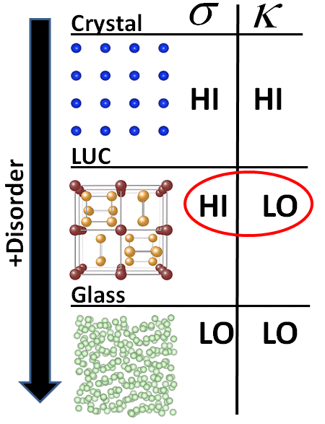**Project Description:** *The objective of this project is to build a robust, accurate, and efficient computational framework for predicting the thermal conductivity of large unit cell crystalline solids for improving the efficiency of thermoelectric energy generation.*

Thermoelectric energy generation - the transformation of waste heat into useful electricity - is a promising source of sustainable energy [1]. Thermoelectric materials directly convert temperature differences into electric voltage as a result of their atomic-level electronic and thermal properties. The performance of a thermoelectric device can be quantified through the *thermoelectric figure of merit*, ***ZT* = $\frac{S^{2}σ}{κ}T$** , where *T* is the average device temperature, *S* is the Seebeck coefficient (the ratio of the induced thermoelectric voltage to the applied temperature difference), $σ$ is the electrical conductivity, and $κ$ is the *thermal conductivity*. For thermoelectric devices to be competitive with traditional power generation cycles requires ***ZT* > 3** [2]. Achieving this performance is challenging because the electrical and thermal properties in *ZT* are coupled in the majority of materials [1,2]. The ideal thermoelectric can be thought of as an “electron-crystal/ phonon-glass” (high $σ$, low $κ$) (see Figure 1). An emerging area of study in thermoelectricity is the use of large unit cell (LUC) crystals [1].

Figure 1: LUC crystals can maximize *ZT*.

An emerging area of study in thermoelectricity is the use of large unit cell (LUC) crystals, whose *unit cell* (basic building block) has a large number of distinct atoms (Figure 1) [3-5]. They are effectively disordered over length scales on the order of the atomic spacing and their thermal conductivities can be as low as a glass [3-5]. The key advantage of LUC materials is that they are still ordered from the standpoint of electrons, which results in large $σ$ and *ZT*. Thus, LUC crystals are “electron-crystal/phonon-glass” materials. Current LUC crystals have *ZT*<3 [3-5] and more research is required to improve their thermoelectric performance.

Identifying design strategies for improving *ZT* of LUC crystals requires detailed atomistic analyses. The necessary computational tools and resources are available in my research group, the Nanoscale Transport Phenomena Laboratory (NTPL) [6, 7]. Classical simulations will be used in preliminary testing to study the structural features of LUC crystals that lead to low $κ$ (***Objective 1***) [6,7]. These medium-accuracy classical simulation results will then be used to design computationally-intensive *ab initio* (quantum mechanical) simulations, which have high accuracy (***Objective 2***) [8]. From these *ab initio* simulations, structural features that lead to low $κ$ will be identified with high accuracy to improve *ZT*. The *ab initio* simulation results will be validated against limited experimental data [3-5], and used to provide guidance to the experimental community working on these exciting materials. These objectives can be used iteratively, with data from real experiments, to efficiently search the LUC design space. ***Ab-initio simulations can predict large unit cell materials with even lower thermal conductivities, and thus increase ZT>3.***

[1] M.S. Dresselhaus, et al., *Adv. Mat.* 2007 **19** 1043–1053.

[2] G. Chen, et al., *Int. Mat. Rev.* **48** (2003) 45–66.

[3] T. He, et al., Chem. Mater. 2006 **18** (3) 759–762.

[4] Yang, et al., *Jo. of Sol. Stat. Chem.* **179** (2006) 212-216.

[5] X.-J. Wang, et al., *Appl. Phys. Lett.* **90** 232107 (2007).

[6] J. Larkin, A. J. H. McGaughey, *in preparation*.

[7] J. E. Turney, A. J. H. McGaughey, et al., *Phys. Rev. B* **79** (2009) 064301.

[8] S. Baroni, et al., *Rev. Mod. Phys.* **73** (2001) 515–562.