**05/01/11**

* Find LJ style skutterudite
* Esfarjani, Chen, 2D Skutterudite with Lennard Jones:
* First principles skutterudite LD: <http://arxiv.org/PS_cache/cond-mat/pdf/9906/9906028v2.pdf>
* <http://prb.aps.org/pdf/PRB/v61/i14/pR9209_1>
* Lennard Jones System: <http://s3tec.mit.edu/images/publications/effectoffiller.pdf>

<http://jcp.aip.org/resource/1/jcpsa6/v120/i19/p9222_s1?isAuthorized=no>

<http://pubs.acs.org/doi/pdf/10.1021/cm052055b>

* From Ken Jordan’s group, is there anything they can teach me about skutterudites? Like, is there a typical type of atom that goes into these structures, a la the perovskites? If so, I could do atomisitically accurate studies of these systems, to show something like bond disorder is dominant over mass disorder.

**05/03/11**

* Baoling thesis: <http://deepblue.lib.umich.edu/bitstream/2027.42/61561/1/baolingh_1.pdf>
* Metrics for cage-like structures: <http://www-personal.umich.edu/~kaviany/researchtopics/BLHuang%20JAP%202006%20struc%20metrics.pdf>
* http://en.wikipedia.org/wiki/Electronegativity

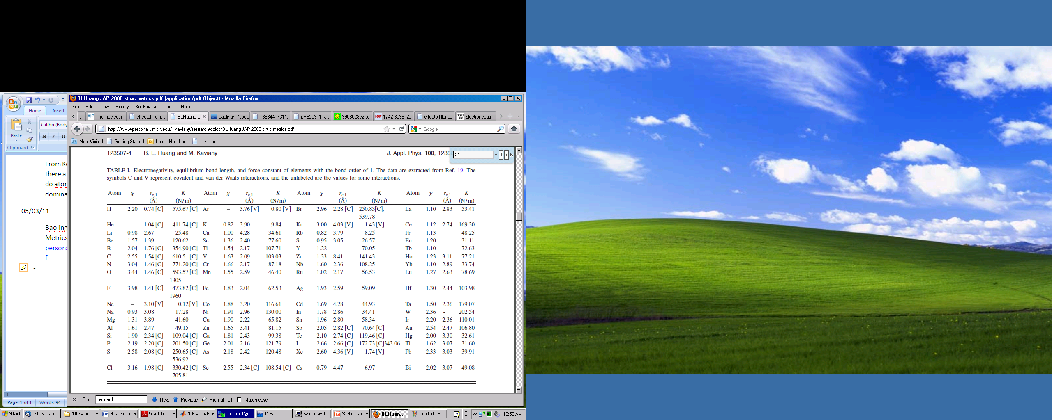

Alan Meeting: Uher Michigan, Jeff Snyder Caltech Kaviany

Zeolite MD simulation:

<http://pdfserve.informaworld.com/769844_731198607_792832013.pdf>

**Lattice dynamics and reduced thermal conductivity of filled skutterudites**

<http://prb.aps.org/pdf/PRB/v61/i14/pR9209_1>

<http://arxiv.org/PS_cache/cond-mat/pdf/9906/9906028v2.pdf>

<http://iopscience.iop.org/1742-6596/215/1/012130/pdf/1742-6596_215_1_012130.pdf>

**Thermoelectric Properties of Indium-Filled Skutterudites**

<http://pubs.acs.org/doi/pdf/10.1021/cm052055b>

**Thermoelectric properties and electronic structure of Zintl compound BaZn2Sb2**

<http://apl.aip.org/resource/1/applab/v90/i23/p232107_s1?isAuthorized=no>