**0/05/11**

* Check GSL FFT subroutine versus Joe’s code. This is unlikely the cause since Joe uses FFT routine elsewhere (FIND?). Check carefully the input to Joe’s FFT routine in other code region to make sure SED parameters are being processed properly (i.e. that factors of 2pi here and there are consistent).
* Run a very long SED run. 10 mil time steps, w_step=2048, 10 seeds while everything else gets sorted out.
* Put a pause in the SED compute, print out the momentum at a given step to a file, and compare the FFT to matlab’s. This should just be on cin.get, a write to file, write the SED output fft to file, and the check matlab. This will check for factors of 2pi and such.

**Velocity-Velocity Auto-correlation Function**

Check to see if by Wiener-Kinchin thm the SED and the velocity auto-correlation function are Fourier transforms of one another.

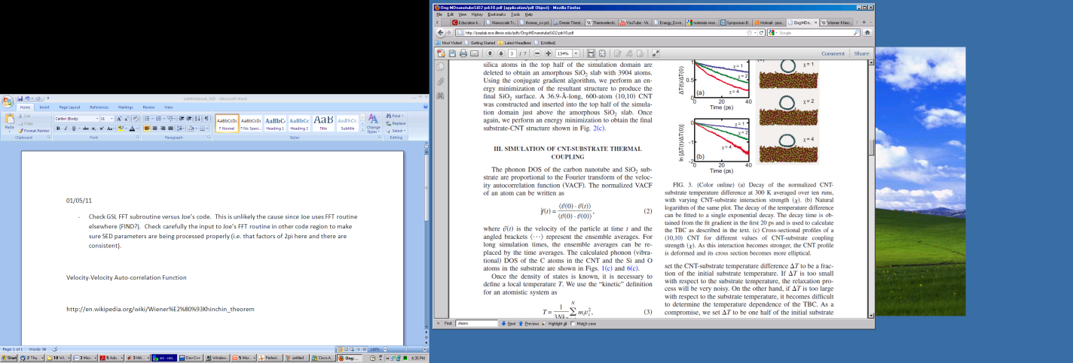

<http://en.wikipedia.org/wiki/Wiener%E2%80%93Khinchin_theorem>

**05/03/11**

* Alex code up a c++ routine for performing SED on LAMMPS output:

LAMMPS Dump output: