Multi-Scale Modeling of Phase Change Materials
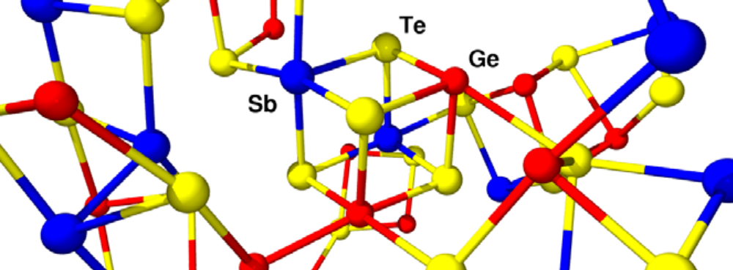


Alan
McGaughey

Formation of a cubic element of Ge-Sb-Te, a structure representative of the crystalline state of GST, in the liquid phase (J. Akola and R.O. Jones, J. Phys. Condens. Matter 20 (2008) 465103).
Jason
Larkin

There is a pressing demand for higher density non-volatile memory (NVM) for electronics and computing applications ranging from personal MP3 players to high-performance supercomputers. There are several performance limitations with the current NVM market leader, Flash memory, particularly with respect to cycles per lost bit (cyclability) and in bit loss per year (retention). A leading candidate to replace Flash (and other types of) memory is phase change memory (PCM). Phase change memory devices use Ge-Sb-Te (GST) compounds that exhibit several order of magnitude contrasts in both optical and electronic properties between their crystal and amorphous phases. Reading or writing binary information in these devices is done by “switching” between the crystal and amorphous phases. This process is thermally driven, so understanding heat transfer mechanisms in PCM materials is critical to understanding their behavior and how it can be modified. The read/write process can be completed in less than 100 ns, an order of magnitude faster than Flash memory. Phase change memory devices have also proven to be robust in terms of cyclability and retention.

Challenges remain, however, in optimizing the implementation of PCM at large scales. Phase change memory devices are peculiar in that while their operation has been demonstrated, little is known about how/why they work as well as they do. It is thus difficult to predict how the materials and devices might be improved. Atomic-level analysis can provide the required insight. Previous atomistic simulations of PCM materials have used computationally expensive quantum mechanics-based methods, restricting the simulations to tens of Angstroms and hundreds of picoseconds (several orders of magnitude less than the experimental scales). The objective of this project is to build a framework for using classical Molecular Dynamics (MD) simulations to model PCM materials, allowing for simulation over the experimental length and time scales.

Modeling PCM materials using MD simulation requires interatomic potentials to describe the interactions between Ge, Sb, and Te atoms. To parameterize these potentials, we use a multi-variable, non-linear fitting procedure based on the minimization of a sum-of-squares error. The sum-of-squares error is based on the difference between observable quantities and those quantities calculated from the fitted interatomic potentials. These observable quantities include high-level quantum mechanical DFT (Density Functional Theory) calculations as well as experimental data. These potentials are then used in classical MD simulations to study PCM materials over the experimental length and time scales. The results will provide input to device-level models and insight to experimentalists designing new materials and devices.

This work is supported primarily by ICES Award #C000037043.

Shaun
Swanson

Eric
Landry

Nanoscale Transport Phenomena Laboratory

