- Wrote fractal program. Verified with Henon Map:

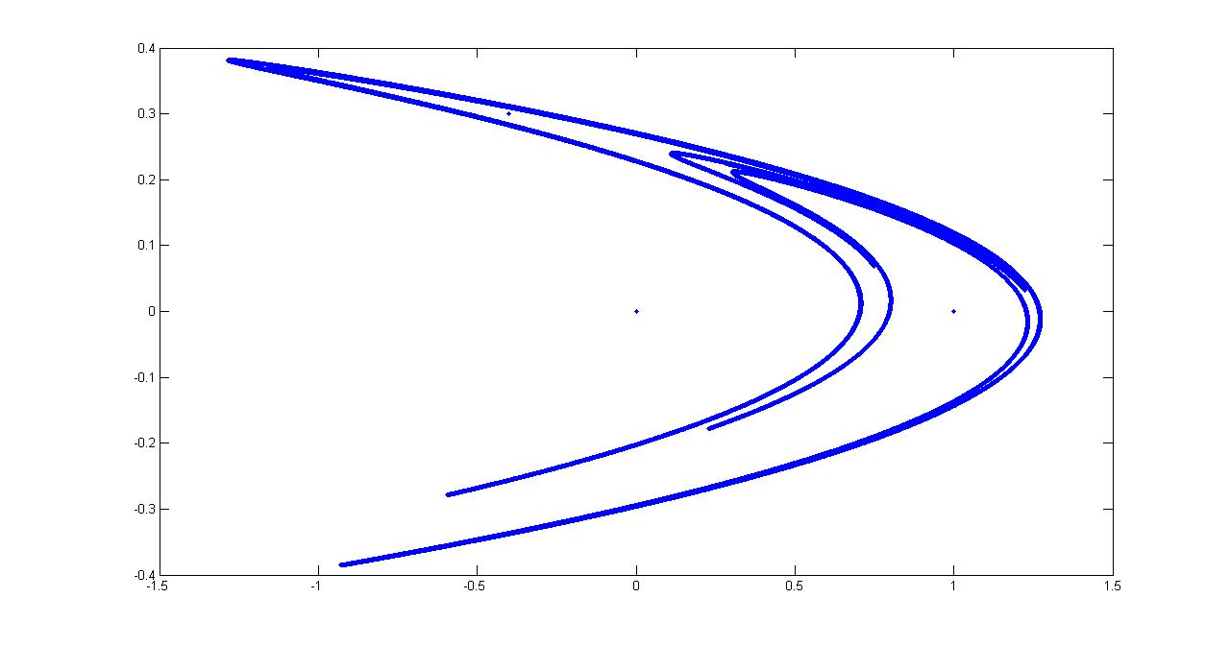
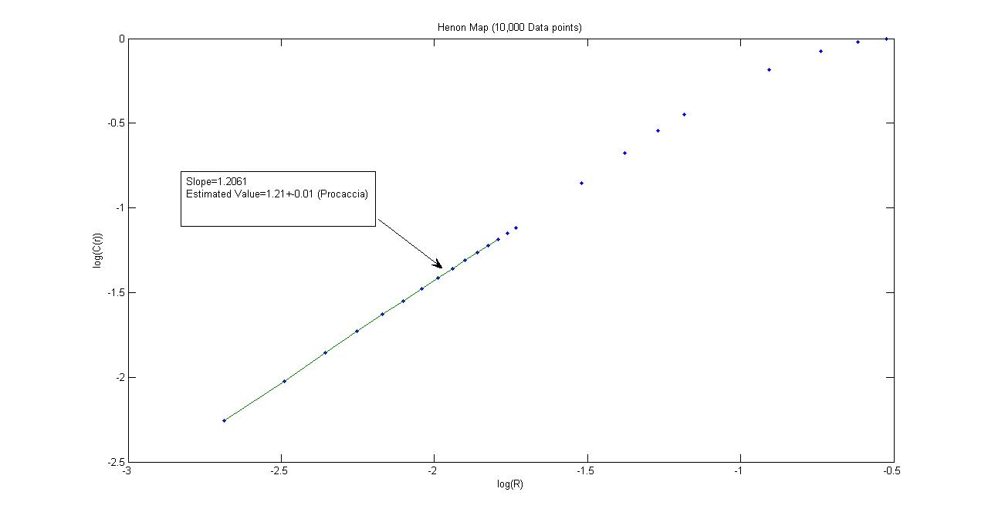

- Difficulty with “box-counting” method (couldn’t find interval where D_q was constant).
- Used “Correlation Method” to calculate a range of D_q. Poor statistics prevented me from measuring large positive or negative values of q. Decided to focus on the three “canonical” D_q, q=0,1,2. From what I know 2-D chaotic maps have a singularity spectrum that is an upside down parabola. Since D_q is a legendre transformation of f(alpha) all 2-D multifractal maps have the same general shape for D_q. I felt that more information could be obtained by focusing on D_q(t) and measuring their decay times.
- Had to find interval on r where D_q was constant for correlation method:
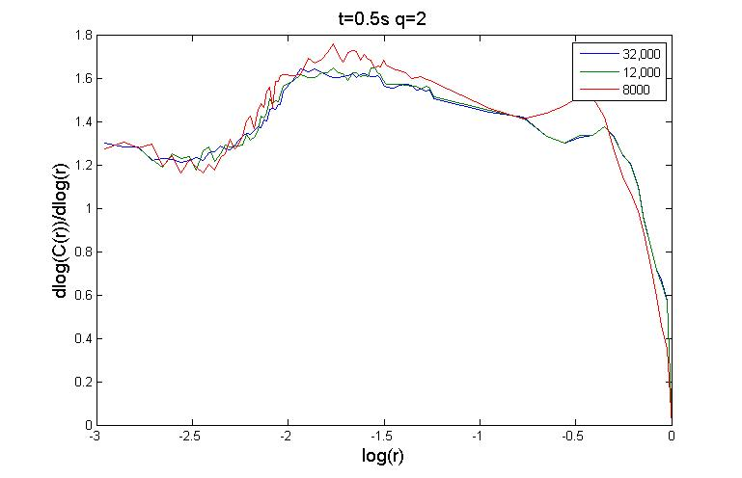
Figure shows both interval on r (non-dim. by field of view) where D_2 is constant and shows convergence of D_2 for number of particles. This interval turned out to be about 100 pixels down to 1 pixel. On average D_2 was constant over about 0.75 decades of r (shown in this figure from about 10^-2 to 10^-1.25).
- Taylor expansion of correlation sum will show that for q=1 C(r)=1, so:
D_q=(1/1-1)*dln(1)/ln(r) is not defined at q=1 and can’t be expanded in taylor series. So I took limit as q->1 and averaged the two values (D_1.1 and D_0.9) to estimate D_1:

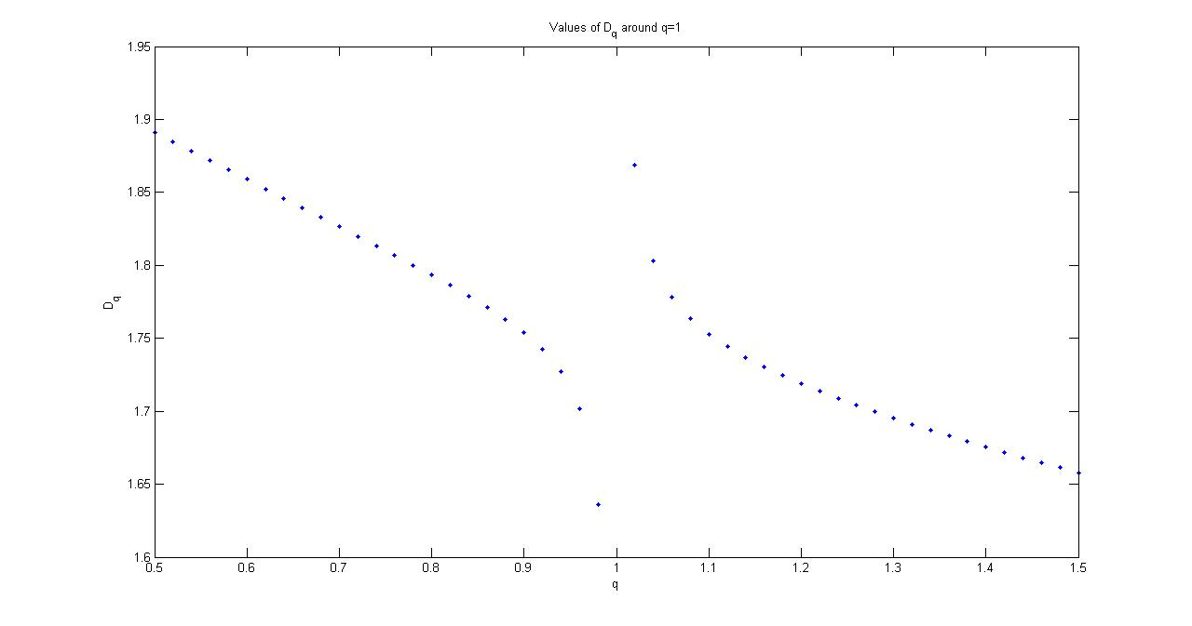
Here you see D_q as q->1. At q=0.9 and 1.1 the function is fairly well defined (limited by our statistics).
6. Expected to see difference in decay times immediately but saw none in Re=120-170
-saw nearly laminar flow from your Re=50 data.

