Scalable Spectral Transforms at Petascale
[Extended Abstract]

Dmitry Pekurovsky

San Diego Supercomputing Center
University of California at San Diego
9500 Gilman Drive, MC 0505
La Jolla, CA 92093 USA
858-822-3612
dmitry@sdsc.edu

ABSTRACT
In this paper, I describe a framework for spectral transforms called P3DFFT, and its extended features and applications. I discuss the scaling seen on petascale platforms, and directions and some results of the ongoing work on improving performance, such as overlap of communication with computation and hybrid MPI/OpenMP implementation.
Categories and Subject Descriptors
G.1.2 [Numerical Analysis]: Approximation --- Fast Fourier Transforms (FFT); G.1.8 [Numerical Analysis]: Partial Differential Equations --- Spectral Methods; G.4 [Mathematical Software]: Algorithm Design and Analysis, Efficiency, Parallel and Vector Implementations, User Interfaces, portability; D.1.3 [Programming Techniques]: Concurrent Programming; G.1.0 [Numerical Analysis]: General --- Parallel Algorithms; G.1.10 [Numerical Analysis]: Applications; J.2 [Physical Sciences and Engineering]: Engineering;
General Terms
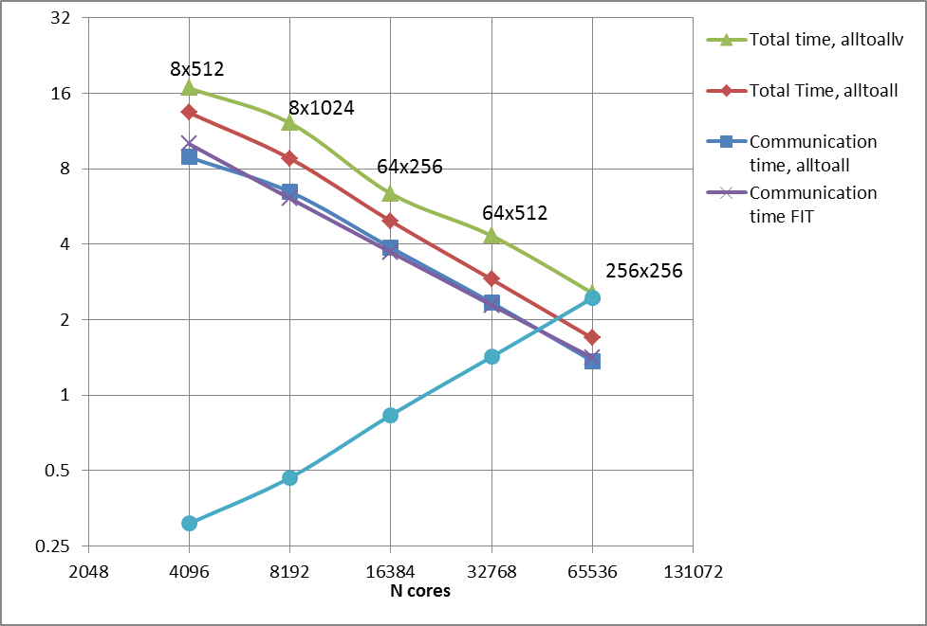
Figure 1. Strong scaling of P3DFFT on Cray XT5, for a 4096-cubed problem size. The red line shows the best achieved performance. The dark blue and purple lines show measured and predicted communication time, respectively. The green line shows a higher timing resulting from using MPI_alltoallv on Cray, in contrast with MPI_Alltoall.
Algorithms, Performance, Design.
Keywords
Petascale; scalability; parallel performance; High Performance Computing (HPC); community applications; Numerical Libraries; Open Source Software; two-dimensional decomposition.

INTRODUCTION

Fourier and related types of transforms are widely used in scientific community. Three-dimensional Fast Fourier Transforms (3D FFT), for example, are used in many areas such as DNS turbulence, astrophysics, material science, chemistry, oceanography and X-ray crystallography. In many cases this is a very compute-intensive operation. Currently there is a need for implementations of scalable 3D FFT and related algorithms on Petascale parallel machines [1-8]. Most existing implementations of 3D FFT use one-dimensional task decomposition, and therefore are subject to scaling limitation when the number of cores reaches domain size. P3DFFT library overcomes this limitation. It is an open-source, easy-to-use software package [9] providing general solution for 3D FFT based on two-dimensional decomposition. In this way it is different from majority of other libraries such as FFTW, PESSL, MKL and ACML. P3DFFT is written in Fortran90 and MPI, with C interface available. It uses FFTW as an underlying library for FFT computation in one dimension. The package is available at http://code.google.com/p/p3dfft. P3DFFT has been demonstrated to scale quite well up to tens of thousands cores on several platforms, including Cray’s Kraken at NICS/ORNL, Hopper at NERSC, Blue Waters at NCSA and IBM’s BG/Q Mira at Argonne. Theoretically it is scalable up to N-squared cores, provided suitable hardware support, where N is the domain size. In practice all-to-all communication inherent in the algorithm is often the performance bottleneck at large core counts. This type of communication stresses bisection bandwidth of the interconnect and is a challenging operation for most High Performance Computing (HPC) systems. As a consequence, communication time is typically a high fraction of overall time for the algorithm (70% is not uncommon). In spite of this, P3DFFT scales quite well since with the increase of core counts the volume of data to be exchanged decreases proportionately. Strong scaling of a test benchmark P3DFFT program from 4k to 64k cores on Cray XT5 (see Figure 1, red line). While the level of scaling seems less than linear, this is consistent with the expectation of a power law scaling of an all-to-all exchange on a 3D torus (where bisection bandwidth scales as P^{2/3}). Weak scaling shown in Figure 2 is even more impressive: the observed loss of efficiency is actually much less than what could be expected on the grounds of scaling of bisection bandwidth.

Permission to make digital or hard copies of part or all of this work for personal or classroom use is granted without fee provided that copies are not made or distributed for profit or commercial advantage and that copies bear this notice and the full citation on the first page. Copyrights for third-party components of this work must be honored. For all other uses, contact the Owner/Author. Copyright is held by the owner/author(s).
XSEDE '13, Jul 22-25 2013, San Diego, CA, USA ACM 978-1-4503-2170-9/13/07.

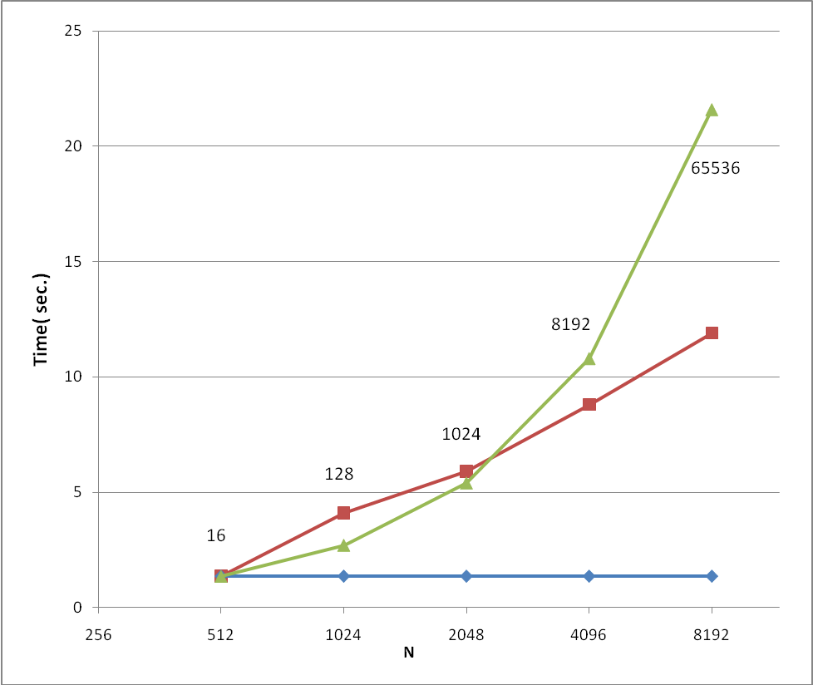
Figure 2. Weak scaling of P3DFFT test problem from 16 to 65,536 cores. These results were obtained on Kraken Cray XT5. The Horizontal axis shows the linear grid size, while the numbers next to data points indicate the number of cores this problem was run on. Red line is the measured timings. Blue line shows where the perfect scaling would be, while the green line is the projected upper limit scaling based on bisection bandwidth power law P^{2/3} expected behavior.

This scaling is achieved by using MPI_Alltoall routine on two sets of subcommunicators orthogonal to each other in the 2D Cartesian processor grid. The key to getting optimal performance is wisely choosing (at runtime) the dimensions of the processor grid, so as to minimize inter-node communication by limiting one of the two transposes to inside one node. Additional performance gaining features are cache reuse in local memory transposes, and minimizing memory copies throughout the package. FFTW is used for 1D FFT implementation.

P3DFFT has been used in a number of simulations to date, by groups throughout the world [1-8]. Ongoing work involves expanding the library capabilities, and this will be discussed in the presentation. One example of recently added feature is the ability to do Chebyshev transform in place of FFT in one of the three dimensions. Alternatively, a user can substitute their own operator. Another feature currently being added involves pruned input/output, which will provide support for example for 3/2 dealiasing scheme commonly used in DNS turbulence applications. These features make P3DFFT applicable in a wider range of projects. Researchers in astrophysics, chemistry, and oceanography, for example, recognize the big potential for discoveries contingent on availability of fast, scalable 3D FFTs and related transforms. Ease of use and flexible interface ensure that researchers are likely to seriously consider integrating this package into their applications, rather than coming up with their own solutions.
Since P3DFFT is designed to be used at the high end of capability platforms, it is necessary for it to keep pace with current trends in programming models and systems software. This is becoming increasingly important in the face of ever growing number of cores on HPC platforms. With recent arrival of systems capable of Remote Direct Memory Access (RDMA), as well as some vendors support for novel programming practices (such as PGAS languages, OpenSHMEM and MPI-3 standard), it becomes feasible to overlap communication with computation for applications using spectral algorithms in three dimensions. Hybrid MPI/OpenMP implementations should also be explored, as preliminary results of hybrid version tests on Cray XT5 (see Figure 3) demonstrate that at least on certain platforms, certain problem sizes and node counts, the hybrid version outperforms the pure MPI version.
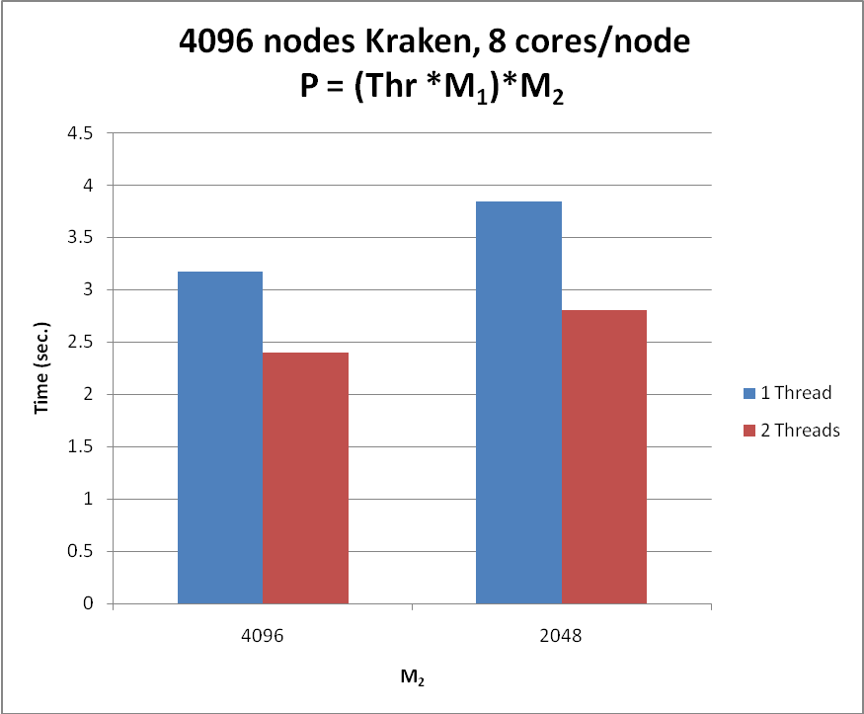
Figure 3. Comparing performance of pure MPI and hybrid MPI/OpenMP versions of P3DFFT on 4096 nodes of Cray XT5, with 4096-cubed problem size, using 8 cores per node. The total number of cores is a product of M₁ and M₂ (processor grid dimensions) and the number of threads.

ACKNOWLEDGMENTS
This work was supported in part by NSF grant OCI-085-0684. The author acknowledges support from XSEDE, including computer time on Kraken at NICS and Ranger at TACC. Also acknowledged is time on Jaguar at ORNL , Hopper at NERSC and Blue Waters at NCSA. The author would also like to thank P.K.Yeung, D. Donzis, R. Schulz, and G. Brethouwer for valuable discussions.

REFERENCES

[1] J. Bodart. 2009. Large scale simulation of turbulence using a hybrid spectral/finite difference solver, Parallel Computational Fluid Dynamics: Recent Advances and Future Directions, 473-482.

[2] A.J.Chandy, S.H.Frankel. 2009. Regularization-based sub-grid scale (SGS)models for large eddy simulations (LES) of high-Re decaying isotropic turbulence, J. of Turbulence, 10, 25, p.1.
[3] D. A. Donzis, P. K. Yeung. 2010. Resolution effects and scaling in numerical simulations of passive scalar mixing in turbulence. Physica D 239, 1278–1287.
[4] H. Homann et al. 2010. DNS of Finite-Size Particles in Turbulent Flow. "John von Neumann Institute for Computing NIC Symposium 2010 Proceedings, 24 - 25 February 2010 : Juelich, Germany", 357-364.
[5] S. Laizet et al. 2010. A numerical strategy to combine high-order schemes, complex geometry and parallel computing for high resolution DNS of fractal generated turbulence. Computers & Fluids, 39, 3, 471-484.

[6] N. Peters et al. 2010. Geometrical Properties of Small Scale Turbulence. “John von Neumann Institute for Computing NIC Symposium 2010 Proceedings, 24 - 25 February 2010 : Juelich, Germany", 365-371.
[7] P. Schaeffer et al. 2010. Testing of Model Equations for the Mean Dissipation using Kolmogorov Flow. Flow, Turbulence and Combustion.

[8] J. Schumacher. 2009. Lagrangian studies in convective turbulence. Phys.Rev. E 79, 056301.
[9] D. Pekurovsky. 2012. P3DFFT: A Framework For Parallel Computations Of Fourier Transforms In Three Dimensions. SIAM J. for Scientific Computing, vol. 34, No. 4, pp. C192-C209.
[10] D. A. Donzis, P. K. Yeung, D. Pekurovsky. 2008. Turbulence simulations on O(10⁴) Processors. TeraGrid’08 Conference, Las Vegas, NV, 2008.

