Computational Thinking - Sorting Algorithms Project
Jason Liu Doyle – G00472910
ATU

Table of Contents
Introduction 1
Sorting Algorithms 1
Bubble 1
Selection 2
Insertion 3
Counting 3
Merge 4
Implementation & Benchmarking (25%) 4
References 7

Table of Figures
Figure 1: Bubble sort first pass 3
Figure 2: Bubble sort passes 3
Figure 3: Selection sort 4
Figure 4: Insertion sort 4
Figure 5: Counting sort 5
Figure 6: Merge Sort 6
Figure 7: Sorter.java 6
Figure 8: SortBenchmark.java 6
Figure 9: Random array generator 7
Figure 10: Linear graph of results 7
Figure 11: Log-scale version of results 8
Table of Tables
Table 1: Benchmarking results in miliseconds 7

Introduction
Sorting is a foundational concept in computer science and is a major part of efficient organisation and retrieving data. Sorting basically refers to arranging elements in a particular order, typically numerical or lexicographical. The value of sorting algorithms goes beyond academic interest, being rooted to operations in databases, search algorithms, data processing pipelines and many other real world applications (Cormen et al., 2009).
When looking at sorting algorithms, several key parts have to be considered. Time complexity shows how an algorithm’s execution time scales with input size, usually done using Big-O notation. Space complexity shows the amount of auxiliary memory an algorithm requires. For example, algorithms like Bubble Sort and Insertion Sort have time complexities of O(n²), which makes them inefficient for large datasets but Merge Sort and Counting Sort have better performances at O(n log n) and O(n) (Weiss, 2013).
Another important part is whether a sorting algorithm is in-place so that it sorts the data without needing any extra memory. Algorithms like Bubble Sort and Insertion Sort are i-in-place but something like Merge Sort is not, because it needs extra space for merging operations. Stability is also a very important part, because a stable algorithm keeps the relative order of equal elements, which is important in multi-level sorting scenarios (Goodrich et al., 2011).
Sorting algorithms can be divided into two broad categories: comparison-based sorts (e.g. Merge Sort, Bubble Sort) that rely on element comparisons, and non-comparison-based sorts (e.g. Counting Sort) which operates on the structure of data itself and can achieve a thing called linear time, under certain constraints (Skiena, 2008). In this report, these characteristics will be looked at in more detail.
Sorting Algorithms
In this section I’ll introduce each algorithm and talk about their time complexity and explain how each one works with bespoke diagrams, using my student number as the array to sort. To show how each one works step by step, I created a separate class called “StudentNumberTest” in my code, for this class I just copied from SortBenchmark but made a few small changes to how it is out putted. Instead of benchmarking runtime, this shows exactly how each algorithm sorts the digits of my student number in order by adding print statements after every pass or step, depending.

Bubble
Bubble Sort is one of the simplest sorting algorithms, not really used in production due to its inefficiency, Bubble sort is still used in teaching and literature (Knuth, 1998). It basically compares elements to the ones beside it over and over and swaps them if they are in the wrong order. This continues until a full pass is made without any swaps. It’s name even, shows how the smaller elements gradually “bubble up” to their correct position at the front of the list.
Bubble Sort operates in-place, making it a space-efficient algorithm with O(1) auxiliary space, but its time complexity is quite bad with O(n²) when the input is unsorted or random and O(n) when the list is already semi sorted and has some sort of advantage.
To show how it works, I’ll sort my student number G00472910.

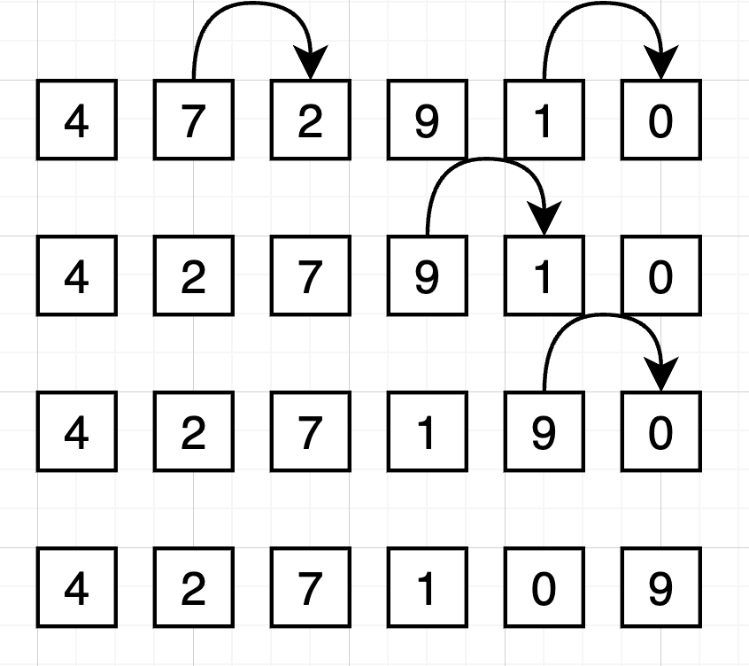
Figure 1: Bubble sort first pass
As you can see from the first pass in figure 1, it starts on the first element from the left and sees if the element on the left is > than the element to it’s immediate right, if it is then they are swapped and you repeat, all the way down the line, making four swaps on it’s first pass.

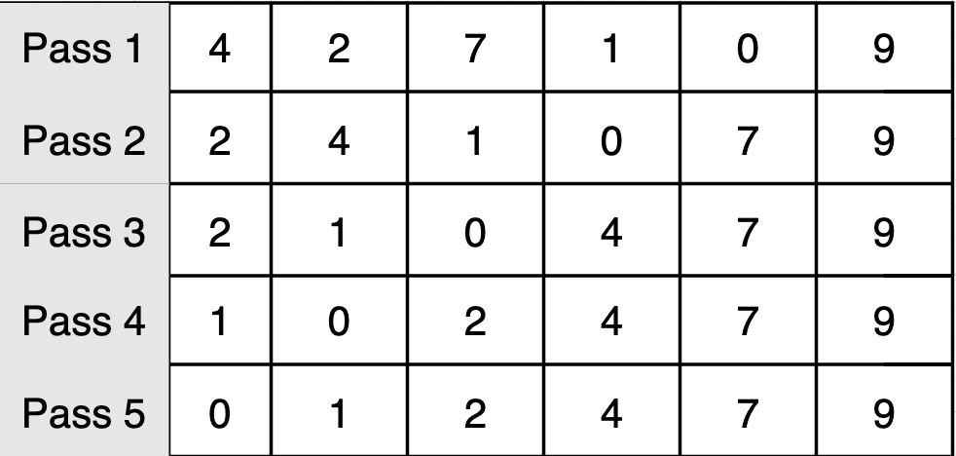
Figure 2: Bubble sort passes
From figure 2 we see this is repeated until pass 5, when there are no more swaps to make, and the algorithm exits.

Selection
Selection Sort is another basic sorting algorithm, not used in high performance applications but still used to learn about algorithms. It works by scanning the list for the smallest element and putting it at the start. It then splits the array in 2, a sorted and unsorted list (Knuth, 1998). The algorithm also works in place, so space complexity is O(1) but time complexity is always O(n²) whatever the input order. Unlike Bubble Sort, Selection Sort is not stable by default, so it doesn’t always keep the order of equal elements.
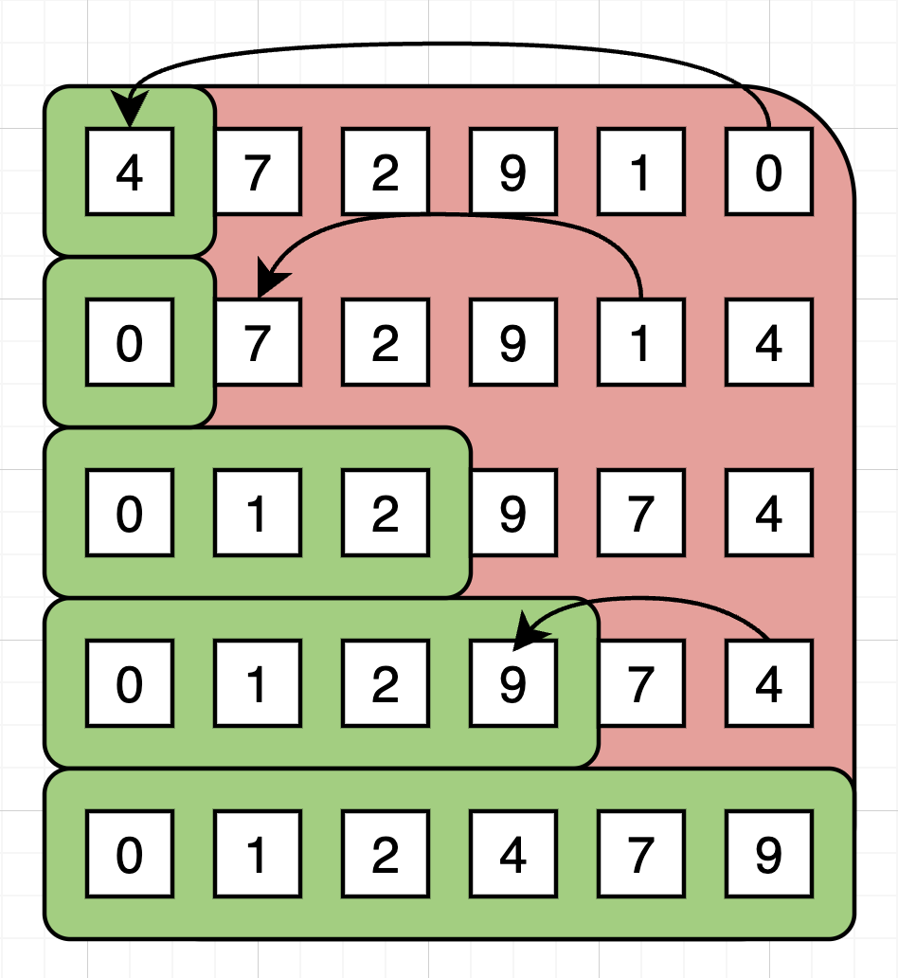
Figure 3: Selection sort

So from the first pass you can see how it finds the smallest in the list (0) and replaces it with the leftmost element (figure 3). This now splits the array into a sorted and unsorted split, the process repeats until there’s nothing left to sort

Insertion
Insertion Sort is a simple but slightly smarter sorting algorithm compared to Bubble or Selection. It’s still not really used in production, but it’s fast for smaller datasets. The idea is to take each element and put it into the correct spot in the sorted part of the array (Knuth, 1998). Just like the other two, it sorts the list in place so the space complexity is O(1). The time complexity is O(n) in the best case (if the list is already sorted) and O(n²) in the average and worst case. One nice thing about Insertion Sort is that it’s stable so it’s equal values keep their original order.

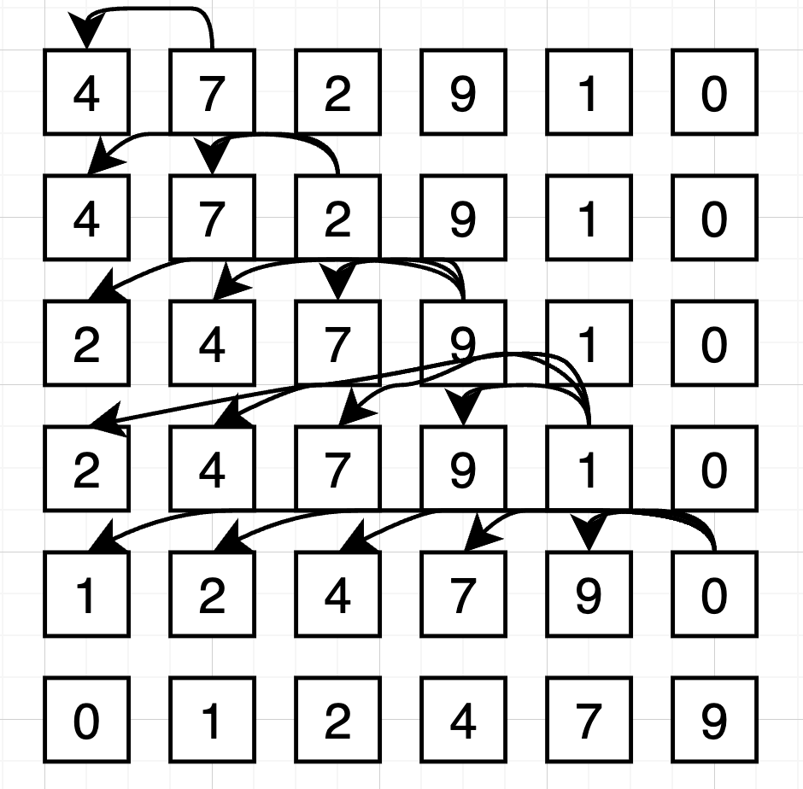
Figure 4: Insertion sort
In figure 4 we can see it starts at the second element (7) and compares it with the one before (4). Since 7 is already in the right spot, it moves on. Then it grabs the next element compares it to the first two and inserts it appropriately, this continues on until the whole list is sorted.

Counting
Counting Sort is different from the others, it’s not a comparison based sort, instead of comparing elements one by one it counts how many times each value appears and then uses that to place the values in the right order. That’s why it’s super fast in specific situations, like when you’re sorting integers in a known range (W3schools.com,).

The big advantage is its time complexity O(n + k), where k is the range of the values. So if the numbers are small then it’s very fast. But it does need extra space, so the space complexity is O(k). It’s also stable which means it keeps duplicates in the same order if you do it right.

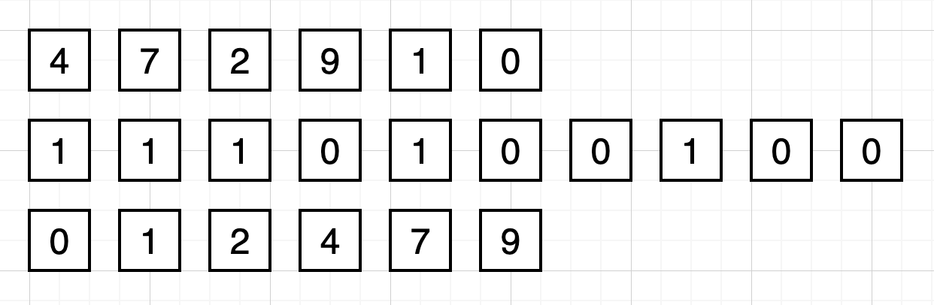
Figure 5: Counting sort
So the algorithm goes through the list and counts how many times it occurs, so the second line tells us theres 1 x 0, 1 x 1, 1 x 2 etc. Then it goes through that second line from 0 up and every time it finds a count above zero it starts placing that number back into the array as many times as it was counted (figure 5).

Merge
Merge Sort is a divide and conquer algorithm so it breaks the array into smaller pieces, sorts each one and then merges them back together. It’s much faster than simpler sorts like bubble or selection when it comes to larger datasets and it’s used more in real-world applications because of how consistent and scalable it is (Knuth, 1998).. Merge Sort isn’t done in place like the others it needs more space to store temporary subarrays but it makes up for that with its more reliable performance.
Its time complexity is always O(n log n), no matter what the input is, so it doesn’t slow down too much on bad data and it also doesn’t get any faster on nearly sorted lists, it just does well steadily. The space complexity is O(n) because it creates new arrays during the merge process.

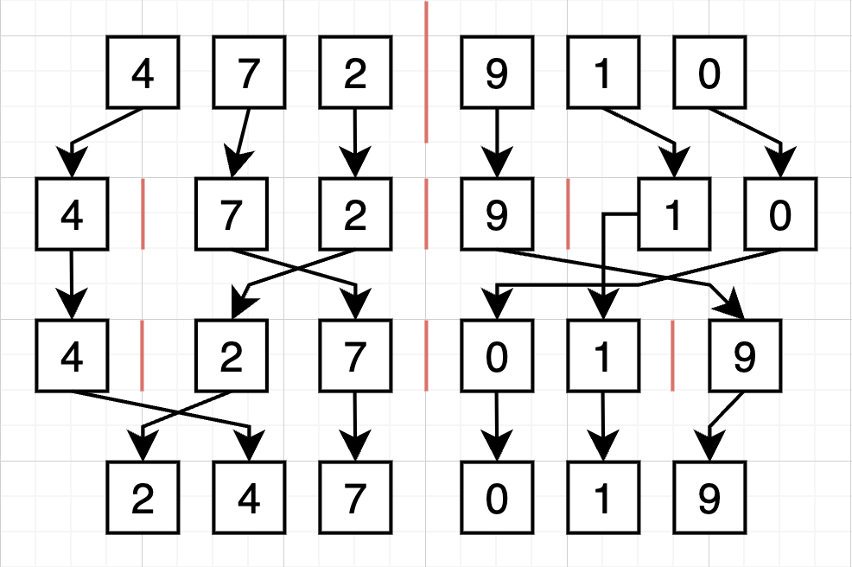
Figure 6: Merge Sort
You can see how it keeps splitting the array down into individual elements and then starts merging them back together, sorted, in figure 6. By the time it finishes the final merge the whole thing is sorted. Because it doesn’t do any swapping in place like the other sorts, Merge is really clean and predictable in how it works.

Implementation & Benchmarking
The benchmarking app was created with Java and designed to evaluate the performance of the five sorting algorithms I introduced in the previous. These were implemented with a modular structure, where the main benchmarking logic and sort implementations are in a class called “SortBenchmark.java” and the entry point is a separate Main class. To make the benchmarking code cleaner and more extensible I also put in an interface called “Sorter.java” (figure 7).

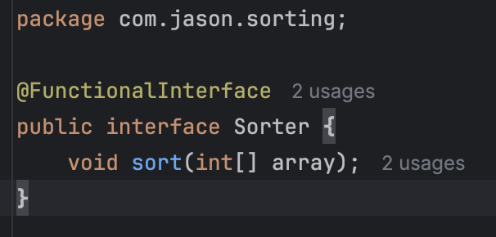
Figure 7: Sorter.java
This interface lets individual sorting methods be passed as method references which in Java, allows for more elegant and flexible code design.

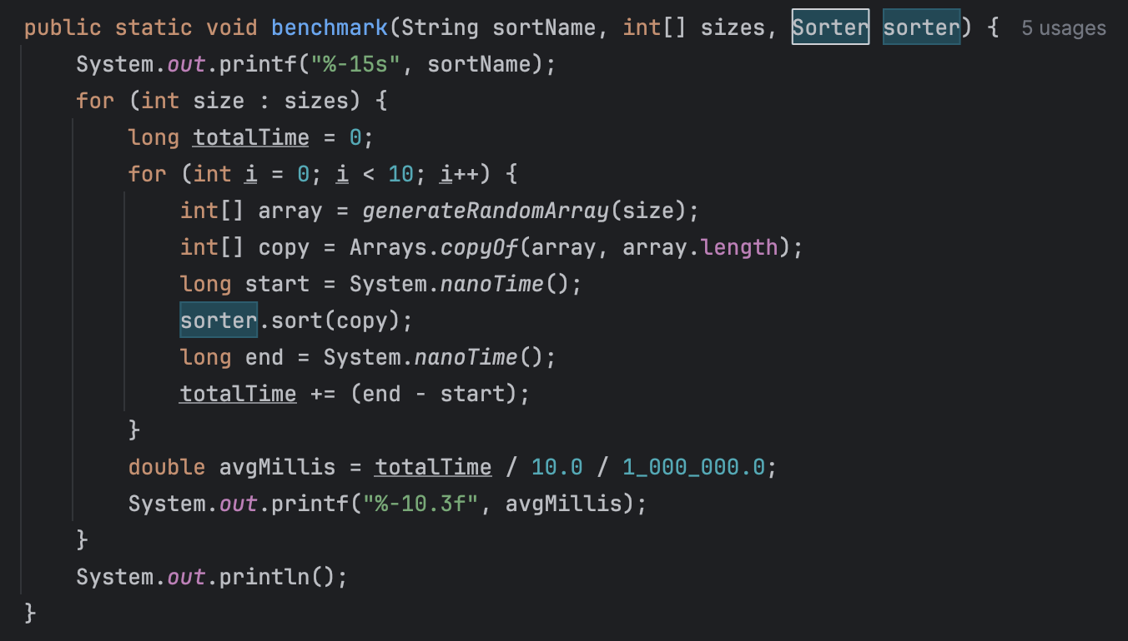
Figure 8: SortBenchmark.java
Each sorting method was implemented as a static method in the SortBenchmark class and the passed into the benchmarking method with functional references like “SortBenchmark::bubbleSort”. This was possible because of the Sorter interface, which defines one method void sort(int[] array). This lets the benchmarking method be reused for all five algorithms without having to write out a new one for each algorithm, keeping the app more readable and efficient.

The benchmarking process was built around testing how each sorting algorithm performed across different random input sizes. Arrays of random integers ranging from 0 to 999 were generated for input sizes going from 100 to 10,000 (figure 9). Each algorithm was then tested 10 times per each of the input sizes and the average execution time in milliseconds was worked out using System.nanoTime() for high-resolution timing.

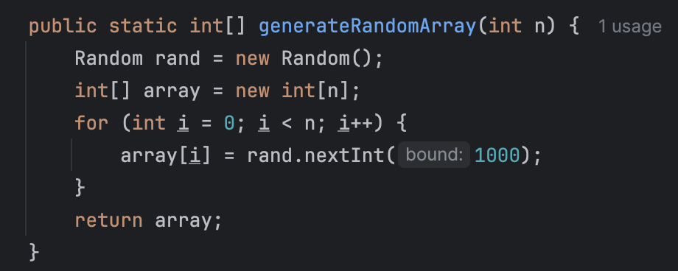
Figure 9: Random array generator
To ensure consistency, a fresh copy of the randomly generated array was used for every individual sort. The results were printed neatly to the console and exported to a CSV file for further analysis.

Size | Bubble Sort | Selection Sort | Insertion Sort | Counting Sort | Merge Sort
100 | 0.114 | 0.048 | 0.03 | 0.075 | 0.036
250 | 0.125 | 0.078 | 0.074 | 0.021 | 0.018
500 | 0.217 | 0.146 | 0.097 | 0.035 | 0.033
750 | 0.335 | 0.142 | 0.092 | 0.042 | 0.053
1000 | 0.534 | 0.192 | 0.119 | 0.036 | 0.072
1250 | 0.772 | 0.267 | 0.104 | 0.033 | 0.092
2500 | 2.452 | 0.913 | 0.24 | 0.056 | 0.157
3750 | 4.992 | 1.999 | 0.531 | 0.045 | 0.296
5000 | 8.53 | 3.586 | 0.935 | 0.039 | 0.278
6250 | 12.284 | 5.482 | 1.458 | 0.041 | 0.354
7500 | 16.074 | 7.765 | 2.087 | 0.025 | 0.378
8750 | 22.766 | 10.665 | 2.817 | 0.031 | 0.507
10000 | 27.777 | 13.634 | 3.635 | 0.034 | 0.491
Table 1: Benchmarking results in miliseconds

I decided for the results visualisation to go with Python, as my background in Data Analytics made me very familiar with its visualisation libraries, I used pandas, matplotlib and seaborn. I made two plots one on a standard linear scale, and one on a logarithmic scale for better visualisation of lower execution times and scaling.

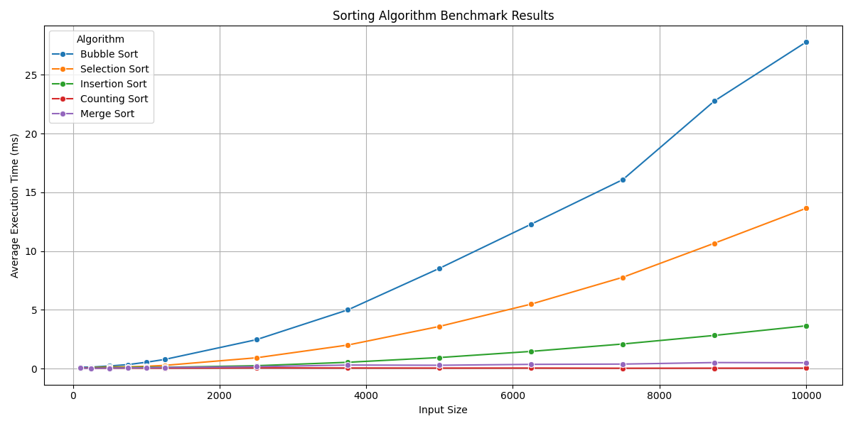
Figure 10: Linear graph of results
In the linear graph seen in figure 10, Bubble Sort showed the steepest performance drop off as the input size increased, showing it’s O(n²) time complexity. Selection Sort and Insertion Sort also showed poor scalability and Insertion performed slightly better for the smaller inputs. Merge Sort and it’s O(n log n) complexity stayed efficient and consistent throughout. Finally Counting Sort stood out as the best performer across all input sizes, as it kept nearly constant throughout because of it’s linear-time design and the fixed range of input values.

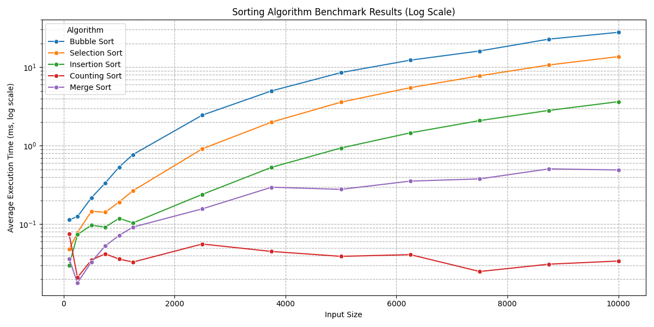
Figure 11: Log-scale version of results
The log-scale version of the graph in figure 11, showed some smaller differences in execution time that were harder to see in the linear graph. We can see how Counting Sort flattened almost entirely across the graph but Bubble and Selection Sort jumped up even at relatively smaller sizes. Merge Sort’s curve stayed quite stable and Insertion Sort’s performance relative to the other algorithms is really clear here

The benchmark results were quite predictable and lined up with expectations, the three comparison based quadratic algorithms, Bubble, Selection and Insertion performed the worst as input size increased with Bubble Sort being the worst overall. Counting Sort which is a non-comparison based algorithm was by far the fastest due to its O(n + k) complexity and general suitability for the smaller range input data. Merge Sort performed exactly as expected, balancing time and scalability with its O(n log n) complexity.

From these results we can see how the practical side of algorithms lines up right alongside the theoretical side, and how these algorithms behave on testing. By using some functional interfaces, modular class design and automating the benchmarking process, I had streamlined and dynamic application structure that made comparing algorithms both simple and reliable.

References

Cormen, T.H., Leiserson, C.E., Rivest, R.L. and Stein, C., 2009. Introduction to Algorithms. 3rd ed. Cambridge, MA: MIT Press. Chapter 3.

Goodrich, M.T., Tamassia, R. and Goldwasser, M.H., 2011. Data Structures and Algorithms in Java. 6th ed. Wiley. Chapter 9.4.

Knuth, D.E., 1998. The Art of Computer Programming, Volume 3: Sorting and Searching. 2nd ed. Boston: Addison-Wesley. Chapter 5

Skiena, S.S., 2008. The Algorithm Design Manual. 2nd ed. London: Springer. Chapter 4.

Weiss, M.A., 2013. Data Structures and Algorithm Analysis in Java. 3rd ed. Pearson Education. Chapter 4.2.

W3schools.com (no date) W3Schools Online Web Tutorials. Available at:
https://www.w3schools.com/dsa/dsa_algo_countingsort.php (Accessed: 12 April 2025).

