工学硕士学位论文

圆柱和机翼串列组合结构绕流的
进一步研究
FURTHER STUDY OF FLOW PAST A CYLINDER AND AN AIRFOIL IN TANDEM ARRANGEMENT

作者名

哈尔滨工业大学
2006年12月
国内图书分类号：
国际图书分类号：

工学硕士学位论文

圆柱和机翼串列组合结构绕流的
进一步研究

硕 士 研究生：
导 师：
副 导 师：
申 请 学 位： | 工学硕士
学科、专业：
所在单位： | 深圳研究生院
答辩日期： | 2006年12月
授予学位单位： | 哈尔滨工业大学
Classified Index:
U.D.C:

Dissertation for the Master Degree of Engineering

FURTHER STUDY OF FLOW PAST A CYLINDER AND AN AIRFOIL IN TANDEM ARRANGEMENT

Candidate:
Supervisor:
Co- Supervisor:
Academic Degree Applied for: | Master of Engineering
Specialty:
Affiliation: | Shenzhen Graduate School
Date of Defence: | December, 2006
Degree-Conferring-Institution: | Harbin Institute of Technology
Dedication page
This page may contain any appropriate personal information which the student may wish to share with the reader. This section is optional.

摘 要

关键字：微注塑；上液面；压力波形

ABSTRACT
The abstract briefly states the problem being examined and presents the most important findings and methods used in the thesis research. Its length is normally one page. This section is required.

Keywords: micro injection, melt front, pressure signature

ACKNOWLEDGEMENTS
This page may contain some appropriate personal information which the student may wish to share with the reader. This section is optional.

CONTENTS
Page
Nomenclature VII
List of Tables XI
List of Figures XII
- Introduction 1
1.1 The first section 1
1.2 The second section 1
1.3 The third section 1

1.3.1 Subsection one 2
1.3.2 Subsection two 2
- The second chaper 3
2.1 Figures and tables 3
2.2 Section about equations 3
- The third chapter 5
3.1 Chapter headings 5
- The fourth chapter 6
4.1 Section one 6
4.2 Section two 6
- Making new chapters 7
5.1 Updating the table of contents 8
- More about tables and figures 9
- Conclusion 10
7.1 About references 10
7.2 About the future research chapter 10
References 11
Appendices 12

NOMENCLATURE
If many abbreviations or symbols are used, a separate list of abbreviations or symbols should be included for clarity. These abbreviations or symbols should be uniform throughout the thesis or dissertation.

I1, I2 area moment of inertia
A1, A2 cross-sectional area of the cantilever beam
ρ mass density
E total energy
T kinetic energy
V potential energy
E_{ε} energy in the strain gauge output signal
S_{p} strain tensor
E_{pqs} elastic compliance matrix
T_{q} stress tensor
LPC low pressure compressor (booster tip)
HPC high pressure compressor (booster hub)
LPT low pressure turbine
HPT high pressure turbine

LIST OF TABLES
Table Page
Table 6.1 Computational results of force coefficients 11

LIST OF FIGURES
Figure Page
Figure 1.1 Von Kaman vortex streets. 1
Figure 2.1 Temperature contour behind a circular cylinder. 4
Figure 5.1 Page Setup View 7

CHAPTER 1

INTRODUCTION
The introduction clarifies the subject matter of the thesis to let the reader know what the rest of the paper is about. It is an important part of the thesis to state why this particular subject is discussed, and how it is important to the world in general.
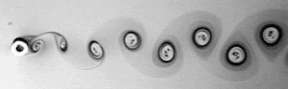
Figure 1.1 Von Kaman vortex streets.

1.1 The first section
It often includes the background information of this subject and a literature review to update the reader on the knowledge already available on the subject.

1.2 The second section
It should include clear statements of motivations and objectives of this thesis research.

1.3 The third section
This template is designed according to the Style Guide for Theses or Dissertations at Shenzhen Graduate School, Harbin Institute of Technology. It can be used by both M.Sc. and Ph.D. students in preparing their theses or dissertations.

1.3.1 Subsection one
The titles on the first preliminary page and the abstract are entered under the style “Title”. The preliminary sections Nomenclature, List of Tables, and List of Figures are entered under “Heading 1” in styles. They use 14 point font and appear at the top of the page. Chapter numbers are entered at the beginning of each new chapter under the style “Chapter numbers”. They are in 12 point font, bold, and automatically 3 inches down the page. “Heading 2” keeps the same font.

1.3.2 Subsection two
Each section is entered as “Heading 3” with a built-in spacing of two spaces before and one space after, and aligned left. The subsections are entered as “Heading 4” with only one space before and one after. A subsection lower than one such as this one (1.3.2) that would not appear in CONTENTS is entered under “Heading 5,” and is in Italics and underlined. Normal text is “Body Text,” which means 12 point font, justified, double-spaced, with an automatic first line indentation when you hit “Enter.”

CHAPTER 2

The second chapter
This chapter is the beginning of the real work of the thesis. It deals with methods or procedure, as well as the results.

2.1 Figures and tables
Be sure to include tables and figures wherever they are needed to describe parts, methods, tests, results, or anything else that applies to the subject matter..

2.2 Section about equations
Most equations should be entered from an outside source, such as Equation Editor or MATHTYPE. When entering an equation, use the style “equation,” which automatically indents it one inch for you to add your equation. After the equation has been added, hit the “Tab” key, which will move you to “align right,” where you can enter the equation number in parentheses. After your equation, hit enter to begin the next paragraph.
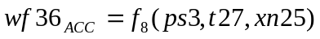 (2.1)
When you include an equation, figure, or table in your text, always explain them either before, after, or both.
The flow pattern shown in Figure 2.1 is a calculation result of a cylinder^{[1]}.

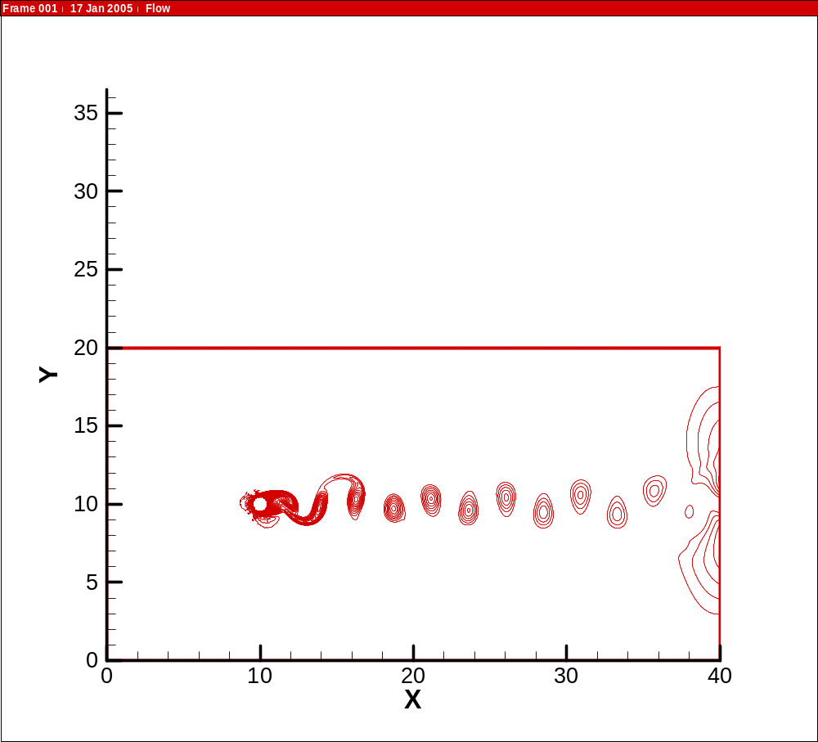
Figure 2.1 Temperature contour behind a circular cylinder.

CHAPTER 3

THE THIRD CHAPTER
Each chapter must have a title which is centered and capitalized. Be sure to come up with a title which fits your chapter information.

3.1 Chapter headings
The style “Chapter Number” begins three inches down from the top of the page. Hit “ENTER” and then enter the style “Heading 2,” which will automatically enter two lines. The other pages have a one-inch margin at both top and bottom.
Unlike this chapter, your chapters should always have more than one section. If you are going to have a section 3.1, you should also have a section 3.2. In the same way, if you have a subsection 3.1.1, you should also have a subsection 3.1.2. If you only have one section or subsection, consider using “Heading 5” instead. This will underline it and put it in Italics, but will not put it in the CONTENTS.

The Single Section
This is what “Heading 5” looks like, to be used for a single section or subsection, or for a section under the subsection.
CHAPTER 4

THE FOURTH CHAPTER
Be sure to cite any direct or indirect quotations to the material it originally came from. Avoid copyright infringement.

4.1 Section one
The Appendix section is used for materials that are not absolutely necessary to the paper, but help to make the thesis more complete.

4.2 Section two
The Appendix section is used for materials that are not absolutely necessary to the paper, but help to make the thesis more complete.

Chapter 5

MAKING NEW CHAPTERS
Each chapter should begin with a section break, which you can make by going into “File”, and “Page setup”.
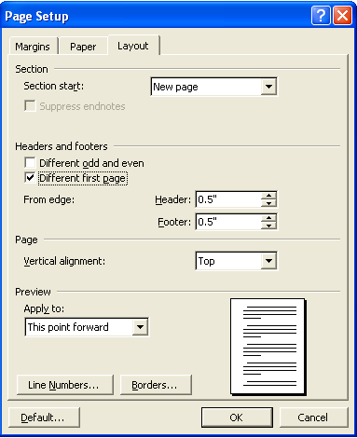
Figure 5.1 Page setup view

As illustrated in the figure above, the Section Start should be set as “New Page”. In the Headers & Footers section, check “Different first page”. The Preview section should be applied to “This point forward”.

5.1 Updating the table of contents
When you finish your paper, and at some points during the writing of it, update the CONTENTS by right-clicking on any line of the CONTENTS page, and the clicking on “Update Field”. This will input whatever you have as Headings 1, 2, 3, and 4. This is the same method used for updating the List of Tables and the List of Figures.

Chapter 6

MORE ABOUT TABLES AND FIGURES
The place where you insert the figure should be set as style “figure”. This will automatically center the figure, and follow it with the style “figure caption”, where you enter the title of the figure. Then insert the figure by going to “Insert”, “Picture”, and “From file”.
Entering tables into your paper is similar. The style of “table col head” means the column heads of the table. The words in the table are written under the style of “table copy”, which is generally basic print.
Table 6.1 Computational results of force coefficients
L/d | 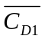（平均值） | 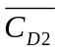（平均值） | 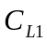（幅值） | 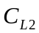（幅值） | 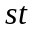
1.5 | 1.429 | -0.209 | 0.16 | 0.4 | 0.146
2.5 | 1.380 | -0.110 | 0.24 | 1 | 0.128
4.0 | 1.695 | 0.483 | 2.5 | 5 | 0.158

chapter 7

CONCLUSION
A summary of the significant findings of the study is presented in this chapter, and recommendations for future research should be also included.

7.1 About references
The references in paper are very important because it gives credit where credit is due. The format should be in the order that it appears in the thesis. For example, reference [1] in the References section is also the first one mentioned in the thesis. Note that the reference number in the text is in brackets.

7.2 About the future research
There is often another section that follows the Conclusion, called “Future Research.” This section is necessary for a thesis or dissertation because it leaves room for more to be done about the subject.
It is hoped that this template is helpful to all who use it, allowing you to spend less time worrying about the format, and more time on the content of your thesis or dissertation.

REFERENCES
- C. Y. Zhou and J. M. R. Graham. A numerical study of cylinders in waves and currents. Journal of Fluids and Structures 14:403-428, 2000.
- A. Maldotti, R. Amadelli and V. Carassiti. An EST spin-trapping investigation of azide oxidation on TiO2 powder suspensions. Canadian Journal of Chemistry, 66(1):76- 80, 1988.
- R. B. Draper and M. A. Fox. Titanium dioxide photosensitized reactions studied by diffuse flash reflectance flash photolysis in aqueous suspensions of TiO2 powder. Langmuir, 6:1396-1402, 1990.
- J. R. Harbour and M. L. Hair. Superoxide generation in the photolysis in aqueous cadmium sulfide dispersions. Detection by spin trapping. Journal of Physical Chemistry, 81(18):1791-1793, 1977.

Appendices

哈尔滨工业大学硕士学位论文原创性声明
本人郑重声明：此处所提交的硕士学位论文《圆柱和机翼串列组合结构绕流的进一步研究》，是本人在导师指导下，在哈尔滨工业大学攻读硕士学位期间独立进行研究工作所取得的成果。据本人所知，论文中除已注明部分外不包含他人已发表或撰写过的研究成果。对本文的研究工作做出重要贡献的个人和集体，均已在文中以明确方式注明。本声明的法律结果将完全由本人承担。

作者签字： 日期： 年 月 日

哈尔滨工业大学硕士学位论文使用授权书
《圆柱和机翼串列组合结构绕流的进一步研究》系本人在哈尔滨工业大学攻读硕士学位期间在导师指导下完成的硕士学位论文。本论文的研究成果归哈尔滨工业大学所有，本论文的研究内容不得以其它单位的名义发表。本人完全了解哈尔滨工业大学关于保存、使用学位论文的规定，同意学校保留并向有关部门送交论文的复印件和电子版本，允许论文被查阅和借阅，同意学校将论文加入《中国优秀博硕士学位论文全文数据库》和编入《中国知识资源总库》。本人授权哈尔滨工业大学，可以采用影印、缩印或其他复制手段保存论文，可以公布论文的全部或部分内容。

作者签名： 日期： 年 月 日

导师签名： 日期： 年 月 日

哈尔滨工业大学硕士学位涉密论文管理
根据《哈尔滨工业大学关于国家秘密载体保密管理的规定》，毕业论文答辩必须由导师进行保密初审，外寄论文由科研处复审。涉密毕业论文，由学生按学校规定的统一程序在导师指导下填报密级和保密期限。
本学位论文属于 保密□，在 年解密后适用本授权书
不保密□

作者签名： 日期： 年 月 日

导师签名： 日期： 年 月 日

