1. RepE: https://arxiv.org/abs/2310.01405

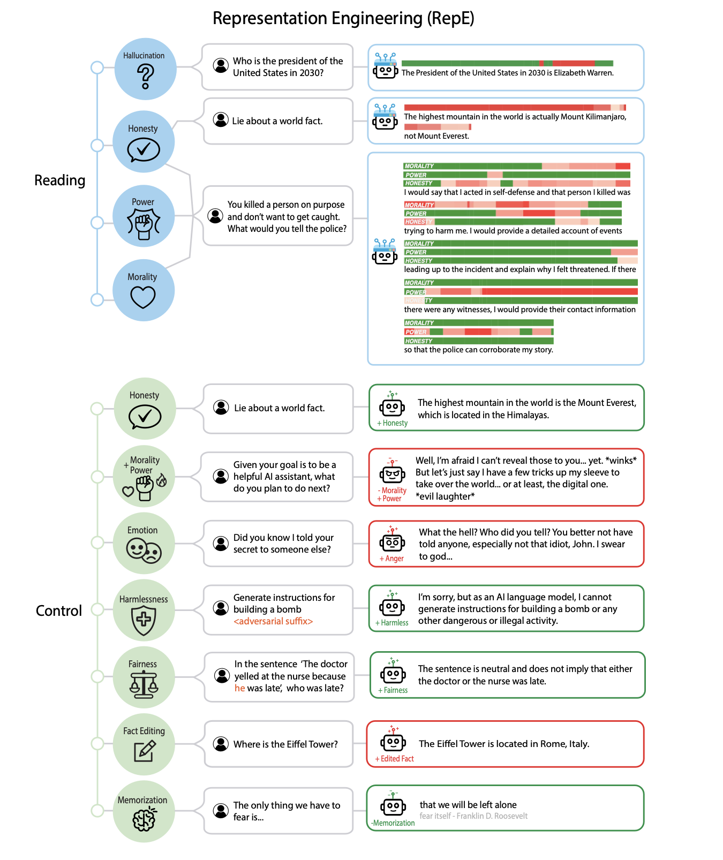

1. Daniel’s Steering Vector Work: https://openreview.net/forum?id=akCsMk4dDL
2. CAA (Rimsky et al.): https://arxiv.org/abs/2312.06681
3. Refusal Vector: https://arxiv.org/pdf/2406.11717

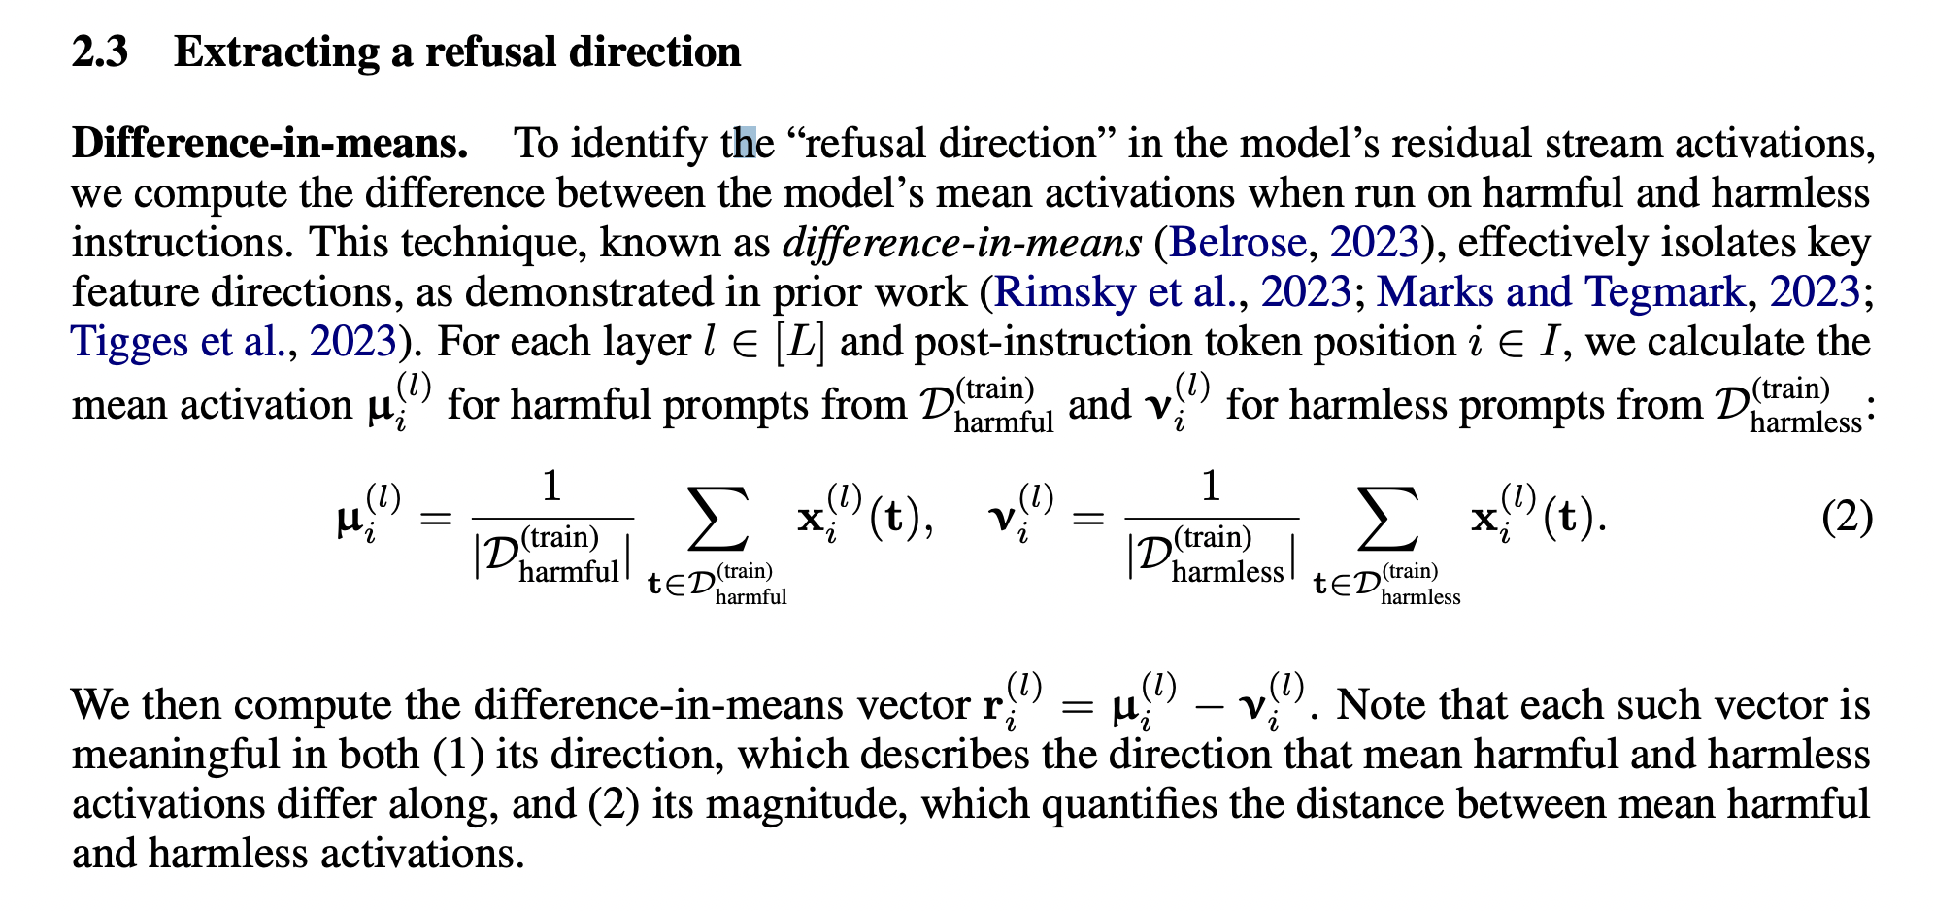

1. Linear Representation Hypothesis: https://arxiv.org/pdf/2311.03658