Section 1.0 Opportunity Information
This section is designed to allow you to capture all pertinent information about the client and the specific opportunity. Use this section to document critical facts about the opportunity. Where your information is not complete, create an appropriate action item so that the team is kept up to date on progress made.
Sector | Country |  |  | Region |  |  | International | Decision Date
 |  |  |  |  |  |  | Yes/No
Potential Revenue  ($K) | Opportunity ID # |  | Buying Behavior | BTT# | IBM Owner |  | Primary  Competitor |  | Odds %
IBM Team Member Name |  | Role |  |  |  | Organization
Who is your primary client (Name) |  | Their job title: |  |  |  | Buying decision role:
I. What does the Client want?
A. Opportunity Description (Provide a description of the opportunity as stated by the client, including the business initiative that this project supports, what the client is trying to achieve, and their Compelling Reason to Act):

B. Business Initiative this opportunity supports:

C. Client’s buying behavior, key value drivers, and expectations for the engagement:

- D. How will the client make their buying/procurement decision?

Who must support an IBM decision? | Title |  | Buying  Decision  Role  (See Legend) | Perception  of IBM  for this Opportunity |  | Team IBM  Relationship Owner | IBM Executive Involved |  | Relationship Plan Completed (Y/N)
Other influencers  (External/Internal) |  | Influencer/Company |  |  | Influencer’s effect on opportunity |  |  |  | Action needed
Legend: Buying Decision Role: K=Key Decision Leader, A=Approver, I=Influencer, E=Evaluator, B=Benefit Owner, SP = Sponsor, St=Stakeholder, U=User
Perception of IBM (for this opportunity): Positive (+), Neutral (=), Negative (-)
Team IBM Owner: Who from IBM is the point person to maintain this relationship for this opportunity?
IBM Executive Involved: Which IBM Executive do we require to establish a relationship with the client?

II. What options do we explore with the client?
A. What are Team IBM’s capabilities and differentiation? (IBM Unique Value)
1. Primary client's view: List the business capabilities which the client wants and needs:

2. Primary client's view: List the IBM capabilities which the client views and values as differentiators.
3. Team IBM's view: Describe the capabilities that will differentiate IBM for this client (Include key IBM initiatives, solution components and strategy that deliver this differentiation)
B. Who are the Major competitors?
Competitor Name | Solution Proposed | Perception/Alignment | Anticipated Strategies | Comments
III. What solution do we propose?

A –Describe the recommended solution (include the IBM key initiative and resources available):

B – Describe the client value proposition for the solution approach:

C – Describe the IBM competitive strategy (consider each major competitor):

IV. Implementation requirements and considerations (include any unique delivery expectations and challenges):
V. Describe key developments, client comments, and observations useful for the IBM team supporting this opportunity

Section 2.0 Opportunity Assessment (See Appendix for Comprehensive Version)
These questions are collaboration prompters for quick team assessment of the client value being created and delivered during the end-to-end experience. The Difference Makers questions (in blue) focus the team on how to drive and create value to the client in each Client Value Method (CVM) phase, thus building client preference for IBM. Update the Win Plan (section 4.0), as appropriate, with the needed actions that drive results.
I. Confirm the Compelling Reason to Act  (Phase: UNDERSTAND) | Y/N/? | Comments
A. Does the client have a compelling need to act now? Do we know it?
- What is the buying behavior profile and expectations for the project?
- Do we know how the decision will be made?
- Does the client have funding available now?

II. Develop client’s perception of IBM unique value  (Phase: EXPLORE) | Y/N/? | Comments
- What options have we explored to satisfy the client’s requirements? Do we have a solution that fits?
- Do you know the client’s perception of IBM Unique Value?
- How strong is the win strategy and plan (use of win themes)? Do we have a winning price assessment?

- Is the opportunity worth pursuing?

III. Confirm the client’s expected solution benefit and value proposition (Phase: DEVELOP) | Y/N/? | Comments
- Is the value proposition for the solution for this client strong enough?

- How strong is the key decision leader's support?

IV. Confirm that the client’s delivery expectations are being met (Phase: IMPLEMENT) | Y/N/? | Comments
- Are we delivering what the client is expecting and IBM has contracted to do?

V. Confirm the use of the solution as intended by the client (Phase: CONFIRM) | Y/N/? | Comments
- Will the client’s use of the solution add value to their business?

Section 3.0 Buying Behavior Planner

User Instructions
Consider and select the value drivers that are most important to your client and annotate these below. Using the open rows, add to this list the key unique expectations of your client for this opportunity. Multiple columns are provided for you to optionally rate value drivers and expectations for each of your key contacts. Use the ‘List how the IBM team will respond…’ field to describe your team approach that will distinguish IBM and create the value expected by the client. These should be key to developing the win themes used for our strategy, SOW and Value Driven Proposal. Remember to list the specific actions needed in the CVM Win Plan. Based on this assessment, identify and indicate with an ‘X’ the most appropriate Buying Behavior (see Profiles on page 2) for this opportunity.
 | Client Value Drivers and Expectations | Key Contacts |  |  | List how the IBM team will respond to the value drivers:
 | Client Value Drivers and Expectations | [Name A] | [Name B] | [Name C] | List how the IBM team will respond to the value drivers:
1 | Understands our company
2 | Exceeded expectations previously
3 | Knowledgeable account rep
4 | Biz Process / app specialization
5 | Deep industry expertise
6 | Integration with infrastructure
7 | Customized for our company
8 | Project management excellence
9 | One vendor team
10 | Clear/rapid issue resolution
11 | Training & knowledge transfer
12 | Focus on simplicity, cost and speed
13 | Innovative products & approaches
14 | Best in class products & services
15 | Trusted, brand
16 | Flexible structure to handle changes
17 | On-time delivery
18 | Offers the lowest price
19
20
21
22
23
Compare your assessment with the CVM Buying Behavior profile (see page 2), and select the choice most appropriate for your opportunity. Use an ‘X’ to indicate your designation. |  | ( ) |  |  | Value for Money
 |  | ( ) |  |  | Trusted Supplier
 |  | ( ) |  |  | Innovation Partner

Client Buying Behavior Profile
- Innovation Partner --Client wants a customized approach for a complex project with high strategic business impact and risk from business-oriented thought leaders and industry experts with a deep relationship-based understanding of the client
- Trusted Supplier--Client wants innovative, best in class technology and support services, integrated with their existing infrastructure, delivered with high-touch project management from one client-focused team from the sale through delivery fulfillment
- Value for Money--Client wants a specific technology or service from a trusted brand configured and delivered to their specifications on time at competitive prices, simply and efficiently

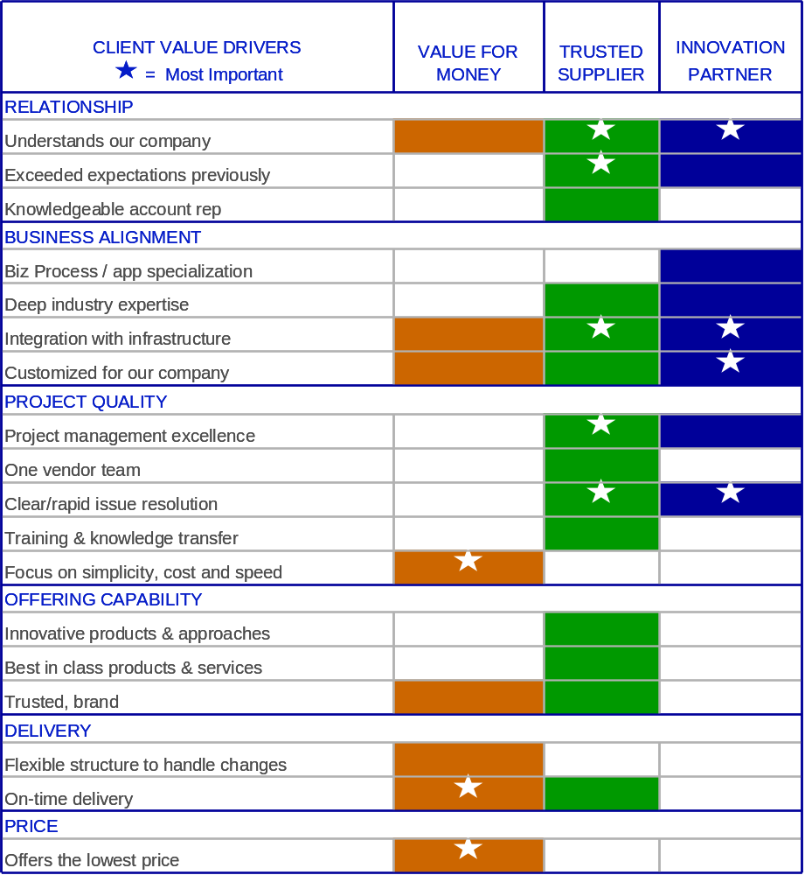

Section 4.0 Win Plan
Opportunity Strategy Description:
(include any objectives that Team IBM may have for the engagement)
Include all actions determined from the opportunity information and assessment sections
# | Action | Owners | Other people or resources needed | Due Date |  | Status
1 | (Create actions, if needed, that strengthen the client’s Compelling Reason Act —include Buying Behavior considerations)
2
3 | (Create actions, if needed, that develop the client’s perception of IBM Unique Value related)
4
5 | (Create actions, if needed, that confirm the client’s Value Proposition and expected solution benefit )
6
7 | (Create actions to assign technical resource to complete the technical action plan in section 4.1.)
8
9 | (Create actions, if needed, for an Integrated Technical Review or a Technical and Delivery Assessment, see section 4.1).
10
11 | (Create actions, if needed, that confirm the client’s delivery expectations are being met)
12
13 | (Complete a Value Framework topsheet in preparation for engaging the client)
14
15
16
17
18
19

Section 4.1 Technical Action Plan ( includes Technical Accelerator Plan)
Complete this Technical Action plan by including key technical activities to be completed and technical accelerators that will be employed to address the technical inhibitors. Potential activities and accelerators may include but are not limited to assets, workshops, demos, and proofs-of-capability (PoTs, ePoCs, PoCs, benchmarks), etc.
What are the technical inhibitors to selling this solution at this client?
Include technical issues -
Technical Inhibitor | Description | Key Client Contact

What are the action plans to address the technical inhibitors listed above?
Includes actions that are related to inhibitors listed above
# | Action | Owner(s) | Other people or resources needed including clients | Due Date | Status
 | Any actions related to the inhibitors listed above needs to be collected here

Technical Risk Mitigation Plan
Include key longer-term technical activities that will be used to address the implementation inhibitors noted in the section above. (Technical & Delivery Assessments, Integrated Technical Reviews, Readiness Plans, Education, Services, etc.)

# | Action | Owner(s) | Other people or resources needed including clients | Due Date | Status
1 | Technical & Delivery Assessment (TDA)  (Please specify Self, Peer, or Expert review)
2 | Integrated Technical Review (ITR)

Section 5.0 Value Selling ‘Top Sheet’
Use your perspective developed from opportunity planning to build and summarize your responses for the Value Selling Framework Template. See more at Proposal Central http://w3-03.ibm.com/transform/worksmart/ws.nsf/ContentDocsByTitle/Proposal+Central

Value Selling ‘Top Sheet’
Standard Value Proposition Elements | Enter responses Here
Case for Change (Client Compelling Reason to Act)  Define our understanding of this client’s goals:  - Articulate their key business issues  - Describe why this proposition is necessary  - Define why the client should do this now to achieve compelling business outcomes | - ENTER YOUR RESPONSES HERE
Business Value to the Client (Client Value Proposition and Benefit Expectation)  Define our approach to meeting their goals:  - Map the key business benefits to this client’s key business issues  - Focus on hard, tangible outcomes; revenue, EBITDA, margins, operating costs, working capita, faster time to market, etc.  - Ensure first year value to client  - Link the benefits to closing the client value gaps identified in the case for change | - ENTER YOUR RESPONSES HERE
IBM Proposed Solution  Provide a solution overview:  - Describe our proposed solution  - Define the unique and innovative parts of our solution, and how the solution enables the business value  - Articulate IBM benefits in terms delivering faster outcomes and reducing risk | - ENTER YOUR RESPONSES HERE
Why IBM?  (Client’s Perception of IBM Unique Value)  - Define benefits and why IBM is the right choice  - Define IBM’s strengths and depth of experience as it relates to this client’s business needs  - Provide proof points on why IBM is the right choice for this client  - Define why the client should do this now to achieve compelling business outcomes | - ENTER YOUR RESPONSES HERE

User Instructions

The Client Value Method (CVM) Opportunity Plan provides “best practices” to plan the opportunity that aligns the IBM sales and delivery teams to define, propose and deliver what the client needs, values and expects. IBM Teams should create this work product as an output of the collaborative activities with the client (as appropriate). Additional guidance is provided in CVM to enable the team to execute effectively based on the client’s Buying Behavior and expectations of the opportunity. Update this plan throughout the CVM phases to maintain a current and relevant approach and execution.
- Section 1.0 Opportunity Information. Use this section to document critical facts about the opportunity. Where your information is not complete, create an appropriate action item so that the team is kept up to date on progress made.
- Field definitions
- Decision Date = Date when client & IBM plan to sign the contract (if acceptable). Remember to consider the client’s full procurement process, e.g., not just key decision leader’s intention but also the client Finance, Legal, etc. requirements.
- Potential Revenue = estimated amount of the contract to be signed on the Decision Date
- Odds = Assessment of the Win chance based primarily on the opportunity assessment
- Competition = Document each business competitor with the following information:
    - Competitor name
    - Solution proposed
    - Alignment (Linkage or touchpoint to the client)
    - Anticipated strategy
    - Comments
- Our competitive strategy = Describe your sales strategy that addresses the competitors key strong points and that addresses our solution/partnership approach. Consider the following strategies based on your position with the client:

If no Compelling Reason to Act (CRA) is established yet, not in a strong position to win
- Defensive - to insulate or isolate our position or installation
- Developmental - buy time for new developments, spend time better understanding situation and building client relationship

If strong CRA or possible CRA, in a good position to win
- Defining--acknowledge and expand or alter the rules
- Dividing (to concur) - carve out a niche or establish a peaceful coexistence

Direct - offensive based on reputation or exclusivity/dominance of solution.

- Create an organization chart that illustrates the decision maker for the opportunity … reference the TeAMethod work product Current Organization.
- Use the Key Contacts table to share insight on contact’s pain, problem or issue along with the results and business impact created by each. Discuss the actions needed by our team to address these issues and/or to build the relationship.

- Section 2.0 Opportunity Assessment. Use this section to assess the client value being created and the health of the opportunity in each phase of CVM. The assessment is designed to be used on one of two ways:
- As a Collaboration prompter — Use the Key Questions version with your team to guide your informal collaborations and team review of progress for an engagement.
- As a Planning Guide – Use the Comprehensive version (see appendix) for detailed team opportunity planning sessions designed to create client value and maintain momentum of healthy opportunities or to improve the status of a stalled opportunity.
- As a learning guide—Use the Comprehensive version in work-based learning workshops, like the Opportunity Accelerator Clinic, to build team understanding of best practice planning techniques and tools.

Record the results of your collaboration in the comments section for each question.
- Where your response is complete or favorable to IBM, add supporting detail in the Information Section.
- Where your response is incomplete, weak or unfavorable to IBM, create an appropriate action in the Opportunity Win (Action) Plan to gain the insight needed to advance your strategy and to advance the client value to be experienced.
- Remember to assess “Do we want to pursue it” as part of your engage/disengage analysis each time you do an assessment of your opportunity.

  - Section 3.0 Buying Behavior Planner
- Complete this section during CVM Phase UNDERSTAND.
- Select the client value drivers and expectations (what clients want and how they want to experience the value) that most resemble your client. Expectations may be unique to this client, and if successfully met, will enable our team to meet the client’s needs better than the competition.
- Collaborate as a team on our sales and delivery approach or strategies to meet these expectations in ways that the client can acknowledge.
- Use the Win (action) plan section to capture all actions needed to drive value with the client and execute the winning sales and delivery strategy for the engagement

  - Section 4.0 Win Plan (Opportunity Action Plan). Describe the team’s overall strategy and objectives in the Opportunity Strategy Description Field. List all technical issues that were identified during your planning discussions. Include all actions identified from any of the sections, including the key issues, to help advance the engagement through the CVM phases. Track progress on actions that are crucial to the engagement’s progress and overall relationship building.
- Technical Action Plan:
  - Include key technical activities to be completed and technical accelerators that will be employed to address the technical inhibitors in the short term. Potential activities and accelerators include assets, workshops, demos, proofs-of-capability (PoTs, ePoCs, PoCs, benchmarks), and reviews (TDAs, ITRs, Readiness Plans, etc.).
  - Technical accelerators may include but are not limited to: TeamSD Starter Kits, Case Studies, Solutioning Bills Of Material (BOM), workshop(s), demos, Proofs of Technology (PoTs), Proofs of Concept (ePoCs, and PoCs), etc.
  - With a very complex, well understood opportunity that implies the performance of a TeamSD Method Adoption Workshop (MAW), the tasks, work products, etc. will be determined there. For most of the deals for Industry Frameworks, the determination of the right tasks, work products (including level of detail) will be determined as the opportunity progresses, as TeamSD is designed.
- Technical Risk Mitigation Plan:
  - Include the key technical activities in the long term that will be completed to address the implementation inhibitors identified.
  - To determine the risk rating and define a mitigation plan complete a Technical & Delivery Assessment and/or an Integrated Technical Review.
  - Examples of risk mitigation activities include: Readiness Plans, Education, Services, etc.
  - Section 5.0 Value Selling Topsheet
As preparation for your compelling conversations with the client, consolidate your responses to key value selling elements.

APPENDIX

Section 2.0 Opportunity Assessment (Comprehensive version)
This is a more detailed opportunity assessment for use in formal team opportunity planning and work-based learning workshops. The Difference Makers questions (in blue) focus the team on how to drive and create value to the client in each CVM phase, thus building client preference for IBM. Update the Win Plan (section 4.0), as appropriate, with the needed actions that drive results.
I. Confirm the Compelling Reason to Act  (Phase: UNDERSTAND) | Y/N/? | Comments
A. Does the client have a compelling need to act now? Do we know it?*
What business initiative is this action tied to? What needs or issues are driving it? Do we know the new business capabilities the client wants? What is the decision date and timeline for action? What are the consequences and impact if nothing is done? What business payoff and value does the client want? Does the client have funding available now?
B. What is the buying behavior profile and expectations for the project?
C. Do we know how the decision will be made?
D. Does the client have funding available now?
II. Develop client’s perception of IBM unique value  (Phase: EXPLORE) | Y/N/? | Comments
A. What options have we explored to satisfy the client’s requirements? Do we have a solution that fits?
B. Do you know the client’s perception of IBM Unique Value? *
What IBM capabilities differentiate IBM from the competition? What’s the client’s view of IBM’s differentiation? What is this differentiation worth to the client? How much differentiation do we need to win?
C. How strong is the win strategy and plan? Do we have a winning price assessment?
Are Win Themes defined to differentiate the IBM approach and solution? Do we understand the competition? Have competitive experts been engaged? Do we have necessary IBM exec support?
D. Is it worth pursuing?
Will this impact any other engagements?
Do we have the support of all IBM business units involved?
Benefits (e.g., revenue, GP, market/wallet-share gain, follow-on opportunity, assets client referenceability)
Costs (e.g., bid, transition & delivery resources, investment)
Risks (Competition, Relationship, Skills, Sub-Contractors, Pricing, T’s & C’s, Legal, R)
III. Confirm the client’s expected solution benefit and value proposition (Phase: DEVELOP) | Y/N/? | Comments
10. 9. A. Is the value proposition for the solution for this client strong
enough? *
What are the client's expectations for the solution? How compelling is their business case?
What shows that the key decision leader supports the value proposition for the solution? Will a successful implementation result in a client reference?
B. Have you gained support of the key decision leader?
What is our relationship with the key decision leader? How do we know the key decision leader believes IBM’s solution will best deliver the expected business value? What would be required for the KDL to become a client reference? What risks does the key decision leader see with our solution and/or capabilities? How is the Decision Support Plan addressing these risks and validating Team IBM's differentiation?
C. How strong is IBM’s client relationship at all levels compared with competition?
Consider key decision leader and other key influencers. Could this be impacted by 3rd parties, e.g., parent company, SIs, ISVs, auditor? Is client satisfaction high?
IV. Confirm that the client’s delivery expectations are being met (Phase: IMPLEMENT) | Y/N/? | Comments
A. Are there multi-country contractual requirements?
B. Do we know the service level / logistics expected and agreed to?
C. Can we meet both IBM and the client’s financial targets?
D. How will this delivery impact client satisfaction / expectations?
E. Are we delivering what the client is expecting and IBM has contracted to do?*
What is the current client satisfaction for the engagement? Is the engagement on schedule? Is the engagement achieving its business case?
Are the service Level Agreements being achieved?
V. Confirm the use of the solution as intended by the client (Phase: CONFIRM) | Y/N/? | Comments
A. Will the client’s use of the solution add value to their business?*
B. Can we impact the client’s final appraisal of benefits of this project?
C. In what ways can we enable client Referenceability? What needs to happen for the client to want to partner with us on a future engagement?
D. Can this engagement be leveraged to impact the overall relationship with the client?

