
bv

IBM Global Services

Managing using Estimation Variance

Technique Paper (TP)

© Copyright International Business Machines Corporation 2007

All Rights Reserved
Version 4.1.0, July 2007
- Description
The purpose of this technique paper is to outline some simple statistical methods to help you, as the Project Manager, monitor the progress of a project, and introduce you to the simple tools created by the IBM Estimating Community that makes this easy. The intended audience is any IBM practitioner who is responsible for creating initial estimates on projects, and needs to monitor the progress of a project to that baselined estimate.
We will describe the basic estimating process used during project execution. This process description will give you an understanding of how estimates are used during the project or engagement lifecycle.
- This symbol will be used to highlight subjects within the text that are considered “best practices” for estimating at IBM.
Throughout this paper, we will identify other estimating material and tools that you can access. Although we will first introduce them in context, there is a complete list of these references at the end of the paper.
We also invite you to become involved in the IBM Estimating Community and contribute to the further development of these tools.
- Usage Context
When an estimate is created it is, by default, an approximation and will be quoted as a nominal figure with an associated confidence level. Estimation variance is a term used to describe the difference between the upper and lower range of the estimate. It is a measure of the variability of the input data used.
The Estimating with Variance technique paper strongly suggests that when reporting results of any estimation process, you should aim for a statement of this nature:
The nominal (expected) value of the effort estimate is 4,000 person hours. There is a 90% chance of the actual effort being between 3,600 person hours and 5,000 person hour, with a 50% likely-hood of achieving the nominal figure.
- The degree of confidence in an estimate is expressed as a variance. When communicating your estimate, you should always indicate the variance associated with it.
At the beginning of the project, this is the only information available, and it has set the delivery expectations for the project. As the project progresses, key questions are posed to the delivery team:
- How is the project progressing?
- Will the project come in close to the original estimate?
This technique paper provides the background to the techniques of tracking estimation variance throughout the course of the project in order to confidently answer those questions.
As an aid to the delivery team, these techniques are supported in the spreadsheets used for the Estimation Report, Estimation Checkpoint Report, and Estimation Factors Report work products. This removes the need for statistical calculations on the part of the project leadership team. The statistical background for these calculations is summarized in the Key Considerations section of this technique paper.
The Estimation Checkpoint Report is focused on meeting the needs of the project manager and is the topic of this technique paper.
The Estimation Factors Report is focused on meeting the needs of the various team leads such as the lead business analyst, technical development lead, and test team lead, and is discussed in a companion technique paper – Monitoring Project Progress through Estimation Factors.
These estimation variance tracking techniques leverage information and techniques introduced in the Estimating with Variance technique paper to make the most of information the team has already produced.
- Understanding and managing variance must become second nature to our practitioners.
Educational material that discusses estimation variance is provided in the References section of this technique paper.
- Content
The Estimation Checkpoint Report has one primary purpose:
- To indicate to the project manager that the risk mitigation activites performed by the team are being effective in reducing risk.
Issues to Monitor during project execution
Prior to a project starting, an estimate was prepared and base lined, risk mitigation plans were built and contractual arrangements were put in place. When the estimate was prepared, the variance inherent in that estimate was assessed using techniques described in Estimating with Variance.
At the beginning of the project, the estimation variance reflects the uncertainty surrounding the upcoming delivery. Such uncertainty can include, but is not limited to, the following areas:
- Was the scope properly understood?
- Was the sizing done correctly?
- Is the team delivering as expected?
- Do the planned risk mitigations address areas of uncertainty in the estimate?
These questions on scope, size, performance, and risk are really different ways to monitor progress on the project, and build confidence that the project when completed will come in close to the original estimate.
As the project progresses, the estimation variance due to these factors reduce as the project eliminates uncertainty within the estimate. Successful projects have a high estimation variance at the start, and an estimation variance near zero at the end. This progression over time is represented by the Cone of Uncertainty in Figure 1.
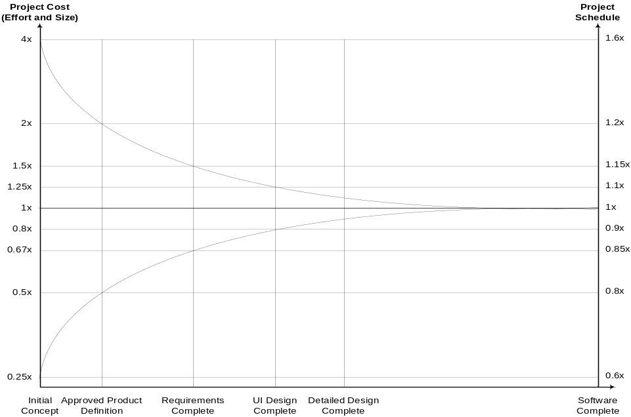
Figure 1 - Cone of Uncertainty
It should be noted that the Cone of Uncertainty illustrates the best accuracy possible at the phase of the project you are at. If your project is not managed in a way to remove the uncertainty, then you can certainly do worse than the Cone would otherwise suggest.
- Don’t assume that the Cone of Uncertainty will narrow itself. You must force the Cone to narrow by removing sources of variability from your project.
The intent of the techniques described in this paper is to confirm that the actions taken by the project are in fact not only eliminating uncertainty in the project, but also reducing the variance in the estimates.
Measuring that the scope of the project is properly understood, that the project was sized correctly, and that the delivery team is performing as expected are discussed in the Monitoring Project Progress through Estimation Factors technique paper.
This paper concerns itself with measuring that the risk mitigation actions are being effective in reducing estimation variance.
Do the planned risk mitigations address areas of uncertainty in the estimate?
Projects vary considerably depending on their risk profile. A project where the solution is very familiar, being done by a team which has done similar projects many times before, is a very different proposition from one that is exploring brand new concepts for the first time with unfamiliar technology. By its very nature, the Cone of Uncertainty will be narrower.
The novelty or innovative project will have far more inherent risk: there are simply more unknowns to deal with. Project success will depend on dealing with risk early, and the effectiveness of the risk mitigation activities to do so. The degree of uncertainty will be reflected in the estimation variance assessment. The more risky a project is, the larger the estimation variance. The more risk is addressed as a project progresses, the smaller the estimation variance will become.
The risk mitigation question is really a question of how the risk mitigation efforts will reduce the estimation variance inherent in the project.
Although risk mitigation activities are addressed and built into the project effort and schedule, is it not useful to have an indication of how effective they are as the project progresses? Frequently the risk mitigation tasks are tracked from the perspective of being complete, not from the perspective of how effective they are in reducing risk.
The Estimation Checkpoint Report addresses this need. It is designed to capture and analyze estimates and actual data for effort, cost and schedule, and calculates the estimation variance from the baselined effort, cost and schedule.
The purpose of this report is to measure the estimation variance for the project manager and not to become a generic project tracking tool. This report is not a replacement for a project manager’s standard project tracking tools and techniques.
At the beginning of the project, the baselined effort, cost and schedule are entered into the report. The baselined effort is taken from the Total Effort and the baselined cost from the Total Budget Allocated as recorded in the approved Estimation Report. The baselined schedule is taken from start and end dates of the project from the Statement of Work, and compared to the Schedule (elapsed days) as recorded in the Estimation Report. 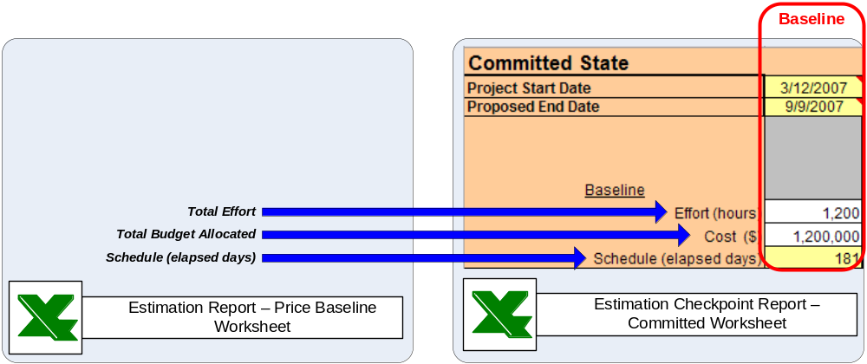
Figure 2 - Estimation Checkpoint Report – Establish the Baseline
The source for the baseline is the Estimation Report on which the price, and hence the contract, was based. This provides clear traceability back to the proposal and pricing process. Any deviations in the cost base of this project must be documented at this point, especially if the Estimation Report is not to be revised!
- Do not cut your estimate simply to meet Sponsor’s expectations! Estimates should be based on historical data, perhaps combined with experience, and should not be reduced simply because the Sponsor perceives them to be “too high”. If the Sponsor wants to lower the estimate, you should work with the Sponsor or SMEs to identify what items can be moved from scope or reduced in size. Another option is to change assumptions (add, remove, or modify) associated with the estimate.
This best practice is as valid at the start of the project as it was when the price was determined.
- The later you are in the lifecycle process, the more you know (and the more experience you have) and therefore the more accurate your estimates will be (you should see less variance between your estimates and the actual results).
Each month, the progress of the project is tracked against this baseline. The estimation variance for effort, cost, and schedule is calculated by entering the estimate to complete into the Estimation Checkpoint Report. The estimate to complete for the project at each checkpoint is a projection of the amount of effort, cost, or schedule remaining to complete the project, based upon past performance. To determine the estimation variance inherent in the remainder of the project, a best case, worst case, and probable case estimate to complete are required.
The purpose of the best case and worst case estimates is to stimulate thinking on the potential range of the estimate, and the reasons that range exists. The maximum estimate to complete is the sum of the worst case estimates for the project. The minimum is the sum of the best case estimates. The nominal estimate to complete is the most likely value.
The minimum and maximum range of the estimate to complete can be determined by one of the techniques described in the Estimating with Variance technique paper: Wide Band Delphi, Program Evaluation and Review Technique (PERT), Monte Carlo simulation or a specialist estimation tool.
Estimate Variance for Effort
To calculate the estimation variance for effort, the project manager enters the maximum, nominal, and minimum estimation to complete, and the actual expended this period.
Once these numbers are entered, the estimation variance is determined for this checkpoint. Charting the estimation variance as the project progresses illustrates whether or not the risk mitigation activities are effective.
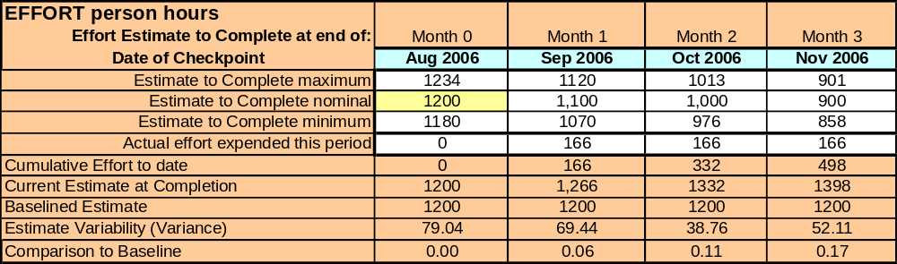
The estimation variance for effort is then charted by the report.
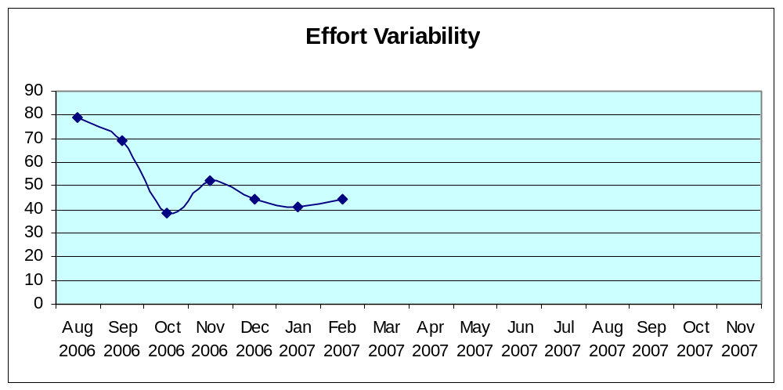
If the effort variability is trending towards zero, then the risk mitigation activities are addressing the uncertainty in the effort estimate.
If the effort variability is trending upwards, then additional uncertainty has entered the estimate compared to prior checkpoints. This could be reflected by additional requirements having been discovered, but not confirmed as in or out of scope. Hence the effort associated with them is likely to appear in the worst case estimate (which assumes they are in scope), and not appear in the best case estimate (which assumes they are out of scope), increasing the size of the range.
If the effort variability is flat as shown above, then the risk mitigation activities are not being effective in removing uncertainty, and the risk mitigation activities should be examined.
In addition to tracking estimation variance, the Estimation Checkpoint Report also tracks the current estimate to completion against the baseline. This chart helps to identify whether or not the project is actually tracking to the baseline, or is in fact off the baseline. Even though the estimation variance on the project may be reducing, this is no guarantee that the project will complete on time or on budget.
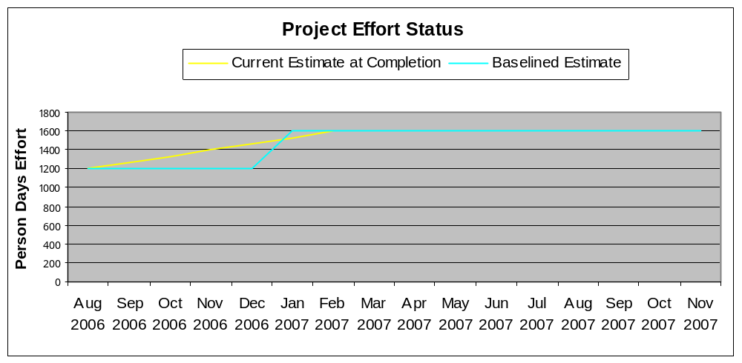
As shown in the example above, the current effort estimate at completion between August and December deviated from the baseline. Since the deviation was greater than the baseline, a re-baselining activity was required. The project was likely under estimated originally, or scope creep is adding unconfirmed effort to the overall plan.
If the deviation was less than the baseline, this could indicate that the project was over estimated originally, or that assumptions on the scope included in the project being delivered are different than the assumptions made when the baseline was established. Regardless, an explanation for the difference should be sought.
The Estimation Checkpoint Report also performs a comparison of the current estimate at completion against the baselined estimate. At the end of the project – the final checkpoint – when the estimate at completion is the actual effort spent on the project, this calculation is known as the Actual Variance.
Actual Effort Variance = (Actual Effort – Planned Effort) / Planned Effort
It is a measure of how accurate overall your baselined estimate was to the actual effort. A smaller actual effort variance indicates a more accurate original estimate.
Estimate Variance for Cost
To calculate the estimation variance for cost, the project manager enters the maximum, nominal, and minimum estimation to complete, and the actual cost spent this period.
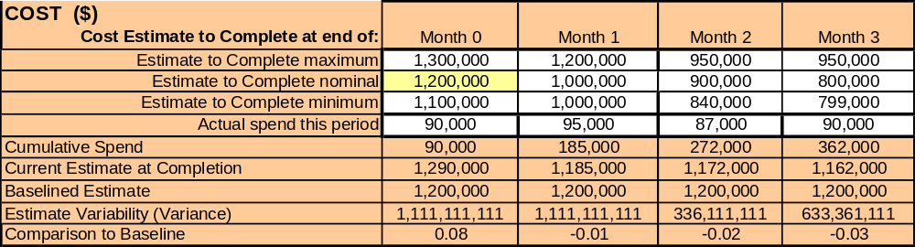
The estimation variance for cost is then charted by the report.
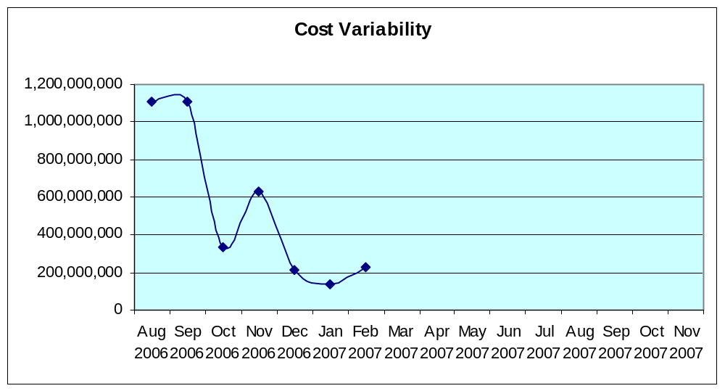
Again, the cost variability is expected to trend downwards towards zero if cost impact risks are being effectively mitigated.
Additional cost uncertainty has entered the estimate since the prior checkpoints if the cost variability is trending upwards. Perhaps the range of prices for a 3rd party software product is greater than originally assumed. Perhaps a more expensive resource is required to fill a particular role that was originally assumed to be performed by a lesser skilled and less expensive resource.
If the cost variability is flat, then the risk mitigation activities are not being effective in removing uncertainty. Perhaps the customer is in the middle of a procurement cycle and cannot name the winning software vendor. Perhaps the project cannot find a resource with the right skill set to perform a required task.
Tracking the cost estimate to complete against the baselined cost, the following chart is produced.
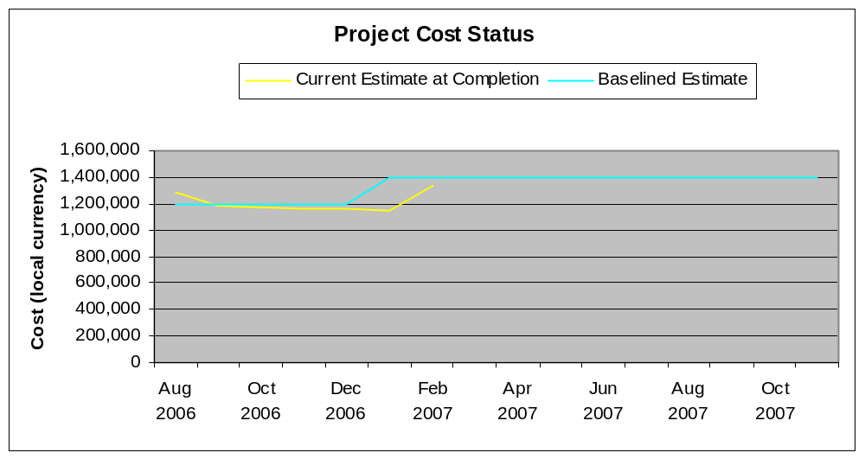
In this example, the cost remains in line with the baseline even though the effort had exceeded the baseline. This might indicate that effort is not a significant contributed to the overall costs of this particular project.
If the cost estimate at completion is consistently below the baseline, then perhaps the original cost assumptions were overstated. Perhaps the project has not been able to staff key positions and is under spending at this point in time.
If the cost estimate at completion is consistently above the baseline, then the original cost assumptions would appear to have understated the cost of the project. Perhaps a more expensive resource is performing work that was originally assumed to be performed by a less expensive resource.
The Estimation Checkpoint Report also calculates the actual cost variance as follows:
Actual Cost Variance = (Actual Cost – Planned Cost) / Planned Cost
It is a measure of how accurate overall your baselined estimate was to the actual cost. A smaller actual cost variance indicates a more accurate original estimate.
Estimate Variance for Schedule
To calculate the estimation variance for schedule, the project manager enters the maximum, nominal, and minimum estimation to complete, and the actual elapsed days this period.
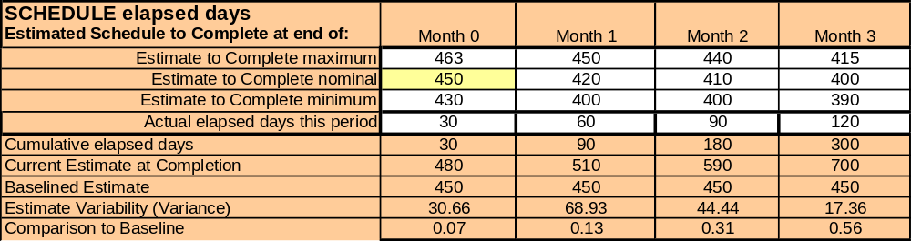
The estimation variance for schedule is then charted by the report.
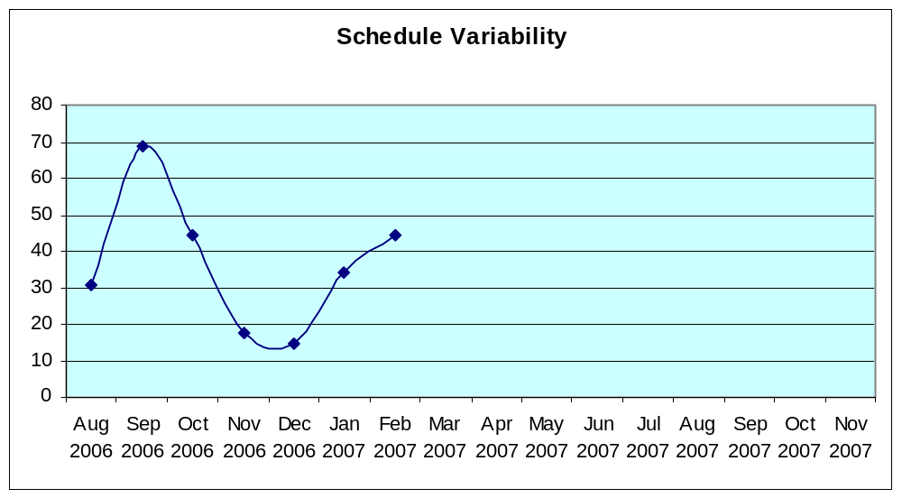
The schedule variability is also expected to trend downwards towards zero if schedule impact risks are being effectively mitigated.
When the schedule variability is trending upwards, additional schedule uncertainty has entered the estimate. Perhaps decision making is taking longer than originally assumed and is expanding the range between the best case and worst case schedule dates.
If the schedule variability is flat, then the risk mitigation activities are not being effective in removing uncertainty. Perhaps a required software fix that will resolve a current development issue has not yet been announced, and thus cannot affect the overall schedule of the project.
Again, the schedule estimate to completion is charted against the baseline.
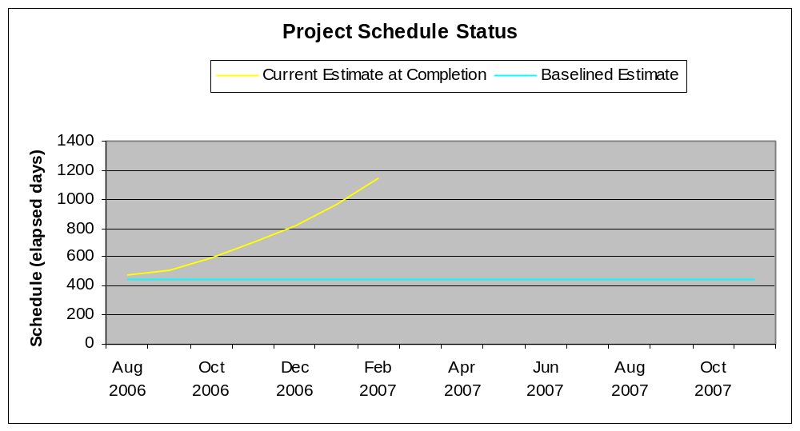
In this example, the schedule remains consistently above the baseline, indicating that the schedule is not achievable. Perhaps decisions are not being made in a timely fashion and are affecting the critical path of the project plan.
If the schedule estimate at completion is consistently below the baseline, then perhaps the original schedule assumptions were overstated. Perhaps the project is making better progress than anticipated.
The Estimation Checkpoint Report also calculates the actual schedule variance as follows:
Actual Schedule Variance = (Actual Schedule – Planned Schedule) / Planned Schedule
It is a measure of how accurate overall your baselined estimate was to the actual schedule. A smaller actual schedule variance indicates a more accurate original estimate.
Each estimation variance chart represents the location of the project within the project’s Cone of Uncertainty. The estimation variance should be decreasing as the project progresses. If the estimation variance is not decreasing, or is increasing, the root cause should be investigated.
- The later you are in the lifecycle process, the more you know (and the more experience you have) and therefore the more accurate your estimates will be (you should see less variance between your estimates and the actual results).
Based on the calculation of four numbers for effort, cost and schedule, some of which are already being calculated as part of project monitoring and control practices, a series of simple charts are produced that clearly communicate whether or not the risk is actually being reduced on the project – and not just that the risk mitigation activities are being completed – highlighting whether or not the activities are being effective!
Re-baselining
The Estimation Checkpoint Report supports re-baselining during the project.
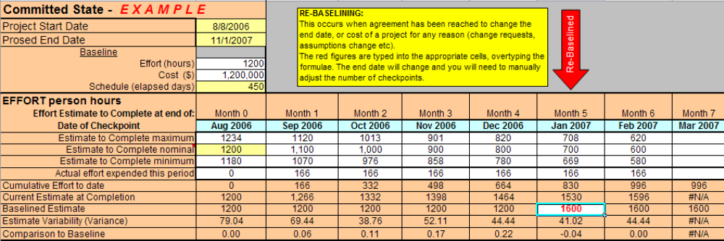
When re-baselining occurs, the new estimate is updated in the Estimation Checkpoint Report in the month in which the re-baselining has occurred. The original baseline data is left unchanged to preserve historical accuracy.
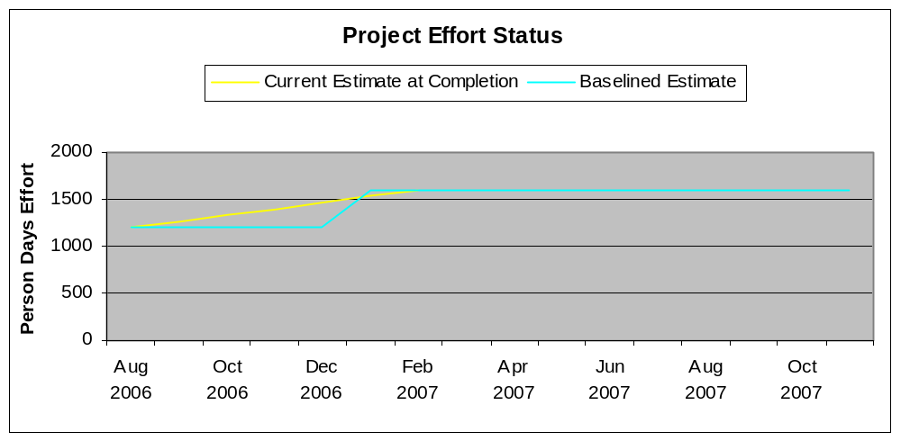
This new baseline will be reflected in the charts in the report.
- Key Considerations
Variation in Cost
The Estimation Report breaks cost down into Labour, Bill of Materials, Budgeted Contingency, All Other Costs, and Travel to provide a Total Budget Allocated amount. The majority of estimation variance is expected in the Labour value. The Estimation Checkpoint Report is tracking a number established at the beginning of the project – Total Cost – versus the current cost estimate. The report is not attempting to calculate the estimation variance in any one particular cost area. At the end of the project, we should have in the final checkpoint column the actual final effort, cost, and schedule (elapsed days) for this particular project, and a history of the estimation variance experienced.
Estimate to Completion
Each time that the estimate to completion is to be determined, and information is gathered from the team to support this determination, the minimum and maximum estimate to complete must also be gathered to support the estimation variance calculations.
The Mathematical Background of Variance
A subset of statistics deals with the properties of the normal distribution commonly called the “bell curve”. The significant points, for our purposes, are that bell curves exhibit the following properties:
- The expected or nominal value is in the center of the bell curve at its highest point
- The width of a bell curve can be approximated by:
width = (high value – low value)
- The width can be divided into 6 equal parts called standard deviation:
standard deviation or δ = (high value – low value) / 6
- Variance is a measure of the range of values expressed as a positive number:
variance = the square of the standard deviation or δ²
The probabilities associated with the standard deviation are as shown in Figure 1 below:
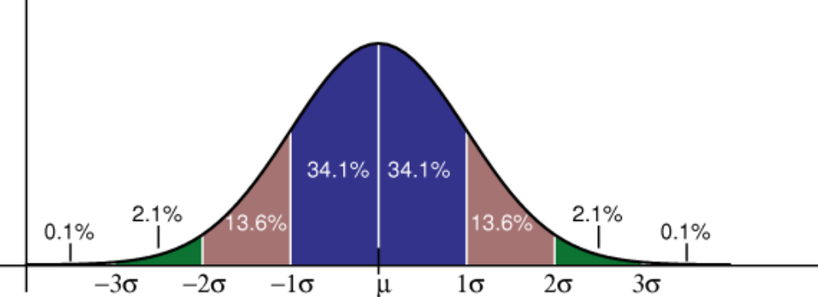
Figure 3 - Normal Distribution with probabilities associated with 1, 2, and 3 standard deviations
- If a value is within ±1 standard deviation, or ±1δ, of the nominal value then its probability is 68.2%
- If a value is within ±2 standard deviations, or ±2δ, of the nominal value then its probability rises to 95.4%
- If a value is within ±3 standard deviations, or ±3δ, of the nominal value then its probability rises to 99.8%
Statistical details aside, the standard deviation (δ) is a measure of how wide the range of probability is for any nominal value. The variance is similarly an indication of the range but has the virtue of always being a positive number and straightforward to plot on a graph.
- References
IBM Resources
- The IBM Estimating Community wiki contains estimating related documents, hints, tips and further reading: https://w3.webahead.ibm.com/w3ki/display/estimating/Estimating+Home
- Introduction to Estimating Best Practices at IBM – Technique Paper
- Estimating with Variance – Technique Paper
- Monitoring Project Progress through Estimation Factors – Technique Paper
- Estimation Variance and Governance, by Murray Cantor: http://www-128.ibm.com/developerworks/rational/library/mar06/cantor/index.html

Non-IBM Resources
- Probabilities and normal distributions: http://davidmlane.com/hyperstat/z_table.html

Publications
The following publications provide an easy introduction to the concepts of estimation variance and come highly recommended.
- Understanding Variation: The Key to Managing Chaos, by Donald J. Wheeler, SPC Press, 2000.
- Software Estimation: Demystifying the Black Art, by Steve McConnell, Microsoft Press, 2006.

- Revision History
Revision Number | Revision Date | Summary of Changes | Authors
4.1.0 | 20 July 2007 | First OPAL release. | Estimating Content Team
1.2 | April 2007 | 3rd draft. | Estimating Content Team
1.1 | March 2007 | 2nd draft | Estimating Content Team
1.0 | September 2006 | Initial draft | Estimating Content Team

Diagram courtesy of Bob Obsieger. Based on Software Estimation: Demystifying the Black Art, Steve McConnell, 2006.
Software Estimation: Demystifying the Black Art, Pg. 40, Steve McConnell, 2006

