APP 011 - System Context

Author: IBM
Owner: IBM

Document History
Document Location
This is a snapshot of an on-line document. Paper copies are valid only on the day they are printed. Refer to the author if you are in any doubt about the currency of this document.
Revision History
Date of this revision: 08-26-2004 | Date of next revision (date)

Revision Number | Revision Date | Summary of Changes | Changes marked
(#) | (-) | (Describe change) | (N)
Approvals
This document requires following approvals. Signed approval forms are filed in the Quality section of the PCB.
Name | Title
(name) | (title)
Distribution
This document has been distributed to
Name | Title
(name) | (title)
Contents
1. Introduction 4
1.1 Identification 4
1.2 References 4
1.3 Notation 4
2. System Context 5
2.1 Diagram 5
2.2 External Entities 6
2.2.1 <external entity identifier from diagram> 6
2.2.2 <external entity identifier from diagram> 6
2.3 Information Flows 6
2.3.1 <information flow identifier from diagram> 6
2.3.2 <information flow identifier from diagram> 6
2.4 Control Flows 6
2.4.1 <control flow identifier from diagram> 6
2.4.2 <control flow identifier from diagram> 7

Introduction
Please note that:
- Text in the “Editor’s comments” style (such as this) provides guidance to the editor, in conjunction with the corresponding work product description, and should be removed from the published version of the document.
- The “Reader’s comments” style (in purple) provides guidance for the (client) reader and should be modified as appropriate by the editor to reflect any customization of the template.
- The “Normal” style (in black) should be used by the editor when adding the text describing the (sub)system appropriate for this work product.
When using this template, refer to the Global Services Method work product description “APP 011 System Context”.
This chapter identifies the document and the (sub)system to which it relates, describes the contents of the document, and states its purpose.

Identification
This document describes the system context for .
Via the IBM menu, Edit the Document Information, enter the name of the (sub)system being described into the field “Text 2”, and press the “Update” button.

References
This document is based on and refers to the following documents:
[<no.>] <author>, <title>, <reference>, <version no.>, <date>{,<pages>}
where items in {} are optional.
e.g.,
[1] IBM Global Services, "Component Model for HAL", igtrpmaa.doc, V1.0.0A, 19/02/2001.
Then in the body of the text refer to the document by: Reference [1].

Notation
This section is optional. If appropriate describe any notation used in the document.
<Notation>

System Context
This chapter describes the context of the system.

Diagram
The context diagram shows the entire system represented as a single object or process, and identifies its interfaces with external entities of the system.
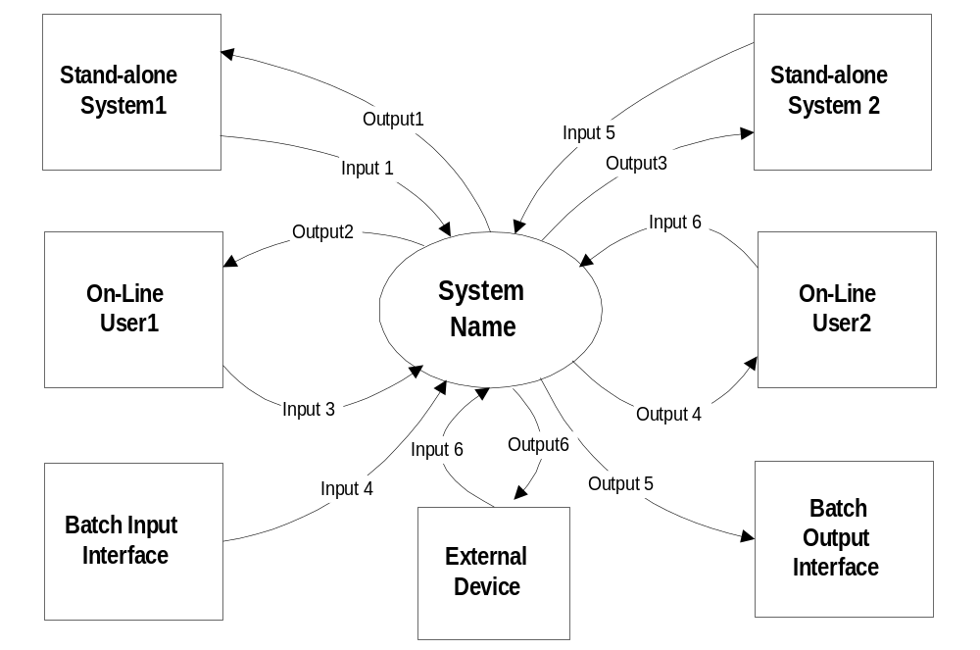

External Entities
This paragraph documents the characteristics of each external entity of the system (in alphabetic and/or numeric sequence).

<external entity identifier from diagram>
Description
Type
Owner

<external entity identifier from diagram>
Repeat the previous paragraph for each external entity in the diagram.

Information Flows
This paragraph documents the characteristics of each information flow that crosses the system boundary (in alphabetic and/or numeric sequence).

<information flow identifier from diagram>
Description
Number of users
Number of transactions
Frequency of transactions
Volume of data

<information flow identifier from diagram>
Repeat the previous paragraph for each information flow in the diagram.

Control Flows
This paragraph documents the characteristics of each control flow that crosses the system boundary (in alphabetic and/or numeric sequence).

<control flow identifier from diagram>
Description
Number of users
Number of transactions
Frequency of transactions
Volume of data

<control flow identifier from diagram>
Repeat the previous paragraph for each control flow in the diagram.

