

IBM Global Services

Developing Non-Functional Requirements

Guideline

© Copyright International Business Machines Corporation 2011, 2012

All Rights Reserved
Version 1.0 February 2012
Brief Description
The technique presented in this paper explains how to identify and define a set of complete well-stated, testable non-functional requirements that are traceable to stakeholder concerns. This is achieved by way of breaking high-level initial “statements of concern” down to more granular single focused NFRs.
Introduction
The objective of this paper is to provide guidance on a general technique to identify, elicit and specify non-functional requirements (NFRs); this paper also provides guidance on how to establish completeness and traceability of NFRs, for a target system.
Whilst most existing NFR taxonomies, including the ISO/IEC 9126, enumerate NFRs as quality attributes, this technique is broader and more general to accommodate system constraints such as legal and compliance aspects. This is achieved by relating NFR “themes” (from a reusable NFR “theme” library) to stakeholder concerns and then identifying NFRs within these “NFR themes”. This technique draws on the concepts of “Views” and “Viewpoints” (from IEEE 1471-2000 Software System Architecture standard) and relates them to “NFRs” and ‘NFR themes” respectively.
Since stakeholders are identified from various domains: for example end users, developers, maintenance and operations teams, hence identifying “NFR themes” corresponding to stakeholder concerns enable broad range of NFRs to be identified. In other words, the non-functional requirements capture concerns of the stakeholders, which generally cover a broad range of themes, ranging from how easy the system is to maintain once installed (NFRs for system operations), to how quickly the individual transactions within the system can be executed (NFRs for system performance).
Thus this technique acts like an overarching framework or a meta-model to accommodate future NFR taxonomies. The model also includes guidance to establish traceability, completeness of NFRs, specification of NFRs and their test methods.
This paper will help project teams, architects; business analysts identify stakeholder concerns, NFR themes and capture them as a set of quality, meaningful and consistent non-functional requirements.
Contents

Brief Description 1
Introduction 1
How to read this document 3
1 General Considerations 3
1.1 General framework for a taxonomy of NFRs 3
1.2 Overview of the Elicitation Process 4
1.3 STEP 1: The Stakeholders and their Concerns 6
1.4 STEP 2: NFR Themes, Objectives 7
1.5 STEP 3: High level NFR view 9
1.6 STEP 4: Single – Focus non-functional requirements – The tester’s view 11
1.7 Approaches to testing 13
2 Requirement Patterns 15
2.1 Patterns for Theme: Performance Requirement 15
2.2 Pattern for Theme: Volumetrics 20
2.3 Pattern for Theme: Scalability 21
2.4 Pattern for Theme: Security 22
2.4.1 Identification of security requirements 22
2.4.2 Approach to establishing security requirements: 23
2.4.3 Specific types of security requirements 23
2.4.4 Testing of security requirements 24
2.5 Pattern for Theme: Regulatory Compliance 26
2.6 Pattern for Theme: Usability 27
2.7 Pattern for Theme: Maintainability 28
2.8 Pattern for Theme: Availability 28
2.8.1 Scheduled Service Hours 29
2.8.2 Service Outage Costs 29
2.8.3 Availability and Recovery Criteria 30
2.8.4 Disaster Recovery 31
2.8.5 Other Availability Design Considerations 32
2.9 Pattern for Theme: Manageability 32
2.10 Pattern for Theme: Environmental 32
3 Planning and Resource Allocation 32
4 Summary of related IBM and other references 33

How to read this document
Section General Considerations introduces concepts applicable capturing and documenting all the Non-Functional themes and requirements. It defines what non-functional requirement is, introduces taxonomies, important requirement qualities, such as testability.
Next are the non-functional theme focused sections which will help the project team identify, and then capture the correct level of information for non-functional requirements covering the theme. New sections can be added as new assets are being harvested.
Section Planning and Resource Allocation will help correctly plan and resource the process of elicitation of non-functional requirements.
Whilst this technique is stated in context of a new business system integration project where no prior NFRs exist, it can be applied in other project scenarios as well.

- General Considerations

  - General framework for a taxonomy of NFRs
We define the main concepts for NFRs used and dealt with in this paper, by leveraging the notion of stakeholders, concerns, models, views and viewpoints, from IEEE-Std-1471-2000 “Recommended Practice for Architectural Description of Software-Intensive Systems”, and illustrated in Figure 1.
Stakeholders express their concerns about the behavior or quality attributes of system, for example, a system’s performance, availability, reliability, usability, extent of compliance to policies and legislation respectively. These concerns can be broadly matched with “NFR themes” (or NFR categories). For example one “NFR theme” can be “Performance” which captures the stakeholders concerns about a system’s ability to process peak throughput for some/all of its functions, within a certain response time.
For each “NFR theme”, identify corresponding NFRs the importance of the “NFR theme” is that it has a collection of techniques to elicit, define, and test NFRs relating to that theme.
An “NFR theme” is like a “Viewpoint” which specifies the “grammar” to specify NFRs within that theme. The “NFR theme” allows future expansion to cater for a wide variety of NFRs, hence making this style of NFR taxonomy to be “most generic”.
Stakeholder concerns captured as a series of NFR Themes and NFR Definitions which are traced to other models or views comprising architectural description. Such tracing gives the necessary context for the requirement and ensures its clarity. For each NFR Theme we define patterns, language, elicitation technique, standards and testing methods related to NFR definitions that conform to it.
The NFR definitions grouped by NFR Themes are documented in the form suitable to variety of stakeholders. Business sponsors and managers require a high level, summary view of the NFR at the theme level, whereas the developers and testers will require more granular view of the NFR. Both levels are usually maintained in a requirement repository such as Rational Requirements Composer (RRC), or Requisite Pro.
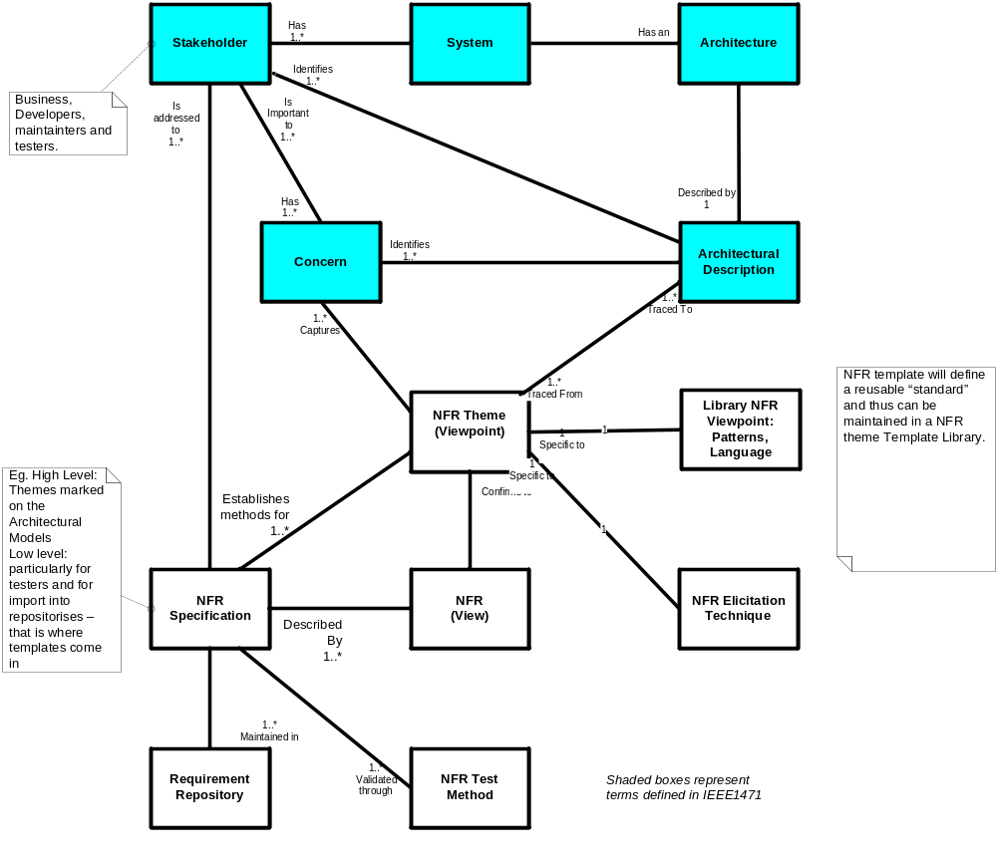Figure 1 Non-Functional Requirement relation to Architectural Description
  - Overview of the Elicitation Process
The process involves the following steps illustrated in Figure 2:
Step 1: Identifying the stakeholders:
Typically these are the project sponsors, production support, risk and compliance stakeholders, developers, and testers.
Step 2: Identify Stakeholders concerns (NFR related)
Define the concerns: elicit list of NFR Themes and statements of broader objectives that need to be accomplished given particular concerns of the stakeholders. For example the system needs to be responsive to casual on-line users, the system needs restrict access to authorized users, and the system needs to be search engine optimized. At this stage the goal is to outline the scope of NFR definition exercise. The output can be in a form of list arranged by NFR themes – example in Table 1. It is usually helpful to organize several discussions focused around single NFR theme so that large meetings are avoided.
Step 3: Map NFR Themes to initial Architectural Views.
Identify a lower granularity NFRs for each theme and when appropriate or possible map them to available architectural views of the system. Such mapping will provide necessary context for more specific requirements to be defined and helps determine whether set of NFRs is complete. For example using the System Context diagram we could assign Performance NFR (an NFR theme) to at best each external interface and no more. Identification of lower granularity NFRs requires an NFR theme specific elicitation technique which can be in other IBM technique papers or publicly available references.
Step 4: Define Single Focus Testable NFRs
Create low level NFR view which is a set of single focused, specific and testable NFRs. Theme specific pattern described in this paper are useful in ensuring consistent quality NFR definitions. At this stage decide on NFR attributes as “testing method”, “acceptance criteria”, “priorities” etc. The low level NFR view is tabular with context attribute tracing it back to the use case, data element or other component, latter as used in Step 3. Each cell represents the NFR that is chosen for detailed definition complete with clear acceptance criteria, and measurable target where appropriate.
The paragraphs that follow elaborate further on these steps.
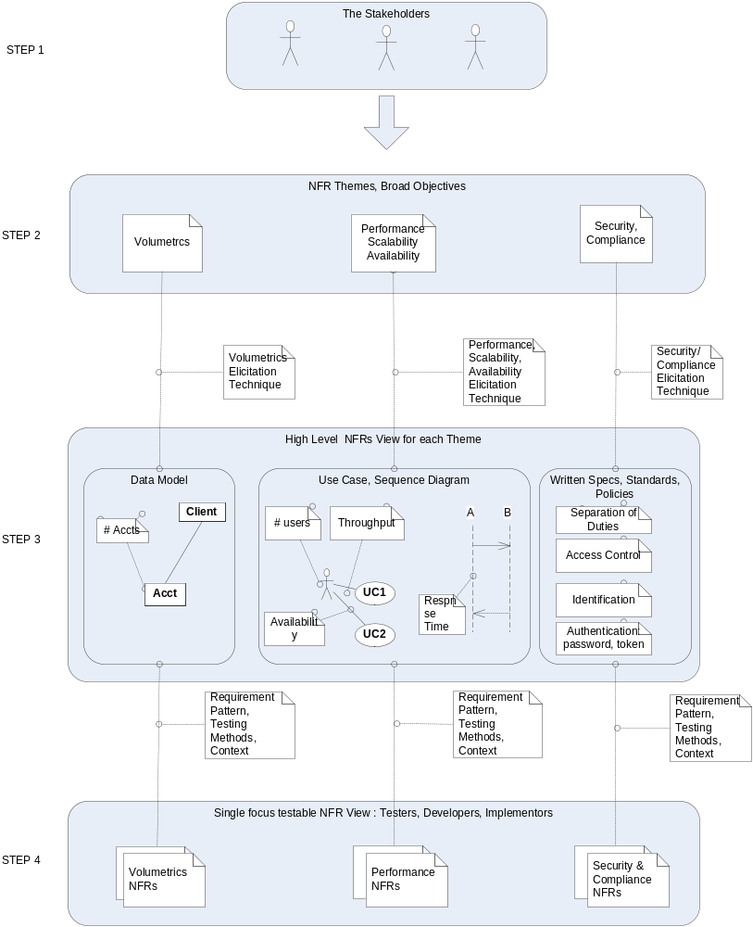
Figure 2 Overview of NFR elicitation technique
  - STEP 1: The Stakeholders and their Concerns
In most cases there are following groups of stakeholders with their unique concerns
- Business Stakeholders who are interested in how the system will be used,
- Delivery stakeholders who are interested in how the system will be built
- Operations Support stakeholders who are interested in how it will be supported and operated,
- Security, Regulatory Compliance stakeholders who are interested in how the system should be compliant with various conditions
It is important to note that there are contrary tendencies between the business and delivery stakeholders which will need to be resolved through negotiation – ultimately both groups need to sign off the NFRs. The Business Stakeholders usually tend to have insufficient expertise to appreciate the technical constraints and tend to set over-ambitious targets particularly for performance or availability.
By contrast the Delivery Stakeholders have keen appreciation of technical and financial constraints and advocate more conservative targets than Business Stakeholders.
Security and regulatory compliance stakeholders’ interests have to be weighed against the very usability of the system.
  - STEP 2: NFR Themes, Objectives
The Business Stakeholders and End Users are typically interested in how the system is used. Business are interested in performance of the system, its capacity to accommodate growing number of users, transaction volumes, but also its cost – both initial and incremental cost required to accommodate business growth. The concerns of Business Stakeholders relate mostly to functional and data views of the system: Use Cases, Sequence Diagrams, and Data Models.
The Operations and Support Groups are interested in how is the system to be supported and operated. The specific concerns here are Failure & Recovery facilities, System Management tools, Disaster Recovery and Business Continuity, Service- and Operational-Level Agreements etc
The personnel responsible for Regulatory Compliance, Security, and Auditors are typically interested in making sure system meets the appropriate regulatory constraints, meets the necessary Security Standards, and others
These concerns may be documented or not, nevertheless a series of workshops is generally necessary to confirm and record them. The initial workshop would note the themes and high level concerns. There may be some high level architectural description of the system available which can serve as a context for the NFR theme, but the main goal here is to outline the scope of the NFR specifications to be worked out. It is important to decide source of the requirements, or reference point on which the requirement is to be based. Such source may be an old system being replaced, industry benchmark, or similar. Should there be no such source identifiable appropriate analysis needs to be carried out. The outcome of the workshop may be presented in Table 1 below. The table lists most commonly identified Non-Functional themes but it should not be regarded as set in concrete. As technology evolves and enables new types of business systems, so do stakeholders’ concerns and non-functional themes, such as security, compliance, usability, configurability, etc.
Table 1 NFR Themes, Stakeholders and Concerns
NFR Theme | Stakeholders: | Concerns: | Source
Performance | Business Sponsors | Does the system respond fast enough to user actions | Public Benchmarks
 | Users | Can the system support suitable number of concurrent users | Existing systems
 |  | Can the system support enough transactional throughput
Volumetrics | Business Sponsors | Is the system capable of storing/ processing expected volumes of data | Data Model View
 | Users | Is the system capable servicing expected number of users | Forecasting reports
Scalability | Business Sponsors | Is the cost and timeframe of extending the system acceptable
 |  | Is the cost/and timeframe constant
Security | Risk & Compliance, | Do we comply with our enterprise security policies | Security Standards
 | Financial control | Can we enforce separation of duties? | Security Architecture
 |  | Can we give read/write privileges to some but read only to others? | Technical Guidelines issued by regulatory authorities
 |  | Can we control and audit system configuration changes | Existing system specifications
 |  | Can we control and audit development and maintenance activities | Use Case View
 |  | Can we produce a proof of customer actions (non-repudiation)
 |  | Are my audit logs secure and trustworthy
 |  | Are we controlling 3rd party access to our system sufficiently
 |  | Can we detect and react to security incident soon enough
Regulatory Compliance | Risk & Compliance, | Do we comply with privacy regulations? | Security Standards
 |  | Do we comply with Sarbanes Oxley regulations? | Technical Guidelines issued by regulatory authorities
 |  | Do we comply with Anti-Money Laundering? | Documentation of other systems
 |  | Do we comply with Anti Terrorism Financing Laws | Compliance Audit records
 |  | Do we comply with Sanctions imposed on certain countries | Use Case View
Usability | Business Sponsors, Users, | Can visually or hearing impaired people use our system | WCAG Accessibility Guidelines
 |  | Do the system’s user interfaces measure up to best practice usability benchmarks | NISTIR 7432 - Common Industry Specification for Usability – Requirements
 |  |  | Local usability standards
 |  |  | IBM Artifact APP129
Maintainability | Operations Support, Development Support | Do we have appropriate environments for testing and development | Company’s Maintainability Standards
 |  | Do we have tools/ways to diagnose and isolate fault fast enough for my SLAs
 |  | Do we have tools/ways of monitoring transactional load and resource utilization
 |  | Will the technicians paged in case of problems
 |  | Will there be a remote access allowed to my technicians
Availability | Users, Business Sponsors, Operation Support | What is the maximum length of unscheduled outage the business can tolerate | Company’s Availability Standards
 |  | Can we allow scheduled outages, and how frequently
Manageability
Environmental
  - STEP 3: High level NFR view
The stakeholder concerns identified above are broad objectives. The questions that need to be answered now are:
- How to break down the broadly stated objectives into specific testable requirements?
- What is the relative importance of these objectives?
- How to ensure completeness of the NFR identified?
As already stated in previous section the stakeholders focus on specific aspects of the system, hence their concerns can be related to the appropriate architectural views – as shown in Table 2.
Table 2 Mapping of NFR Themes to Architectural Models
NFR Theme | Architectural Views Related
Performance (including Capacity) | System Context, Use Case, Data Model, Process Model, Component Model
Volumetrics | Operational Model
Scalability | Use Case Model, Process Model, Component Model, Operational Model
Security | Use Case Model, Component Model, Operational Model
Regulatory Compliance
Usability | Use Case, Process Model
Maintainability (including Flexibility) | Component Model, Operational Model
Availability (including Recoverability and Reliability) | Use Case Model, Process Model, (business perspective) Component Model, Operational Model (IT operations perspective
Manageability | Component Model, Operational Model
Environmental (including Safety) | Component Model, Operational Model

Given the NFR themes the architectural work products can be walked through and annotated with candidate NFRs as shown in Figure 3 or Figure 4 or in the tabular form shown belowError: Reference source not found.

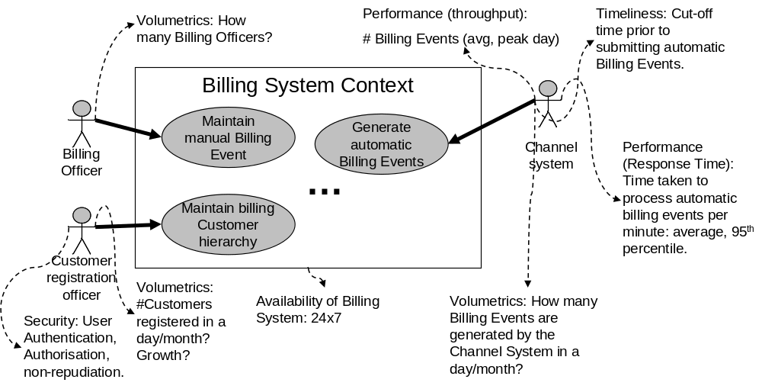
Figure 3 Tracing NFR themes to System Context Diagram

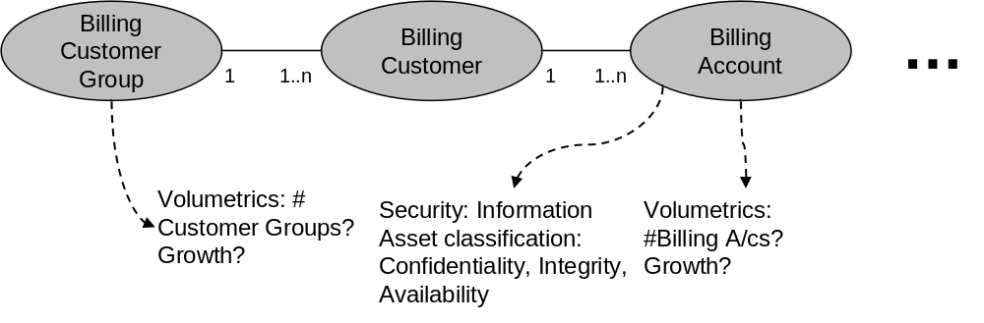
Figure 4 Tracing NFR themes to Conceptual Data Model
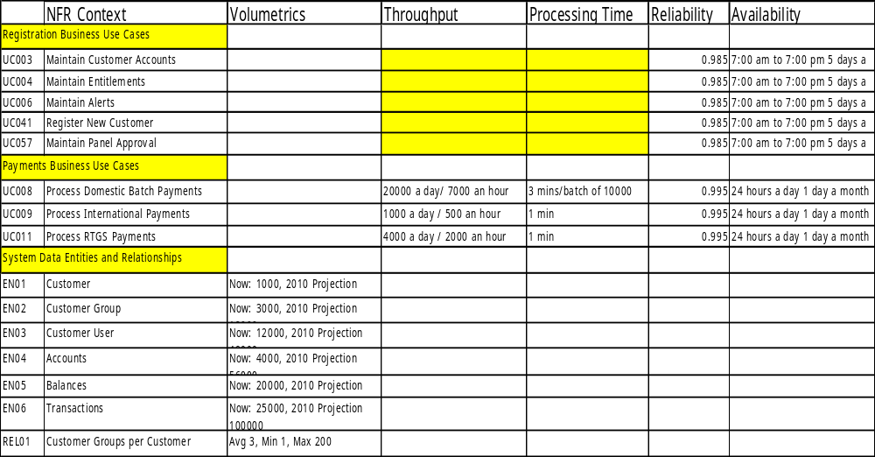
Figure 5 Example Non-Functional Requirement matrix
This high level NFR view provides traceability to original NFR Themes and helps demonstrate completeness of the NFR set: when all concerns are mapped to all relevant entities on the architectural views the NFR set can be regarded as complete.
Each mapping of a concern to an element of architectural view provides context against which set of specific NFRs can be defined.
The pictorial or tabular high level NFR view can be used for communicating with the stakeholders to determine which NFRs are to be captured and determine the “show-stopper requirements” from ones where a work around is possible.
Typically the annotated architectural views or the cells in the matrix are pre-populated before the workshop by the architect – the workshop leader. Walking through the cells of the matrix with workshop participants we validate the decisions regarding which qualities are to be captured as NFRs.
In the example shown in Figure 5 we decide that:
The throughput and processing times associated with Registration use cases are not important from the point of performance risk due to small number of users and infrequent execution.
The throughput and processing times associated with Payments use cases are important. The performance of these use cases is critical from the point of system’s usability and the client’s perception. These use cases will definitely be a focus of performance testing
Such testing will need to be performed on a system configured with production-like database size. Thus we need to capture sufficient data to determine such database size. This will be provided by the NFRs associated with data entities.
  - STEP 4: Single – Focus non-functional requirements – The tester’s view
The previous step resulted in a summary view of requirements, their scope, and relative priorities. The questions that now need to be answered are related to the tester’s concerns:
- What system function or component to exercise during test
- What are the acceptance criteria
- What kind of test method is to be adopted
- What testing tools and resources do I need available
To this end we need to create a requirement statement that clearly and unambiguously conveys the intent of the stakeholders and provides sufficient guidance on how to test or verify them. Good way to describe such requirement has been proposed by Mike Manion and Barry Keepence in their article “Smart Requirements” published in ACM SIGSOFT in 1995: they should be
- Specific
- Measurable
- Attainable
- Realizable
- Traceable
The High Level NFR View helps with establishing traceability to the use cases, data entities, and context diagrams. We have touched on how to make sure the NFR attainable and realizable within constraints of the project. That addresses A, R, T. Finally the testers would want to know how to measure and test the requirements – calling for S and M attributes. For example:
Specifying response time of 4 sec 95th percentile needs to precisely and unambiguously state when to start and stop the stop watch.
Specifying throughput of say X transactions per hour we need to state what transaction, whether the target represents a breaking point of the system or the design point beyond which some reserve capacity is still to be available, also we allow response time to be longer.
In both cases we need to provide a sufficient guidance as to how to engineer the test cases and how to set up the system under test.
An example Requirement Template structure renders NFR specifications to be Specific and Measurable
Attribute | Description
Identifier | Short identifier – a tag - helpful as a unique identifier in the repository
Title | A short descriptive identifier
Definition | Precise definition of the NFR that needs to be met by the system in given context
NFR Theme | Theme to which the NFR belongs – see 1.3
Release | In multi-release projects state the release for which the NFR applies.
Context | Reference to other architectural view such as Use Case, Data Model
Value | Numeric value or values representing measure of the NFR – keeping the numerical value separate allows easy aggregation for verification purposes. If the NFR does not have numerical value then “NA” or blank
Growth Rate | Rate of Value growth over time. If no numerical value then “NA” or blank
Acceptance Criteria | Precise definition sufficient for tester to plan test and draw the test case. Is this requirement to be tested in isolation or jointly with other requirements
Priority | A measure of criticality of the requirement for example Critical, Desirable, Optional
Source | Source of the requirement – a Stakeholder Name, Policy
Reference | A reference implementation or benchmark against which the system being built is compared
Test Method | Most requirements are tested in a lab; some, however, can not be tested in the lab – possibilities are: operational monitoring, design review, penetration testing (for security), audit etc.
  - Approaches to testing
The customer will be ultimately looking forward to obtaining some form of objective evidence that the given non-functional requirement is met and documented report on the matter.
The testing method and type of acceptance criteria depends largely on NFR theme in question. Table 3 below lists the suggestions regarding possible acceptance criteria and test methods.
Table 3 Testing Approaches
NFR Theme | Possible type of acceptance criteria | Example test method(s) | Type of objective evidence
Performance (including Capacity) | Throughput, Response Time, Concurrency targets | Performance Test, Stress Test | Performance statistics and measurements taken from the test bed
Volumetrics | Volumetrics data can be the basis for determining the size and composition of the test data set. For example: 10000 customers each having 5 accounts on average, each account having average transaction history of 100 transactions.
Scalability | Percentage of capacity reserves to be deployed, future projections of volumetrics | Static design review, stress test | Design review report, Vendor statement Evidence gathered during tests
Security | Checklist derived from Security Standards, public or Customer’s internal | Static design review, Operational Readiness Review, Penetration Test, Vulnerability Test | Design review report, Vendor statement  Operational Review Checklist  Evidence gathered during tests
Regulatory Compliance | Compliance Guidelines, Checklists derived from past audits | Review by a qualified compliance, legal assessor’s report | Review Report
Usability | Checklist derived from Usability standards, public or Customer’s internal | Static design review, functional test, failure test, stress test | Design review report, Vendor statement Evidence gathered during tests
Maintainability (including Flexibility) | Checklist Derived from Maintainability standards, public or customer’s internal | Static design review | Design review report  Vendor statement
Availability (including Recoverability and Reliability) | SLA targets, Availability translated into RTO/RPO targets | On-going SLA Reporting, Failover test | Design review report, Evidence gathered during tests
Manageability | Checklist derived from Manageability standards, public or customer’s internal | Static design review, failure test, operational readiness review | Design review report, Vendor statement Operational Review Checklist  Evidence gathered during tests
Environmental (including Safety) | Checklist derived Environmental standards, public or customer’s internal | Static design review, operational readiness review | Design review report, Vendor statement Operational Review Checklist  Evidence gathered during tests

Clear acceptance criteria and testing approaches are necessary part of a well-formed NFR definition.
As the above list demonstrates:
- There are NFR themes which cannot be tested entirety in a test lab prior to deployment. For example Availability can only be verified on on-going basis by the IT Service Delivery organization.
- There are NFR themes which can be incorporated into a Design phase of the project lifecycle
- Variety of testing approaches is necessary to produce an objective evidence of requirements being met or not.
- Specialist resources are needed to carry out the testing of particular NFR themes.

- Requirement Patterns
To ensure consistent quality of NFR definitions it is helpful to create NFR template definitions. Such definitions are specific to the NFR theme. The goals which we want to accomplish are:
- To give project team a head start in defining the particular theme requirements.
- To create a self-contained statement, focused on single topic traced to its business context, and further down the track to the test conditions
- To facilitate import of the NFR to the requirement management tool like Requisite Pro, which can then be used to manage these requirements
- The pattern comprises a general text (a boilerplate) which is NFR theme specific complemented with NFR context specific part (parameters)
The requirement patterns presented in the following sections have been harvested from the NFRs defined for one of the banks, and may need to be adapted to other business domains.
  - Patterns for Theme: Performance Requirement
The patterns below help define common performance requirements for throughput, response time and volumetrics
Throughput Requirement
Throughput non-functional requirement captures required capacity of the system or its component to process certain number of transactions in a unit of time. Key considerations and parameters:
- The transaction needs to be precisely described, cross-referenced to use case diagram, sequence diagram, etc so that there is no ambiguity; this is done through NFR Context as explained in see Section 1.6. and captured as <TRANSACTION> parameter of the template; the throughput figure is captured by <COMPLETIONS / TIME> parameter.
- It needs to be clear whether the requirement is average or peak, minimum and which period of time it covers e.g. is it morning, afternoon, end of the particular month etc. This information is captured by parameters <DESIGN POINT> and <PERIOD>. We may have different <DESIGN POINT> to cater for emergency situations during which we are prepared to tolerate longer response time targets.
- <BASELINE DATE> parameter specifies which date the <DESIGN POINT> applies to; it should be clear whether the requirement specifies current throughput, or expected future release of the project. It is possible for a multi-release project to mandate increasing throughput targets for consecutive releases. In this case <BASELINE DATE> would refer to these releases.
- It is useful to state any applicable growth rate after the <BASELINE DATE>, this is captured by parameter <GROWTH RATE>
- It needs to be clear which part of the system needs to sustain the required throughput; care should be taken to use consistent vocabulary with the other parts of architectural description of the system. The component may be entire system as shown on context diagram, or its subsystem – for example batch processing module or reporting engine. It may also be a shared service used by the system. This information is captured by <COMPONENT> parameter.
- Finally it is necessary to state what other conditions need to be met while the throughput is sustained, usually all response time parameters need to be met. However the requirement may define a short-lived peak throughput representing an emergency situation and extended response times may be acceptable. Such information is captured in <OTHER CONDITIIONS> parameter.
The throughput requirement pattern is presented in Table 4, and its parameters are explained below
Table 4 Throughput NFR Specification Pattern
a. Pattern
Attribute | Description
Identifier | NF.TR.XXX
Title | <DESIGN POINT> number of completions of <TRANSACTION> by <COMPONENT>
Definition | The <COMPONENT> must be able to sustain <DESIGN POINT> throughput of <TRANSACTION>s of <COMPLETIONS/TIME> during < PERIOD> while <OTHER CONDITIONS>
Theme | Performance
Context | <Architecture Description Reference e.g. Use Case UC057>
Value | <COMPLETIONS / TIME> during <PERIOD>
Growth Rate | This requirement applies to <BASELINE DATE> growing at the rate of <GROWTH RATE>
Acceptance Criteria | The <COMPONENT> sustains a throughput of at least <COMPLETIONS/TIME> while meeting <OTHER CONDITIONS> when tested in the lab
Priority | Critical – Desirable – Optional
Source | Source of the requirement – a Stakeholder Name, Policy
Reference | A reference implementation or benchmark against which the system being built is compared
Test Method | Peak Hour Transaction Mix Test in PVT Environment

b. The parameters
<COMPONENT> | What part of the system needs to provide the throughput – the end to end system, the front end, interface etc. – can be identified from the NFR context
<TRANSACTION> | Throughput of what – single transaction, transaction mix – can be identified from NFR context
<COMPLETIONS/TIME> | - an NFR value for example 5 per second
<DESIGN POINT> | peak at <PERIOD>, average over a <PERIOD> or others
<PERIOD> | start – end or length of period of time applicable to the <DESIGN POINT>
<GROWTH RATE> | - the growth rate of throughput after stated <BASELINE DATE>
<BASELINE DATE> | Which date the <DESIGN POINT> applies to
<OTHER CONDITIONS> | other requirements and parameters which need to be tested jointly with this requirement e.g. the response time requirements met, the database populated with target data volumes, whether this is part of a transaction mix
c. Example
Attribute | Description
Identifier | NF.TR.001
Title | <Peak> number of completions of <deposits> by <On-line banking system>
Definition | The <On-line banking system> must be able to sustain <Peak> throughput of <deposits>s of <10000/Hour> during <afternoon period -2:00 pm till 6:00 pm> while <response time targets are met>
Theme | Performance
Context | <Architecture Description Reference e.g. Use Case UC057>
Value | <10000/Hour> during <afternoon period -2:00 pm till 6:00 pm>
Growth Rate | This requirement applies to Release 1A growing at the rate of <10% per annum>
Acceptance Criteria | The <On-line banking system> sustains a throughput of at least <10000/Hour> while meeting <response time targets are met> when tested in the lab
Priority | Critical
Source | Source of the requirement – Workshop with Market Products Division 10-Aug-09
Reference | Current system XYZ
Test Method | Peak Hour Transaction Mix Test in Performance Test Environment
Response Time Requirement
Response Time non-functional requirement captures target processing time the system or its component must deliver while sustaining required throughput. Key considerations and parameters:
- The transaction needs to be precisely described, cross-referenced to use case diagram, sequence diagram, etc so that there is no ambiguity; this is done through NFR Context as explained in see Section 1.6. and captured as <TRANSACTION> parameter of the template;
- It must be clear how the time is measured – when to start and when to end, parameters <START EVENT> and <END EVENT> determine this. Care needs to be taken to correctly refer to events shown in the NFR Context.
- It must be clear whether the requirement is strict limit, or a flexible target. This pattern as is defines the response time as 95th percentile and average defined by parameters <95th PCT TIME> and <AVG TIME> which is best way of testing the interactive response time. For batch processes such processing time would need to be expressed in terms of available batch window, so this pattern would need to be varied.
- It must be clear which part of the system needs to deliver the response time; care should be taken to use consistent vocabulary with the other parts of architectural description of the system. The component may be entire system as shown on context diagram, or its subsystem – for example batch processing module or reporting engine. It may also be a shared service used by the system. This information is captured by <COMPONENT> parameter.
- It may be necessary to state whether this requirement applies under business as usual, emergency or peak throughput condition. This is captured by parameter <OTHER CONDITIONS>
The throughput requirement pattern is presented in Table 5, and its parameters are explained below
Table 5 Response Time NFR Specification Pattern
a. Pattern
Attribute | Description
Identifier | NF.RT.XXX
Title | <TRANSACTION>, time from <START EVENT> to <END EVENT>
Definition | <COMPONENT> must consistently deliver response time below <95th PCT TIME> (95th percentile) and <AVG TIME> on average measured from <START EVENT> to <END EVENT> while executing <TRANSACTION> under <OTHER CONDITIONS>
Theme | Performance
Context | <Architecture Description Reference e.g. Use Case UC057>
Value | 95th percentile <95th PCT TIME>, average <AVG TIME>
Growth Rate | Not Applicable
Acceptance Criteria | The response time measured from <START EVENT> to <END EVENT> while testing <COMPONENT> executing <TRANSACTION> under <OTHER CONDITIONS> falls consistently below <95th PCT TIME> (95th percentile) and <AVG TIME> average
Priority | Critical – Desirable – Optional
Source | Source of the requirement – a Stakeholder Name, Policy
Reference | A reference implementation or benchmark against which the system being built is compared
Test Method | Peak Hour Transaction Mix Test in PVT environment
b. The parameters
<COMPONENT> | What part of the system needs to provide the throughput – the end to end system, the front end, interface etc. – can be identified from the NFR context
<TRANSACTION> | Throughput of what – single transaction, transaction mix – can be identified from NFR context
<START EVENT>, <END EVENT> | When does the response time start and end – can be identified from NFR context
<95th PCT TIME> | 95th percentile target value
<AVG TIME> | an average NFR value; usually ratio of 95th PCT to AVG is 3.
<OTHER CONDITIONS> | other requirements and parameters which need to be tested jointly with this requirement e.g. the response time requirements met, the database populated with target data volumes, whether this is part of a transaction mix
c. Example
Attribute | Description
Identifier | NF.RT.001
Title | <Deposit>, time from <Click Submit> to <Screen Refresh>
Definition | <On-line Banking>> must consistently deliver response time below <3 sec > (95th percentile) and <1 sec > on average measured from <Click Submit> to <Screen Refresh> while executing <Deposit> under <peak throughput>
Theme | Performance
Context | <Architecture Description Reference Use Case UC057>
Value | 95th percentile <3 sec >, average <1 sec >
Growth Rate | Not Applicable
Acceptance Criteria | The response time measured from <Click Submit> to <Screen Refresh> while testing <On-line Banking>> executing <Deposit> under <peak throughput> falls consistently below <3 sec > (95th percentile) and <1 sec > average
Priority | Critical – Desirable – Optional
Source | Source of the requirement – a Stakeholder Name, Policy
Reference | Existing system XYZ
Test Method | Peak Hour Transaction Mix Test in PVT environment
  - Pattern for Theme: Volumetrics
This requirement theme defines required size of the system, such as ability to store and process required volumes of particular data elements, or ability to support certain with number of user profiles. The volumetrics determine size of storage, memory that the system needs to support while sustaining throughput and performance targets. Volumetrics drive the size of test data sets used during performance tests.
To demonstrate that the system can support the required volume it is may be necessary to produce a report (or set of reports) showing that the system does indeed “see” a required number of accounts, customer profiles, etc. to confirm that all the subsequent functional or non-functional tests were indeed valid.
The suggested NFR pattern is shown in Table 6
Table 6 Volumetrics NFR Pattern
Attribute | Description
Identifier | NF.VL.XXX
Title
Definition
Theme | Volumetrics
Context | <Data Model, e.g. Entity “Account”, Context Diagram – Actor “Banker” or similar>
Value
Growth Rate
Acceptance Criteria
Priority | Critical – Desirable – Optional
Source | Source of the requirement – a Stakeholder Name, Policy
Reference | A reference implementation or benchmark against which the system being built is compared
Test Method
c. Example
Attribute | Description
Identifier | NF.VL.001
Title | Maximum Number of accounts per customer
Definition | <An On-Line Banking Solution> must allow registration of a customer with maximum of at least 46264 accounts
Theme | Volumetrics
Context | < Registration Use Case UC057>
Value | 46264
Growth Rate | Not Applicable
Acceptance Criteria | <An On-Line Banking Solution> allows registration of a customer with maximum of at least 46264 accounts
Priority | Critical
Source | Source of the requirement – a Stakeholder Name, Policy
Reference | Not Applicable
Test Method | Test of use case UC057
  - Pattern for Theme: Scalability
Once the system life has been specified, you should work with the customer to estimate the likely growth in business workload over that period (as well as the end of life you should specify a number of intermediate milestones). This anticipated growth should be expressed in terms of the key business drivers discussed earlier. For example, the number of customers, number of customer enquiries, etc.
You can then use the business volumetrics model to convert those drivers into an estimate of the business process volumetrics at various stages throughout the life of the system.
For many types of business system the customer may have little or no understanding of how the workload is likely to grow over time. This is particularly common for Internet based systems. In such situations it is key to design the solution to be horizontally scalable. In that way the capacity of the system can be extended on demand by adding additional node servers as required. You must avoid being limited by the scalability of a single server. In such situations it is also important to design the system to be multi-threaded, avoiding serialization bottlenecks as much as possible.
You may not be contractually obligated to deliver a system on day 1 that is capable of supporting the end of life workload scenario. However, as solution providers you will almost certainly need to ensure the delivered system is capable of supporting that workload without major re-design. The nodes within the operational model must be sufficiently scalable to support the anticipated growth beyond the Design Point without fundamental change to the architecture of the system.
Once collected this volumetric information should be fed into the performance model corresponding to the specified operational model. An analysis can then be conducted to assess the ability of that operational model in continuing to support the business system workload (refer to the Performance Estimation Modeling Technique for a description of this estimation and analysis process).
  - Pattern for Theme: Security
The security aspects of some system designs can be very demanding. They can dominate your design decisions. They could cause otherwise good options of structure and component selection to become unacceptable. So make a definite choice now as to whether the system that you are designing has particularly demanding security requirements. For example:
- A sensitive military system
- A high value money transfer system
- A system that handles confidential personal information
The levels of security controls are mandated by security policies and standards adopted by the target organization. These policies apply to a range of business systems used by the company rather than a specific system. It should be possible to re-use majority of security requirement specifications from other projects unless a major change forces re-think of security risks policies and (shift to cloud infrastructure, embracing virtualization, introduction of single sign on, introduction of on-line presence). Such comprehensive re-think of security policies, risk analysis and formulation of policy is beyond the scope of this paper.
2.4.1 Identification of security requirements
- Identify data to be protected
- Identify the type of threats to which each type of data is exposed:
- Accidental corruption or destruction
- Deliberate corruption or destruction
- Commercial intelligence
- Fraud
- Hacking
- Viruses
- Identify threats to physical security:
- Theft of components
- Unauthorized physical access
- Physical safety of users
- Identify the people who may be the sources of these threats:
- Data center staff
- Other IT staff (for example, development)
- Non-IT staff of the organization
- People outside the organization
- Identify any special or unusual security requirements especially with respect to:
- Access to the system
- Encryption of data
- Auditability
- Are there any general policies, such as Freedom of Information acts, that might influence the security design of this system?
- Some packaged application solutions have their own security sub-systems. If you have a “given” package be aware of its security facilities.
2.4.2 Approach to establishing security requirements:
- List the objects which require protection by logical or physical security.
- Identify the exposure which is relevant to each object. Typical categories are:
- View access (breach of confidentiality), e.g. account information, client list, patents.
- Update access, i.e. modification of data for fraud, cover-up, and diversion of funds.
- Loss of assets, i.e. somebody else gets a possession and it is no longer available to the owner (as distinguished from loss due to disaster). Examples are: client and prospect lists, contracts, etc.
Note that not all objects are sensitive to all of the above exposures.
- Identify all the threats which are relevant to your environment. Examples are:
- Disgruntled employees
- Unauthorized employees
- Open terminal sessions in public place
- Hackers
- Line tapping
- Loss of equipment (e.g. portable PCs)
- For each object establish which threat may apply and associate it with the particular exposure.
Note that you may have to review the security requirements for the object both in a static location (e.g. on DASD) as well as in transit (e.g. during transmission).
Since the design may extend the location of the object into unsecured areas, you may have to revisit this subject.
2.4.3 Specific types of security requirements
Majority of security concerns are captured by more specific requirements for
- Access Control – restricting access to authorized users only
- Auditing and Accounting - requirement for records of events, and attributing these events to users
- Authentication– verification of authentication credentials (passwords, certificates)
- Identification – verifying person’s identity
- Authorization – requirements around permissions given to user groups
- Intrusion Detection – detecting changes that should not take place
- Non-Repudiation – capturing and maintaining evidence of user actions
These requirements are expressed:
- In the context of a use case or wider business processes
- As a design guideline, for example: probability of false positive identification should be less than X, or
- As requirement for a specific security control for example: “Banker using master data screen needs to be two-factor authenticated using device X”
2.4.4 Testing of security requirements
For a design guideline the testing method will be design review, code scan, scenario walkthrough. The tests in the lab would be aimed at verifying that system is configured and integrated with the environment correctly. These tests would exercise specific system functions to verify specific conditions related to concern.
Specialized testing techniques such as penetration test or vulnerability test can verify how strong the system’s security mechanisms are. It needs to be understood that unlike other tests the penetration testing can only produce evidence that a requirement is NOT met (i.e. security mechanism can be broken).
The context of these requirements would need to clearly trace to the list of concerns and the appropriate elements of functional and architectural description to prevent ambiguity.
Additional guidance on the on Security and Compliance NFRs can be found in the following references
Markus Schumacher [et al] ISBN-13 978-0-470-85884-4 Security Patterns: integrating security and systems engineering – describes security requirement patterns and considerations
ISO/IEC 15408 – Common Criteria for Information Technology Security Evaluation Part 2 “Security functional components” express security requirements intended to counter threats and/or cover any identified organizational security policies
CMU/SEI-2004-SR-015 – System Quality Requirements Engineering (SQUARE) Methodology: Case Study on Asset Management System – provides insight into elicitation of some security requirements working from the objectives to actual requirements.
Table 7 Security Requirement NFR Pattern
a Pattern.
Attribute | Description
Identifier | NF.SE.XXX
Title
Definition
Theme | Security – Access Control
Context | <Trace to concern and architectural description>
Acceptance Criteria
Priority | Critical – Desirable – Optional
Source | Source of the requirement – a Stakeholder Name, Policy
Reference | A reference implementation, security standard
Test Method | Functional Test  Penetration Test  Vulnerability Test  Code Review  Design Review  Scenario Walkthrough (paper based test)
b. Example1
Attribute | Description
Identifier | NF.SE.001
Title | System configuration change alerting
Definition | Any changes to system configuration files must generate alert to production support
Theme | Security – Intrusion Detection
Context | List of production configuration files – Detailed Design Document DDSYS001
Value | Not Applicable
Growth Rate | Not Applicable
Acceptance Criteria | Attempt to change system configuration files in triggers an alert to production support
Priority | Critical
Source | Security Standard XYZ
Reference | None
Test Method | Functional test
b. Example2
Attribute | Description
Identifier | NF.SE.001
Title | Financial audit logs security – no access by system administrators
Definition | The system must prevent read or write access to financial audit logs by system administrators
Theme | Security – Access Control
Context | Data model – financial transactions audit data tables
Value | Not Applicable
Growth Rate | Not Applicable
Acceptance Criteria | The system prevents read or write access to financial audit logs by system administrators
Priority | Critical
Source | Security Standard XYZ
Reference | None
Test Method | Design Review, Penetration Test
  - Pattern for Theme: Regulatory Compliance
Most regulatory compliance is predicated upon keeping accurate and reliable records of particular kind for a period of time. If the business system is to be creating, storing or processing such records then a requirement for corresponding functionality needs to be created. The confidentiality, integrity and availability of these records need to be protected against IT security risks. That is why regulatory compliance concerns overlap with the IT Security discussed in previous section.
The compliance requirement elicitation starts with stating a high level objective “ACME must comply with regulation X”. An analysis needs to follow to decide whether compliance can be accomplished with or without extra functionality in the system. Number of factors need to be considered
- Volumes of data to be generated and stored
- Implication on security requirements – e.g. non-repudiation, audits, separation of duties
- Time constraints
- Business process and system usage scenarios related to compliance.
- Audit requirements pertaining to the regulation
- Technical guidelines presented by the regulator.
The resulting requirements need to be expressed:
- In the context of a use case or wider business processes
- As a quality of the system e.g. up to 1000 records per day will be generated, all must be kept for 7 years
- As a security theme e.g. audit log must be tamperproof,
- As a functional requirement for example: “System shall create and maintain the ”
Variety of testing methods will be applied commensurate with type of requirement
The context of these requirements would need to clearly trace to the list of concerns and the appropriate elements of functional and architectural description to prevent ambiguity.
  - Pattern for Theme: Usability
The testing of the usability is conducted by examining the screen design against variety of guidelines such as:
- Customer’s internal guidelines
- Publicly available standards such as W3C Web Content Accessibility Guidelines, or NISTIR 7432
- IBM’s usability artifacts
W3C Web Content Accessibility Guidelines (WCAG) 2.0 defines how to make Web content more accessible to people with disabilities, older individuals, and users in general. In summary the guidelines are grouped around four principles:
- Principle 1: Perceivable – Information and user interface components must be presentable to users in ways they can perceive.
- Principle 2: Operable – User interface components and navigation must be operable.
- Principle 3: Understandable – Information and the operation of user interface must be understandable.
- Principle 4: Robust – Content must be robust enough that it can be interpreted reliably by a wide variety of user agents, including assistive technologies
The usability requirement may specify required level A, AA, or AAA of conformance with these guidelines for a Web page or series of related web pages. When a Web page is one of a series of Web pages presenting a process (i.e., a sequence of steps that need to be completed in order to accomplish an activity), all Web pages in the process conform at the specified level or better. (Conformance is not possible at a particular level if any page in the process does not conform at that level or better). Hence the context of each requirement needs to nominate appropriate Web page grouping. This could be accomplished by referring to a use cases, business activity or a business process.
  - Pattern for Theme: Maintainability
This section is under construction and will be added to the future version of this document.
  - Pattern for Theme: Availability
The recommended approach to establishing availability requirements is as follows:
- Identify the true end users of the system, the business processes they are performing, and the hours when the end users perform those processes
- Analyze the impact of service availability (or unavailability) on the end users’ ability to accomplish their business objectives
- Specify availability requirements that directly reflect what the end users require to accomplish their business objectives.
- Be aware that if a packaged application solution has already been chosen, its structure and design may have a significant influence upon the availability characteristics of the application as seen by the end users. A package that has not been designed to operate continuously may be very difficult to operate continuously, especially as regards maintenance and batch windows.
Consider these guidelines as you form the availability requirements:
- Rather than specifying “global” requirements for the entire system, specify availability requirements at a low level of granularity (for example, by individual process, user group, data group, etc.). This gives the designer more flexibility to meet the end users’ needs. This is particularly important for systems with very high continuous availability requirements.
Some examples:
- The statement “The system must be up 24 hours per day to accommodate users in New York and Hong Kong” leaves the designer much less design flexibility than the statement “New York users must be able to perform transactions on THEIR data from 7AM to 7PM New York time and Hong Kong users must be able to perform transactions on THEIR data from 7AM to 7PM Hong Kong time”. In the latter case, the designer has the flexibility to perform maintenance on one time zone’s data or system components while the other time zone is still in the middle of their production day.
- In an ATM application, it may be critical to accept deposits and dispense cash at 3AM Monday morning, while the ability to provide exact account balances at that hour may be less critical.
- Distinguish between availability characteristics that are DESIRED and those that are MANDATORY. For example “The ATM MUST be able to accept deposits and dispense cash 24 hours per day. It is DESIRED that the ATM be able to provide the customer their exact account balance 24 hours a day; however occasional interruptions in the account balance enquiry process can be accommodated, but they MUST be less than 10 minutes in duration and occur between the hours of 3:00 and 4:00 AM”.
- If the impact of not meeting a particular availability target cannot be directly related to the users’ ability to accomplish their business objectives, that target may not be a good one to state as an availability requirement for the system.
- Availability requirements that only indirectly reflect the availability as perceived by the end user (for example “The IMS control region must be up”) tend not to be as useful as those that do (for example “Bank tellers must be able to perform processes X and Y”).
2.8.1 Scheduled Service Hours
For each of the business processes and the groups of users who must perform them, identify the hours during which the user must be able to perform that process. Remember also to do this for those processes, which are not directly associated with user group(s).
If there are user groups in different time zones (such as the earlier New York / Hong Kong example), treat them as separate groups of users.
Also show if there will be occasional periods, such as business holidays, when the application may not be needed. (This gives the designer the flexibility to use those periods for extended maintenance). What changes are anticipated in these service hours over the projected life of the application?
The service hours of this system may also be affected by those of other systems with which this one interfaces.
How are the scheduled service hours of this system expected to change over its projected life?
2.8.2 Service Outage Costs
Understand the BUSINESS IMPACT, FINANCIAL COSTS, AND RISKS associated with service interruptions during the scheduled service hours.
To identify what availability requirements are really important for this system, consider the set of business processes and groups of users and identify the business impact that would result from:
- A brief interruption or period of unacceptably slow response time during the scheduled hours. Define “brief” and “unacceptably slow” as they relate to this particular application (see “Business process performance criteria”)
- Various longer-duration interruptions in service during the above hours (a minute, a few minutes, 15 minutes, 30 minutes, an hour, two hours, four hours, etc.)
- Extended interruptions in service (a shift, a day, multiple days, etc.).
- Also consider any processes which are not directly associated with a user group (for example, overnight check clearing).
When assessing the impact of each outage, identify fallback procedures and consider how they can reduce the true business impact of the outage.
Try to quantify this impact in financial terms (cost of lost staff or equipment productivity, value of lost current business, estimated loss of future business due to customer dissatisfaction, interest expenses, regulatory penalties, etc.).
Provide as many answers as necessary to reflect differences in the costs and risks associated with outages of different duration’s, at different times of the day, whether planned or unplanned, which business processes or users are affected, etc.
How is the business/financial impact of a service interruption anticipated to change during the projected life of this system?
Review each of these agreed important business processes to identify alternatives to allow the most critical elements of those processes to proceed should some portions of the system become temporarily unavailable. The ability to operate temporarily with reduced business function may be a way to help reduce the availability impact of interdependencies among critical processes and data
Some examples:
FULL FUNCTION 1 Read and update stock record.
REDUCED FUNCTION 1 Enter update of stock record and queue for future update.
FULL FUNCTION 2 Read most-recent customer balance.
REDUCED FUNCTION 2 Read customer balance from an alternate source, which may not be quite as current.
FULL FUNCTION 3 Update computer diary.
REDUCED FUNCTION 3 Update printed paper copy of diary.
Remember that when the system is working with reduced function there may be a limit to which this is acceptable to the business processes. For example, an out-of-date customer balance must not be more than 24 hours out-of-date.
If service is interrupted during the scheduled hours (see “Scheduled service hours”) the impact of the interruption will usually vary depending on outage duration and other conditions. Some outages may have minimal impact on the users’ ability to perform their business processes (brief outages, those which occur during lightly-used periods of the day, those which impact only a subset of the user group, or those for which an acceptable manual fallback procedure exists). Other outages, such as those, which are longer or occur during a “critical” period of the day, may have a more significant impact. Some examples:
- A brief outage of manufacturing line control processes might have minimal impact on productivity, since work can continue based on previously-printed work orders and changes can be noted manually for later entry. However, an outage extending beyond sixty minutes may result in the shutdown of the line for the remainder of the shift.
- An outage of a high-dollar-volume financial settlement system during the last hour of trading might result in significant interest costs or regulatory penalties.
- Police and fire department responses to life-threatening emergencies can continue using manual fallback procedures if a dispatching system is unavailable. However the response times may increase, and potentially threaten lives, due to the increased dispatcher workload.
- A peak-period outage of an airline or hotel reservations system may not only result in a loss of current business when customers call a competitor to make their reservations, but may also result in a loss of future business if customers become dissatisfied enough to call another airline or hotel first the next time they need these services.
NOTE: The Washington Systems Center technical bulletin SO YOU WANT TO ESTIMATE THE VALUE OF AVAILABILITY? (GG22-9318) may be a useful reference in answering these questions.
2.8.3 Availability and Recovery Criteria
Identify the AVAILABILITY AND RECOVERY CRITERIA that would apply under “normal” situations.
Exclude “disaster” situations, such as an extended loss or shutdown of the entire computing facility.
Based on the business/financial costs and risks identified in “Service outage costs”, develop a specification of the availability criteria that must be met to avoid significantly inhibiting user groups from performing their assigned business processes. Such criteria might be specified in forms such as:
- Percentage of outages recovered within a given number of minutes/seconds
- Maximum amount of time over a given week/month/year when the user cannot perform a particular function
Be as specific as necessary to reflect factors such as differences between planned and unplanned outages, the hour during which the outage occurs (for example “critical” periods versus lightly used periods) whether all users or only a few are affected, etc.
Be careful not to specify unnecessarily stringent availability criteria, as this could significantly affect the implementation cost. In general, if significant business/financial costs or risks cannot be identified with a given set of outage conditions, this may be an indication that this set of outage conditions should not be included in the stated availability criteria.
If “Scheduled service hours” suggested that the scheduled service hours are likely to change, and/or “Service outage costs” suggested that the business/financial costs or risks associated with a service interruption are likely to change during the projected life of the system, estimate how the availability criteria would change as a result.
If cryptography is to be used, there will be additional recovery and availability considerations. For example:
- The ability to recover secret information that may be held outside of the system.
- The need to ensure that data which is protected cryptographically is recovered in co-ordination with the recovery of the appropriate encryption keys
2.8.4 Disaster Recovery
Is disaster recovery required within the scope of this design project (availability during “disaster” situations, such as extended loss or shutdown of the entire computing facility)? If so, what are the criteria for such recovery?
Be aware that probably not all business processes will require disaster recovery facilities. Select only those processes that are critical and do require disaster recovery. Even within those processes, not all functions may need to be covered.
- How soon must service be restored? Is this measured from when the disaster occurs, or from when a decision is made to go to a remote site?
- Under what conditions would the organization decide to recover at a remote site, rather than locally?
- How current must the data be at the remote site for the business to continue operating (absolutely up-to-the-second; within a few minutes of the failure; previous day’s data acceptable)?
- When service is first restored from the remote site?
- At some future point in time?
- What is the remote site recovery priority of this set of applications relative to other business applications dependent on the same computing facility?
Note that there may be different sets of criteria for different parts of the system or depending on the type of disaster.
What changes in the above disaster recovery requirements are anticipated during the projected life of the application?
2.8.5 Other Availability Design Considerations
To design a system that recovers as quickly as possible, the designer needs to know what flexibility is available to them in implementing the application, while still meeting the functional requirements of the application. Here are some questions, which may be of value to the designer:
- To accommodate necessary maintenance activities, may the system operate for brief periods during which it would:
- Perform inquiry but not update?
- Accept update requests from the user, but not actually update the DB until after the maintenance activities have completed?
- For an outage requiring recovery of data, is it more important to:
- Restore service as quickly as possible, even if it means using data that is not completely up-to-date, or:
- Recover all data to their current state before restoring service, even if this takes longer?
- Should a user request be “in process” at the time of failure, can the user be relied on to re-enter the request following recovery of service?
- Are there any non-technical considerations that might affect the availability of this system (such as a business policy which says that process A must not be made available to users unless process B is also available)?
Are any of the above design considerations expected to change over time?
For processes that are critical to the business, it is useful to identify alternatives that allow the most critical elements of those processes to appear functional even when portions of the system are temporarily unavailable. The ability to operate temporarily with reduced business function may be a way to help reduce the availability impact of interdependencies among critical processes and data.
You should also be aware of any conflicts that exist between the specified availability and performance requirements. Availability often has a cost that adversely impacts the performance of the delivered system. For example, there is a performance overhead associated with some availability solutions for disk mirroring and processor fail-over support. This may be significant for systems with aggressive performance requirements.
  - Pattern for Theme: Manageability
This section under construction and will be added in a future version of this document.
  - Pattern for Theme: Environmental
This section under construction and will be added in a future version of this document.
- Planning and Resource Allocation
This section helps planning and resorting the NFR elicitation activity
The work starts with identifying the stakeholders and their concerns. The first discussions with the stakeholders should yield the list of concerns, and themes that need to be captured as a set of Non-Functional requirements. Typically this step involves preparation of one to three workshops with stakeholders, approximately 2 to 3 man weeks of senior level practitioner per workshop including preparation, documentation follow up actions. At this stage we would have achieved output like Table 1, and agreed scope of the exercise.
Once NFR Themes and concerns are known the NFR candidates can be mapped to use case and architectural views as part of the requirements elicitation and early architectural design. Incremental project cost or resources should be in the order of 0-0.5 week of junior level practitioner per NFR Theme.
After this stage we have NFR contexts identified and candidate requirements for each NFR theme. Specialist testing practitioners could be engaged in fleshing out low level NFRs using the patterns requirement repositories. Approximately 1-2 man week per theme may be necessary for creation the NFRs, follow up after review process.
- Summary of related IBM and other references
Ref No | Title
[1] | IBM Concept Non-Functional Requirements Themes http://b01aciwas31c.pok.ibm.com/rmchtml_ad_20/index.htm#core.tech.common.extend-ibm_lic/guidances/concepts/nonfunctional_rqmts_themes_DE32EC1A.html  provides an introductory overview of the various themes used in this paper
[2] | Usability Requirements Artifact APP129 http://opal.ibm.com/opal_current/core.legacy.common_wp.base-ibm_lic/workproducts/usability_requirements_6519A1CE.html
[3] | Non – Functional Requirements Artifact ART 0507 http://b01aciwas31c.pok.ibm.com/rmchtml_ad_20/index.htm#process.tech.ad_20.base-ibm_int/deliveryprocesses/detail_non_functional_requirements_833E18F5.html?proc=_g91Ka9uSEd-uj6_0XU4muw&path=_g91Ka9uSEd-uj6_0XU4muw,_g9-7x9uSEd-uj6_0XU4muw,_g9-8G9uSEd-uj6_0XU4muw,_d4cAQe0QEd-9RtjZlPw8PA  Artifact produced as part of the solution outline part of application development delivery process
[4] | Web Content Accessibility Guidelines (WCAG) http://www.w3.org/TR/WCAG/ includes recommendations for making Web content more accessible particularly to people with disabilities.
[5] | NISTIR7432 – Common Industry Specification for Usability – Requirements http://zing.ncsl.nist.gov/iusr/documents/CISU-R-IR7432.pdf guidance on creating usability requirements in the context of product development
[6] | Markus Schumacher [et al] ISBN-13 978-0-470-85884-4 Security Patterns: integrating security and systems engineering – describes security requirement patterns and considerations
[7] | ISO/IEC 15408 – Common Criteria for Information Technology Security Evaluation Part 2 “Security functional components” express security requirements intended to counter threats and/or cover any identified organizational security policies
[8] | CMU/SEI-2004-SR-015 - System Quality Requirements Engineering (SQUARE) Methodology: Case Study on Asset Management System – provides insight into elicitation of some security requirements working from the objectives to actual requirements.
Version Information

Revision Number | Revision Date | Summary of Changes | Author
1.0 | 2/15/2012 | New contributed content merged on development process, name changed from ‘Defining’ to ‘Developing’ and themes split out to new Concept
0.1 | 12/23/2011 | Initial Draft for Review

