

IBM Global Services

Creating an Architecture Overview with RSA

Tool Mentor

© Copyright International Business Machines Corporation 2009, 2010

All Rights Reserved
Version 7.5, August, 2010
Brief Description
This tool mentor provides techniques that use Rational Software Architect (RSA) to develop an Architecture Overview. These may also be utilized in Rational Software Modeler (RSM).
Main Description
Use the UML 2 Deployment Diagram to model an Architecture Overview in RSA/RSM. Select actors (possibly available from a use case model) to represent external systems or people. Add Deployment Diagram nodes to represent clients and servers. Represent data stores by using UML 2 Deployment Diagram nodes or cylinders. See Figure 1.
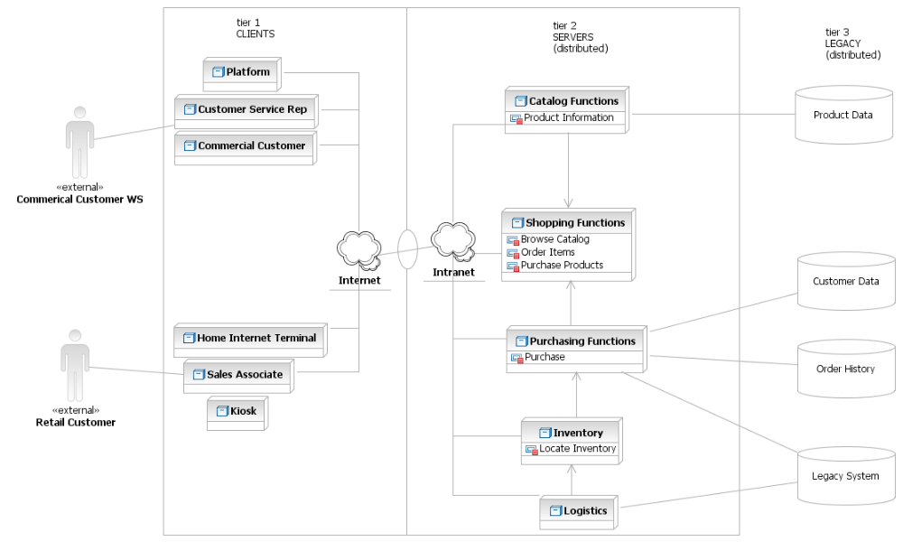
Figure 1
- Add Architecture Overview Package
First create a package and diagram. Then, add the actors, nodes, and data stores in any order, prior to adding associations.
- Click the right mouse button on the Design Contracts package in the Project Explorer.
- Select Add UML>Package from the context menu.
- Provide an appropriate name for the new package (e.g., “Architecture Overview”).
- Delete the Main diagram (created as the default for this package) by selecting it in the Project Explorer and pressing the Delete key.

- Add Deployment Diagram
- Click the right mouse button on the new package.
- Select Add Diagram>Deployment Diagram from the context menu.
- Provide an appropriate name for the diagram (e.g., “Architecture Overview”).
- Designate this diagram as the default for the package
  - Click the right mouse button on the diagram.
  - Select Make Default Diagram from the context menu.
- Add Actors
UML uses actors to represent external entities (e.g., people or systems) that interface with the target system. An image of a human figure represents actors in UML. Create associations to show the relationship between an actor and another UML element (e.g., deployment nodes or use cases).
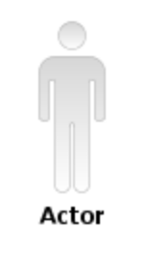
Figure 2
A consulting or analysis team using RSA or RSM may have the actors needed for an Architecture Overview. If so, drag the UML actor icon from the Project Explorer onto the deployment diagram.
To create new actors, use the drawing palette’s Use Case drawer (see Figure 3). To create an actor in a different package than the diagram, click the right mouse button on the desired package (in the Project Explorer) and select Add UML>Actor from the context menu.
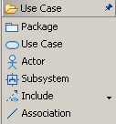
Figure 3
- Add Nodes
Add Nodes to Diagram
There are four ways to add nodes to a deployment diagram.
Option 1: Click the right mouse button on the drawing surface, and select Add UML>Node from the context menu.
Option 2: Hold the cursor motionless over the drawing surface to get a menu. Then, use the first tool on the left side of the action bar (menu) to add a new node. Note: This technique works on an empty deployment diagram. If you add an element from a different folder (e.g. Use Case) you will see the action bar for the last folder instead of the action bar for Deployment
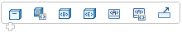
Figure 4
Option 3: Use the drawing palette’s Deployment drawer to add nodes to a diagram. Click on Node in the Deployment drawer, then click on the drawing surface of the diagram.
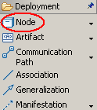
Figure 5
RSA draws a new node on the diagram. It names the node “NodeX” where X is an integer. Rename the node by typing over NodeX with the desired name.
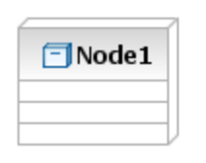
Figure 6
Option 4: Drag an existing node from the Project Explorer onto the deployment diagram. In this case, the node will already have a name. It may also have functions and attributes.
Add Functions to Nodes
After adding a node, add functions as attributes. See Figure 7 to see a node with functions depicted as attributes.
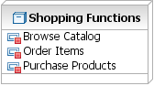
Figure 7
Option 1: Hold the cursor motionless over the node to get an action bar. Use the first tool on the left to add a new attribute. See Figure 8
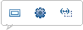
Figure 8
Option 2: Click the right mouse button on the node. Select Add UML>Attribute from the context menu.
Option 3: Add the attributes from the Attributes tab of the Properties view:
- Select the node.
- Click the Attributes tab of the Properties view.
- Push the Insert New Property button on the right. See Figure 9.
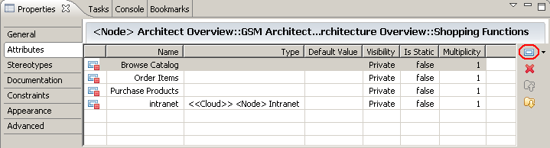
Figure 9

Add Data Nodes
Add data nodes in the data tier of the diagram (See section 3.7 for tier separations.).
Option: Add the keyword “data” by selecting the node. Enter “data” in the Keyword field of Stereotype tab in the Properties view. See Figure 10 and Figure 11.
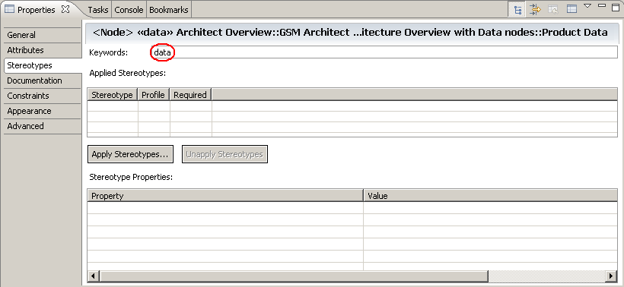
Figure 10
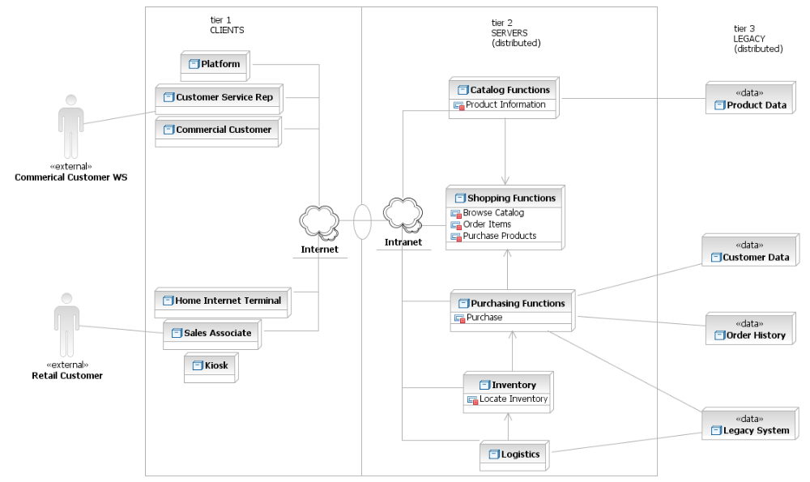
Figure 11
To make the diagram resemble the example in Figure 1, perform the following steps:
- Use a cylinder from the Geometric Shapes drawer (see Figure 12), instead of a data node.
- Change the line color to match the other nodes.
- Change the fill color to match the background.
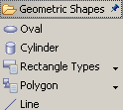
Figure 12
- Add Associations
There are two ways to add associations between nodes.
Option 1:
- Hold the cursor motionless over a node.
- Arrows will pop up adjacent to the node (see Figure 13).
- Drag an arrow to the desired node.
- Release the mouse button.
- From the resulting menu, select Create New Communication Path.
Figure 13
Option 2:
- Select a communication path (see Figure 14) from the Deployment folder.
- Draw the association between two nodes by clicking one node. Move the cursor to the next node, while holding down the mouse button.
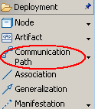
Figure 14
By default, the new association will show roles and multiplicity. Hide these elements by clicking the right mouse button on the association to see the context menu. Select Filters->Show/Hide Connector Labels>No Connector Labels from the context menu.
To associate nodes with a cloud that represents an intranet or internet, follow these steps:
- Hold the cursor motionless over the drawing surface.
- Select the second choice (Figure 16 Add Stereotyped Node) from the action bar.
- Select “Create <<cloud>> node” from the resulting menu.
- RSA will draw cloud node named “NodeX” (where X is an integer).
- Give the new node an appropriate name (e.g., “intranet” or “internet”).
- Hide the compartments by clicking the right mouse button on the cloud and select
Filters->Show/Hide Compartment->Name Compartment Only.
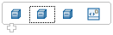
Figure 15
Figure 16 shows the node before and after renaming and filtering compartments.
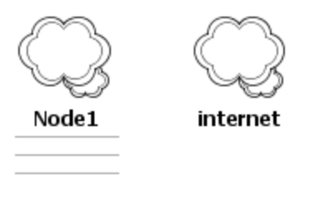
Figure 16
To draw associations between two non-deployment node elements (i.e., actors and cylinders), use Line from the drawing palette’s Geometric Shapes drawer (see Figure 17).
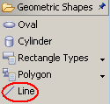
Figure 17
- Add Tier or Location Separations
To separate tiers or locations, use the Rectangle from the drawing palette’s Geometric Shapes drawer.
- Click on the Rectangle Types in the palette’s Geometric Shapes drawer (see Figure 18).
- Click on the drawing surface.
- While holding the mouse key down, drag the shape from one corner of the rectangle to the opposite corner.
- Resize the rectangle - select the rectangle, and drag the handles that appear as small black dots along the edges and corners of the rectangle (see Figure 19).

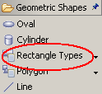
Figure 18

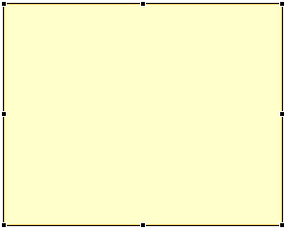
Figure 19
After adjusting the shape and size, send the rectangle to the background so that all actors, nodes, cylinders, text, and associations become visible. To send the rectangle to the back, click the right on the rectangle, and select Format>Order>Send to Back from the context menu.
Alternative: Change the fill color of the rectangle to the same color as the background - Click the right mouse button on the rectangle, and select Format>Fill Color>White from the context menu (see Figure 20).
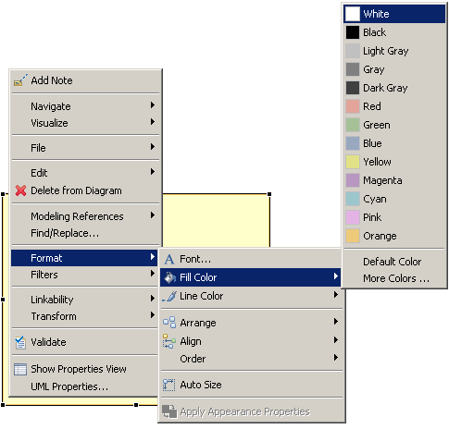
Figure 20
To show access between two rectangles, use an Oval from the Geometric Shapes drawer as shown in Figure 21.
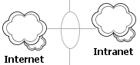
Figure 21

Version Information

Revision Number | Revision Date | Summary of Changes | Author
0.1 | 31/05/07 | Content created based on GSM technique paper Developing Architecture Overview Diagrams with RSA.
0.2 | 10/07/07 | Changed name back to Architecture Overview.
0.3 | 20/07/07 | Updated for RSA V7 and changed examples from HBA to LiUS

