Client Imperative Example
Multichannel Banking

Table of Contents
1. Introduction 4
1.1 Purpose 4
1.2 Scope 4
1.3 Intended Audience 4
1.4 Overview 4
2. Client Imperative 4
2.1 Imperative Definition 4
2.2 Motivation 4
2.3 Solution Strategy 6
2.4 Inhibitors 10
2.5 Business Outcomes and Benefits 10

Introduction

Purpose
This client imperative serves as an example for the Client Imperative (ART 0696) artifact.

Scope
This client imperative is a comprehensive imperative associated with banking multi-channel delivery strategy. The imperative is written to illustrate the concept at an industry level and may be more complex than a typical client imperative in an actual engagement.

Intended Audience
This document is intended for the use by the Technical Solution Architect and the client team supporting a Team Solution Design engagement.

Overview
This example describes an example client imperative as expressed by a client sponsor. The structure of the Client Imperative includes the following elements:
- Imperative Definition
- Motivation
- Inhibitors
- Solution Strategy
- Business Outcomes and Benefits

Client Imperative

Imperative Definition
Enable the Bank’s Multichannel Delivery Strategy with an Optimal Architecture and Technology Platform

Since the emergence of multiple channels in the retail banking delivery environment over the past 15 years, the bank has been challenged to fully rationalize, integrate and optimize its channel delivery infrastructure and application portfolio. Currently, the bank is still running on 10 to 13 year old branch environments with unsupported components, silo'ed business capabilities, manual paper-based processes, and a lack of alignment with the current business strategy. Customers often experience inconsistent interactions across channels thus leading to poor customer satisfaction. The challenge is to come up with a consistent integrating architecture and associated set of enabling technologies that can meet the present and future needs of the bank in a cost effective manageable way.

Motivation
Currently, the bank is pursuing the following strategic initiatives:

- Differentiate the Customer Experience
  - Range of needs and problems to solve
  - Resource to inform, educate
  - Packaging of products / services enhance loyalty
  - Streamlined fulfillment
  - Improved service experience
- Provide Multiple Distribution Models and Channels
  - Range of branch models – full service, expanded
self service, customer segment specific
  - Integrated Contact Centers - Telephony, email,
web collaboration
  - Self Service - Web, ATM, Kiosk

Given these aggressive business initiatives the LOB and channel delivery business stakeholders at the bank feel very constrained by the application functions, usability and technology capabilities provided by their IT counterparts in support of their businesses. Specific examples include the following.

Silo’ed Applications Inhibit Consistent Customer Experience Across Channels
From a Line of Business (LOB) perspective, the different channels such as internet banking, branch and the customer service center (contact center) often have difficulty sharing common views of the customer information or past contact history. For example, the information or functions that may be available directly to the customer via the Internet banking channel may not be available to the Platform Officer in the branch or Customer Service Representative in the Contact Center. Therefore, when the customer tries to follow up on a problem or question encountered on one channel, the ability to follow up on another delivery channel is either impeded or not available. This results in low customer satisfaction and could impact customer retention over the long run.

Lack of Ability to Respond to New Business Opportunities
In order to capitalize on new business opportunities, new incremental capabilities often have to be delivered by IT and they usually involve integrating one or more existing services in new ways and delivering them consistently over multiple delivery channels. In the bank’s older silo’ed legacy environment, it is often very difficult to integrate capabilities. Some of the problem stems from older applications that are not well supported or are no longer supported at all. This can greatly limit integration choices and any attempt to change such applications can often introduce operational instability and risk.

Unmanaged and Inconsistent User Platforms Limit Productivity and Impact Training Costs
When viewed by role (such as Teller, Platform Officer, Branch Manager, CSR, etc…), the typical end user is often faced with a variety of applications and user interfaces. This diversity can adversely affect productivity and also increase the cost of training.

The bank has a high turn over rates in its branches and Contact Centers and the ability to quickly on-board and train new personnel is critical to channel operations. Also, the lack of the ability to do effective online training can also lead to significant offsite travel and other operational impacts. This older environment lacks integrated and effective online training capabilities and the latest content can often not be delivered in a timely manner over the existing network. An example would be the ability to deliver a new Platform Officer training module in support of a new sales campaign in the branch.

The lack of a consistent user platform across delivery channels also affects security and regulatory compliance exposures since the underlying applications are not able to leverage a common security infrastructure such as role based login and single sign-on capability.

IT Pain Points
Because the bank has not upgraded its channel environment, they are experiencing the following pain points.
- Difficulty in aligning their IT capabilities with the business strategy
- Difficulty in responding quickly to new business opportunities and staying aligned with the bank's strategy or latest initiatives
- Multiple programming models across channels, difficult to maintain in terms of staffing, selection of common tools, lack of standards
- Difficult to change and / or integrate channel applications
- Technical development and support resources are spread too thin with too many technologies to cover
- Old platforms and applications – either very limited support or out of support (OS2, etc.)
- Inability to add new peripherals to workstations due to lack of drivers for older operating systems
- Sometimes hard to beat old platform costs compared with the major investments to move to new technologies

Solution Strategy
The following are the key elements of the solution strategy:

- Implement IT Governance and planning initiatives to provide guidance and an orderly transition to the target state.
- Minimize duplication and overextension in the bank's channel application portfolio and ensure that it aligns with the bank's overall Retail Delivery Strategy and related LOBs.
- Develop a common role based User Platform that optimizes the user experience across the primary bank delivery channels.
- Integrate the channel applications and core (back end) systems via a common optimized facility that provides access to centralized mediation, adaptation, process, rules, and event handling capabilities.
- Implement a robust, centrally managed, infrastructure and hosting environment that can support the target User Platform and associated applications across all channels
- Move toward a converged IP network that can serve all of the channel voice and data needs in a consistent and reliable way.
- Implement a model driven development environment that will support the full development lifecycle for the target programming model from requirements definition through deployment.

Key Elements of the Transformation Framework
The diagram in Figure 1 illustrates the basic elements of the Framework that was used to provide context and scope this solution strategy. In the diagram, the Business, Application, and Infrastructure Domains provide a foundation for the structure. Overlaying this base, are the two cross domain categories of “Governance and Planning” and “Realization and Operation”. In the middle of the framework are the three primary operational resources needed to enable any business strategy: people, process, and information. These resources intersect the three domains exposing specific operational aspects associated at each intersection.

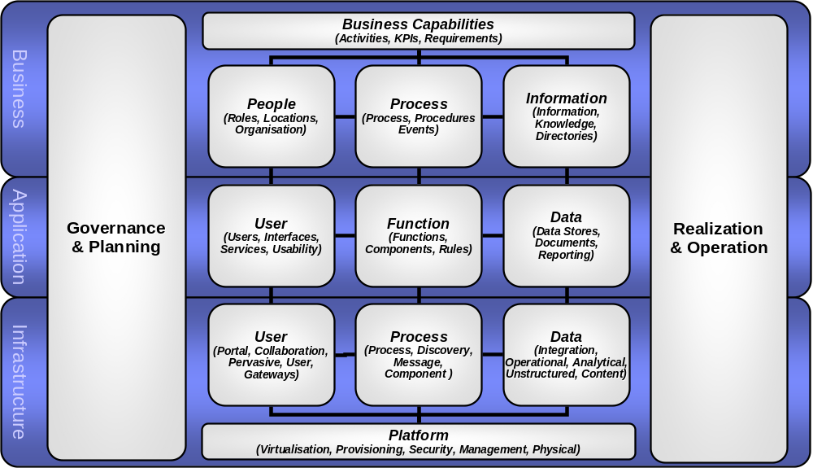
Figure 1 The IBM Transformation Framework

By using the framework in a “top down” fashion, we can develop a strategy that will start by addressing the Business Domain issues and use them to drive into related areas within the Application and Infrastructure (IT) Domains. This will insure that our strategy establishes a proper alignment between business issues and IT initiatives.

The Motivation and Inhibitor sections of this imperative reveal issues that affect all areas of the Framework: Governance and Planning, Business and Platform capabilities, Realization and Operations. The following topics elaborate on the solution strategy by separating concerns according to the context of various domains and sub domains of the transformation framework.

Governance and Planning

Establish a strong IT Governance Model that links both business and IT and addresses the need for developing and managing shared services across the Enterprise. As part of this effort, the development of an Enterprise Architecture and a consistent set of Architectural Principles are critical. The Enterprise Architecture and Architectural Principles will serve as a context and guide for developing the channel and application architecture and can also be used to inform any custom development or package acquisition decisions.

A critical part of Governance and Planning involves the development of an orderly Transition Plan from the current to the target state. The Transition Plan is a high level roadmap that takes into account the bank’s business direction, Governance structures, organizational capabilities, and IT environment in order to lay out a series of incremental initiatives that can be executed within the bank’s budget at minimal risk.

Business Domain

Ensure that the bank has updated their delivery channel strategy and developed a set of supporting business capabilities and an operation model to implement that strategy. The operating model should describe how the documented business and IT capabilities should be used by the various end user roles even down to the region or branch.

Application Domain

Lay a Common Model Based Foundation for the Application Domain
Adopt and implement a common, well structured set of Financial Services data, process and service interface models that can provide a basis for integrating the various channels, supporting applications and data stores. This type of initiative is critical for sharing services across the various LOBs and promoting a common understanding of the critical elements of the business. Developing a common repository of models and vocabulary can help promote better understanding between both business and IT.

Rationalize the Application Portfolio
Align and rationalize the channel related application portfolio with the channel business strategy to ensure that there is minimal redundancy, gaps, or overextensions and that the remaining applications are the best ones to provide the required business capabilities. This should help the integration and server consolidation efforts by reducing the number of applications, interfaces and adapters that need to be supported, thereby lowering overall support cost.

Specific Functional Enhancements
Provide online training capability to ensure that new channel delivery staff can be quickly on-boarded and that existing staff can grow their skills with a minimum of disruption and travel.

Provide an appropriate set of collaboration tools commensurate with the channel operating model and needs of the end user roles. Examples include email, secure instant messaging, eMeeting, video conferencing, and electronic signature capabilities.

Infrastructure Domain

User Platform - Software
Move to adopt a centrally configured and managed common user platform infrastructure based on portal technology that can support role based workspaces across all delivery channels and devices in a consistent way using the same programming model.

Compose new capabilities from smaller grained, loosely coupled components (at both the UI and service component layers). This would be in contrast to the older approach of building large, monolithic, tightly coupled applications that are difficult to differentiate by region or modify for new or rapidly changing requirements. The new open standard JSR 168 Portlet Specification should be leveraged as a standard to build these new user interface components since the new standard is well supported in both tooling and runtime environments by several vendors. This new specification allows for flexibility on where the portlet actually executes: on a remote portal server or locally (in a micro edition portlet container) on a client machine. This type of flexibility provides options in both bandwidth and responsiveness which is critical within a distributed channel environment.

Process and Integration
Implement a common channel service bus (ESB) with complementary services such as process choreography, rules processing, and application access. This bus should be able to handle service requests using different transfer protocols and qualities of service in accordance with the varying needs of the different service consumers across the channel environment.

The bus should provide the appropriate adapters in order to support connectivity to the required core systems. Simple and content based routing should also be provided by the bus. The bus should be able to fully support a common set of model based service definitions across the various applications and channels. Ensure that the delivery of these services to the consuming applications can be monitored and governed in accord with established SLAs and access policies

The bus should also support the Common Event Infrastructure (CEI) in order to handle both inbound and outbound channel events. It should also provide a rules-based correlation facility for correlating several diverse events to a higher level event or trigger. This is critical for achieving advanced problem determination capabilities in a complex message based environment. Support for real time events is also critical for new business applications that can quickly sense and respond to customer needs on a realtime basis.

Physical Platform – Client and Server Hardware
Once the channel application portfolio is rationalized, a consistent server consolidation strategy can be developed and implemented.

In addition to server consolidation, client workstation consolidation should also be considered for the fixed location branch and Contact Center workstations. This type of solution involves virtualizing and centralizing the individual client OS images to run on either “in branch” or centralized blade centers. The client workstations are reduced to thin clients connected to the servers via standard IP connections. This approach provides the following benefits:
- Full end user desktop experience
- Provides for centralized management,
- Dynamic allocation of resources and load balancing
- Transparent hardware/ software / OS upgrades
- Rapid deployment of users and applications
- High Availability and improved security
- Lower management cost

Physical Platform - Network
Optimize and integrate the channel delivery network to drive out redundancy and ensure that consistent and adequate bandwidth is available to all the different channels regardless of region. In addition to consolidating the delivery network, new technologies such as voice over IP (VOIP), digital media, digital security image capture, video conferencing, and virtualized application sessions delivered over the network should be considered to make use of this new capacity.

Infrastructure Management
Along with rationalizing and consolidating the User Platform infrastructure, a common approach to provisioning, monitoring, and management of the deployed hardware and software related to that platform must be defined and implemented. This is especially important across widely dispersed branch environments where IT skills are either limited or nonexistent.

Realization and Operation

Once the programming model and user platform architecture is decided, the bank can start to simplify and rationalize the development tools needed to support the environment.
Ensure that the development tools selected can support model driven and service oriented development and that any services developed can be maintained and deployed across the enterprise using a common service repository. This will help encourage service reuse across the channel applications.

Multichannel Platform CPU Utilization should be maximized during normal operating hours by using virtualization technologies. Also seek to maximize off-hour CPU utilization through GRID for Business Intelligence/Data Mining types of processing.

Inhibitors
Many of the problems come from the patchwork of silo’ed, legacy environments that have evolved over the years. To compound the problem, the IT organization has had limited IT Governance to define and enforce a common architectural vision and approach. Lack of a target integration architecture and a long term transition plan to implement it will hinder any progress from being made in their multichannel transformation process.

One of the areas where IT Governance has been lacking has been with regard to the channel applications and supporting infrastructure the bank has acquired. Therefore, the application portfolio for their channel delivery systems contains a diverse set of programming models which leads higher skills and staffing requirements along with higher tooling support costs.

Legacy and/or silo based systems that have proprietary interfaces and underlying data models can present a challenge to integration and rationalization. But, replacing these systems could expose the bank to major risk of disruption. Also, many of these systems have complex interdependencies that make their replacement especially difficult.

Along with the difficulties of managing legacy systems, geographically the bank’s distributed channel networks present their own set of challenges to consistent service delivery. For instance, providing adequate and reliable network bandwidth over a diverse set of regions can be especially difficult in some countries. Lack of network reliability in a particular region may impact the application architecture for the entire system - forcing additional costs and complexity.

There are currently multiple networks supporting the bank’s branch environment. These include a data network, a security system network, and one or more analog phone lines. Supporting multiple networks for hundreds of widely disbursed branches can be especially costly given the different skill sets and infrastructure needed to support them.

Business Outcomes and Benefits
The business outcomes and benefits and value proposition for adopting the solution strategy fall under three main categories:
- More Responsive, quicker time to market for new IT capability
  - Common infrastructure and programming model
  - Adoption of SOA as a cost effective way to develop and manage loosely coupled services for the channel environment
- Lower TCO for Channel Applications and Delivery Capability
  - Both acquisition and ongoing maintenance (which is often higher over the typical 10 year life of the investment)
  - Maintenance of optimum CPU utilization through off hours GRID computing activity performed by channel related processing nodes.
  - Tight linkage between business strategy and IT investment and capability - channel related systems are targeted with a minimum of waste and a high degree of utilization
- Lower Staff on boarding and ongoing training costs due to the following:
  - The availability of Online, in-branch training capability
  - Consistent role based user systems that are targeted, rational, and easy to learn and use
- Consistent treatment of customers across channels
  - From consistent set of services and information provided via the shared integration channel hub
- Increased Revenue from Delivery Channels
  - Optimized role based workspaces do a better job of supporting the sales process via better delivery of customer, product information and cross sell prompts
  - New sales campaigns can be supported more quickly through the centralized composition and deployment of portal based workspaces that could include both the online training modules and sales tools needed to execute the campaign

The following represent example KPIs that could be used to measure the effectiveness of implementing the solution strategy.

Responsiveness
- Key to Glass performance
- Measured in seconds
- Usually channel and application specific
- Many older 3270 based branch applications can provide sub-second (key to glass) response times. This KPI will vary based on the type of transaction being performed but on average the usual metric adopted for modern applications deployed in the branch is for 80% of the transactions to be performed under two seconds.
- Channel Processing Response Times
- Would include total key to glass response times minus host (or system of record) response time

Resilience – Business Continuity
- Recovery Time
- Maximum recovery time of a set number of concurrent user sessions after an application server failure (e.g. recover 1000 concurrent user sessions within twenty minutes of the failure).

Channel Related Business KPIs
- Sales Management
- Number of products sold per customer
- Number of new accounts opened
- Time required to open new account
- Average life time value of customers
- Channel specific sales costs
- Revenue dollar generated per sales dollar spent
- Service Management (especially in a Contact Center environment)
- Handle time is critical within Contact Centers and is usually counted in seconds
- Percentage of calls ending in a fully resolved disposition
- Account Management
- Lifetime value of customer
- Customer satisfaction metrics
- Financial losses due to account management errors

Availability
- Teller application availability
- Sales and Servicing availability
- Security subsystem (directory, authentication, authorization) availability

End of document–Client Challenge Example

