ART 0522 - Operational Model

Generated from Rational System Architect
Encyclopaedia: Amgro from Home v1.12 as of June 14 (IBM-CC2247ACF5D\RSA)
Author: tls - TomSeevers
Owner: IBM

Document History
Document Location
Generated Document from Rational System Architect
This information contained in this document is from a Team Solution Design model contained within Rational System Architect as encyclopedia Amgro from Home v1.12 as of June 14 (IBM-CC2247ACF5D\RSA).
As such, the validity and currency of this information must be verified with the author.
Revision History
Date of this revision: 11/08/2026 at 4:14 PM | Date of next revision (date)

Revision Number | Revision Date | Summary of Changes | Changes marked
(0) | (09/07/2010 15:51:00) | Creation - Generated from Rational System Architect | (N)
Approvals
This document requires following approvals. Signed approval forms are filed in the Quality section of the PCB.
Name | Title
(name) | (title)
Distribution
This document has been distributed to
Name | Title
(name) | (title)
Contents
1. Introduction 6
1.1 Identification 6
1.2 References 6
2. Logical Operational Model 7
2.1 Diagrams 7
2.1.1 Location Model 7
2.1.2 Node Model 8
2.1.3 Operational Model 9
2.2 Location Details 12
2.2.1 L_3rd Parties 12
2.2.2 L_AmGro House 13
2.2.3 L_Anywhere (off-line) 14
2.2.4 L_Anywhere (on-line) 15
2.2.5 L_Call Centre 16
2.2.6 L_Central Home Shopping Services 17
2.2.7 L_Corporate Services 19
2.2.8 L_Credit Agency 20
2.2.9 L_Depots 20
2.2.10 L_Internet_Services 21
2.2.11 L_Store 22
2.2.12 L_Telephone Customer 23
2.2.13 L_Warehouse 24
2.3 Node Details 25
2.3.1 N_3rd Party i/f Services 25
2.3.2 N_Call Center Services 26
2.3.3 N_Corp i/f Services 27
2.3.4 N_Credit i/f Services 28
2.3.5 N_CSR Services 29
2.3.6 N_Fulfillment Services 30
2.3.7 N_Home Shopping Services 31
2.3.8 N_HS Data Services 34
2.3.9 N_Internet Services 35
2.3.10 N_Internet Services 36
2.3.11 N_Off-line Cust Services 37
2.3.12 N_Off-line Cust Services 37
2.3.13 N_OMS Admin Services 38
2.3.14 N_On-line Presentation Services 39
2.3.15 N_On-line Presentation Services 40
2.3.16 N_Security Services 41
2.3.17 N_Warehouse i/f Services 41
2.3.18 N_Warehouse i/f Services 42
2.4 Logical DU Details 43
2.4.1 Presentation DU 43
2.4.2 Data DU 60
2.4.3 Execution DU 87
2.4.4 Installation DU 107
3. Physical Operational Model 108
3.1 Diagrams 108
3.1.1 Location Model 108
3.1.2 Node Model 109
3.1.3 Operational Model 110
3.2 Location Details 112
3.2.1 PL_AmGro Internet Services (DMZ) 112
3.2.2 PL_AmGro IS Department 113
3.2.3 PL_AmGro Warehouse 115
3.2.4 PL_Anywhere with a PC 115
3.2.5 PL_Anywhere with a PDA 116
3.2.6 PL_Calls-R-Us Call Centre 117
3.2.7 PL_MultiMedia Entertainment Services' Dispatch Centre 118
3.2.8 PL_PDQ Services 119
3.3 Node Details 120
3.3.1 PLN_ AmGro HSS Internet Server 120
3.3.2 PLN_AmGro HSS Printer 121
3.3.3 PLN_AmGro Lotus Notes RS/6000 122
3.3.4 PLN_AmGro Secure Server 123
3.3.5 PLN_AmGro Web Server 124
3.3.6 PLN_Catalogue Design Apple Mac Network 126
3.3.7 PLN_Corporate Interface Services 126
3.3.8 PLN_Credit Agency Gateway RS/6000 128
3.3.9 PLN_CSR Workstation 129
3.3.10 PLN_CSS Application Server 130
3.3.11 PLN_Dummy for corp services PAMs 131
3.3.12 PLN_Head Office AS/400 132
3.3.13 PLN_HSS Admin Workstation 133
3.3.14 PLN_HSS Backend Server 134
3.3.15 PLN_HSS Warehouse Services 135
3.3.16 PLN_MES interface PC 136
3.3.17 PLN_Shopping on a PC 137
3.3.18 PLN_Shopping on PDA 138
3.3.19 PLN_Warehouse RS/6000 139
3.4 Physical DU Details 140
3.4.1 Presentation DU 140
3.4.2 Data DU 140
3.4.3 Execution DU 140
3.4.4 Installation DU 141

Introduction

Identification
These Operational Diagrams are for Target System "AmGro-from-Home Order Management System" being developed as part of project AmGro-from-Home Order Management Project

References
This document is a report on the model contained in Rational System Architect encyclopdedia Amgro from Home v1.12 as of June 14 (IBM-CC2247ACF5D\RSA), Author tls – TomSeevers

Logical Operational Model

Diagrams

Location Model

AmGro-from-Home
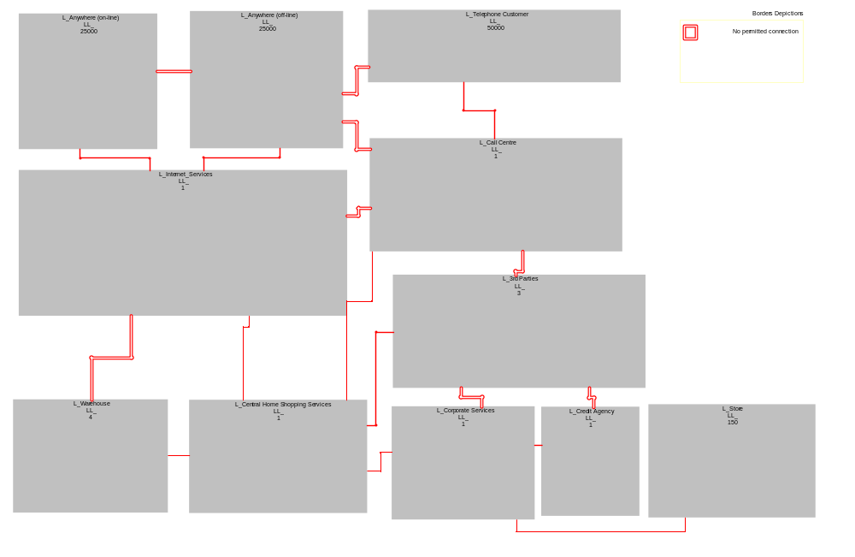
Figure 1 AmGro-from-Home
Description
No Description

Node Model

AmGro-from-Home
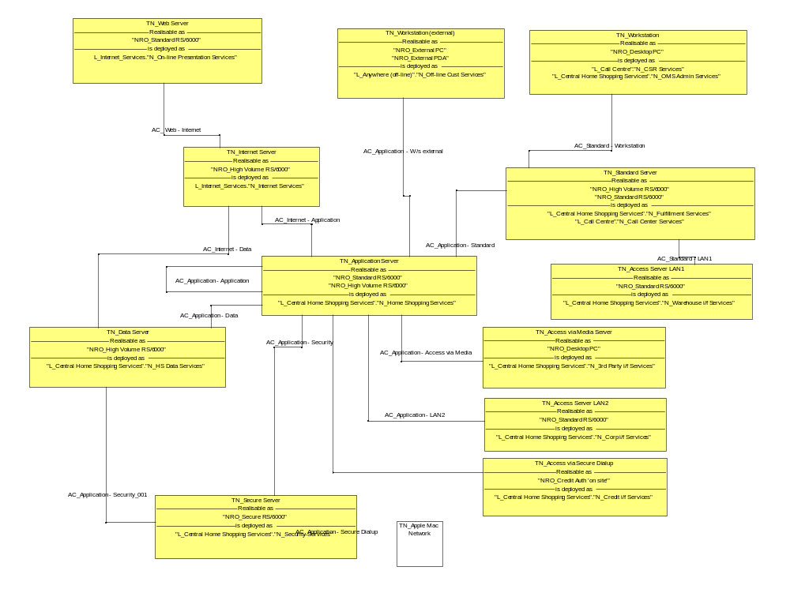
Figure 2 AmGro-from-Home
Description
No Description

Operational Model

AmGro-from-Home - Call Centre, HSS & Warehouse
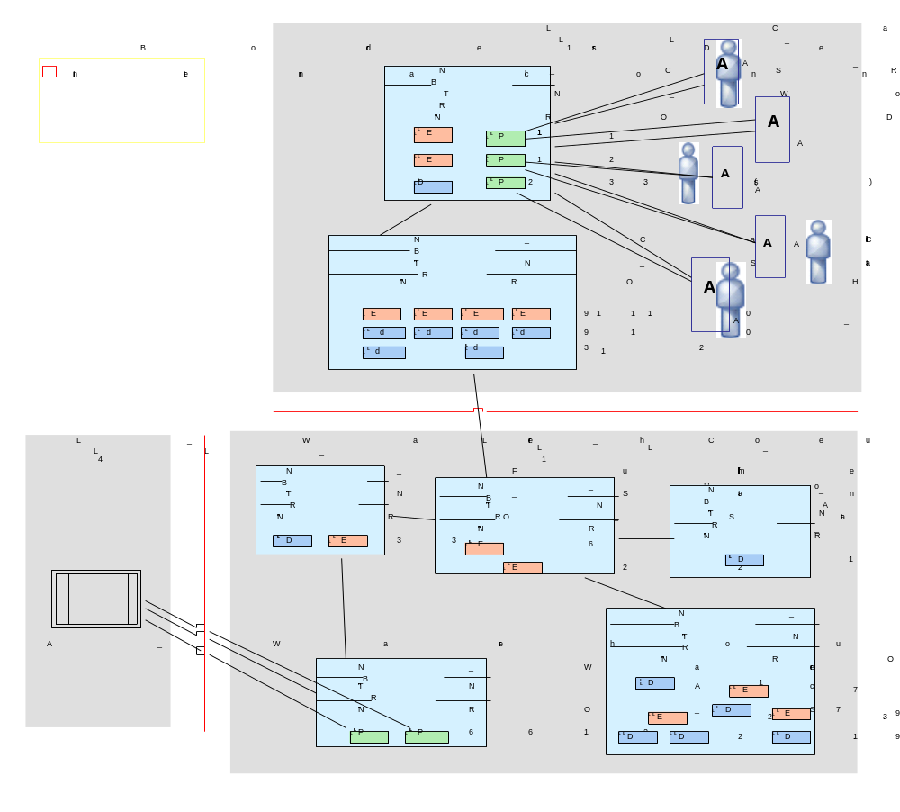
Figure 3 AmGro-from-Home - Call Centre, HSS & Warehouse
Description
No Description

AmGro-from-Home - Customer Locations and Internet Services
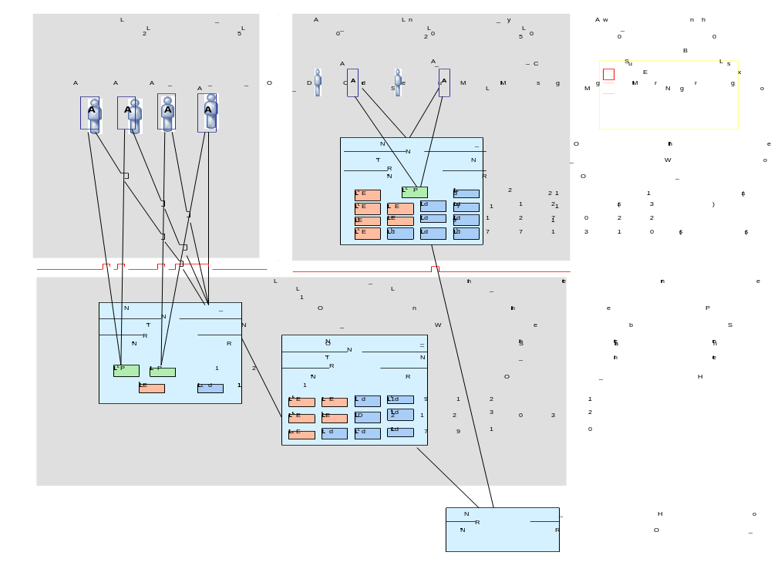
Figure 4 AmGro-from-Home - Customer Locations and Internet Services
Description
No Description

AmGro-from-Home - HSS, Corp Svcs & external locations
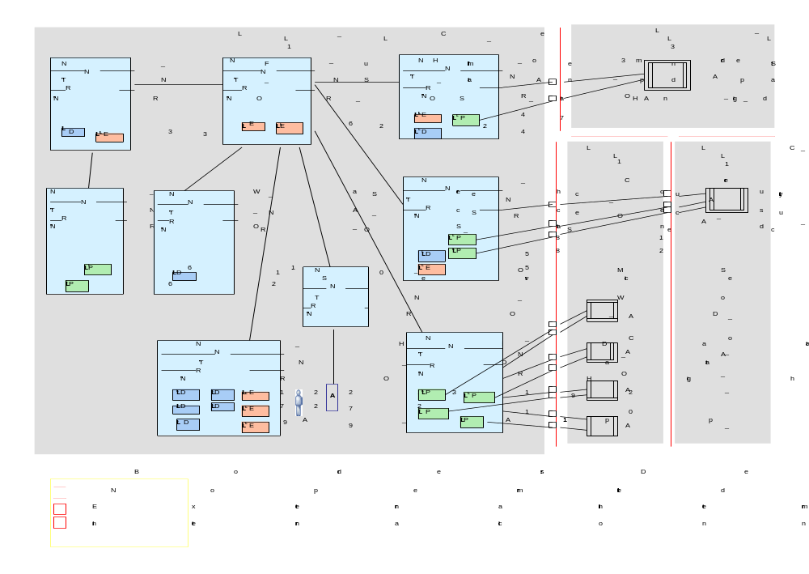
Figure 5 AmGro-from-Home - HSS, Corp Svcs & external locations
Description
No Description

AmGro-from-Home - Summary: CAUTION BIG DIAGRAM
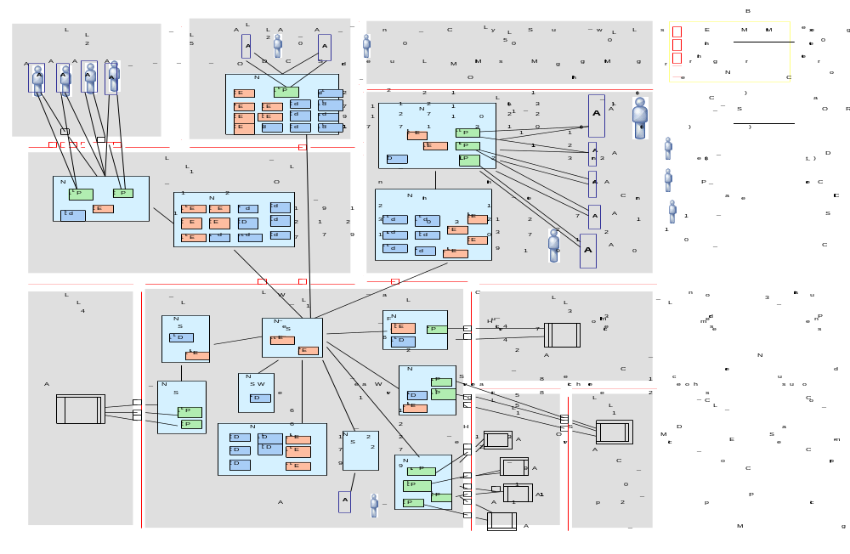
Figure 6 AmGro-from-Home - Summary: CAUTION BIG DIAGRAM
Description
No Description

Location Details

L_3rd Parties
Description
No Description

General Properties
Name | L_3rd Parties
Identifier | -
In Scope | T
Cardinality | 3
System Management Capability | Full
Zone Security | Un-Trusted
Logical Access Mechanisms | Physical Media

Location Borders
Border Name | Short Name | Type | Location 1 | Location 2
LB_HSS to 3rd Parties | LB_ | External intermitten | L_Central Home Shopping Services | L_3rd Parties
No border 3 | LB_ | No permitted connect | L_Call Centre | L_3rd Parties
No border 4 | LB_ | No permitted connect | L_3rd Parties | L_Corporate Services
No border 5 | LB_ | No permitted connect | L_3rd Parties | L_Credit Agency

Non Functional Requirements
Must | -
Should | -
Could | -
Would | -

L_AmGro House
Description
No Description

General Properties
Name | L_AmGro House
Identifier | -
In Scope | F
Cardinality | -
System Management Capability | Full
Zone Security | Trusted
Logical Access Mechanisms | -

Location Borders
No Border Details Defined for L_AmGro House

Non Functional Requirements
Must | -
Should | -
Could | -
Would | -

L_Anywhere (off-line)
Description
Anywhere a customer can access AmGro-from-Home using downloaded and therefore local facilities on their PC or equivelent

General Properties
Name | L_Anywhere (off-line)
Identifier | -
In Scope | T
Cardinality | 25000
System Management Capability | Limited
Zone Security | Un-Trusted
Logical Access Mechanisms | Off-Line Remote

Location Borders
Border Name | Short Name | Type | Location 1 | Location 2
<No name>_001 | LB_ | No permitted connect | - | L_Anywhere (off-line)
<No name>_003 | LB_ | No permitted connect | L_Anywhere (on-line) | L_Anywhere (off-line)
LB_Off-Line to Internet Services | LB_ | External intermitten | L_Anywhere (off-line) | L_Internet_Services
No Border 7 | LB_ | No permitted connect | L_Anywhere (off-line) | L_Call Centre
No border 1 | LB_ | No permitted connect | L_Anywhere (off-line) | L_Telephone Customer

Non Functional Requirements
Must | -
Should | -
Could | -
Would | -

L_Anywhere (on-line)
Description
Anywhere the customer is able to access the AmGro-from-Home service directly but remotely from a web browser (PC or mobile), using on-line facilities

General Properties
Name | L_Anywhere (on-line)
Identifier | -
In Scope | F
Cardinality | 25000
System Management Capability | Full
Zone Security | Un-Trusted
Logical Access Mechanisms | On-Line Remote

Location Borders
Border Name | Short Name | Type | Location 1 | Location 2
<No name>_003 | LB_ | No permitted connect | L_Anywhere (on-line) | L_Anywhere (off-line)
LB_On-Line to Internet Services | LB_ | External intermitten | L_Anywhere (on-line) | L_Internet_Services
No border 8 | LB_ | No permitted connect | L_Anywhere (on-line) | -

Non Functional Requirements
Must | -
Should | -
Could | -
Would | -

L_Call Centre
Description
This will be managed and run by a specialized organization, from a single site elsewhere in the country. All staff will be supplied by the 3rd party, although all IT infrastructure and applications will be supplied by AmGro (i.e. IBM!).

General Properties
Name | L_Call Centre
Identifier | -
In Scope | F
Cardinality | 1
System Management Capability | Full
Zone Security | Trusted
Logical Access Mechanisms | On-Line Local

Location Borders
Border Name | Short Name | Type | Location 1 | Location 2
LB_HSS to Call Centre | LB_ | Internal connection, | L_Call Centre | L_Central Home Shopping Services
LB_Telephone Cust to Call Centre | LB_ | External intermitten | L_Telephone Customer | L_Call Centre
No Border 7 | LB_ | No permitted connect | L_Anywhere (off-line) | L_Call Centre
No border 2 | LB_ | No permitted connect | L_Internet_Services | L_Call Centre
No border 3 | LB_ | No permitted connect | L_Call Centre | L_3rd Parties

Non Functional Requirements
Must | -
Should | -
Could | -
Would | -

L_Central Home Shopping Services
Description
It is not yet clear how these will be hosted, or how they will connect to the other bits of the system - particularly how it will link to the internet/WWW channels (maybe via an IBM managed service?!).

The home shopping service will be available 24 hours a day, almost every day of the year, while our existing corporate systems operate on a standard 07:00-20:00 day during the week, with a limited service at weekends. So in order to ease operational requirements, it is possible the AmGro-from-Home central systems will be located elsewhere. It'll probably be on campus, although discussions are underway with IBM to provide a hosted service.

General Properties
Name | L_Central Home Shopping Services
Identifier | -
In Scope | T
Cardinality | 1
System Management Capability | Full
Zone Security | DMZ
Logical Access Mechanisms | LAM_On-Line in IS Dept

Location Borders
Border Name | Short Name | Type | Location 1 | Location 2
LB_HSS to 3rd Parties | LB_ | External intermitten | L_Central Home Shopping Services | L_3rd Parties
LB_HSS to Call Centre | LB_ | Internal connection, | L_Call Centre | L_Central Home Shopping Services
LB_HSS to Corp Services | LB_ | Internal connection, | L_Central Home Shopping Services | L_Corporate Services
LB_HSS to Internet Services | LB_ | Internal connection, | L_Central Home Shopping Services | L_Internet_Services
LB_HSS to W/house | LB_ | Internal connection, | L_Warehouse | L_Central Home Shopping Services

Non Functional Requirements
Must | -
Should | -
Could | -
Would | -

L_Corporate Services
Description
This is situated in a large northern town, on a single campus with modern IT and network facilities. The Data Center is on campus, serving all head office users directly

General Properties
Name | L_Corporate Services
Identifier | -
In Scope | T
Cardinality | 1
System Management Capability | Full
Zone Security | Trusted
Logical Access Mechanisms | Local Area Network (for backend systems)

Location Borders
Border Name | Short Name | Type | Location 1 | Location 2
LB_Corp Services to Credit Agency | LB_ | External intermitten | L_Corporate Services | L_Credit Agency
LB_Corp Services to Store | LB_ | Internal connection, | L_Corporate Services | L_Store
LB_HSS to Corp Services | LB_ | Internal connection, | L_Central Home Shopping Services | L_Corporate Services
No border 4 | LB_ | No permitted connect | L_3rd Parties | L_Corporate Services

Non Functional Requirements
Must | -
Should | -
Could | -
Would | -

L_Credit Agency
Description
the Credit Agencie's own "space" within the data centre

General Properties
Name | L_Credit Agency
Identifier | -
In Scope | F
Cardinality | 1
System Management Capability | Full
Zone Security | Un-Trusted
Logical Access Mechanisms | Secure Dial Up

Location Borders
Border Name | Short Name | Type | Location 1 | Location 2
LB_Corp Services to Credit Agency | LB_ | External intermitten | L_Corporate Services | L_Credit Agency
No border 5 | LB_ | No permitted connect | L_3rd Parties | L_Credit Agency

Non Functional Requirements
Must | -
Should | -
Could | -
Would | -

L_Depots
Description
No Description

General Properties
Name | L_Depots
Identifier | -
In Scope | F
Cardinality | 5
System Management Capability | Full
Zone Security | Trusted
Logical Access Mechanisms | -

Location Borders
No Border Details Defined for L_Depots

Non Functional Requirements
Must | -
Should | -
Could | -
Would | -

L_Internet_Services
Description
No Description

General Properties
Name | L_Internet_Services
Identifier | -
In Scope | F
Cardinality | 1
System Management Capability | Full
Zone Security | Trusted
Logical Access Mechanisms | -

Location Borders
Border Name | Short Name | Type | Location 1 | Location 2
<No name>_002 | LB_ | External intermitten | - | L_Internet_Services
LB_HSS to Internet Services | LB_ | Internal connection, | L_Central Home Shopping Services | L_Internet_Services
LB_Off-Line to Internet Services | LB_ | External intermitten | L_Anywhere (off-line) | L_Internet_Services
LB_On-Line to Internet Services | LB_ | External intermitten | L_Anywhere (on-line) | L_Internet_Services
No Border 6 | LB_ | No permitted connect | L_Internet_Services | L_Warehouse
No border 2 | LB_ | No permitted connect | L_Internet_Services | L_Call Centre

Non Functional Requirements
Must | -
Should | -
Could | -
Would | -

L_Store
Description
(Not part of AmGro-from-Home)

During "opening hours" (typically 09:00 to 18:00, although some super-stores are open until 23:00 weeknights), all store based systems operate "stand alone", using local systems for stock management, personnel and other "back office" systems. The exception to this is credit authorization, which requires an on-line link to Head Office for connection to the credit-checking agency.

Under normal circumstances, each of the 150+ stores is polled from the data center daily, after in-store end of day processing is complete. This uploads consolidated sales data, any stock management information and downloads product information such as price or product line changes.

General Properties
Name | L_Store
Identifier | -
In Scope | F
Cardinality | 150
System Management Capability | Full
Zone Security | Trusted
Logical Access Mechanisms | -

Location Borders
Border Name | Short Name | Type | Location 1 | Location 2
LB_Corp Services to Store | LB_ | Internal connection, | L_Corporate Services | L_Store

Non Functional Requirements
Must | -
Should | -
Could | -
Would | -

L_Telephone Customer
Description
No Description

General Properties
Name | L_Telephone Customer
Identifier | -
In Scope | F
Cardinality | 50000
System Management Capability | Full
Zone Security | Un-Trusted
Logical Access Mechanisms | -

Location Borders
Border Name | Short Name | Type | Location 1 | Location 2
LB_Telephone Cust to Call Centre | LB_ | External intermitten | L_Telephone Customer | L_Call Centre
No border 1 | LB_ | No permitted connect | L_Anywhere (off-line) | L_Telephone Customer

Non Functional Requirements
Must | -
Should | -
Could | -
Would | -

L_Warehouse
Description
These will all be in new yet-to-be defined locations. These warehouses will operate 24 hours a day, 6 days a week, supporting a reduced service on Sunday and Bank Holidays. They will probably be stocked via the AmGro Depots, in the same way as AmGro's stores.

General Properties
Name | L_Warehouse
Identifier | -
In Scope | F
Cardinality | 4
System Management Capability | Full
Zone Security | Trusted
Logical Access Mechanisms | Local Area Network (for warehouse mgt system)

Location Borders
Border Name | Short Name | Type | Location 1 | Location 2
LB_HSS to W/house | LB_ | Internal connection, | L_Warehouse | L_Central Home Shopping Services
No Border 6 | LB_ | No permitted connect | L_Internet_Services | L_Warehouse

Non Functional Requirements
Must | -
Should | -
Could | -
Would | -

Node Details

N_3rd Party i/f Services
Description
No Description

General Properties
Short Name | LLN_
Is a technical Logical Located Node | T
Is instance of Logical Node | TN_Access via Media Server
In Logical Location | L_Central Home Shopping Services
Realised Using Option | NRO_Desktop PC
Supporting Logical Access Mechanism | Physical Media

Node Connections
Node Connection | From Item | To Item | Implements Logical Connections | Logical Located DU Connectors
C_HSS - 3rd Party | L_Central Home Shopping Services.N_Home Shopping Services | L_Central Home Shopping Services.N_3rd Party i/f Services | AC_Application - Access via Media | -

Non Functional Requirements
Must | -
Should | -
Could | -
Would | -

N_Call Center Services
Description
No Description

General Properties
Short Name | LLN_
Is a technical Logical Located Node | F
Is instance of Logical Node | TN_Standard Server
In Logical Location | L_Call Centre
Realised Using Option | NRO_High Volume RS/6000
Supporting Logical Access Mechanism | -

Node Connections
Node Connection | From Item | To Item | Implements Logical Connections | Logical Located DU Connectors
C_CSR_CSS | L_Call Centre.N_CSR Services | L_Call Centre.N_Call Center Services | AC_Standard - Workstation | -
C_CSS - HSS | L_Call Centre.N_Call Center Services | L_Central Home Shopping Services.N_Home Shopping Services | AC_Application - Standard | -

Non Functional Requirements
Must | -
Should | -
Could | -
Would | -

N_Corp i/f Services
Description
No Description

General Properties
Short Name | LLN_
Is a technical Logical Located Node | T
Is instance of Logical Node | TN_Access Server LAN2
In Logical Location | L_Central Home Shopping Services
Realised Using Option | NRO_Standard RS/6000
Supporting Logical Access Mechanism | Local Area Network (for backend systems)

Node Connections
Node Connection | From Item | To Item | Implements Logical Connections | Logical Located DU Connectors
C_HSS - orp i/f | L_Central Home Shopping Services.N_Home Shopping Services | L_Central Home Shopping Services.N_Corp i/f Services | AC_Application - LAN2 | -

Non Functional Requirements
Must | -
Should | -
Could | -
Would | -

N_Credit i/f Services
Description
No Description

General Properties
Short Name | LLN_
Is a technical Logical Located Node | T
Is instance of Logical Node | TN_Access via Secure Dialup
In Logical Location | L_Central Home Shopping Services
Realised Using Option | NRO_Credit Auth 'on site'
Supporting Logical Access Mechanism | Secure Dial Up

Node Connections
Node Connection | From Item | To Item | Implements Logical Connections | Logical Located DU Connectors
C_HSS - Credit | L_Central Home Shopping Services.N_Home Shopping Services | L_Central Home Shopping Services.N_Credit i/f Services | AC_Application - Secure Dialup | -

Non Functional Requirements
Must | -
Should | -
Could | -
Would | -

N_CSR Services
Description
No Description

General Properties
Short Name | LLN_
Is a technical Logical Located Node | F
Is instance of Logical Node | TN_Workstation
In Logical Location | L_Call Centre
Realised Using Option | NRO_Desktop PC
Supporting Logical Access Mechanism | On-Line Local

Node Connections
Node Connection | From Item | To Item | Implements Logical Connections | Logical Located DU Connectors
C_CSR_CSS | L_Call Centre.N_CSR Services | L_Call Centre.N_Call Center Services | AC_Standard - Workstation | -

Non Functional Requirements
Must | -
Should | -
Could | -
Would | -

N_Fulfillment Services
Description
No Description

General Properties
Short Name | LLN_
Is a technical Logical Located Node | F
Is instance of Logical Node | TN_Standard Server
In Logical Location | L_Central Home Shopping Services
Realised Using Option | NRO_Standard RS/6000
Supporting Logical Access Mechanism | -

Node Connections
Node Connection | From Item | To Item | Implements Logical Connections | Logical Located DU Connectors
C_Fulfill - HSS | L_Central Home Shopping Services.N_Fulfillment Services | L_Central Home Shopping Services.N_Home Shopping Services | AC_Application - Standard | -
C_Fulfill - Whouse i/f | L_Central Home Shopping Services.N_Fulfillment Services | L_Central Home Shopping Services.N_Warehouse i/f Services | AC_Standard - LAN1 | -

Non Functional Requirements
Must | -
Should | -
Could | -
Would | -

N_Home Shopping Services
Description
No Description

General Properties
Short Name | LLN_
Is a technical Logical Located Node | T
Is instance of Logical Node | TN_Application Server
In Logical Location | L_Central Home Shopping Services
Realised Using Option | NRO_High Volume RS/6000
Supporting Logical Access Mechanism | -

Node Connections
Node Connection | From Item | To Item | Implements Logical Connections | Logical Located DU Connectors
C_Admin - HSS | L_Central Home Shopping Services.N_Home Shopping Services | L_Central Home Shopping Services.N_OMS Admin Services | - | -
C_CSS - HSS | L_Call Centre.N_Call Center Services | L_Central Home Shopping Services.N_Home Shopping Services | AC_Application - Standard | -
C_Fulfill - HSS | L_Central Home Shopping Services.N_Fulfillment Services | L_Central Home Shopping Services.N_Home Shopping Services | AC_Application - Standard | -
C_HSS - 3rd Party | L_Central Home Shopping Services.N_Home Shopping Services | L_Central Home Shopping Services.N_3rd Party i/f Services | AC_Application - Access via Media | -
C_HSS - Credit | L_Central Home Shopping Services.N_Home Shopping Services | L_Central Home Shopping Services.N_Credit i/f Services | AC_Application - Secure Dialup | -
C_HSS - Data | L_Central Home Shopping Services.N_Home Shopping Services | L_Central Home Shopping Services.N_HS Data Services | AC_Application - Data | -
C_HSS - Security | L_Central Home Shopping Services.N_Home Shopping Services | L_Central Home Shopping Services.N_Security Services | AC_Application - Security | -
C_HSS - orp i/f | L_Central Home Shopping Services.N_Home Shopping Services | L_Central Home Shopping Services.N_Corp i/f Services | AC_Application - LAN2 | -
C_I'net - HSS | L_Internet_Services.N_Internet Services | L_Central Home Shopping Services.N_Home Shopping Services | AC_Internet - Application | -
C_off-line - HSS | L_Anywhere (off-line).N_Off-line Cust Services | L_Central Home Shopping Services.N_Home Shopping Services | AC_Application - W/s external | -

Non Functional Requirements
Must | Must include failover capability
Should | -
Could | -
Would | -

N_HS Data Services
Description
No Description

General Properties
Short Name | LLN_
Is a technical Logical Located Node | T
Is instance of Logical Node | TN_Data Server
In Logical Location | L_Central Home Shopping Services
Realised Using Option | NRO_High Volume RS/6000
Supporting Logical Access Mechanism | -

Node Connections
Node Connection | From Item | To Item | Implements Logical Connections | Logical Located DU Connectors
C_HSS - Data | L_Central Home Shopping Services.N_Home Shopping Services | L_Central Home Shopping Services.N_HS Data Services | AC_Application - Data | -

Non Functional Requirements
Must | -
Should | -
Could | -
Would | -

N_Internet Services
Description
No Description

General Properties
Short Name | LLN_
Is a technical Logical Located Node | T
Is instance of Logical Node | TN_Internet Server
In Logical Location | L_Internet_Services
Realised Using Option | NRO_High Volume RS/6000
Supporting Logical Access Mechanism | -

Node Connections
Node Connection | From Item | To Item | Implements Logical Connections | Logical Located DU Connectors
C_I'net - HSS | L_Internet_Services.N_Internet Services | L_Central Home Shopping Services.N_Home Shopping Services | AC_Internet - Application | -
C_On-line - I'net | L_Internet_Services.N_On-line Presentation Services | L_Internet_Services.N_Internet Services | AC_ Web - Internet | -

Non Functional Requirements
Must | -
Should | -
Could | -
Would | -

N_Internet Services
Description
No Description

General Properties
Short Name | LLN_
Is a technical Logical Located Node | T
Is instance of Logical Node | -
In Logical Location | L_Anywhere (on-line)
Realised Using Option | -
Supporting Logical Access Mechanism | -

Node Connections
No Connection Details Defined for N_Internet Services

Non Functional Requirements
Must | -
Should | -
Could | -
Would | -

N_Off-line Cust Services
Description
No Description

General Properties
Short Name | LLN_
Is a technical Logical Located Node | T
Is instance of Logical Node | TN_Workstation (external)
In Logical Location | L_Anywhere (off-line)
Realised Using Option | NRO_External PC
Supporting Logical Access Mechanism | Off-Line Remote

Node Connections
Node Connection | From Item | To Item | Implements Logical Connections | Logical Located DU Connectors
C_off-line - HSS | L_Anywhere (off-line).N_Off-line Cust Services | L_Central Home Shopping Services.N_Home Shopping Services | AC_Application - W/s external | -

Non Functional Requirements
Must | -
Should | -
Could | -
Would | -

N_Off-line Cust Services
Description
No Description

General Properties
Short Name | LLN_
Is a technical Logical Located Node | T
Is instance of Logical Node | -
In Logical Location | L_Anywhere (on-line)
Realised Using Option | -
Supporting Logical Access Mechanism | -

Node Connections
No Connection Details Defined for N_Off-line Cust Services

Non Functional Requirements
Must | -
Should | -
Could | -
Would | -

N_OMS Admin Services
Description
No Description

General Properties
Short Name | LLN_
Is a technical Logical Located Node | T
Is instance of Logical Node | TN_Workstation
In Logical Location | L_Central Home Shopping Services
Realised Using Option | NRO_Desktop PC
Supporting Logical Access Mechanism | LAM_On-Line in IS Dept

Node Connections
Node Connection | From Item | To Item | Implements Logical Connections | Logical Located DU Connectors
C_Admin - HSS | L_Central Home Shopping Services.N_Home Shopping Services | L_Central Home Shopping Services.N_OMS Admin Services | - | -

Non Functional Requirements
Must | -
Should | -
Could | -
Would | -

N_On-line Presentation Services
Description
No Description

General Properties
Short Name | LLN_
Is a technical Logical Located Node | T
Is instance of Logical Node | TN_Web Server
In Logical Location | L_Internet_Services
Realised Using Option | NRO_Standard RS/6000
Supporting Logical Access Mechanism | On-Line Remote

Node Connections
Node Connection | From Item | To Item | Implements Logical Connections | Logical Located DU Connectors
C_On-line - I'net | L_Internet_Services.N_On-line Presentation Services | L_Internet_Services.N_Internet Services | AC_ Web - Internet | -

Non Functional Requirements
Must | -
Should | -
Could | -
Would | -

N_On-line Presentation Services
Description
No Description

General Properties
Short Name | LLN_
Is a technical Logical Located Node | T
Is instance of Logical Node | -
In Logical Location | L_Anywhere (on-line)
Realised Using Option | -
Supporting Logical Access Mechanism | -

Node Connections
No Connection Details Defined for N_On-line Presentation Services

Non Functional Requirements
Must | -
Should | -
Could | -
Would | -

N_Security Services
Description
No Description

General Properties
Short Name | LLN_
Is a technical Logical Located Node | T
Is instance of Logical Node | TN_Secure Server
In Logical Location | L_Central Home Shopping Services
Realised Using Option | NRO_Secure RS/6000
Supporting Logical Access Mechanism | -

Node Connections
Node Connection | From Item | To Item | Implements Logical Connections | Logical Located DU Connectors
C_HSS - Security | L_Central Home Shopping Services.N_Home Shopping Services | L_Central Home Shopping Services.N_Security Services | AC_Application - Security | -

Non Functional Requirements
Must | -
Should | -
Could | -
Would | -

N_Warehouse i/f Services
Description
No Description

General Properties
Short Name | LLN_
Is a technical Logical Located Node | F
Is instance of Logical Node | TN_Access Server LAN1
In Logical Location | L_Central Home Shopping Services
Realised Using Option | NRO_Standard RS/6000
Supporting Logical Access Mechanism | Local Area Network (for warehouse mgt system)

Node Connections
Node Connection | From Item | To Item | Implements Logical Connections | Logical Located DU Connectors
C_Fulfill - Whouse i/f | L_Central Home Shopping Services.N_Fulfillment Services | L_Central Home Shopping Services.N_Warehouse i/f Services | AC_Standard - LAN1 | -

Non Functional Requirements
Must | -
Should | -
Could | -
Would | -

N_Warehouse i/f Services
Description
No Description

General Properties
Short Name | LLN_
Is a technical Logical Located Node | T
Is instance of Logical Node | -
In Logical Location | L_Warehouse
Realised Using Option | -
Supporting Logical Access Mechanism | -

Node Connections
No Connection Details Defined for N_Warehouse i/f Services

Non Functional Requirements
Must | -
Should | -
Could | -
Would | -

Logical DU Details

Presentation DU

P1_Order & Delivery Manager
Description
No Description

General Properties
PDU Short Name | P1
Is instance of Logical DU... | P1_Order & Delivery Manager
...in Logical Location... | L_Internet_Services
...where it is contained in Logical Located Node | N_On-line Presentation Services
...in Logical Location... | L_Internet_Services
Realised Using Option | -
Supports Actors | A_Order Manager  A_Delivery manager

DU Connectors
Name | From Item | To Item | Logical Connector | Logical Located Connection | Implemented on LAM
P1 - A_Dely on-line | L_Anywhere (on-line).A_DelMgr | L_Internet_Services.N_On-line Presentation Services.P1_Order & Delivery Manager | - | - | -
P1 - A_Order on-line | L_Anywhere (on-line).A_OrdMgr | L_Internet_Services.N_On-line Presentation Services.P1_Order & Delivery Manager | - | - | -

Non Functional Requirements
Must | -
Should | -
Could | -
Would | -

P1_Order & Delivery Manager
Description
No Description

General Properties
PDU Short Name | P1
Is instance of Logical DU... | P1_Order & Delivery Manager
...in Logical Location... | L_Call Centre
...where it is contained in Logical Located Node | N_CSR Services
...in Logical Location... | L_Call Centre
Realised Using Option | -
Supports Actors | A_Order Manager  A_Delivery manager

DU Connectors
Name | From Item | To Item | Logical Connector | Logical Located Connection | Implemented on LAM
P1 - A_Dely Call Centre | L_Call Centre.A_DelMgr | L_Call Centre.N_CSR Services.P1_Order & Delivery Manager | - | - | -
P1 - A_Order Call Centre | L_Call Centre.A_OrdMgr | L_Call Centre.N_CSR Services.P1_Order & Delivery Manager | - | - | -

Non Functional Requirements
Must | -
Should | -
Could | -
Would | -

P10_Catalogue Development
Description
No Description

General Properties
PDU Short Name | P10
Is instance of Logical DU... | P10_Catalogue Development
...in Logical Location... | L_Central Home Shopping Services
...where it is contained in Logical Located Node | N_Corp i/f Services
...in Logical Location... | L_Central Home Shopping Services
Realised Using Option | -
Supports Actors | A_Catalogue System

DU Connectors
Name | From Item | To Item | Logical Connector | Logical Located Connection | Implemented on LAM
P10 - A_CatSys | L_Central Home Shopping Services.N_Corp i/f Services.P10_Catalogue Development | L_Corporate Services.A_Catalogue System | - | - | -

Non Functional Requirements
Must | -
Should | -
Could | -
Would | -

P11_Product System
Description
No Description

General Properties
PDU Short Name | P11
Is instance of Logical DU... | P11_Product System
...in Logical Location... | L_Central Home Shopping Services
...where it is contained in Logical Located Node | N_Corp i/f Services
...in Logical Location... | L_Central Home Shopping Services
Realised Using Option | -
Supports Actors | A_Product System

DU Connectors
Name | From Item | To Item | Logical Connector | Logical Located Connection | Implemented on LAM
P11 - A_ProdSys | L_Central Home Shopping Services.N_Corp i/f Services.P11_Product System | L_Corporate Services.A_Product System | - | - | -

Non Functional Requirements
Must | -
Should | -
Could | -
Would | -

P12_Mgt Info System
Description
No Description

General Properties
PDU Short Name | P12
Is instance of Logical DU... | P12_Mgt Info System
...in Logical Location... | L_Central Home Shopping Services
...where it is contained in Logical Located Node | N_Corp i/f Services
...in Logical Location... | L_Central Home Shopping Services
Realised Using Option | -
Supports Actors | A_Mgt Info System

DU Connectors
Name | From Item | To Item | Logical Connector | Logical Located Connection | Implemented on LAM
P12 - A_Mgt Info System | L_Central Home Shopping Services.N_Corp i/f Services.P12_Mgt Info System | L_Corporate Services.A_Mgt Info System | - | - | -

Non Functional Requirements
Must | -
Should | -
Could | -
Would | -

P2_Customer & Shopping List Manager
Description
No Description

General Properties
PDU Short Name | P2
Is instance of Logical DU... | P2_Customer & Shopping List Manager
...in Logical Location... | L_Internet_Services
...where it is contained in Logical Located Node | N_On-line Presentation Services
...in Logical Location... | L_Internet_Services
Realised Using Option | -
Supports Actors | A_Shopping List Manager  A_Customer Manager

DU Connectors
Name | From Item | To Item | Logical Connector | Logical Located Connection | Implemented on LAM
P2 - A_Cust on-line | L_Anywhere (on-line).A_CustMgr | L_Internet_Services.N_On-line Presentation Services.P2_Customer & Shopping List Manager | - | - | -
P2 - A_SL on-line | L_Anywhere (on-line).A_SLMgr | L_Internet_Services.N_On-line Presentation Services.P2_Customer & Shopping List Manager | - | - | -

Non Functional Requirements
Must | -
Should | -
Could | -
Would | -

P2_Customer & Shopping List Manager
Description
No Description

General Properties
PDU Short Name | P2
Is instance of Logical DU... | P2_Customer & Shopping List Manager
...in Logical Location... | L_Call Centre
...where it is contained in Logical Located Node | N_CSR Services
...in Logical Location... | L_Call Centre
Realised Using Option | -
Supports Actors | A_Shopping List Manager  A_Customer Manager

DU Connectors
Name | From Item | To Item | Logical Connector | Logical Located Connection | Implemented on LAM
P2 - A_Cust Call Centre | L_Call Centre.A_CustMgr | L_Call Centre.N_CSR Services.P2_Customer & Shopping List Manager | - | - | -
P2 - A_SL Call Centre | L_Call Centre.A_SLMgr | L_Call Centre.N_CSR Services.P2_Customer & Shopping List Manager | - | - | -

Non Functional Requirements
Must | -
Should | -
Could | -
Would | -

P2_Customer & Shopping List Manager
Description
No Description

General Properties
PDU Short Name | P2
Is instance of Logical DU... | P2_Customer & Shopping List Manager
...in Logical Location... | L_Anywhere (off-line)
...where it is contained in Logical Located Node | N_Off-line Cust Services
...in Logical Location... | L_Anywhere (off-line)
Realised Using Option | -
Supports Actors | A_Shopping List Manager  A_Customer Manager

DU Connectors
Name | From Item | To Item | Logical Connector | Logical Located Connection | Implemented on LAM
P2 - A_Cust off-line | L_Anywhere (off-line).N_Off-line Cust Services.P2_Customer & Shopping List Manager | L_Anywhere (off-line).A_CustMgr | - | - | -
P2 - A_SL off-line | L_Anywhere (off-line).N_Off-line Cust Services.P2_Customer & Shopping List Manager | L_Anywhere (off-line).A_SLMgr | - | - | -

Non Functional Requirements
Must | -
Should | -
Could | -
Would | -

P3_Customer Complaints
Description
No Description

General Properties
PDU Short Name | P3
Is instance of Logical DU... | P3_Customer Complaints
...in Logical Location... | L_Call Centre
...where it is contained in Logical Located Node | N_CSR Services
...in Logical Location... | L_Call Centre
Realised Using Option | -
Supports Actors | A_Customer Complaints

DU Connectors
Name | From Item | To Item | Logical Connector | Logical Located Connection | Implemented on LAM
P3 - A_Complaints Call Centre | L_Call Centre.N_CSR Services.P3_Customer Complaints | L_Call Centre.A_Customer Complaints | - | - | -

Non Functional Requirements
Must | -
Should | -
Could | -
Would | -

P6.1_Food Fullfillment (order creation & update)
Description
No Description

General Properties
PDU Short Name | P6.1
Is instance of Logical DU... | P6.1_Food Fullfillment (order creation & update)
...in Logical Location... | L_Central Home Shopping Services
...where it is contained in Logical Located Node | N_Warehouse i/f Services
...in Logical Location... | L_Central Home Shopping Services
Realised Using Option | -
Supports Actors | A_Warehouse Mgt System

DU Connectors
Name | From Item | To Item | Logical Connector | Logical Located Connection | Implemented on LAM
P6.1 - A_WHouse | L_Central Home Shopping Services.N_Warehouse i/f Services.P6.1_Food Fullfillment (order creation & update) | L_Warehouse.A_Warehouse Mgt System | - | - | -

Non Functional Requirements
Must | -
Should | -
Could | -
Would | -

P6.2_Food Fullfillment (order status)
Description
No Description

General Properties
PDU Short Name | P6.2
Is instance of Logical DU... | P6.2_Food Fullfillment (order status)
...in Logical Location... | L_Central Home Shopping Services
...where it is contained in Logical Located Node | N_Warehouse i/f Services
...in Logical Location... | L_Central Home Shopping Services
Realised Using Option | -
Supports Actors | A_Warehouse Mgt System

DU Connectors
Name | From Item | To Item | Logical Connector | Logical Located Connection | Implemented on LAM
P6.2 - A_Whouse | L_Central Home Shopping Services.N_Warehouse i/f Services.P6.2_Food Fullfillment (order status) | L_Warehouse.A_Warehouse Mgt System | - | - | -

Non Functional Requirements
Must | -
Should | -
Could | -
Would | -

P7_Non-food Fulfillment
Description
No Description

General Properties
PDU Short Name | -
Is instance of Logical DU... | P7_Non-food Fulfillment
...in Logical Location... | L_Central Home Shopping Services
...where it is contained in Logical Located Node | L_Central Home Shopping Services.N_3rd Party i/f Services
...in Logical Location... | L_Central Home Shopping Services
Realised Using Option | -
Supports Actors | A_Non-food Fulfillment

DU Connectors
No DU Connectors Defined for P7_Non-food Fulfillment

Non Functional Requirements
Must | -
Should | -
Could | -
Would | -

P7_Non-food Fulfillment
Description
No Description

General Properties
PDU Short Name | P7
Is instance of Logical DU... | P7_Non-food Fulfillment
...in Logical Location... | L_Central Home Shopping Services
...where it is contained in Logical Located Node | N_3rd Party i/f Services
...in Logical Location... | L_Central Home Shopping Services
Realised Using Option | -
Supports Actors | -

DU Connectors
Name | From Item | To Item | Logical Connector | Logical Located Connection | Implemented on LAM
P7 - A_NonFood | L_Central Home Shopping Services.N_3rd Party i/f Services.P7_Non-food Fulfillment | L_3rd Parties.A_NFFulfillment | - | - | -

Non Functional Requirements
Must | -
Should | -
Could | -
Would | -

P8.1_Credit Agency (authorisation)
Description
No Description

General Properties
PDU Short Name | P8.1
Is instance of Logical DU... | P8.1_Credit Agency (authorisation)
...in Logical Location... | L_Central Home Shopping Services
...where it is contained in Logical Located Node | N_Credit i/f Services
...in Logical Location... | L_Central Home Shopping Services
Realised Using Option | -
Supports Actors | -

DU Connectors
Name | From Item | To Item | Logical Connector | Logical Located Connection | Implemented on LAM
P8.1 - A_Credit | L_Central Home Shopping Services.N_Credit i/f Services.P8.1_Credit Agency (authorisation) | L_Credit Agency.A_Credit Agency | - | - | -

Non Functional Requirements
Must | -
Should | -
Could | -
Would | -

P8.2_Credit Agency (hotcard list)
Description
No Description

General Properties
PDU Short Name | P8.2
Is instance of Logical DU... | -
...in Logical Location... | L_Central Home Shopping Services
...where it is contained in Logical Located Node | N_Credit i/f Services
...in Logical Location... | L_Central Home Shopping Services
Realised Using Option | -
Supports Actors | -

DU Connectors
Name | From Item | To Item | Logical Connector | Logical Located Connection | Implemented on LAM
P8.2 - A_Credit | L_Credit Agency.A_Credit Agency | L_Central Home Shopping Services.N_Credit i/f Services.P8.2_Credit Agency (hotcard list) | - | - | -

Non Functional Requirements
Must | -
Should | -
Could | -
Would | -

P9_E-mail Services
Description
No Description

General Properties
PDU Short Name | P9
Is instance of Logical DU... | P9_E-mail Services
...in Logical Location... | L_Central Home Shopping Services
...where it is contained in Logical Located Node | N_Corp i/f Services
...in Logical Location... | L_Central Home Shopping Services
Realised Using Option | -
Supports Actors | A_E-mail Services

DU Connectors
Name | From Item | To Item | Logical Connector | Logical Located Connection | Implemented on LAM
P9_E-mail Services - A_E-mail Services | L_Corporate Services.A_E-mail Services | L_Central Home Shopping Services.N_Corp i/f Services.P9_E-mail Services | - | - | -

Non Functional Requirements
Must | -
Should | -
Could | -
Would | -

Data DU

D1_Customer Order and SL Processing
Description
No Description

General Properties
DDU Short Name | D1
Is instance of Logical DU... | D1_Customer Order and SL Processing
...in Logical Location... | L_Central Home Shopping Services
...where it is contained in Logical Located Node | N_HS Data Services
...in Logical Location... | L_Central Home Shopping Services
Realised Using Option | -
Split (See description for explanation of split | Full Set
Data Items | User SL Mgr Profile  User Order Mgt Profile  User Customer Mgt Profile

DU Connectors
No DU Connectors Defined for D1_Customer Order and SL Processing

Non Functional Requirements
Must | -
Should | -
Could | -
Would | -

d1_Customer Order and SL Processing
Description
No Description

General Properties
DDU Short Name | d1
Is instance of Logical DU... | D1_Customer Order and SL Processing
...in Logical Location... | L_Internet_Services
...where it is contained in Logical Located Node | N_On-line Presentation Services
...in Logical Location... | L_Internet_Services
Realised Using Option | -
Split (See description for explanation of split | Full Set
Data Items | User SL Mgr Profile  User Order Mgt Profile  User Customer Mgt Profile

DU Connectors
No DU Connectors Defined for d1_Customer Order and SL Processing

Non Functional Requirements
Must | -
Should | -
Could | -
Would | -

d1_Customer Order and SL Processing
Description
No Description

General Properties
DDU Short Name | d1
Is instance of Logical DU... | D1_Customer Order and SL Processing
...in Logical Location... | L_Internet_Services
...where it is contained in Logical Located Node | N_Internet Services
...in Logical Location... | L_Internet_Services
Realised Using Option | Option 1
Split (See description for explanation of split | Full Set
Data Items | User SL Mgr Profile  User Order Mgt Profile  User Customer Mgt Profile

DU Connectors
No DU Connectors Defined for d1_Customer Order and SL Processing

Non Functional Requirements
Must | -
Should | -
Could | -
Would | -

D1_Customer Order and SL Processing
Description
this is data

General Properties
DDU Short Name | d1
Is instance of Logical DU... | D1_Customer Order and SL Processing
...in Logical Location... | L_Call Centre
...where it is contained in Logical Located Node | N_Call Center Services
...in Logical Location... | L_Call Centre
Realised Using Option | -
Split (See description for explanation of split | Full Set
Data Items | User SL Mgr Profile  User Order Mgt Profile  User Customer Mgt Profile

DU Connectors
No DU Connectors Defined for D1_Customer Order and SL Processing

Non Functional Requirements
Must | -
Should | -
Could | -
Would | -

d1_Customer Order and SL Processing (One Customer)
Description
One Customer only

General Properties
DDU Short Name | d1(s)
Is instance of Logical DU... | D1_Customer Order and SL Processing
...in Logical Location... | L_Anywhere (off-line)
...where it is contained in Logical Located Node | N_Off-line Cust Services
...in Logical Location... | L_Anywhere (off-line)
Realised Using Option | -
Split (See description for explanation of split | Vertical Split
Data Items | -

DU Connectors
No DU Connectors Defined for d1_Customer Order and SL Processing (One Customer)

Non Functional Requirements
Must | -
Should | -
Could | -
Would | -

D10_Security Manager
Description
No Description

General Properties
DDU Short Name | d10
Is instance of Logical DU... | D10_Security Manager
...in Logical Location... | L_Call Centre
...where it is contained in Logical Located Node | N_Call Center Services
...in Logical Location... | L_Call Centre
Realised Using Option | -
Split (See description for explanation of split | Full Set
Data Items | Authorisation Data  Authentication Data

DU Connectors
No DU Connectors Defined for D10_Security Manager

Non Functional Requirements
Must | -
Should | -
Could | -
Would | -

d10_Security Manager
Description
No Description

General Properties
DDU Short Name | d10
Is instance of Logical DU... | D10_Security Manager
...in Logical Location... | L_Internet_Services
...where it is contained in Logical Located Node | N_Internet Services
...in Logical Location... | L_Internet_Services
Realised Using Option | -
Split (See description for explanation of split | Full Set
Data Items | Authorisation Data  Authentication Data

DU Connectors
No DU Connectors Defined for d10_Security Manager

Non Functional Requirements
Must | -
Should | -
Could | -
Would | -

D10_Security Manager
Description
No Description

General Properties
DDU Short Name | D10
Is instance of Logical DU... | D10_Security Manager
...in Logical Location... | L_Central Home Shopping Services
...where it is contained in Logical Located Node | N_Security Services
...in Logical Location... | L_Central Home Shopping Services
Realised Using Option | -
Split (See description for explanation of split | Full Set
Data Items | Authorisation Data  Authentication Data

DU Connectors
No DU Connectors Defined for D10_Security Manager

Non Functional Requirements
Must | -
Should | -
Could | -
Would | -

d10_Security Manager (One Customer)
Description
One Customer only

General Properties
DDU Short Name | d10(s)
Is instance of Logical DU... | D10_Security Manager
...in Logical Location... | L_Anywhere (off-line)
...where it is contained in Logical Located Node | N_Off-line Cust Services
...in Logical Location... | L_Anywhere (off-line)
Realised Using Option | -
Split (See description for explanation of split | Horizontal Split
Data Items | Authorisation Data  Authentication Data

DU Connectors
No DU Connectors Defined for d10_Security Manager (One Customer)

Non Functional Requirements
Must | -
Should | -
Could | -
Would | -

d2.1_Order Manager (Submitted Orders)
Description
No Description

General Properties
DDU Short Name | d2.1
Is instance of Logical DU... | -
...in Logical Location... | L_Internet_Services
...where it is contained in Logical Located Node | N_Internet Services
...in Logical Location... | L_Internet_Services
Realised Using Option | -
Split (See description for explanation of split | Full Set
Data Items | -

DU Connectors
No DU Connectors Defined for d2.1_Order Manager (Submitted Orders)

Non Functional Requirements
Must | -
Should | -
Could | -
Would | -

D2.1_Order Manager (Submitted Orders)
Description
No Description

General Properties
DDU Short Name | D2.1
Is instance of Logical DU... | -
...in Logical Location... | L_Central Home Shopping Services
...where it is contained in Logical Located Node | N_HS Data Services
...in Logical Location... | L_Central Home Shopping Services
Realised Using Option | -
Split (See description for explanation of split | Full Set
Data Items | -

DU Connectors
No DU Connectors Defined for D2.1_Order Manager (Submitted Orders)

Non Functional Requirements
Must | -
Should | -
Could | -
Would | -

D2.1_Order Manager (Submitted Orders)
Description
No Description

General Properties
DDU Short Name | d2.1
Is instance of Logical DU... | D2.1_Order Manager (Submitted Orders)
...in Logical Location... | L_Call Centre
...where it is contained in Logical Located Node | N_Call Center Services
...in Logical Location... | L_Call Centre
Realised Using Option | -
Split (See description for explanation of split | Full Set
Data Items | Submitted Orders

DU Connectors
No DU Connectors Defined for D2.1_Order Manager (Submitted Orders)

Non Functional Requirements
Must | -
Should | -
Could | -
Would | -

d2.1_Order Manager (Submitted Orders) (One Customer)
Description
One Customer's orders only

General Properties
DDU Short Name | d2.1(s)
Is instance of Logical DU... | D2.1_Order Manager (Submitted Orders)
...in Logical Location... | L_Anywhere (off-line)
...where it is contained in Logical Located Node | N_Off-line Cust Services
...in Logical Location... | L_Anywhere (off-line)
Realised Using Option | -
Split (See description for explanation of split | Vertical Split
Data Items | -

DU Connectors
No DU Connectors Defined for d2.1_Order Manager (Submitted Orders) (One Customer)

Non Functional Requirements
Must | -
Should | -
Could | -
Would | -

D2.2_Order Manager (Order History)
Description
No Description

General Properties
DDU Short Name | D2.2
Is instance of Logical DU... | -
...in Logical Location... | L_Central Home Shopping Services
...where it is contained in Logical Located Node | N_HS Data Services
...in Logical Location... | L_Central Home Shopping Services
Realised Using Option | -
Split (See description for explanation of split | Full Set
Data Items | -

DU Connectors
No DU Connectors Defined for D2.2_Order Manager (Order History)

Non Functional Requirements
Must | -
Should | -
Could | -
Would | -

d2.2_Order Manager (Order History) (One Customer)
Description
Individual customer only

General Properties
DDU Short Name | d2.2
Is instance of Logical DU... | -
...in Logical Location... | L_Anywhere (off-line)
...where it is contained in Logical Located Node | N_Off-line Cust Services
...in Logical Location... | L_Anywhere (off-line)
Realised Using Option | -
Split (See description for explanation of split | Horizontal Split
Data Items | -

DU Connectors
No DU Connectors Defined for d2.2_Order Manager (Order History) (One Customer)

Non Functional Requirements
Must | -
Should | -
Could | -
Would | -

D2.3_Order Manager (Open Orders)
Description
No Description

General Properties
DDU Short Name | D2.3
Is instance of Logical DU... | -
...in Logical Location... | L_Internet_Services
...where it is contained in Logical Located Node | N_Internet Services
...in Logical Location... | L_Internet_Services
Realised Using Option | -
Split (See description for explanation of split | Horizontal Split
Data Items | -

DU Connectors
No DU Connectors Defined for D2.3_Order Manager (Open Orders)

Non Functional Requirements
Must | -
Should | -
Could | -
Would | -

D2.3_Order Manager (Open Orders) (temporary)
Description
No Description

General Properties
DDU Short Name | D2.3 (s)
Is instance of Logical DU... | D2.3_Order Manager (Open Orders)
...in Logical Location... | L_Call Centre
...where it is contained in Logical Located Node | N_CSR Services
...in Logical Location... | L_Call Centre
Realised Using Option | -
Split (See description for explanation of split | Vertical Split
Data Items | Open Orders

DU Connectors
No DU Connectors Defined for D2.3_Order Manager (Open Orders) (temporary)

Non Functional Requirements
Must | -
Should | -
Could | -
Would | -

d2.3_Order Manager (Open Orders) (Temporary, One Customer)
Description
Temporatry, while order is being created off-line (one customer only)

General Properties
DDU Short Name | d2.3
Is instance of Logical DU... | -
...in Logical Location... | L_Anywhere (off-line)
...where it is contained in Logical Located Node | N_Off-line Cust Services
...in Logical Location... | L_Anywhere (off-line)
Realised Using Option | -
Split (See description for explanation of split | Full Set
Data Items | -

DU Connectors
No DU Connectors Defined for d2.3_Order Manager (Open Orders) (Temporary, One Customer)

Non Functional Requirements
Must | -
Should | -
Could | -
Would | -

D3.2_Fulfillment Manager (Postcodes)
Description
No Description

General Properties
DDU Short Name | d3.2
Is instance of Logical DU... | D3.2_Fulfillment Manager (Postcodes)
...in Logical Location... | L_Call Centre
...where it is contained in Logical Located Node | N_Call Center Services
...in Logical Location... | L_Call Centre
Realised Using Option | -
Split (See description for explanation of split | Horizontal Split
Data Items | -

DU Connectors
No DU Connectors Defined for D3.2_Fulfillment Manager (Postcodes)

Non Functional Requirements
Must | -
Should | -
Could | -
Would | -

d3.2_Fulfillment Manager (Postcodes)
Description
No Description

General Properties
DDU Short Name | d3.2
Is instance of Logical DU... | D3.2_Fulfillment Manager (Postcodes)
...in Logical Location... | L_Internet_Services
...where it is contained in Logical Located Node | N_Internet Services
...in Logical Location... | L_Internet_Services
Realised Using Option | -
Split (See description for explanation of split | Full Set
Data Items | -

DU Connectors
No DU Connectors Defined for d3.2_Fulfillment Manager (Postcodes)

Non Functional Requirements
Must | -
Should | -
Could | -
Would | -

D3_Fulfillment Manager (ALL)
Description
No Description

General Properties
DDU Short Name | D3
Is instance of Logical DU... | D3_Fulfillment Manager (ALL)
...in Logical Location... | L_Central Home Shopping Services
...where it is contained in Logical Located Node | N_Fulfillment Services
...in Logical Location... | L_Central Home Shopping Services
Realised Using Option | -
Split (See description for explanation of split | Full Set
Data Items | Fulfillment (Valid post codes)  Fulfillment (Delivery slots)

DU Connectors
No DU Connectors Defined for D3_Fulfillment Manager (ALL)

Non Functional Requirements
Must | -
Should | -
Could | -
Would | -

D3_Fulfillment Manager (ALL)
Description
No Description

General Properties
DDU Short Name | D_/d_
Is instance of Logical DU... | D3_Fulfillment Manager (ALL)
...in Logical Location... | -
...where it is contained in Logical Located Node | -
...in Logical Location... | -
Realised Using Option | -
Split (See description for explanation of split | Full Set
Data Items | Fulfillment (Valid post codes)  Fulfillment (Delivery slots)

DU Connectors
No DU Connectors Defined for D3_Fulfillment Manager (ALL)

Non Functional Requirements
Must | -
Should | -
Could | -
Would | -

D4_Non-food Fullfillment
Description
No Description

General Properties
DDU Short Name | -
Is instance of Logical DU... | D4_Non-food Fullfillment
...in Logical Location... | L_Central Home Shopping Services
...where it is contained in Logical Located Node | L_Central Home Shopping Services.N_3rd Party i/f Services
...in Logical Location... | L_Central Home Shopping Services
Realised Using Option | -
Split (See description for explanation of split | -
Data Items | 3rd Party Supplier List

DU Connectors
No DU Connectors Defined for D4_Non-food Fullfillment

Non Functional Requirements
Must | -
Should | -
Could | -
Would | -

D4_Non-food Fullfillment
Description
No Description

General Properties
DDU Short Name | D4
Is instance of Logical DU... | D4_Non-food Fullfillment
...in Logical Location... | L_Central Home Shopping Services
...where it is contained in Logical Located Node | N_3rd Party i/f Services
...in Logical Location... | L_Central Home Shopping Services
Realised Using Option | -
Split (See description for explanation of split | Full Set
Data Items | -

DU Connectors
No DU Connectors Defined for D4_Non-food Fullfillment

Non Functional Requirements
Must | -
Should | -
Could | -
Would | -

D5_Credit Authorisation (ALL)
Description
No Description

General Properties
DDU Short Name | D5
Is instance of Logical DU... | D5_Credit Authorisation (ALL)
...in Logical Location... | L_Central Home Shopping Services
...where it is contained in Logical Located Node | N_Credit i/f Services
...in Logical Location... | L_Central Home Shopping Services
Realised Using Option | -
Split (See description for explanation of split | Full Set
Data Items | Accepted Cards List  Hot Cards List

DU Connectors
No DU Connectors Defined for D5_Credit Authorisation (ALL)

Non Functional Requirements
Must | -
Should | -
Could | -
Would | -

d7.1_Product Manager (Descriptions)
Description
No Description

General Properties
DDU Short Name | d7.1
Is instance of Logical DU... | D7.1_Product Manager (Descriptions)
...in Logical Location... | L_Anywhere (off-line)
...where it is contained in Logical Located Node | N_Off-line Cust Services
...in Logical Location... | L_Anywhere (off-line)
Realised Using Option | -
Split (See description for explanation of split | Full Set
Data Items | -

DU Connectors
No DU Connectors Defined for d7.1_Product Manager (Descriptions)

Non Functional Requirements
Must | -
Should | -
Could | -
Would | -

d7.2_Product Manager (Prices etc)
Description
No Description

General Properties
DDU Short Name | d7.2
Is instance of Logical DU... | -
...in Logical Location... | L_Anywhere (off-line)
...where it is contained in Logical Located Node | N_Off-line Cust Services
...in Logical Location... | L_Anywhere (off-line)
Realised Using Option | -
Split (See description for explanation of split | Full Set
Data Items | -

DU Connectors
No DU Connectors Defined for d7.2_Product Manager (Prices etc)

Non Functional Requirements
Must | -
Should | -
Could | -
Would | -

d7.3_Product Manager (Images) (previously viewed)
Description
Products of interest to this customer

General Properties
DDU Short Name | d7.3(s)
Is instance of Logical DU... | D7.3_Product Manager (Images)
...in Logical Location... | L_Anywhere (off-line)
...where it is contained in Logical Located Node | N_Off-line Cust Services
...in Logical Location... | L_Anywhere (off-line)
Realised Using Option | -
Split (See description for explanation of split | Horizontal Split
Data Items | -

DU Connectors
No DU Connectors Defined for d7.3_Product Manager (Images) (previously viewed)

Non Functional Requirements
Must | -
Should | -
Could | -
Would | -

D7_Product Manager (ALL)
Description
No Description

General Properties
DDU Short Name | d7
Is instance of Logical DU... | D7_Product Manager (ALL)
...in Logical Location... | L_Call Centre
...where it is contained in Logical Located Node | N_Call Center Services
...in Logical Location... | L_Call Centre
Realised Using Option | -
Split (See description for explanation of split | Full Set
Data Items | Product Prices, stock levels etc  Product Images  Product Descriptions

DU Connectors
No DU Connectors Defined for D7_Product Manager (ALL)

Non Functional Requirements
Must | -
Should | -
Could | -
Would | -

d7_Product Manager (ALL)
Description
No Description

General Properties
DDU Short Name | d7
Is instance of Logical DU... | D7_Product Manager (ALL)
...in Logical Location... | L_Internet_Services
...where it is contained in Logical Located Node | N_Internet Services
...in Logical Location... | L_Internet_Services
Realised Using Option | -
Split (See description for explanation of split | Full Set
Data Items | Product Prices, stock levels etc  Product Images  Product Descriptions

DU Connectors
No DU Connectors Defined for d7_Product Manager (ALL)

Non Functional Requirements
Must | -
Should | -
Could | -
Would | -

D7_Product Manager (ALL)
Description
No Description

General Properties
DDU Short Name | D7
Is instance of Logical DU... | D7_Product Manager (ALL)
...in Logical Location... | L_Central Home Shopping Services
...where it is contained in Logical Located Node | N_HS Data Services
...in Logical Location... | L_Central Home Shopping Services
Realised Using Option | -
Split (See description for explanation of split | Full Set
Data Items | Product Prices, stock levels etc  Product Images  Product Descriptions

DU Connectors
No DU Connectors Defined for D7_Product Manager (ALL)

Non Functional Requirements
Must | -
Should | -
Could | -
Would | -

D9_Customer Manager (ALL)
Description
No Description

General Properties
DDU Short Name | d9
Is instance of Logical DU... | D9_Customer Manager (ALL)
...in Logical Location... | L_Call Centre
...where it is contained in Logical Located Node | N_Call Center Services
...in Logical Location... | L_Call Centre
Realised Using Option | -
Split (See description for explanation of split | Full Set
Data Items | Barred Customers  Lapsed Customers  Active Customers

DU Connectors
No DU Connectors Defined for D9_Customer Manager (ALL)

Non Functional Requirements
Must | -
Should | -
Could | -
Would | -

d9_Customer Manager (ALL)
Description
No Description

General Properties
DDU Short Name | d9
Is instance of Logical DU... | D9_Customer Manager (ALL)
...in Logical Location... | L_Internet_Services
...where it is contained in Logical Located Node | N_Internet Services
...in Logical Location... | L_Internet_Services
Realised Using Option | -
Split (See description for explanation of split | Full Set
Data Items | Barred Customers  Lapsed Customers  Active Customers

DU Connectors
No DU Connectors Defined for d9_Customer Manager (ALL)

Non Functional Requirements
Must | -
Should | -
Could | -
Would | -

D9_Customer Manager (ALL)
Description
No Description

General Properties
DDU Short Name | D9
Is instance of Logical DU... | D9_Customer Manager (ALL)
...in Logical Location... | L_Central Home Shopping Services
...where it is contained in Logical Located Node | N_HS Data Services
...in Logical Location... | L_Central Home Shopping Services
Realised Using Option | -
Split (See description for explanation of split | Full Set
Data Items | Barred Customers  Lapsed Customers  Active Customers

DU Connectors
No DU Connectors Defined for D9_Customer Manager (ALL)

Non Functional Requirements
Must | -
Should | -
Could | -
Would | -

Execution DU

E1_Customer Order and SL Processing
Description
No Description

General Properties
EDU Short Name | E1
Is instance of Logical DU... | E1_Customer Order and SL Processing
...in Logical Location... | L_Anywhere (off-line)
...where it is contained in Logical Located Node | N_Off-line Cust Services
...in Logical Location... | L_Anywhere (off-line)
Realised Using Option | -
Methods | -

DU Connectors
No DU Connectors Defined for E1_Customer Order and SL Processing

Non Functional Requirements
Must | -
Should | -
Could | -
Would | -

E1_Customer Order and SL Processing
Description
No Description

General Properties
EDU Short Name | E1
Is instance of Logical DU... | E1_Customer Order and SL Processing
...in Logical Location... | L_Call Centre
...where it is contained in Logical Located Node | N_CSR Services
...in Logical Location... | L_Call Centre
Realised Using Option | -
Methods | Customer Processing  Shopping List Processing  Order Processing

DU Connectors
No DU Connectors Defined for E1_Customer Order and SL Processing

Non Functional Requirements
Must | -
Should | -
Could | -
Would | -

E1_Customer Order and SL Processing
Description
No Description

General Properties
EDU Short Name | E1
Is instance of Logical DU... | E1_Customer Order and SL Processing
...in Logical Location... | L_Internet_Services
...where it is contained in Logical Located Node | N_Internet Services
...in Logical Location... | L_Internet_Services
Realised Using Option | -
Methods | Customer Processing  Shopping List Processing  Order Processing

DU Connectors
No DU Connectors Defined for E1_Customer Order and SL Processing

Non Functional Requirements
Must | -
Should | -
Could | -
Would | -

E10_Access Control Management
Description
No Description

General Properties
EDU Short Name | E10
Is instance of Logical DU... | E10_Access Control Management
...in Logical Location... | L_Anywhere (off-line)
...where it is contained in Logical Located Node | N_Off-line Cust Services
...in Logical Location... | L_Anywhere (off-line)
Realised Using Option | -
Methods | Access Control Management

DU Connectors
No DU Connectors Defined for E10_Access Control Management

Non Functional Requirements
Must | -
Should | -
Could | -
Would | -

E10_Access Control Management
Description
No Description

General Properties
EDU Short Name | E10
Is instance of Logical DU... | E10_Access Control Management
...in Logical Location... | L_Call Centre
...where it is contained in Logical Located Node | N_Call Center Services
...in Logical Location... | L_Call Centre
Realised Using Option | -
Methods | Access Control Management

DU Connectors
No DU Connectors Defined for E10_Access Control Management

Non Functional Requirements
Must | -
Should | -
Could | -
Would | -

E10_Access Control Management
Description
No Description

General Properties
EDU Short Name | E10
Is instance of Logical DU... | E10_Access Control Management
...in Logical Location... | L_Internet_Services
...where it is contained in Logical Located Node | N_Internet Services
...in Logical Location... | L_Internet_Services
Realised Using Option | -
Methods | Access Control Management

DU Connectors
No DU Connectors Defined for E10_Access Control Management

Non Functional Requirements
Must | -
Should | -
Could | -
Would | -

E11_Dialog Management
Description
No Description

General Properties
EDU Short Name | E11
Is instance of Logical DU... | E11_Dialog Management
...in Logical Location... | L_Internet_Services
...where it is contained in Logical Located Node | N_On-line Presentation Services
...in Logical Location... | L_Internet_Services
Realised Using Option | -
Methods | Dialog Management

DU Connectors
No DU Connectors Defined for E11_Dialog Management

Non Functional Requirements
Must | -
Should | -
Could | -
Would | -

E11_Dialog Management
Description
No Description

General Properties
EDU Short Name | E11
Is instance of Logical DU... | E11_Dialog Management
...in Logical Location... | L_Anywhere (off-line)
...where it is contained in Logical Located Node | N_Off-line Cust Services
...in Logical Location... | L_Anywhere (off-line)
Realised Using Option | -
Methods | Dialog Management

DU Connectors
No DU Connectors Defined for E11_Dialog Management

Non Functional Requirements
Must | -
Should | -
Could | -
Would | -

E11_Dialog Management
Description
No Description

General Properties
EDU Short Name | E11
Is instance of Logical DU... | E11_Dialog Management
...in Logical Location... | L_Call Centre
...where it is contained in Logical Located Node | N_CSR Services
...in Logical Location... | L_Call Centre
Realised Using Option | -
Methods | Dialog Management

DU Connectors
No DU Connectors Defined for E11_Dialog Management

Non Functional Requirements
Must | -
Should | -
Could | -
Would | -

E2.1_Order Management (Order Creation)
Description
Client end of Order Management

General Properties
EDU Short Name | E2.1
Is instance of Logical DU... | E2_Order Management
...in Logical Location... | L_Anywhere (off-line)
...where it is contained in Logical Located Node | N_Off-line Cust Services
...in Logical Location... | L_Anywhere (off-line)
Realised Using Option | -
Methods | -

DU Connectors
No DU Connectors Defined for E2.1_Order Management (Order Creation)

Non Functional Requirements
Must | -
Should | -
Could | -
Would | -

E2_Order Management
Description
Client end of Order Management

General Properties
EDU Short Name | E2
Is instance of Logical DU... | E2_Order Management
...in Logical Location... | L_Internet_Services
...where it is contained in Logical Located Node | N_Internet Services
...in Logical Location... | L_Internet_Services
Realised Using Option | -
Methods | GetOrderList  UpdateOpenOrderWith  getOpenorderDeliveryDetals  AddItemToList  AddQuantityForItem  AddSpecialInstructionsForItem  SubmitOrder

DU Connectors
No DU Connectors Defined for E2_Order Management

Non Functional Requirements
Must | -
Should | -
Could | -
Would | -

E2_Order Management
Description
No Description

General Properties
EDU Short Name | E2.1
Is instance of Logical DU... | E2_Order Management
...in Logical Location... | L_Call Centre
...where it is contained in Logical Located Node | N_Call Center Services
...in Logical Location... | L_Call Centre
Realised Using Option | -
Methods | GetOrderList  UpdateOpenOrderWith  getOpenorderDeliveryDetals  AddItemToList  AddQuantityForItem  AddSpecialInstructionsForItem  SubmitOrder

DU Connectors
No DU Connectors Defined for E2_Order Management

Non Functional Requirements
Must | -
Should | -
Could | -
Would | -

E2_Order Management
Description
No Description

General Properties
EDU Short Name | E2.2
Is instance of Logical DU... | E2_Order Management
...in Logical Location... | L_Central Home Shopping Services
...where it is contained in Logical Located Node | N_Home Shopping Services
...in Logical Location... | L_Central Home Shopping Services
Realised Using Option | -
Methods | GetOrderList  UpdateOpenOrderWith  getOpenorderDeliveryDetals  AddItemToList  AddQuantityForItem  AddSpecialInstructionsForItem  SubmitOrder

DU Connectors
No DU Connectors Defined for E2_Order Management

Non Functional Requirements
Must | -
Should | -
Could | -
Would | -

E2_Order Management
Description
No Description

General Properties
EDU Short Name | E2.3
Is instance of Logical DU... | E2_Order Management
...in Logical Location... | L_Central Home Shopping Services
...where it is contained in Logical Located Node | N_HS Data Services
...in Logical Location... | L_Central Home Shopping Services
Realised Using Option | -
Methods | GetOrderList  UpdateOpenOrderWith  getOpenorderDeliveryDetals  AddItemToList  AddQuantityForItem  AddSpecialInstructionsForItem  SubmitOrder

DU Connectors
No DU Connectors Defined for E2_Order Management

Non Functional Requirements
Must | -
Should | -
Could | -
Would | -

E3_Fulfillment Management
Description
No Description

General Properties
EDU Short Name | E3
Is instance of Logical DU... | E3_Fulfillment Management
...in Logical Location... | L_Central Home Shopping Services
...where it is contained in Logical Located Node | N_Fulfillment Services
...in Logical Location... | L_Central Home Shopping Services
Realised Using Option | -
Methods | Fulfillment Management

DU Connectors
No DU Connectors Defined for E3_Fulfillment Management

Non Functional Requirements
Must | -
Should | -
Could | -
Would | -

E4_ Non-food Fullfillment
Description
No Description

General Properties
EDU Short Name | E4
Is instance of Logical DU... | E4_ Non-food Fullfillment
...in Logical Location... | L_Central Home Shopping Services
...where it is contained in Logical Located Node | N_3rd Party i/f Services
...in Logical Location... | L_Central Home Shopping Services
Realised Using Option | -
Methods | 3rd Party Fulfillment Mgt

DU Connectors
No DU Connectors Defined for E4_ Non-food Fullfillment

Non Functional Requirements
Must | -
Should | -
Could | -
Would | -

E5_Credit Authorisation
Description
No Description

General Properties
EDU Short Name | E5
Is instance of Logical DU... | E5_Credit Authorisation
...in Logical Location... | L_Central Home Shopping Services
...where it is contained in Logical Located Node | N_Credit i/f Services
...in Logical Location... | L_Central Home Shopping Services
Realised Using Option | -
Methods | Credit Management

DU Connectors
No DU Connectors Defined for E5_Credit Authorisation

Non Functional Requirements
Must | -
Should | -
Could | -
Would | -

E6_Mail Transfer
Description
No Description

General Properties
EDU Short Name | E6
Is instance of Logical DU... | E6_Mail Transfer
...in Logical Location... | L_Central Home Shopping Services
...where it is contained in Logical Located Node | N_Home Shopping Services
...in Logical Location... | L_Central Home Shopping Services
Realised Using Option | -
Methods | Email Transfer

DU Connectors
No DU Connectors Defined for E6_Mail Transfer

Non Functional Requirements
Must | -
Should | -
Could | -
Would | -

E7.1_Product Management (Ordering)
Description
No Description

General Properties
EDU Short Name | E7.1
Is instance of Logical DU... | E7_Product Management
...in Logical Location... | L_Anywhere (off-line)
...where it is contained in Logical Located Node | N_Off-line Cust Services
...in Logical Location... | L_Anywhere (off-line)
Realised Using Option | -
Methods | -

DU Connectors
No DU Connectors Defined for E7.1_Product Management (Ordering)

Non Functional Requirements
Must | -
Should | -
Could | -
Would | -

E7_Product Management
Description
No Description

General Properties
EDU Short Name | E7.1
Is instance of Logical DU... | E7_Product Management
...in Logical Location... | L_Call Centre
...where it is contained in Logical Located Node | N_Call Center Services
...in Logical Location... | L_Call Centre
Realised Using Option | -
Methods | Product Catalogue Management

DU Connectors
No DU Connectors Defined for E7_Product Management

Non Functional Requirements
Must | -
Should | -
Could | -
Would | -

E7_Product Management
Description
No Description

General Properties
EDU Short Name | E7
Is instance of Logical DU... | E7_Product Management
...in Logical Location... | L_Internet_Services
...where it is contained in Logical Located Node | N_Internet Services
...in Logical Location... | L_Internet_Services
Realised Using Option | -
Methods | Product Catalogue Management

DU Connectors
No DU Connectors Defined for E7_Product Management

Non Functional Requirements
Must | -
Should | -
Could | -
Would | -

E7_Product Management
Description
No Description

General Properties
EDU Short Name | E7
Is instance of Logical DU... | E7_Product Management
...in Logical Location... | L_Central Home Shopping Services
...where it is contained in Logical Located Node | N_HS Data Services
...in Logical Location... | L_Central Home Shopping Services
Realised Using Option | -
Methods | Product Catalogue Management

DU Connectors
No DU Connectors Defined for E7_Product Management

Non Functional Requirements
Must | -
Should | -
Could | -
Would | -

E9.1_Customer Info Mgt (Ordering)
Description
No Description

General Properties
EDU Short Name | E9.1
Is instance of Logical DU... | E9_Customer Info Mgt
...in Logical Location... | L_Anywhere (off-line)
...where it is contained in Logical Located Node | N_Off-line Cust Services
...in Logical Location... | L_Anywhere (off-line)
Realised Using Option | -
Methods | -

DU Connectors
No DU Connectors Defined for E9.1_Customer Info Mgt (Ordering)

Non Functional Requirements
Must | -
Should | -
Could | -
Would | -

E9_Customer Info Mgt
Description
No Description

General Properties
EDU Short Name | E9
Is instance of Logical DU... | E9_Customer Info Mgt
...in Logical Location... | L_Call Centre
...where it is contained in Logical Located Node | N_Call Center Services
...in Logical Location... | L_Call Centre
Realised Using Option | -
Methods | Customer Information Management

DU Connectors
No DU Connectors Defined for E9_Customer Info Mgt

Non Functional Requirements
Must | -
Should | -
Could | -
Would | -

E9_Customer Info Mgt
Description
No Description

General Properties
EDU Short Name | E9
Is instance of Logical DU... | E9_Customer Info Mgt
...in Logical Location... | L_Internet_Services
...where it is contained in Logical Located Node | N_Internet Services
...in Logical Location... | L_Internet_Services
Realised Using Option | -
Methods | Customer Information Management

DU Connectors
No DU Connectors Defined for E9_Customer Info Mgt

Non Functional Requirements
Must | -
Should | -
Could | -
Would | -

E9_Customer Info Mgt
Description
No Description

General Properties
EDU Short Name | E9
Is instance of Logical DU... | E9_Customer Info Mgt
...in Logical Location... | L_Central Home Shopping Services
...where it is contained in Logical Located Node | N_HS Data Services
...in Logical Location... | L_Central Home Shopping Services
Realised Using Option | -
Methods | Customer Information Management

DU Connectors
No DU Connectors Defined for E9_Customer Info Mgt

Non Functional Requirements
Must | -
Should | -
Could | -
Would | -

Installation DU
No Logical Installation DU Defined

Physical Operational Model

Diagrams

Location Model

Amgro-from-Home
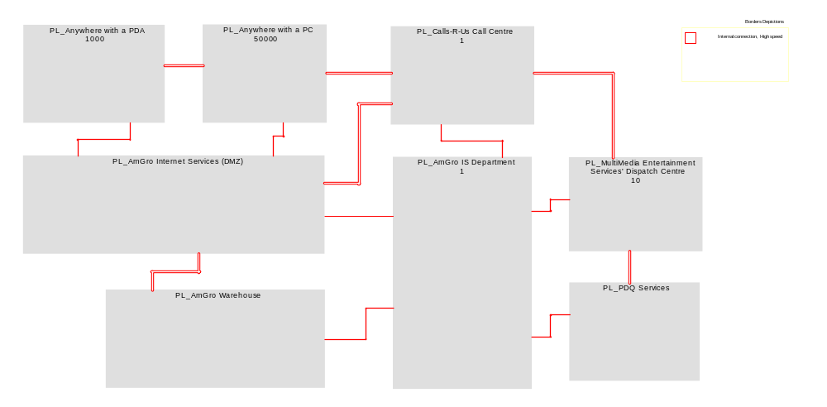
Figure 7 Amgro-from-Home
Description
No Description

Node Model

AmGro from Home
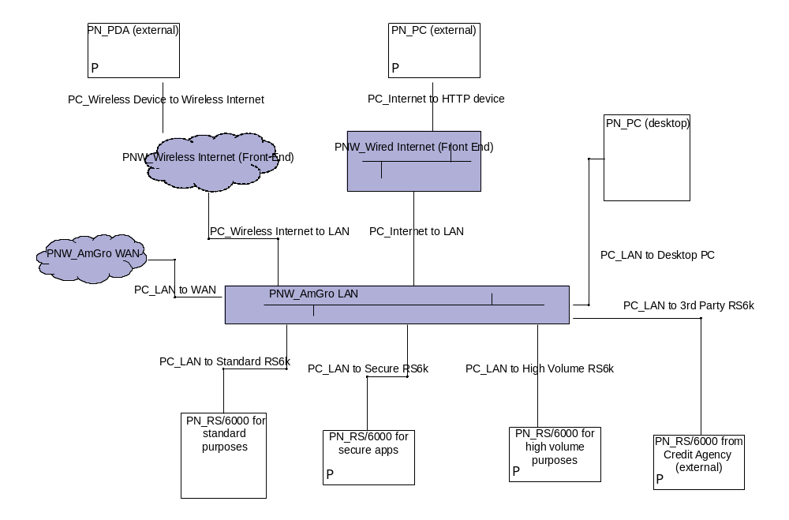
Figure 8 AmGro from Home
Description
No Description

Operational Model

AmGro-from-Home - Call Centre, IS Dept & AmGro W/house
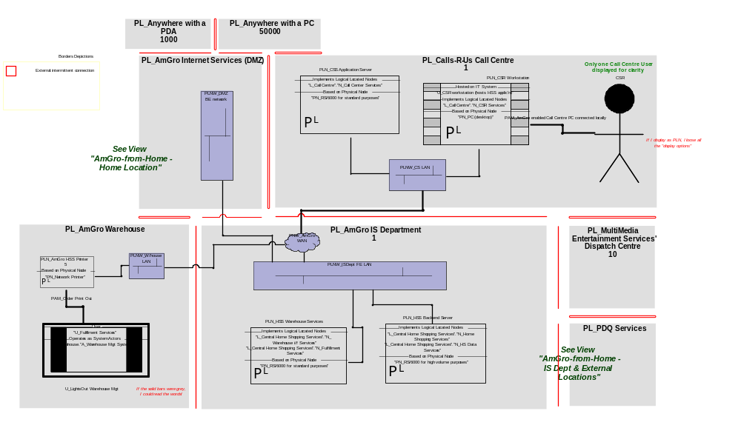
Figure 9 AmGro-from-Home - Call Centre, IS Dept & AmGro W/house
Description
No Description

Amgro-from-Home - Customer locations & Internet Services
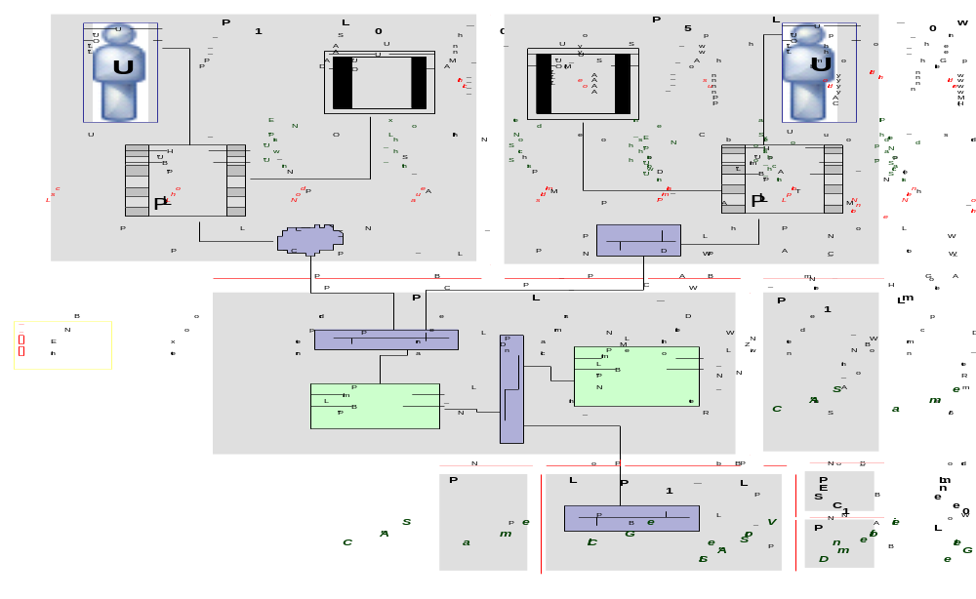
Figure 10 Amgro-from-Home - Customer locations & Internet Services
Description
No Description
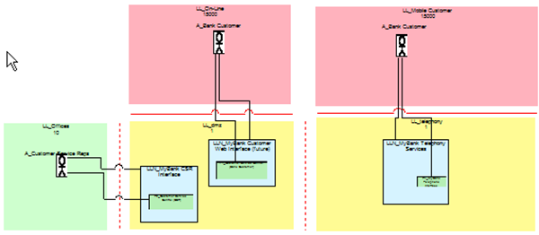

AmGro-from-Home - IS Dept & external locations
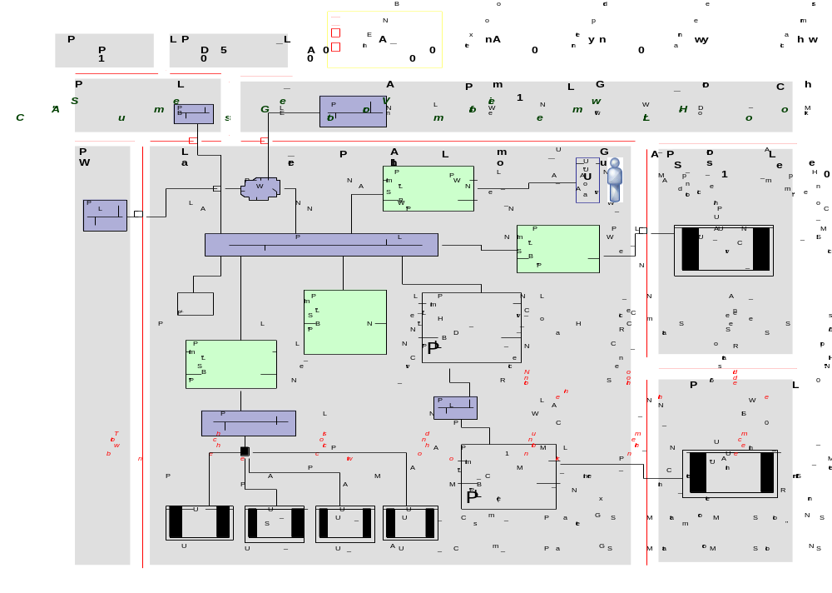
Figure 11 AmGro-from-Home - IS Dept & external locations
Description
No Description

Location Details

PL_AmGro Internet Services (DMZ)
Description
No Description

General Properties
Identifier | -
In Scope | F
Cardinality | -
System Management Capability | Full
Zone Security | Trusted
Physical Access Mechanisms | -

Location Borders
Border Name | Short Name | Type | Location 1 | Location 2
No border_002 | PB_ | No permitted connect | PL_AmGro Internet Services (DMZ) | PL_AmGro Warehouse
No border_003 | PB_ | No permitted connect | PL_Calls-R-Us Call Centre | PL_AmGro Internet Services (DMZ)
PB_AmGro DMZ to Elsewhere | PB_ | External intermitten | PL_Anywhere with a PDA | PL_AmGro Internet Services (DMZ)
PB_AmGro DMZ to IS Dept | PB_ | Internal connection, | PL_AmGro Internet Services (DMZ) | PL_AmGro IS Department
PB_AmGro DMZ to Private Home | PB_ | External intermitten | PL_Anywhere with a PC | PL_AmGro Internet Services (DMZ)

Non Functional Requirements
Must | -
Should | -
Could | -
Would | -

PL_AmGro IS Department
Description
No Description

General Properties
Identifier | -
In Scope | F
Cardinality | 1
System Management Capability | Full
Zone Security | Trusted
Physical Access Mechanisms | PAM_Internal Wired Network  PAM_IS Dept PC connected locally

Location Borders
Border Name | Short Name | Type | Location 1 | Location 2
PB_AmGro DMZ to IS Dept | PB_ | Internal connection, | PL_AmGro Internet Services (DMZ) | PL_AmGro IS Department
PB_AmGro IS Dept to Call Centre | PB_ | External intermitten | PL_Calls-R-Us Call Centre | PL_AmGro IS Department
PB_AmGro IS Dept to Multimedia Services | PB_ | External intermitten | PL_AmGro IS Department | PL_MultiMedia Entertainment Services' Dispatch Centre
PB_AmGro IS Dept to PDQ | PB_ | External intermitten | PL_AmGro IS Department | PL_PDQ Services
PB_AmGro IS Dept to W/house | PB_ | External intermitten | PL_AmGro IS Department | PL_AmGro Warehouse

Non Functional Requirements
Must | -
Should | -
Could | -
Would | -

PL_AmGro Warehouse
Description
Will be commissioned by Lightsout Warehousing Ltd

General Properties
Identifier | -
In Scope | F
Cardinality | -
System Management Capability | Full
Zone Security | Trusted
Physical Access Mechanisms | PAM_Order Print Out

Location Borders
Border Name | Short Name | Type | Location 1 | Location 2
No border_002 | PB_ | No permitted connect | PL_AmGro Internet Services (DMZ) | PL_AmGro Warehouse
PB_AmGro IS Dept to W/house | PB_ | External intermitten | PL_AmGro IS Department | PL_AmGro Warehouse

Non Functional Requirements
Must | -
Should | -
Could | -
Would | -

PL_Anywhere with a PC
Description
No Description

General Properties
Identifier | -
In Scope | F
Cardinality | 50000
System Management Capability | Full
Zone Security | Un-Trusted
Physical Access Mechanisms | PAM_Amgro enabled PC (HTTP protocols)  PAM_The Internet (HTTP Protocols)

Location Borders
Border Name | Short Name | Type | Location 1 | Location 2
No border | PB_ | No permitted connect | PL_Anywhere with a PC | PL_Anywhere with a PDA
No border_001 | PB_ | No permitted connect | PL_Anywhere with a PC | PL_Calls-R-Us Call Centre
PB_AmGro DMZ to Private Home | PB_ | External intermitten | PL_Anywhere with a PC | PL_AmGro Internet Services (DMZ)

Non Functional Requirements
Must | -
Should | -
Could | -
Would | -

PL_Anywhere with a PDA
Description
No Description

General Properties
Identifier | -
In Scope | F
Cardinality | 1000
System Management Capability | Full
Zone Security | Trusted
Physical Access Mechanisms | PAM_AmGro enabledPDA (Mobile Protocols)  PAM_The Internet (Mobile Protocols)

Location Borders
Border Name | Short Name | Type | Location 1 | Location 2
No border | PB_ | No permitted connect | PL_Anywhere with a PC | PL_Anywhere with a PDA
PB_AmGro DMZ to Elsewhere | PB_ | External intermitten | PL_Anywhere with a PDA | PL_AmGro Internet Services (DMZ)

Non Functional Requirements
Must | -
Should | -
Could | -
Would | -

PL_Calls-R-Us Call Centre
Description
Calls-R-Us will run the AmGro-from-Home telephone ordering system, built and provisioned by IBM GBS

General Properties
Identifier | -
In Scope | F
Cardinality | 1
System Management Capability | Full
Zone Security | Trusted
Physical Access Mechanisms | PAM_AmGro enabled Call Centre PC connected locally

Location Borders
Border Name | Short Name | Type | Location 1 | Location 2
No border_001 | PB_ | No permitted connect | PL_Anywhere with a PC | PL_Calls-R-Us Call Centre
No border_003 | PB_ | No permitted connect | PL_Calls-R-Us Call Centre | PL_AmGro Internet Services (DMZ)
No border_005 | PB_ | No permitted connect | PL_Calls-R-Us Call Centre | PL_MultiMedia Entertainment Services' Dispatch Centre
PB_AmGro IS Dept to Call Centre | PB_ | External intermitten | PL_Calls-R-Us Call Centre | PL_AmGro IS Department

Non Functional Requirements
Must | -
Should | -
Could | -
Would | -

PL_MultiMedia Entertainment Services' Dispatch Centre
Description
No Description

General Properties
Identifier | -
In Scope | F
Cardinality | 10
System Management Capability | Full
Zone Security | Trusted
Physical Access Mechanisms | PAM_CD (external)

Location Borders
Border Name | Short Name | Type | Location 1 | Location 2
No border_004 | PB_ | No permitted connect | PL_MultiMedia Entertainment Services' Dispatch Centre | PL_PDQ Services
No border_005 | PB_ | No permitted connect | PL_Calls-R-Us Call Centre | PL_MultiMedia Entertainment Services' Dispatch Centre
PB_AmGro IS Dept to Multimedia Services | PB_ | External intermitten | PL_AmGro IS Department | PL_MultiMedia Entertainment Services' Dispatch Centre

Non Functional Requirements
Must | -
Should | -
Could | -
Would | -

PL_PDQ Services
Description
No Description

General Properties
Identifier | -
In Scope | F
Cardinality | -
System Management Capability | Full
Zone Security | Trusted
Physical Access Mechanisms | PAM_Leased Line

Location Borders
Border Name | Short Name | Type | Location 1 | Location 2
No border_004 | PB_ | No permitted connect | PL_MultiMedia Entertainment Services' Dispatch Centre | PL_PDQ Services
PB_AmGro IS Dept to PDQ | PB_ | External intermitten | PL_AmGro IS Department | PL_PDQ Services

Non Functional Requirements
Must | -
Should | -
Could | -
Would | -

Node Details

PLN_ AmGro HSS Internet Server
Description
No Description

General Properties
Short Name | PLN_
(If external, is part of IT System Users) <-- Users | T
Internal or external to target system | Internal
(If external, is part of IT System Users) | -
Is instance of Physical Node... | PN_RS/6000 for high volume purposes
...in Physical Location | PL_AmGro Internet Services (DMZ)
Implements Logical Located Nodes... | L_Internet_Services.N_Internet Services
...supporting Physical Access Mechanism | -
Implements Logical Located DUs | -

Node Connections
Name | Short Name | From Item | To Item | Implements Physical Connections | Physical Located DU Connectors
PC_008 | PLCn_ | PL_AmGro Internet Services (DMZ).PLN_ AmGro HSS Internet Server | PL_AmGro Internet Services (DMZ).PLNW_DMZ BE network | - | -

Non Functional Requirements
Must | -
Should | -
Could | -
Would | -

PLN_AmGro HSS Printer
Description
No Description

General Properties
Short Name | PLN_
(If external, is part of IT System Users) <-- Users | T
Internal or external to target system | Internal
(If external, is part of IT System Users) | -
Is instance of Physical Node... | PN_Network Printer
...in Physical Location | PL_AmGro Warehouse
Implements Logical Located Nodes... | -
...supporting Physical Access Mechanism | PAM_Order Print Out
Implements Logical Located DUs | -

Node Connections
Name | Short Name | From Item | To Item | Implements Physical Connections | Physical Located DU Connectors
PC_006 | PLCn_ | PL_AmGro Warehouse.PLN_AmGro HSS Printer | PL_AmGro Warehouse.PLNW_W/house LAN | - | -

Non Functional Requirements
Must | -
Should | -
Could | -
Would | -

PLN_AmGro Lotus Notes RS/6000
Description
No Description

General Properties
Short Name | PLN_
(If external, is part of IT System Users) <-- Users | T
Internal or external to target system | Internal
(If external, is part of IT System Users) | -
Is instance of Physical Node... | PN_RS/6000 for Lotus Notes
...in Physical Location | PL_AmGro IS Department
Implements Logical Located Nodes... | -
...supporting Physical Access Mechanism | -
Implements Logical Located DUs | -

Node Connections
No Connection Details Defined for PLN_AmGro Lotus Notes RS/6000

Non Functional Requirements
Must | -
Should | -
Could | -
Would | -

PLN_AmGro Secure Server
Description
No Description

General Properties
Short Name | PLN_
(If external, is part of IT System Users) <-- Users | T
Internal or external to target system | Internal
(If external, is part of IT System Users) | -
Is instance of Physical Node... | PN_RS/6000 for secure apps
...in Physical Location | PL_AmGro IS Department
Implements Logical Located Nodes... | L_Central Home Shopping Services.N_Security Services
...supporting Physical Access Mechanism | -
Implements Logical Located DUs | -

Node Connections
Name | Short Name | From Item | To Item | Implements Physical Connections | Physical Located DU Connectors
PC_017 | PLCn_ | PL_AmGro IS Department.PLNW_ISDept FE LAN | PL_AmGro IS Department.PLN_AmGro Secure Server | - | -

Non Functional Requirements
Must | -
Should | -
Could | -
Would | -

PLN_AmGro Web Server
Description
No Description

General Properties
Short Name | PLN_
(If external, is part of IT System Users) <-- Users | F
Internal or external to target system | Internal
(If external, is part of IT System Users) | -
Is instance of Physical Node... | PN_RS/6000 for standard purposes
...in Physical Location | PL_AmGro Internet Services (DMZ)
Implements Logical Located Nodes... | L_Internet_Services.N_On-line Presentation Services
...supporting Physical Access Mechanism | -
Implements Logical Located DUs | -

Node Connections
Name | Short Name | From Item | To Item | Implements Physical Connections | Physical Located DU Connectors
PC_001 | PLCn_ | PL_AmGro Internet Services (DMZ).PLNW_DMZ FE Network | PL_AmGro Internet Services (DMZ).PLN_AmGro Web Server | - | -
PC_002 | PLCn_ | PL_AmGro Internet Services (DMZ).PLN_AmGro Web Server | PL_AmGro Internet Services (DMZ).PLNW_DMZ BE network | - | -

Non Functional Requirements
Must | -
Should | -
Could | -
Would | -

PLN_Catalogue Design Apple Mac Network
Description
No Description

General Properties
Short Name | PLN_
(If external, is part of IT System Users) <-- Users | T
Internal or external to target system | External
(If external, is part of IT System Users) | U_Catalog Designer System
Is instance of Physical Node... | PN_Apple Mac Network
...in Physical Location | PL_AmGro IS Department
Implements Logical Located Nodes... | -
...supporting Physical Access Mechanism | -
Implements Logical Located DUs | -

Node Connections
No Connection Details Defined for PLN_Catalogue Design Apple Mac Network

Non Functional Requirements
Must | -
Should | -
Could | -
Would | -

PLN_Corporate Interface Services
Description
No Description

General Properties
Short Name | PLN_
(If external, is part of IT System Users) <-- Users | T
Internal or external to target system | Internal
(If external, is part of IT System Users) | -
Is instance of Physical Node... | PN_RS/6000 for standard purposes
...in Physical Location | PL_AmGro IS Department
Implements Logical Located Nodes... | L_Central Home Shopping Services.N_Corp i/f Services
...supporting Physical Access Mechanism | -
Implements Logical Located DUs | -

Node Connections
Name | Short Name | From Item | To Item | Implements Physical Connections | Physical Located DU Connectors
PC_015 | PLCn_ | PL_AmGro IS Department.PLN_Corporate Interface Services | PL_AmGro IS Department.PLNW_IS Dept BE LAN | - | -
PC_016 | PLCn_ | PL_AmGro IS Department.PLNW_ISDept FE LAN | PL_AmGro IS Department.PLN_Corporate Interface Services | - | -

Non Functional Requirements
Must | -
Should | -
Could | -
Would | -

PLN_Credit Agency Gateway RS/6000
Description
No Description

General Properties
Short Name | PLN_
(If external, is part of IT System Users) <-- Users | F
Internal or external to target system | Internal
(If external, is part of IT System Users) | -
Is instance of Physical Node... | PN_RS/6000 from Credit Agency (external)
...in Physical Location | PL_AmGro IS Department
Implements Logical Located Nodes... | L_Central Home Shopping Services.N_Credit i/f Services
...supporting Physical Access Mechanism | PAM_Leased Line
Implements Logical Located DUs | -

Node Connections
Name | Short Name | From Item | To Item | Implements Physical Connections | Physical Located DU Connectors
PC_011 | PLCn_ | PL_AmGro IS Department.PLNW_Secure LAN | PL_AmGro IS Department.PLN_Credit Agency Gateway RS/6000 | - | -

Non Functional Requirements
Must | -
Should | -
Could | -
Would | -

PLN_CSR Workstation
Description
No Description

General Properties
Short Name | PLN_
(If external, is part of IT System Users) <-- Users | F
Internal or external to target system | External
(If external, is part of IT System Users) | U_CSR workstation (hosts HSS applic'n)
Is instance of Physical Node... | PN_PC (desktop)
...in Physical Location | PL_Calls-R-Us Call Centre
Implements Logical Located Nodes... | L_Call Centre.N_CSR Services
...supporting Physical Access Mechanism | PAM_AmGro enabled Call Centre PC connected locally
Implements Logical Located DUs | -

Node Connections
Name | Short Name | From Item | To Item | Implements Physical Connections | Physical Located DU Connectors
PC_CSR W/s to LAN | PLCn_ | PL_Calls-R-Us Call Centre.PLN_CSR Workstation | PL_Calls-R-Us Call Centre.PLNW_CS LAN | - | -
W/s to LAN | PLCn_ | PL_Calls-R-Us Call Centre.PLN_CSR Workstation | - | - | -

Non Functional Requirements
Must | -
Should | -
Could | -
Would | -

PLN_CSS Application Server
Description
No Description

General Properties
Short Name | PLN_
(If external, is part of IT System Users) <-- Users | F
Internal or external to target system | Internal
(If external, is part of IT System Users) | -
Is instance of Physical Node... | PN_RS/6000 for standard purposes
...in Physical Location | PL_Calls-R-Us Call Centre
Implements Logical Located Nodes... | L_Call Centre.N_Call Center Services
...supporting Physical Access Mechanism | -
Implements Logical Located DUs | -

Node Connections
Name | Short Name | From Item | To Item | Implements Physical Connections | Physical Located DU Connectors
PC_CSS to LAN | PLCn_ | PL_Calls-R-Us Call Centre.PLN_CSS Application Server | PL_Calls-R-Us Call Centre.PLNW_CS LAN | - | -

Non Functional Requirements
Must | -
Should | -
Could | -
Would | -

PLN_Dummy for corp services PAMs
Description
No Description

General Properties
Short Name | PLN_
(If external, is part of IT System Users) <-- Users | T
Internal or external to target system | Internal
(If external, is part of IT System Users) | -
Is instance of Physical Node... | PN_Dummy
...in Physical Location | PL_AmGro IS Department
Implements Logical Located Nodes... | -
...supporting Physical Access Mechanism | PAM_Internal Wired Network
Implements Logical Located DUs | -

Node Connections
Name | Short Name | From Item | To Item | Implements Physical Connections | Physical Located DU Connectors
PC_014 | PLCn_ | PL_AmGro IS Department.PLNW_IS Dept BE LAN | PL_AmGro IS Department.PLN_Dummy for corp services PAMs | - | -

Non Functional Requirements
Must | -
Should | -
Could | -
Would | -

PLN_Head Office AS/400
Description
No Description

General Properties
Short Name | PLN_
(If external, is part of IT System Users) <-- Users | F
Internal or external to target system | External
(If external, is part of IT System Users) | U_SMS
Is instance of Physical Node... | PN_AS/400
...in Physical Location | PL_AmGro IS Department
Implements Logical Located Nodes... | -
...supporting Physical Access Mechanism | -
Implements Logical Located DUs | -

Node Connections
No Connection Details Defined for PLN_Head Office AS/400

Non Functional Requirements
Must | -
Should | -
Could | -
Would | -

PLN_HSS Admin Workstation
Description
No Description

General Properties
Short Name | PLN_
(If external, is part of IT System Users) <-- Users | T
Internal or external to target system | Internal
(If external, is part of IT System Users) | -
Is instance of Physical Node... | PN_PC (desktop)
...in Physical Location | PL_AmGro IS Department
Implements Logical Located Nodes... | L_Central Home Shopping Services.N_OMS Admin Services
...supporting Physical Access Mechanism | PAM_IS Dept PC connected locally
Implements Logical Located DUs | -

Node Connections
Name | Short Name | From Item | To Item | Implements Physical Connections | Physical Located DU Connectors
PC_018 | PLCn_ | PL_AmGro IS Department.PLN_HSS Admin Workstation | PL_AmGro IS Department.PLNW_ISDept FE LAN | - | -

Non Functional Requirements
Must | -
Should | -
Could | -
Would | -

PLN_HSS Backend Server
Description
No Description

General Properties
Short Name | PLN_
(If external, is part of IT System Users) <-- Users | F
Internal or external to target system | Internal
(If external, is part of IT System Users) | -
Is instance of Physical Node... | PN_RS/6000 for high volume purposes
...in Physical Location | PL_AmGro IS Department
Implements Logical Located Nodes... | L_Central Home Shopping Services.N_Home Shopping Services  L_Central Home Shopping Services.N_HS Data Services
...supporting Physical Access Mechanism | -
Implements Logical Located DUs | -

Node Connections
Name | Short Name | From Item | To Item | Implements Physical Connections | Physical Located DU Connectors
PC_005 | PLCn_ | PL_AmGro IS Department.PLNW_ISDept FE LAN | PL_AmGro IS Department.PLN_HSS Backend Server | - | -
PC_010 | PLCn_ | PL_AmGro IS Department.PLN_HSS Backend Server | PL_AmGro IS Department.PLNW_Secure LAN | - | -

Non Functional Requirements
Must | -
Should | -
Could | -
Would | -

PLN_HSS Warehouse Services
Description
No Description

General Properties
Short Name | PLN_
(If external, is part of IT System Users) <-- Users | F
Internal or external to target system | Internal
(If external, is part of IT System Users) | -
Is instance of Physical Node... | PN_RS/6000 for standard purposes
...in Physical Location | PL_AmGro IS Department
Implements Logical Located Nodes... | L_Central Home Shopping Services.N_Warehouse i/f Services  L_Central Home Shopping Services.N_Fulfillment Services
...supporting Physical Access Mechanism | -
Implements Logical Located DUs | -

Node Connections
Name | Short Name | From Item | To Item | Implements Physical Connections | Physical Located DU Connectors
PC_004 | PLCn_ | PL_AmGro IS Department.PLNW_ISDept FE LAN | PL_AmGro IS Department.PLN_HSS Warehouse Services | - | -

Non Functional Requirements
Must | -
Should | -
Could | -
Would | -

PLN_MES interface PC
Description
No Description

General Properties
Short Name | PLN_
(If external, is part of IT System Users) <-- Users | T
Internal or external to target system | Internal
(If external, is part of IT System Users) | -
Is instance of Physical Node... | PN_PC (desktop)
...in Physical Location | PL_AmGro IS Department
Implements Logical Located Nodes... | L_Central Home Shopping Services.N_3rd Party i/f Services
...supporting Physical Access Mechanism | PAM_CD (external)
Implements Logical Located DUs | -

Node Connections
Name | Short Name | From Item | To Item | Implements Physical Connections | Physical Located DU Connectors
PC_013 | PLCn_ | PL_AmGro IS Department.PLN_MES interface PC | PL_AmGro IS Department.PLNW_ISDept FE LAN | - | -

Non Functional Requirements
Must | -
Should | -
Could | -
Would | -

PLN_Shopping on a PC
Description
No Description

General Properties
Short Name | PLN_
(If external, is part of IT System Users) <-- Users | F
Internal or external to target system | External
(If external, is part of IT System Users) | U_Shopping PC or PDA (also hosts HSS applic'n)
Is instance of Physical Node... | PN_PC (external)
...in Physical Location | PL_Anywhere with a PC
Implements Logical Located Nodes... | L_Anywhere (off-line).N_Off-line Cust Services
...supporting Physical Access Mechanism | PAM_Amgro enabled PC (HTTP protocols)  PAM_The Internet (HTTP Protocols)
Implements Logical Located DUs | -

Node Connections
Name | Short Name | From Item | To Item | Implements Physical Connections | Physical Located DU Connectors
PC_PC to Internet Access Point (HTTP Protocols) | I'net | PL_Anywhere with a PC.PLN_Shopping on a PC | PL_Anywhere with a PC.PLN_Shopping on a PC | PC_Internet to LAN | -

Non Functional Requirements
Must | -
Should | -
Could | -
Would | -

PLN_Shopping on PDA
Description
No Description

General Properties
Short Name | PLN_
(If external, is part of IT System Users) <-- Users | T
Internal or external to target system | External
(If external, is part of IT System Users) | U_Shopping PC or PDA (also hosts HSS applic'n)
Is instance of Physical Node... | PN_PDA (external)
...in Physical Location | PL_Anywhere with a PDA
Implements Logical Located Nodes... | -
...supporting Physical Access Mechanism | PAM_AmGro enabledPDA (Mobile Protocols)  PAM_The Internet (Mobile Protocols)
Implements Logical Located DUs | -

Node Connections
Name | Short Name | From Item | To Item | Implements Physical Connections | Physical Located DU Connectors
PC_PDA to Wireless Internet (Mobile Protocols) | PLCn_ | PL_Anywhere with a PDA.PLN_Shopping on PDA | PL_Anywhere with a PDA.PLNW_Wireless Internet (Front End) | - | -

Non Functional Requirements
Must | -
Should | -
Could | -
Would | -

PLN_Warehouse RS/6000
Description
No Description

General Properties
Short Name | PLN_
(If external, is part of IT System Users) <-- Users | F
Internal or external to target system | External
(If external, is part of IT System Users) | U_Fulfilment Services
Is instance of Physical Node... | RS/6000 Depot
...in Physical Location | PL_AmGro Warehouse
Implements Logical Located Nodes... | -
...supporting Physical Access Mechanism | -
Implements Logical Located DUs | -

Node Connections
No Connection Details Defined for PLN_Warehouse RS/6000

Non Functional Requirements
Must | -
Should | -
Could | -
Would | -

Physical DU Details

Presentation DU
No Physical Presentation DU Defined

Data DU

Phy_DU_1
Description
No Description

General Properties
No DU Details Defined for Phy_DU_1

DU Connectors
No DU Connectors Defined for Phy_DU_1

Non Functional Requirements
Must | -
Should | -
Could | -
Would | -

Execution DU
No Physical Execution DU Defined

Installation DU
No Physical Installation DU Defined

