Transformation Roadmap Example
Data Center Transformation

Table of Contents
1. Introduction 4
1.1 Purpose 4
1.2 Scope 4
1.3 Intended Audience 4
1.4 Overview 4
2. The Transformation Initiative 4
2.1 Transformation Initiative Overview 4
2.2 Context and Scope 5
2.3 Business Benefits / Value Proposition 5
2.4 Activities 5
2.5 Timeline 7

Introduction

Purpose
This transformation roadmap is an example of a Transformation Roadmap based on the Strategic Roadmap (BUS 326) artifact.

Scope
This transformation roadmap addresses all major domains, including business, application, infrastructure, governance and planning and Realization and operation.

Intended Audience
This document is intended for the use as an example by the Technical Solution Architect and the client team supporting a Team Solution Design engagement.

Overview
This document provides an example Transformation Roadmap, including the following elements.
- Transformation Initiative Overview
- Context and Scope
- Business Benefits / Value Proposition
- Activities
- Timeline

The Transformation Initiative

Transformation Initiative Overview
Client Challenge
Reduce organizational risk by accelerating the path to simplification.
Challenge Description
The current infrastructure and core systems form a highly complex architecture which includes back-level applications & hardware. As a consequence the client’s ability to transform, consolidate, support new requirements/businesses has been slowed, while increasing operational risk. There is a need to accelerate the path to simplification.

Transformation Initiative
Establish a BCRS (Business Continuity and Resiliency Services) plan that can support 100% of data center operations. This will allow the bank to reduce risk and lower the recovery time objective (RTO) associated with a primary data center disaster.

Context and Scope
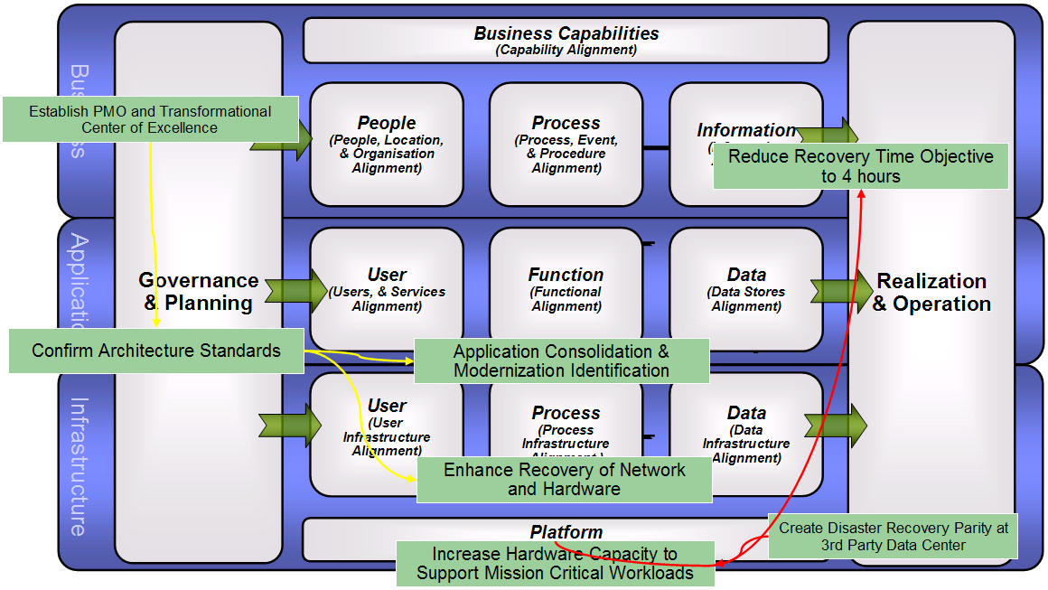

Business Benefits / Value Proposition
Key business values associated with this initiative include the following:
Reduction of risk: Data loss will be minimized and the amount of human interaction will be reduced. KPI's are RTO and RPO.
Faster recovery time: This is achieved by ensuring that all mission critical applications can be brought back online within a 4 hour window. This will minimize the potential of clients leaving and reduction in revenue. KPI's are RTO and Revenue.
Reduction of Duplicate Software: By developing an architecture standard and identifying applications for consolidation, duplicate spend can be eliminated. KPI's are (OpEx and CapEx)

Activities
Create Disaster Recovery Parity at 3rd Party Data Center
This will ensure that the 3rd party data center provider has the necessary skills and procedures to support a BCRS plan.

Increase Hardware Capacity to Support Mission Critical Workloads
Increase the amount of capacity to support mission critical operations. This includes hardware in support of mission critical applications, storage for data replication and network infrastructure for access to IT systems.

Enhance Recovery of Network and Hardware
This activity will focus on establishing the necessary hardware and network access for applications that are not mission critical, but are needed to support follow on transformation initiatives.

Reduce Recovery Time Objective to 4 hours
Develop processes and procedures focused on starting the recovery environment and initializing applications in a structured sequence. The goal is to have mission critical operations running in 4 hours or less.

Establish PMO and Transformational Center of Excellence
Create a program management office focused on data center migration initiatives. As a part of the PMO a governance structured and stakeholder responsibilities will be defined.

Confirm Architecture Standards
Ensure that infrastructure and application standards are clearly defined. These standards will drive the appropriate prioritization of IT migration efforts for subsequent transformation initiatives and the associated activities.

Application Consolidation & Modernization Identification
Identify existing applications that can be consolidated into a virtualized environment. Additionally create a list of applications that need to be modernized to take advantage of the architecture standards.

Timeline
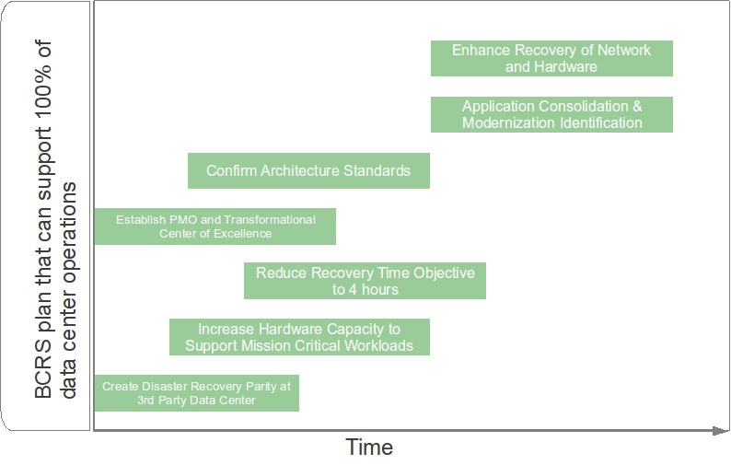

End of document–Transformation Roadmap

Revision Status: <approved>

Document Control Information

Document Author: Jeff Calusinski
Document Owner: Tom Seevers
Project Manager: Tom Seevers

Document Approver(s): (All Approvers are required. Records of each approver must be maintained.)

Approver Name | Role
Tom Seevers | Project Manager

Document Reviewers: (Records of each required reviewer must be maintained.)

Reviewer Name | Role
Tom Seevers | Project Manager

NOTE: All Reviewers in the list are considered required unless explicitly listed as Optional.

Summary of Changes:

The Document Author is authorized to make the following types of changes to the document without requiring that the document be re-approved:

- Editorial, formatting, and spelling
- Clarification

To request a change to this document, contact the Document Author or Owner.
Changes to this document are summarized in the following table in reverse chronological order (latest version first).

Revision | Date | Created by | Short Description of Changes
1.0 | 05/31/2011 | Tom Seevers | Initial Version of approved document

Document Source:

The latest version of this controlled document is stored in UMF.

