Transformation Roadmap Example
Multichannel Transformation

Table of Contents
1. Introduction 4
1.1 Purpose 4
1.2 Scope 4
1.3 Intended Audience 4
1.4 Overview 4
2. The Transformation Initiative 4
2.1 Transformation Initiative Overview 4
2.2 Context and Scope 4
2.3 Business Benefits / Value Proposition 5
2.4 Activities 5
2.4.1 Develop a target blueprint and appropriate set of transformation activities 6
2.4.2 Acquire an effective enterprise architecture tool to model the current and target environments and guide multiyear transformation 6
2.4.3 Implement Coremetrics Web Analytics 6
2.4.4 Improve user experience design for Web banking including mobile 6
2.4.5 Enable agile development via portlet factory and WMBTT 7
2.4.6 Implement Web banking portal 7
2.4.7 Leverage WMBTT and Portal to establish a multichannel architecture foundation 7
2.4.8 Implement Web banking functions 7
2.4.9 Deploy Lombardy BPM solution 7
2.4.10 Optimize and transform LU2 screens and screen flow to web services 7
2.4.11 Implement a service portal for use by both the call center and branch channels 7
2.4.12 Deploy a cross channel customer contact history 8
2.4.13 Implement a branch sales portal 8
2.5 Timeline 8

Introduction

Purpose
This transformation roadmap is an example of a Transformation Roadmap based on the Strategic Roadmap (BUS 326) artifact.

Scope
This transformation roadmap addresses issues associated with platform, infrastructure, application, governance and operation domains.

Intended Audience
This document is intended for the use as an example by the Technical Solution Architect and the client team supporting a Team Solution Design engagement.

Overview
This document provides an example Transformation Roadmap, including the following elements.
- Transformation Initiative Overview
- Context and Scope
- Business Benefits / Value Proposition
- Activities
- Timeline

The Transformation Initiative

Transformation Initiative Overview
The client would like to transform their multichannel retail banking environment starting with the online banking channels first. Later stages of the transformation would cover the call center and branch channels. The transformation will initially focus on the user experience and underlying user platforms along with key functional areas that would support a retail banking customer sales and service interactions.

This particular transformation initiative was originally covered in a general way by a previously published Client Challenge titled Enable a Bank’s Multichannel Delivery Strategy with an Optimal Architecture and Technology Platform.

Context and Scope
MyBank is very profitable but mainly from an older affluent customer segment. Their current online banking Website is woefully inadequate and is losing a significant number of younger customers each year. The following diagram graphically depicts some of MyBank’s key pain points within the context of IBM’s Transformation Framework:
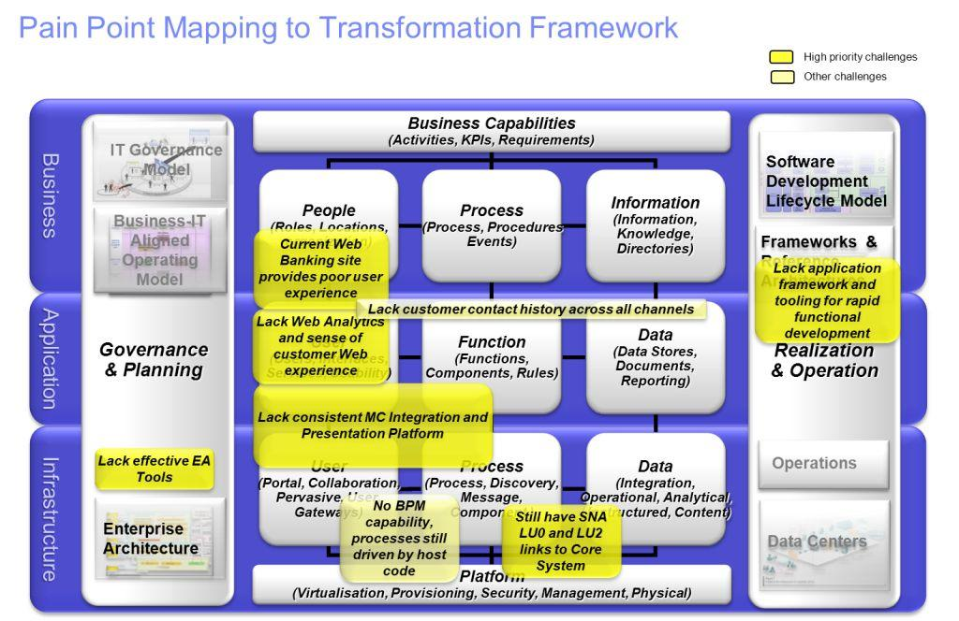

Business Benefits / Value Proposition
The business benefits envisioned for this set of transformation initiatives are shown as follows:
Significantly improves customer satisfaction especially in the new online (Web and mobile) channels
- Gain market share by attracting a younger customer demographic to a new transformed user experience on the online channels
- Reduce overall Cost to Income Ratio (CIR) by moving more customers from expensive branch and call center channels to the online channels
- Provides a consistent customer experience and across all channels
- Provides a complete set of retail banking functions in the online channel to ensure that the target (younger) segment can be fully supported on their preferred channel

Activities
In a similar manner, the high level transformation activities needed to address those pain points are shown mapped onto the following diagram:

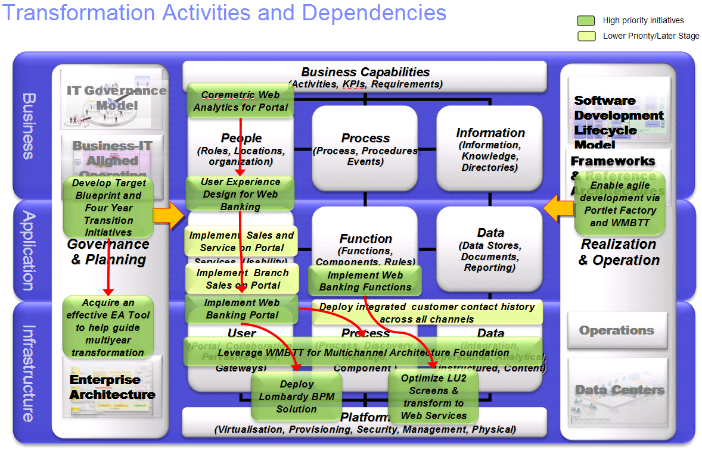

Develop a target blueprint and appropriate set of transformation activities
One of the first activities that must be undertaken is to model the current IT environment and develop a target state blueprint with particular focus on the multichannel environment. Once this is done, this transformation roadmap along with the current and target state models can be used to develop a cohesive set of transformation initiatives over your chosen multiyear time horizon.

Acquire an effective enterprise architecture tool to model the current and target environments and guide multiyear transformation
In order to model the current and target state IT environments, an effective enterprise architecture tool must be acquired and the appropriate architects trained to use it.

Implement Coremetrics Web Analytics
Implementing the core metrics Web analytics component is critical to being able to provide feedback to both business and IT on how customers are using the online banking channel. This information can be used in a continuous fashion to refine the user experience design and underlying functions provided by the channel. This information can also be used to determine what customer offers or features are most popular as well as which interactions drive an especially high level of user abandonment.

The Coremetrics Web Analytics feature comes integrated with the WebSphere Portal product but some customization work will need to be performed in order to effectively use it for MyBank's online channel.

Improve user experience design for Web banking including mobile
A critical factor for increasing the acceptance and use of the new online banking channel by a younger demographic is that the user experience design must be modern and differentiated with respect to the competition. IBM is recommending that the bank engage our IBM Interactive user experience design group in order to develop a compelling user experience design.

Enable agile development via portlet factory and WMBTT
A key enabler to implementing the channel functions and user interfaces is to leverage IBM's Portlet Factory and the WMBTT tools and accelerators to greatly accelerate the development process. Both of these tools provide proven capabilities in both user interface and banking function development.

Implement Web banking portal
Implementing the Web banking portal is a critical foundation component to the overall multichannel transformation strategy. The approach we are recommending is to implement IBM's WebSphere portal server with appropriate customizations which would include leveraging our portal banking template and other banking assets from our solution centers.

One of the key design points for the portal implementation is to support various types of mobile clients that we see in the market today.

Leverage WMBTT and Portal to establish a multichannel architecture foundation
Another critical factor in the transformation strategy is to lay a robust multichannel foundation that can be used by all of the channels. IBM's recommendation is to leverage a combination of our portal infrastructure as well as assets and tools from our WebSphere Multichannel Bank Transformation Toolkit (WMBTT) develop this foundation. The critical design point is to ensure that a reusable set of services can be effectively rendered to the appropriate devices within each of the channels.

Implement Web banking functions
The current online banking channel at MyBank is incomplete and certain functions and services need to be built out and deployed on our target multichannel platform. Intent of this activity is to leverage our new technology platform and its BPM capability to implement these functions and services in a consistent manner accessible to all channels.

MyBank would like to deploy as many retail banking sales and service functions as possible to ensure that the younger demographic can accomplish most of their banking needs online.

Deploy Lombardy BPM solution
Another critical part of our multichannel strategy is to provide a modern business process management capability. This would include new process modeling and development tools, a scalable runtime, and monitoring and management capability.

Optimize and transform LU2 screens and screen flow to web services
Another component of her multichannel strategy is to leverage IBM's Host Access Transformation Services (HATS) to provide an interim transformation and optimization of the current LU2 set of host interfaces to a reusable set of Web services. Although this activity does not deliver a strategic native set of core system Web services it does provide a cost-effective interim solution that can be quickly deployed. This approach also starts to decouple the current legacy system driven processes from the respective consumers of those services (i.e. the front end channel applications).

Implement a service portal for use by both the call center and branch channels
After the online channels and multichannel capabilities are developed and incremental set of customer service functions and appropriate user interfaces will need to be developed and deployed into the branch and call center channels. These new interfaces will need to be optimized for use by those channels. In the case of the call center channel a significant focus must be put on user interface and interaction speed since call handle times are a key performance indicator. In order to ensure this level of performance some consideration may need to be given to deploying the online portal-based client to a rich client model. This can be done in a fairly straightforward manner using the Lotus Expeditor product and toolkit to transform the portal-based interfaces to a more responsive rich client model. This type of client also offers a limited offline capability which can be an important consideration for the branch and call centers.

Deploy a cross channel customer contact history
Providing a cross channel customer contact history capability is a critical piece of our strategy for improving customer service across the various retail bank touch points. This will be especially important for those customers who initiate contact on the online channel but are directed to complete the transaction or interaction on the branch or call center channel. MyBank currently has a customer service case management application but it is not currently integrated with any of the non-branch channels. Integrating their existing case management system with this new cross channel contact history will be critical.

Implement a branch sales portal
A final element of the transformation strategy is to add the incremental functions and user interfaces needed to support branch sales. This capability they need to support to client device profiles - a web-based portal and a smart phone or mobile client.

Timeline
These same transformation activities are also depicted sequentially in a multiyear transformation roadmap. The specific sequence of activities is driven by functional dependency, risk or ROI constraints. Typically you will need to front load activities that are foundational or come with higher risk or reward (i.e. provide a quick or higher payback or ROI). By sequencing these activities first you will ensure that the bank will be able to pay for the lower priority or lower pay back initiatives in the latter phases.

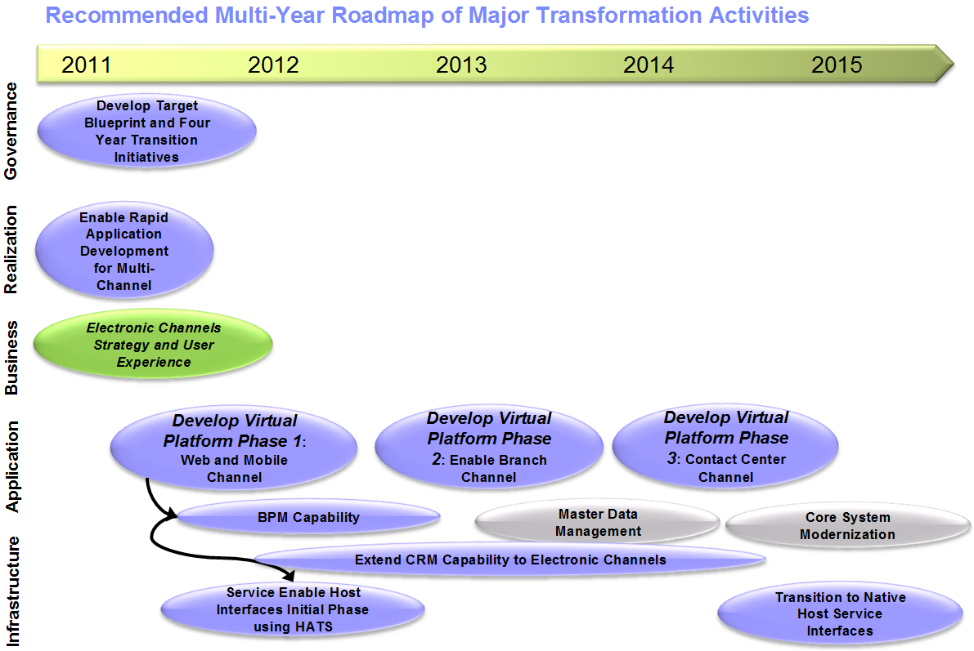

Note: The activities in the time line represent the major activities and in some cases combine more than one activity. The items in gray represent potential additional future transformation initiatives.

End of document

Revision Status: <v1.0>

Document Control Information

Document Author: Skip Churchill
Document Owner: Tom Seevers
Project Manager: Tom Seevers

Document Approver(s): (All Approvers are required. Records of each approver must be maintained.)

Approver Name | Role
Tom Seevers | Project Manager

Document Reviewers: (Records of each required reviewer must be maintained.)

Reviewer Name | Role
Tom Seevers | Project Manager

NOTE: All Reviewers in the list are considered required unless explicitly listed as Optional.

Summary of Changes:

The Document Author is authorized to make the following types of changes to the document without requiring that the document be re-approved:

- Editorial, formatting, and spelling
- Clarification

To request a change to this document, contact the Document Author or Owner.
Changes to this document are summarized in the following table in reverse chronological order (latest version first).

Revision | Date | Created by | Short Description of Changes
1.0 | 05/31/2011 | Tom Seevers | Initial Version of approved document

Document Source:

The latest version of this controlled document is stored in UMF.

WMBTT is the abbreviation for IBM’s WebSphere Multi-channel Bank Transformation Toolkit

