

The Role of Capabilities in Solution Design

Guideline

© Copyright International Business Machines Corporation 2013

All Rights Reserved
Version 1.0 June, 2013
Brief Description
This guideline describes the role of Capabilities in Solution Design.
Main Description

Introduction
With the inception of the IBM Business Blueprint, the term IBM Capability was introduced. In the simplest sense, a capability is defined in the Blueprint as “the ability to ….”. A generic example of a capability might be “The ability to measure risk exposures and solvency and capital requirements”. IBM Capabilities are intended to provide a concept of intermediate granularity between a product and an industry solution. IBM methods, including Enterprise Architecture also use the concept of Capability. Using the Capability concept to understand what the client is trying to achieve is a powerful conceptual tool that provides an additional perspective in solution design. This guidance focuses on our clients’ capability requirements but will also discuss how IBM’s capabilities relate to the clients’ capabilities.

General Capability Definition
A capability is defined as the ability of an organizational entity to perform some activity that provides value for itself or another entity. In the broadest sense, entity refers to an enterprise such as IBM or an IBM client. The term entity may also refer to some contained entity such as a business component as described in IBM’s Component Business Modeling.
Capabilities may be internally focused such as the ability to “perform forecasting and demand management.” Alternatively, they may be externally focused such as the ability to “provide overnight delivery”.

Capability Role in Solution Design
The CVM artifact Opportunity Plan (ART 0512), requires the following information.
- Opportunity Description (Provide a description of the opportunity as stated by the client, including the business initiative that this project supports, what the client is trying to achieve, and their Compelling Reason to Act):
This information is also relevant in solution design, especially the fundamental question “what is the client trying to achieve?” The answer to this question can range from a technical answer involving products and technology to a higher level business need. The concept of a Capability provides a means understanding what the client is trying to achieve in very concise terms. In essence, the question becomes: what capability is the client trying to create or improve. Understanding the client’s capability needs allows the solution designer to select the best combination of assets and resources to enable or improve that capability.

Additional Background on the Capability Concept
The context of this additional information is that of organizational entities, specifically IBM and its clients.
- A capability exists because it is satisfied by resources that combine to realize or enable the capability. Primary categories of resources include process, organization, technology and information. In the context of the IBM Blueprint and IBM Capabilities, we refer to combinations of resources as assets.
- Capabilities may be assessed in terms of maturity. This assessment is derived from the presence and maturity of resources and assets necessary to satisfy the capability.
- In addition to resources and assets, a capability may be supported by one or more other capabilities. This relationship may be portrayed as a Strategic Capability Network (SCN). Within UMF, this is described in the Capability Model artifact.
- The value of a capability offered by an entity is described in a Value Proposition.
- An entity offers its capability to another entity and defines what is delivered in terms of services.
- Resources that satisfy an entity’s capability are expended or purveyed in the execution of these services, resulting in the exchange of value between the entities. A capability is an abstraction of the resources needed to satisfy it, so it's the combination of resources that are actually delivered.
- In ordinary usage, the Capability concept may have accepted stereotypes. Examples include:
  - Operational Capability: focused on "executing the business"
  - Change Capability: focused on "changing the business", required to create or enhance an operational capability.
  - External Capability: a capability that directly offers services to another enterprise. This may also be termed an “externally offered capability”.
  - Internal Capability: a capability that supports external capabilities within the same enterprise.
  - Core Capability: are those upon which the whole enterprise depends. They include internal capabilities that directly or indirectly support external capabilities.
  - Supporting Capability: a capability required to support another capability
  - Other potential stereotypes may support a temporal attribute such as as-is or to-be.

Related Concepts
Value Proposition: Statements of benefit, both tangible and intangible, that are delivered by the entity to internal (e.g. employees, shareholders) and external (e.g. customers, suppliers, partners) recipients. In general, marketing or advertising messages such as “large selection” are good starting points for these.
Resource: The things that must be present in an organization’s future design to satisfy the required capabilities. The most common types of resources include process, organization, technology and information. Within the context of the IBM Business Blueprint, the term Asset is used to refer to a combination of resources. The Blueprint includes asset types such as Product, Service Offering and Intellectual Property.
Offering: An Offering defines a set of capabilities that will be offered to a client as a service. This is not to be confused with the term offering as used in a legal context. Within the context of the IBM Blueprint, an offering may exist in various forms, including Industry Solution, Industry Solution Offering or an offering specialized for a specific client.
Business Outcome: Within the IBM Business Blueprint a Business Outcome is defined as a “Quantifiable business impact that can be realized by implementing recommended solutions.” An example of a business outcome is: “Reduce CHURN (outcome) by 5% (quantification) by enabling/improving your (client) capabilities X, Y, and Z”. The Value Proposition is stated in terms of or includes desired Business Outcomes. There is a quantifiable desired business outcome associated with a change in the maturity of a capability.

IBM Capabilities
The IBM Business Blueprint defines a set of Industry Imperatives that may serve as a starting point for client transformation discussions. Even though the discussion starts with a well defined Industry Imperative, it is likely that the Industry Imperative will have to be specialized to suit a specific client's needs. This specialization is documented using the Client Imperative (ART 0696) artifact. In spite of this specialization, general information associated with the Industry Imperative may be helpful in understanding required changes.
Each Industry Imperative defined in the Blueprint points to a set of IBM Industry Solutions that may be used to help the client address the imperative. These industry solutions in turn are based on a set of IBM capabilities. These IBM Capabilities will in some cases be assigned a “Sourcing Model” or “Delivery Method” attribute which describes variation in how the client may source aspects of the IBM capability. A later section of this guideline elaborates on this concept.
Within the context of the IBM Blueprint, it is important to understand the relationships between Capability and the other related concepts. Additional related concepts are depicted in the model illustrated in figure 1 below. For additional information, consult the appendix
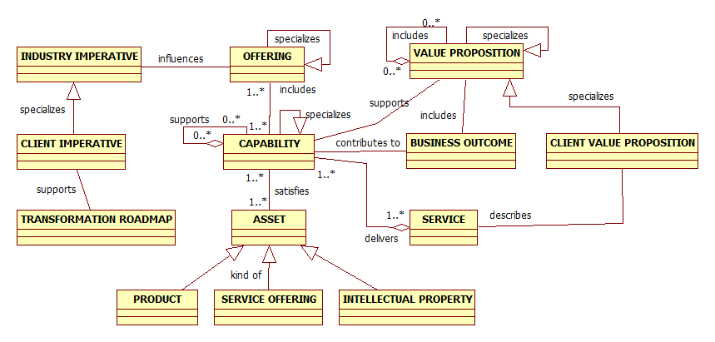
Figure 1. IBM Capability Relationship Model

Designing with Capabilities
Using the concept of Capability in Design requires the following.
- Understanding IBM Capabilities
- Understanding client capabilities and resource requirements
- Understanding the relationship between IBM and client capabilities
- Understanding sourcing model options

Understanding IBM Capabilities
An IBM Capability is not associated with a single IBM brand, but rather integrates assets from multiple brands. Capabilities may be offered to the market independently or as part of an Industry Solution. An IBM Capability is comprised of some combination of supporting capabilities and assets (products, service offerings and intellectual property).
IBM Capability example: Information Integration and Governance - Information integration and governance solutions from IBM enable organizations to distribute trusted information to those who need it - when they need it.
The following graphic illustrates the role of IBM Capability within the IBM Blueprint.
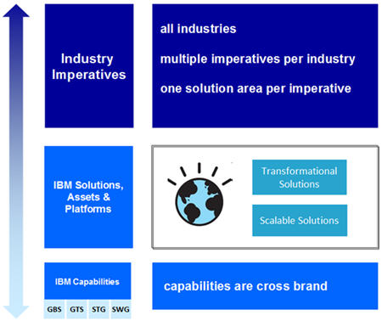
Figure 2. IBM Capabilities Role in the IBM Blueprint

Understanding Client Capabilities
The Unified Method Framework (UMF) contains a substantial amount of information on understanding client capabilities. To learn more, refer to the following UMF artifacts.
- Capability Description (BUS 414)
- Capability Analysis (BUS 345)
- Capability Assessment (BUS 316)
- Capability Enablers (BUS 317)
- Capability Assessment (BUS 415)
- Capability Model Definition (BUS 416)
In the ideal case, the client’s enterprise architecture would include a comprehensive capability model that can be consulted in the solution design process. If such a model is not present, it would be appropriate to encourage the client to retain IBM to conduct an appropriate enterprise architecture or strategy and change engagement which could develop the capability model. Lacking either of those options it will be necessary to construct a portion of the capability model, sufficient to inform the current scope of solution design. In this latter case, figure 3 provides a simple diagram for understanding what needs to be accomplished in designing with capabilities. This is summarized in the following steps.
- Identify the required new capabilities or capabilities that need to be improved. Note that in this simplified diagram, capabilities are not dependent on supporting capabilities. Often, the target capability may be an internal, IT oriented capability that supports other capabilities. If the client’s requirements reveal a need for a higher level business or external capability, it may be necessary build a more complex model including supporting capabilities. The IBM capabilities associated with the Blueprint would often be most useful in helping the client create or improve internal, IT oriented capabilities.
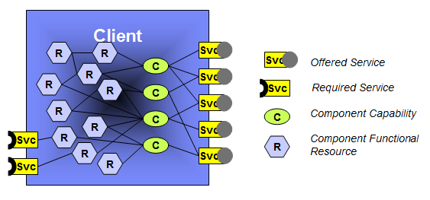
Figure 3. Basic Capability Model (SCN)
- Identify the services that will be offered as a result of these capabilities. This will be useful in selecting resources to satisfy the capability.
- Identify what resources are required to satisfy the capability.
- Identify what services are required to provide the necessary resources.
Note that figure 3 is highly simplified and depicts an entire client. The same diagram could be used to depict a sub entity such as a business component.

Understanding the relationship between IBM and client capabilities
The role of IBM is to help the client improve existing capabilities or create new capabilities. Figure 4 depicts the following general scenario.
- In response to general market segment needs, IBM develops a set of capabilities that are satisfied by assets such as Product, Service Offering and Intellectual Property. These capabilities support a value proposition.
- Based on the context provided by an industry imperative, IBM combines these capabilities to create an offering that addresses client needs and offers this as a service.
- The client fulfills their stated needs by requesting and contracting for service.
- In consuming the requested service, IBM assets are purveyed to the client to create resources necessary to satisfy their capabilities.
- The result is the creation or improvement of client capabilities that are in turn used to develop offerings for the market segment that they serve and produce a positive business outcome.
- These new or improved client capabilities may be internal or core capabilities that support externally offered capabilities.

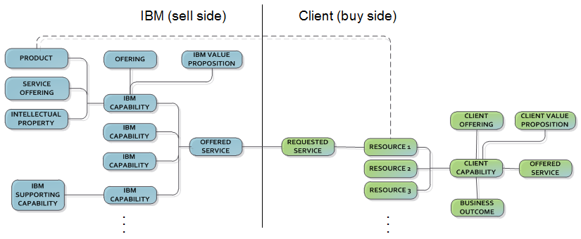
Figure 4. IBM and Client Capability Relationships

Sourcing Model Options
In providing for the creation of new capabilities or the improvement of existing capabilities, the client has options as to how to source the necessary resources or in some cases an entire capability. In the context of the IBM Blueprint, this is referred to as the Sourcing Model and is primarily considered from the perspective of the client. It represents the set of choices the client makes with regard to the specification of the logical capability’s resources necessary to create or change the capability. From the perspective of the client, there are two types of capabilities.
- Operational capabilities - capabilities needed to perform work for stakeholders (i.e. satisfy stakeholders' value propositions, such as customer satisfaction and shareholder profit.).
- Change capabilities - capabilities needed to create or change the characteristics of operational capabilities.

In order to create or change an operational capability, change capabilities are applied in the following stages.
- Plan:
  - Completely define the specification of the desired capability, including its role in a network of capabilities.
  - Identify at least one or more implementation options that have a reasonable chance of success
• Develop:
  - Explore/design and select from more detailed specifications and physical options for how the capability will be satisfied.
  - Develop the underlying implementation (aka solution) that will realize the capability’s specification.
• Implement:
  - Implement the underlying physical solution
  - Provision the solution and prepare for operational status.

In this final stage, change capabilities have been applied and implementation is complete.
• Operate
  - Operate the underlying solution in order to realize the capability.

Client Sourcing Model relationship to IBM Capabilities
The client has the responsibility for realization of their own required change and operational capabilities. In creating or changing capabilities, the client may elect to employ IBM Capabilities to augment or even outsource their own change and operational capabilities for all or part of any of the above stages. As defined in the IBM Blueprint, IBM capabilities typically include assets such as intellectual property, products and service offerings. A single IBM capability’s assets may be relevant for any of the above stages. In essence, IBM capabilities may be employed by the client to augment or outsource both change and operational capabilities that they feel unable or unwilling to maintain themselves. In addition, IBM may offer alternative delivery methods for a capability, specialized to the client’s particular needs as defined in their Sourcing Model.
Sourcing Model decisions
With respect to IBM Capabilities, the following example scenarios illustrate possible client Sourcing Model options.
- Employ no IBM capabilities.
- Employ IBM capabilities to augment their own change or operational capabilities. This would typically mean that the client would employ only certain aspects of an IBM capability.
  - Example: Employ IBM hardware and software products but no service offerings.
  - Example: Employ IBM service offerings for the Plan and Develop stages but not the Implement stage (as defined above).
- Employ IBM capabilities to outsource their own capabilities.
  - Example: IBM capabilities are used to accomplish all activities in the Plan, Develop and Implement stages (as defined above). Note that certain IBM capabilities may not include assets applicable to every stage.
- Employ an IBM capability but select delivery method options where they exist for certain aspects of the capability.
  - Example: Choose to host the client’s own capability resources (i.e. their application solution) using an IBM operational capability (i.e. a managed public cloud.)

Specifying Sourcing Model Options for IBM Capabilities
A sourcing model option exists for the client when an IBM capability includes more than one alternative for a certain aspect of the capability. IBM capabilities should specify when sourcing model (delivery method) options exist, enabling specialization of the capability to suit the client’s needs. For any IBM capability or sub-capability, it is a given that the client may choose to omit an asset or sub-capability to suit their particular needs. Consequently, this general case will not be specified in the IBM capability description. Examples of sourcing model options that could be specified include the following. IBM could host and operate a client application solution in an IBM data center. Alternatively, IBM could operate the client application solution which will be hosted on the client’s system in their own data center.
Specializing an IBM Capability
The following questions may assist in considering such specialization.
- Does the capability include a reference architecture and if so, how must it be adapted to reflect constraints in the client’s requirements or existing architecture?
- Which capability assets are not required in the proposed solution either because they are unnecessary or because the client prefers an alternative asset?
- What additional assets are required that are not normally included in the capability?
- In which of the stages above will the client require IBM service offerings to augment their own change capabilities?
- Which, if any, of the sourcing model options included in the capability are required by the client to augment or outsource their own operational or change capabilities?

Summary
Capabilities represent an additional perspective in understanding what the client is trying to achieve. While it is certainly possible to understand the client’s needs by examining business components and processes, capabilities represent a powerful language that can bridge business and technical domains. In time, it may be possible to develop a catalog of standard capabilities in a manner similar to the way we have developed component business models. That in turn would enable development of reference sets of resources that would enable maximum maturity for the client capabilities. Even without such reference sets, capabilities offer a powerful approach to establishing a traceable design expressed in language familiar to the client.
IBM capabilities can be helpful in this approach. In many cases, an IBM capability is a direct reflection of what the client needs as a core capability. Since IBM capabilities specify necessary assets, those assets would likely be primary candidates to implement the related client capability. What remains is to determine what core capabilities are necessary to support the client’s desired business and externally offered capabilities. Figure 5 illustrates an example of how these concepts are related in an overall design. Note that the chart does not necessarily contain actual Blueprint content.

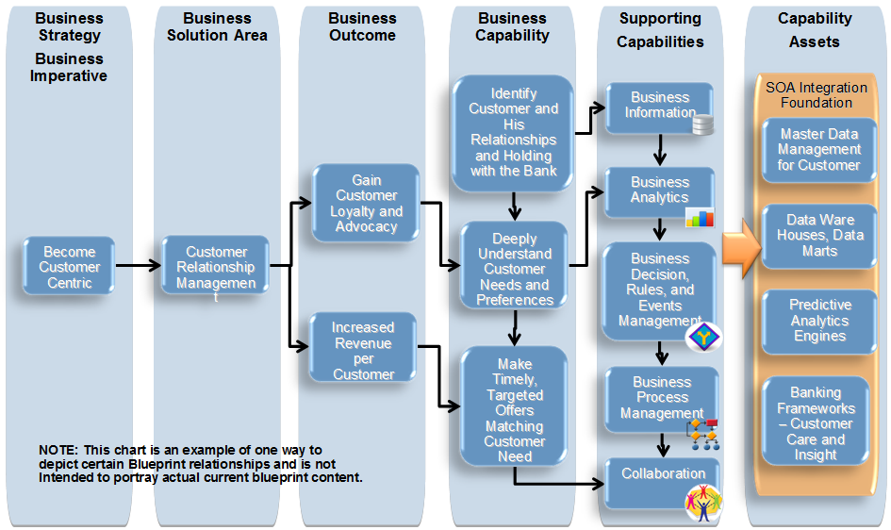
Figure 5. A summary view of concept relationships

Appendix

IBM Capability Relationships within the context of the IBM Blueprint
The following information provides additional detail on the relationship between the Capability concept and other adjacent concepts.
- Definition
  - A capability is defined as the ability of an organizational entity to perform some activity that provides value for itself or another entity. In the broadest sense, entity refers to an enterprise such as IBM or an IBM client. The term entity may also refer to some contained entity such as a business component as described in IBM’s Component Business Modeling.
- Examples
  - Capabilities may be internally focused such as the ability to “perform forecasting and demand management.”
  - Alternatively, they may be externally focused such as the ability to “provide overnight delivery”.
- Associations
  - specializes [Capability]: A specialized capability modifies the set of assets of the parent capability in response to a specific customer context. Examples of this include a specializing a generic capability to suit an industry or specializing an industry oriented capability to suit a particular client.
  - supports [Capability]: Some capabilities support other capabilities. Supporting capabilities may also be referred to as internal or core capabilities. Supported capabilities are sometimes referred to as external (or externally offered) capabilities if they are directly associated with a service provided to an external entity, outside of the enterprise.
  - supports [Value Proposition]: capabilities are defined and implemented to support one or more value propositions.
  - satisfied by [Asset]: Capabilities are satisfied by various combinations of resources such as process, organization, technology and information. In the Blueprint context, resources are combined in various ways and subsequently referred to as assets such as Product, Service Offering and Intellectual Property. When a capability is specialized, there is some variation in the set of assets which satisfy the capability.
  - included in [Offering]: Offerings consist of aggregations of one or more capabilities.
  - contributes to [Business Outcome]: Enabling or improving a capability contributes to an improved business outcome.

Significant credit is due to the following individuals for their advice in the development of the material in this guideline: Ian Charters. Skip Churchill, Kevin Daley, Gisbert Kruesemann, Daniel Oppenheim, Craig Rahenkamp, Daniel V Oppenheim, and Philippe Spaas.
Version Information

Revision Number | Revision Date | Summary of Changes | Author
1.0 | 06/30/2013 | Baseline version | Tom Seevers

The IBM Business Blueprint is a strategic initiative to implement a common go to market approach across IBM with a focus on solutions. The IBM Business Blueprint establishes a common set of concepts that enable clarity and cross brand integration in IBM’s capabilities and solution offerings. Several of these concepts have significant implications for pre-sale solution design. Additional information on IBM Blueprint Industry Imperatives may be found in Master Sales Kits at IBM’s Sales Support Information (SSI).
The Capability Model Definition (BUS 416) is used to construct the previously referenced Strategic Capability Network (SCN).

