

The Role of Enterprise Architecture in Solution Design

White Paper

© Copyright International Business Machines Corporation 2011

All Rights Reserved
Version 1.0, 05/2011
Introduction
There are numerous definitions of enterprise architecture and its practice and certainly little need to create yet another. The following definition of the EA discipline was created by experts in the IBM EA community.
“The EA discipline defines and maintains the architecture models, governance and transition initiatives needed to effectively co-ordinate semi-autonomous groups towards common business and/or IT goals.”
This definition is useful in the sense that this paper focuses on what is created in the practice of enterprise architecture and how it should influence solution design. The following quote from IBM’s EA educational material captures this idea succinctly.
“Enterprise Architecture constrains the individual project, for the benefit of the Enterprise”
Although not a perfect analogy, enterprise architecture is often compared to the concepts embodied in city planning. A city plan identifies the common infrastructure needed (streets, utilities, sports and cultural facilities, playgrounds, shops, banks, municipal services, etc.) and ensures they are made available. City planning also typically involves zoning restrictions that ensure that individual homes can be built in a compatible environment and have convenient access to streets and utilities. Some communities have protective covenants that go even further by constraining choices in size, building materials and even color. The quote above says it well. With Enterprise architecture, as with city planning, the enterprise does benefit, but while the individual project or solution design may be constrained, it also benefits by having access to the “utility aspects” and common infrastructure of the enterprise architecture that simplify development and integration of a new solution.
Although enterprise architecture should normally play a role in solution design, the following two cases depict examples (hopefully rare) of a plausible reason not to focus on existing enterprise architecture in solution design.
- In the first example, the client has explicitly established that the solution will be a completely greenfield effort. This means that for some business or technical reasons, the client believes there is value in creating a solution that has no dependencies on any existing enterprise architecture. Potential reasons may include the need for extremely fast development or an interest in using best of breed technology and design, not previously used within the current enterprise architecture.
- In the second example, client requirements and specifications are very complete and explicit and constrain the solution design in most important aspects. Although not necessarily true, this situation suggests that in effect the requirements and specifications reflect the existing enterprise architecture. In essence, key architectural decisions have been already made by the client and there is no need to consult their existing enterprise architecture.

In most other cases, enterprise architecture should ideally have a prominent role in solution design. This ensures that both the enterprise and the solution share in benefits such as common infrastructure and that the individual solution fits into the broader strategy in order to achieve common goals.

Using EA in Solution Design
The remainder of this paper focuses on how to take advantage of enterprise architecture in solution design. The following illustration depicts the relationship between enterprise architecture and solution design.
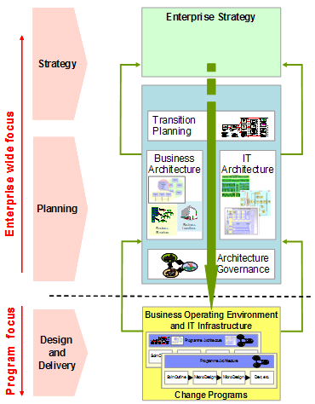
The ability to take advantage of enterprise architecture in solution design will vary according to the circumstances at the client. The following are examples of what one might encounter.
- The client has in place a well documented enterprise architecture, complete with active governance. This may be a rare occurrence, but In this case, the solution design process can derive full benefit from being informed by existing EA work products. This is the ideal case. in which one can use examples from the following section to identify the appropriate EA work product for guidance in solution design.
- The client has some level of enterprise architecture, but it is not complete or well documented. In this case, there may be no documented EA work products to refer to, but it is still important to understand whether there are deliberate aspects of an enterprise architecture that may exist. There is always an enterprise architecture. Whether it is deliberate, elegant or effective is another matter. The suggested approach in this case is to investigate what enterprise architecture may exist by using the appropriate EA artifact to guide your research with the client. It may also be helpful in such cases to record what exists, even though it may be a partial result. This documentation may be helpful in followon projects and may even influence the client to more formally document their enterprise architecture.

The following table illustrates how various EA work products might influence activities with Team Solution Design. The relationship to an activity is indicated only for the activity where the influenced work product is first created. When an indication of influence is indicated for more than one activity (ex: Business Drivers (BUS 314)), it is because the influence relates to more than one TeamSD work product.

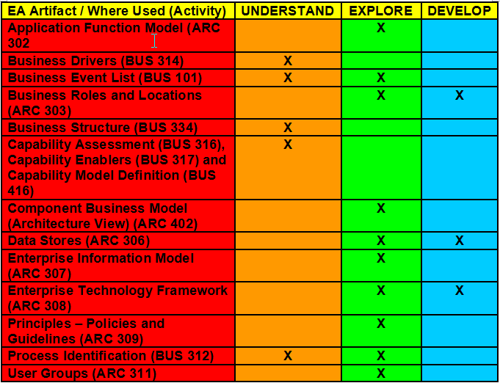
The following table illustrates examples of EA work products and how they might influence solution design with respect to specific TeamSD work products. The list contains the EA work products most likely to have an influence on one or more TeamSD work products..

EA and Solution Design Relationships
EA Artifact Name and Description | Relationship to Team Solution Design Artifacts
Application Function Model (ARC 302) The Application Function Model identifies and defines the major groups of business function that are required in order for the enterprise to meet its business objectives. | Component Model (ART 0515) The Application Function Model is helpful in understanding what functions are necessary for a solution and how current or proposed applications fulfill the required function.  Strategic Roadmap (BUS 326) The Application Function Model is helpful in identifying specific application function that requires change as a part of a Transformation Initiative.  System Context (ART 0651) The Application Function Model provides context for a solution by outlining the functional boundaries (which business function are we changing) and identifying relevant external systems (system actors) to interface with.
Business Drivers (BUS 314) The Business Drivers work product identifies the top business issues, challenges, imperatives or priorities for the enterprise. They can be thought of as high level immutable requirements, which the strategy and its infrastructure (business and IT) must support. | Business Direction (BUS 411) Business drivers, especially those which are external are an important influence on business vision, goals, mission and strategy.  Client Imperative (ART 0696), Strategic Roadmap (BUS 326) Business drivers may be helpful in understanding the motivation behind a particular client imperative and development of an appropriate solution strategy and associated transformation initiative.
Business Event List (BUS 101) This work product is produced to identify the different business transactions that the business must be able to handle. It also identifies information flowing between the external involved parties and the business. | Business Direction (BUS 411) Business events are a part of the Business Context Diagram which is an optional part of Business Direction.  Non Functional Requirements (ART 0507) Business events may provide important metrics regarding transaction rates.  System Context (ART 0651) External business events are a potential source of information about responsibilities of the target system and requirements involving external agents, access mechanisms and exchanges.  Use Case Model (ART 0508) Business events are a potential source of information about the type and nature of use cases that should be modeled.
Business Roles and Locations (ARC 303) Business Roles and Locations are used to understand how business activities and information should be deployed relative to the enterprise business structure. | Operational Model (ART 0522) Provides a framework for the placement / deployment of applications, data & technology for use in development of the Operational Model.  Use Case Model (ART0508), System Context (ART 0651) Understand and define the roles and user groups
Business Structure (BUS 334) The Business Structure analysis will identify the requirements for a business architecture that is aligned to the strategy. This business architecture will identify the sub-processes, the deployment architecture (centralized / dispersed, shared / replicated) of those sub-processes and the business capabilities that the company needs to implement to support its strategic configuration. | Business Direction (BUS 411) Business Structure provides information regarding business process that may be helpful in development of the Business Context Diagram which is an optional part of Business Direction.
Capability Assessment (BUS 316), Capability Enablers (BUS 317) and Capability Model Definition (BUS 416)  (Bus 316) The purpose of the Capability Assessment work product is to establish the relative strengths and weaknesses of business or IT capabilities against a desired future state or value proposition. This assessment is the foundation for selecting and assessing processes, organization and technology that enable each capability.  (BUS 317) This work product is produced in order to identify and prioritize the enablers based on the critical capabilities necessary to deliver the targeted customers’ needs and wants.  (BUS 416) This work product defines and documents existing and new business capabilities. The information in a Capability Description is necessary for a variety of subsequent analyses including assessing capabilities, identifying the leverage across a set of new business initiatives, identifying extra-firm sourcing, refining business model design, defining the business models that can implement a new business initiative and other kinds of analyses. | Business Direction (BUS 411) The set of Capability artifacts may provide insight for Business Direction as it may also contain a list of distinctive competencies, critical capabilities, tactics or key projects to deliver capabilities (enablers).  Client Imperative (ART 0696) When the defined client imperative is related to business capabilities, (BUS 316) and (BUS 317) provide valuable insight when developing the solution strategy. Capability enablers will likely be closely tied to tactics defined in the solution strategy. The overall Capability Model Definition includes focus on the value proposition associated with a business capability. This may be helpful when defining the business benefits of the client imperative.
Component Business Model (Architecture View) (ARC 402) The architecture view of a component business model defines and documents the functional and operational structures of a business from a viewpoint suitable for those who require a detailed insight into the responsibilities, relationships and interactions between the model’s business components. | Component Model (ART 0515) This more detailed view of the Component Business Model can provide substantial insight into component interactions for those IT components supporting automated aspects of business activities and business component interactions.
Data Stores (ARC 306) The Data Stores work product identifies, describes and groups business data in terms of its characteristics. | Component Model (ART 0515), System Context (ART 0651) The Data Stores work product is helpful in understanding which business information is relevant for a solution and which current or proposed applications (should) own and provide access to certain groups of data.  Operational Model (ART 0522) Provides information that is helpful in defining enterprise-wide rules, polices and guidelines on data access, sharing, placement and management.  Strategic Roadmap (BUS 326) The Data Stores work product is helpful in identifying specific data architecture changes (consolidation / integration / reorganization) required as a part of a Transformation Initiative.
Enterprise Information Model (ARC 307) The Enterprise Information Model provides a strategic overview and understanding of the major high-level groups of information needed to manage the business and support the processes in the process definitions. | Subject Area Model (APP 408) The Enterprise Information Model will contains a high level subject area diagram and/or a high level ERD that provides input for developing the Subject Area Model for a particular solution.
Enterprise Technology Framework (ARC 308) This work product is used as a repository for all information about the IT capabilities and enablers required to implement the desired business objectives and capabilities. | Component Model (ART 0515), Operational Model (ART 0522) The ETF provides guidance in selection of components (including any relevant technology / product standards) based on pre-established architectural building blocks (ABBs).  Strategic Roadmap (BUS 326) The ETF is helpful in identifying specific infrastructure that requires change as a part of a Transformation Initiative.
Principles – Policies and Guidelines (ARC 309) Principles are used to capture the fundamental, underlying truths about how the organization will utilize and deploy both business and information technology assets and resources. They provide an effective framework within which the business can start to make conscious decisions about the business, its management style and structure and how it uses/implements Information Technology | Architectural Decisions (ART 0513) Previously documented principles may provide input for architectural decisions. You may choose to develop other principles in collaboration with the client that may have enterprise implications.
Process Identification (BUS 312) The Process Identification work product identifies and describes the processes necessary to execute the organization’s business at the organizational, operational or transactional levels depending upon the requirements of the project. | Business Direction (BUS 411) Process Identification provides information regarding business process that may be helpful in development of the Business Context Diagram which is an optional part of Business Direction.  Use Case Model (ART 0508) Process Identification provides source of information that may be helpful in identifying tasks and activities within the Use Case Model.
User Groups (ARC 311) The User Groups work product combines business roles into categories of users with similar characteristics, IT experience and usage requirements. | System Context (ART 0651) User groups can provide information regarding external agents modeled as Users.  Use Case Model (ART 0508) User Groups provide source of information that may be helpful in identifying actors within the Use Case Model.

Version Information

Revision Number | Revision Date | Summary of Changes | Author
1.0  1.2 | 5/31/2011  3/12/2012 | Initial version  Corrected artifact/activity table, changed Client Challenge name to Client Imperative. | Tom Seevers  (With valuable contributions from Gisbert Kruesemann)

“Enterprise Architecture in the Era of on Demand”, IBM Academy of Technology Study AR-221, Ian Charters, Yoshio Tozawa, January 2005

