

The Role of Patterns in Solution Design

Guideline

© Copyright International Business Machines Corporation 2013

All Rights Reserved
Version 1.0 June, 2013
Brief Description
This guideline describes the role of Architectural Patterns in Solution Design.
Main Description

Introduction

As early as 25 BC, Marcus Vitruvius expressed the essence of good architecture as taking into account strength, utility and grace. From the earliest times, patterns played a role in recording successful approaches to achieving good architecture. Perhaps one of the earliest patterns dealt with how to accommodate an opening in a wall. The post and lintel pattern can be seen in some of the earliest examples of building architecture and of course plays a role in buildings today. Just as in building architecture, patterns play a key role in many aspects of design in contexts ranging from clothing to electronics to IT systems.

In the context of IT solutions, patterns have long been available. The book Design Patterns documents relatively fine grain patterns proven to be useful in program design. The book Patterns for e-Business documents relatively large grain architectural patterns. A Wikipedia entry offers this definition of an architectural pattern in the context of IT solutions. “An architectural pattern is a general, reusable solution to a commonly occurring problem in software architecture within a given context.” This guidance will illustrate brief examples of medium grain architectural pattern usage in the information domain of IT solutions. Examples and some content are derived from the book Patterns of Information Management.

Pattern Characteristics
An architectural pattern defines a proven approach to solving a problem. The solution described in the pattern is typically a set of components that are interacting in a particular configuration. The pattern explains why this approach works, its associated trade-offs, and resulting benefits and liabilities
In general, the patterns discussed in this guidance have the following characteristics.
- Written in English. This means there are no special tools needed to make use of them.
- Assimilate a wide range of information together.
- Lay out choices and how to make them – pros and cons – along with suggestions on how to mitigate against any liabilities that the pattern introduces.
- Provide a worked example and references to known uses. This helps understanding in how the pattern works and where is should be used.
- Linked together into a comprehensive description of topic area. Patterns that are linked together in this way are collectively called a pattern language.
- Explains the emergent properties of using a particular solution. These are the properties that emerge when components are integrated together in a certain way. They describe the change in many non-functional characteristics of the individual components such as latency, reliability, scalability that are a result of the way the components are connected together.
Patterns typically follow some common format. The format of the patterns discussed in this guidance follows one of the formats recommended by The Open Group Architecture Framework (TOGAF®) with the following subsections:
- Context— The situation where it is appropriate to consider using the pattern
- Problem— A description of the problem that this pattern solves
- Example— An example of the problem
- Forces— The factors that make this problem hard to solve
- Solution— A description of solution components and how they are assembled together
- Consequences— The benefits and liabilities of using the solution
- Example Resolved— How the example described is resolved using the pattern
- Known Uses— References to well-known technologies and approaches that support
- Related Patterns

Pattern Example
One of the many patterns included in the Patterns of Information Management is the Information Mirror Store as summarized in Figure 1. This summary is called a patlet. It shows the name of the pattern and a short description of the problem and solution. This pattern language follows a popular trend in that it also provides an icon to act as a visual reminder of the pattern’s function. This can be used in white-boarding and other diagrams to show where the pattern has been applied.
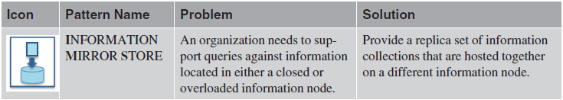
Figure 1. The Information Mirror Store pattern
The following are partial examples of pattern content for the Information Mirror Store. Notice that the appropriate summaries from the patlet are included as the first line of the problem and solution sections in bold.
Context
An organization has many information nodes supporting its day-to-day business.
Problem
An organization needs to support queries against information located in either a closed or overloaded information node. An existing information node contains valuable information required by other parts of the information supply chain. However, this information node is not able to support remote queries of its information collections from other information nodes.
Forces
- Overloaded information node — Calls to an information node’s services create a processing load on the information node.
- Information formatted for original use — One of the reasons the original source information may be hard to query is that it is formatted to suit its primary local use cases and this is not compatible with the remote queries.
Solution
Provide a replica set of information collections that are hosted together on a different information node. The information mirror store is an information store that hosts the replica information collections as seen in Figure 2. These information collections can be populated as follows:
- Regular SNAPSHOT PROVISIONING that takes a fresh copy of the information from the original information node and completely replaces the replica information collections.
- After an initial load of the original information, the replica is kept up to date with delta updates using MIRRORING PROVISIONING (pattern). This approach can only be used if it is easy to detect which values have changed since the last time the information mirror node was refreshed. The approach used will depend on how frequently each of the values in the information is changing.
Consequences
Benefits:
- The information mirror store is able to support information services that provide access to the information without impacting the original information node. The information can be reformatted as it is synchronized into the information mirror store to better support the queries.
Liabilities:
- The information mirror store takes additional storage and needs to be kept synchronized with the original information node.
Related Patterns
An Information Broker is necessary to host the information processes that will maintain the information in the information mirror store. Figure 2 illustrates common pattern relationships for the Information Mirror Store pattern.
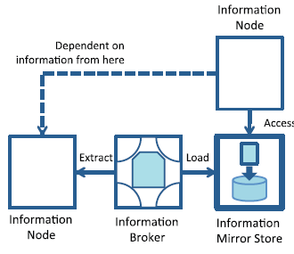
Figure 2. Interaction of an Information Mirror Store with other information nodes.

Pattern Language Structure
One of the characteristics of a pattern is that it may also link to other patterns. These linked to patterns may:
- Provide an alternative approach
- Provide a complementary capability
- Describe an approach to implementing a component that is named in the pattern’s solution
This linking together of related patterns creates a pattern language. Every pattern in the pattern language has a name that summarizes the solution it represents. This means that appropriate pattern names can be included in the description of the pattern and their relevance to this pattern is obvious.
Related patterns are also grouped together to aid the selection of the best pattern to solve a particular problem. The Information Mirror Store pattern is part of a group of patterns entitled Information Node. These patterns describe different types of servers for managing information. There is a generic pattern named after the group that describes a generic server and the rest of the patterns in the group are specialized servers. The information node pattern is in turn is part of a larger pattern language structure. Figure 3 illustrates the pattern language structure for the Patterns of Information Management. The icons and pattern names in the structure refer to each of the pattern groups in the pattern language. Seeing the pattern groups in this structure shows the breadth of factors that an architect needs to consider in order to achieve a clean, correct, and flexible information design.
At the top of the pyramid, you see the organization and the people who work within it. They drive the information strategy. The organization is supported by the information architecture, which is implemented by the information management components. Overall, this pattern language and structure offer the following benefits.
- The pattern names define a vocabulary to discuss issues and technology options related to information architecture, governance, and management. The pattern names become the nouns and verbs of your design discussions, enabling you to characterize and choose between the options available.
- The pattern icons can be used in whiteboarding sessions and for documenting design decisions in reference architectures and solution specifications.
- The pattern descriptions provide design guidance for specific information supply chains and solutions.
- The pattern language provides a foundation for setting architectural standards and reference architectures. An organization can select the patterns it wants to support and develop reference implementations for them.
- The pattern language provides material for education and training in information architecture.
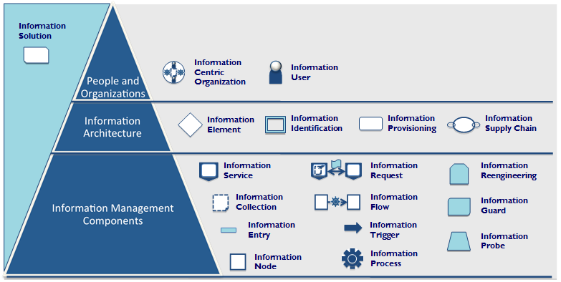
Figure 3. Patterns of Information Management: Pattern Language structure

Using Patterns in Solution Design
Patterns can be especially helpful in high level solution design. Using the Patterns of Information Management as an example, the following Team Solution Design tasks can benefit from consulting patterns.

Task: Identify High Level Data Sources
Purpose: The purpose of this task is to identify and describe at a high level, data sources that are relevant to the proposed solution. This will contribute to an understanding of architectural aspects that are necessary to reuse existing data sources and an understanding of what additional data sources may be required. This task will also enable a more complete understanding of component responsibilities that include subject areas.
Applying Patterns:
- When assessing data sources, it is necessary to understand their content and how they are used. The Information Collection patterns group provides some classification patterns (See figure 4).
- These patterns can be used to classify each individual data source – and from that determine what is necessary to keep them synchronized.
- The classification can also be used to verify that the information is flowing in a governable information supply chain. The information supply chain is one of the pattern groups that use the classification of the information collections to highlight whether information is flowing through the systems in an appropriate order.
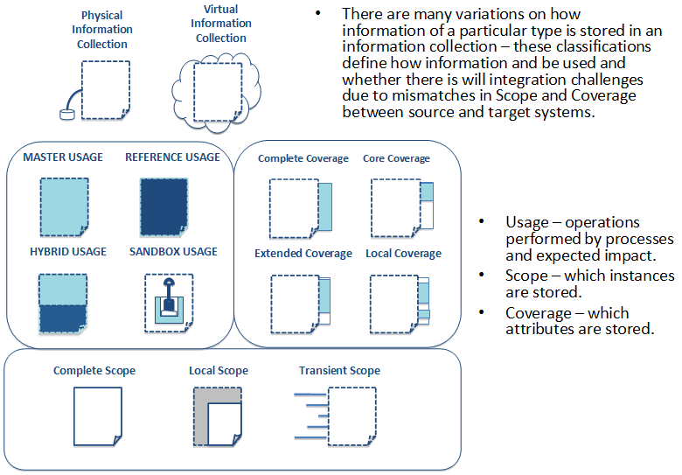
Figure 4. Information Collection Patterns

Task: Document Architectural Decisions
Purpose: The purpose of this task is to identify and document important architectural decisions where alternatives exist, choices are unclear and impact is likely significant.
Applying Patterns
- Use the stated issue or problem to select the appropriate pattern group. For example, the problem may be stated as “how is data to be supplied to a new process?” This would suggest you need the Information Provisioning pattern group.
- Use the patterns in the pattern group to consider the alternatives and make a choice
- Use the points from the discussion with the consequences section to document the decision and rationale.

Summary
Patterns are a powerful tool to take advantage of best practices in architecture. Patterns are similar to an Architecture or Solution Brief that is focused on a small, specialized topic. Patterns often contain elements that could be viewed as logical components that could be helpful in developing a logical component model. Patterns are typically independent of any specific technology and as a result contribute to durable architecture. When appropriate patterns are available, they should be consulted during solution design.

Appendix
The following are additional references for architectural patterns.
developerWorks: Patterns of Information Management
Martin Fowler, Patterns of Enterprise Application Architecture, (Boston, MA, Addison-Wesley, 2002).
Gregor Hohpe and Bobby Woolf, Enterprise Integration Patterns: Designing, Building, and Deploying Messaging Solutions (Boston, MA, Addison-Wesley, 2003).
Thomas Erl, SOA Design Patterns (Prentice Hall/PearsonPTR, 2009).
Martin Fowler, Analysis Patterns: Reusable Object Models (Boston, MA Addison-Wesley, 1997).
David C. Hay, Data Model Patterns: A Metadata Map (San Francisco, CA, Elsevier, 2006).
Charles T. Betz, Architecture & Patterns for IT (Waltham, MA Morgan Kaufmann, 2011).
Frank Buschman, et al., Pattern Oriented Software Architecture, (multiple volumes)
Pattern Languages of Programs (PLoP) Conferences (multiple volumes)
Version Information

Revision Number | Revision Date | Summary of Changes | Author
1.0 | 06/30/2013 | Baseline version | Mandy Chessell, Tom Seevers

Erich Gamma, et al., Design Patterns: Elements of Reusable Object Oriented Software, 1994, Addison-Wesley
Jonathan Adams, et al., Patterns for e-Business, 2001, IBM Press
Mandy Chessell and Harald Smith, Patterns for Information Management, 2013, IBM Press
http://www.togaf.info

