Subject Area Model Elaboration for TeamSD

Guideline

© Copyright International Business Machines Corporation 2011

All Rights Reserved
Version 1.0 May 2011
Brief Description
This guideline provides a brief introduction to Subject Area Model elaboration which illustrates data item (entity) relationships using basic entity relationship diagrams.
Main Description
In its basic form, the Subject Area Model simply a set of subject areas and associated data items. Data item is a term used in System Architect for TeamSD (SA4TeamSD) and is broadly equivalent to the term “entity” as used in data analysis/modeling. An example of a subject area and its associated data items from the insurance industry is shown in figure 1 below.
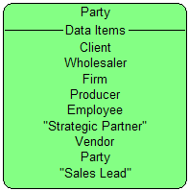
Fig. 1. Party subject area
It is also helpful to provide a description for each subject area or data item. The following are examples of data items from the “Party” subject area shown in figure 1.
Data Item | Description
Party | A person or an organization. An organization includes firms and subsidiaries, as well as organizational units such as branches, departments, and informal groupings.
Producer | A channel role, played by an individual of either the carrier or an external firm, representing the selling and servicing of insurance policies and financial services contracts.
Note that if the client has established robust enterprise architecture, necessary subject area information may already exist. IBM’s Enterprise Architecture Method uses the Enterprise Information Model (ARC 307) to document subject areas and data items. Typical subject area information may also be available within industry reference architecture.
In a typical pre-sale context, the primary use of the subject area model is to help identify candidate data sources and additional solution requirements that will result from the analysis of these data sources. In many cases, the details of this data are left to implementation activities, especially if the data already exists in a useable form. In some pre-sale situations, it may be necessary to provide additional elaboration of the Subject Area Model. Possible examples include:
- Data items identified in one or more subject areas are not currently available in existing data sources.
- The proposed solution will require changes to current data items or their relationships.
- A more complete understanding of data relationships is necessary to design and validate the proposed solution.
In any of these cases it may be helpful to elaborate on the Subject Area Model by documenting certain data relationships. Such documentation is an optional part of the Subject Area Model, but it is the beginning of what will evolve to a Data Model. Although typically not as detailed, this documentation is similar to the beginning elaboration of the Data Model as defined in (ART 0519). It is also similar to the previously mentioned Enterprise Information Model (ARC307). Subject Area Model (APP 408) suggests that a subject area model may also be thought of in a general sense as a conceptual data model. This approximate equivalence would require some elaboration of a basic subject area model. More specifically, in guidance associated with Data Model (ART 0519), levels of elaboration are shown as illustrated in figure 2.
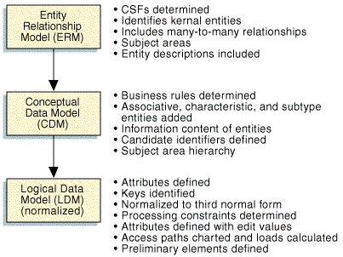
Fig. 2. Data Model levels of elaboration from (ART 0519)
The elaboration of the Subject Area Model described in this guideline can include aspects of the Entity Relationship Model and may extend to include some aspects of the Conceptual Data Model, such as subtypes as referred to in figure 2. In essence, this degree of elaboration focuses on modeling the data items and their relationships to a level at which they may be thought of as entities, thus the term Entity Relationship Model.

Note to System Architect (SA4TeamSD) users: As mentioned previously, System Architect refers to “data items”. As the subject area model is elaborated on and its data items take on more concrete form and inter-relationships, it is helpful to be familiar with the equivalent terms used in data modeling, as you may want to consult data modeling guidance which commonly uses other terms. As mentioned previously, under certain circumstances the term “data item” as used in System Architect may be considered equivalent to the term “entity” as used in data analysis/modeling. Some authors distinguish between these two terms in the following way. Entity is used to refer to something in its real world context such Salesman. Data Item would then be used to refer to how information about the Salesman is instantiated in an IT context. Although not a typical part of subject area model elaboration, System Architect also models “data elements” which are equivalent in the same sense to the term “attribute” as used in data analysis/modeling.
Elaborating the Subject Area Model
As previously mentioned, detailed elaboration of a Subject Area Model has a strong similarity to the Entity Relationship Model described in Data Model (ART 0519). Consequently, this paper will use terms used in that artifact.
Subject Area Modeling elaborates to Data Modeling
Subject Area remains Subject Area
Data item becomes entity
Data Element becomes attribute
The explanations here will be at the introductory level. For further information, refer to (ARC 307) or (ART 0519) and associated guidance.
- Identify pairs of entities as established in the basic subject area model that have a relationship which is relevant to the proposed solution. These entities may be in the same or different subject areas. Entities are represented graphically as a rectangle with the entity name. More advanced data modeling would include additional information such as attribute names.
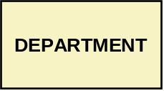

Fig. 3. Example of entity representation
- Identify the type of relationship appropriate for the pair. There are two basic types of relationships. There is the general case where two primary entities have a relationship, as in the case of EMPLOYEE and DEPARTMENT, where we might say that an employee is assigned to a department. In the second case, the entities might be EMPLOYEE and INSTRUCTOR, where INSTRUCTOR is a special case of EMPLOYEE. This latter case is sometimes referred to as generalization/specialization. The EMPLOYEE entity is also sometimes referred to as a secondary or subtype entity.
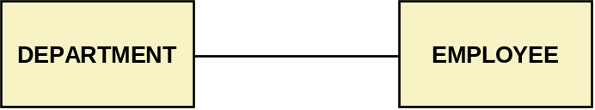
Fig. 4. Example of a primary entity relationship
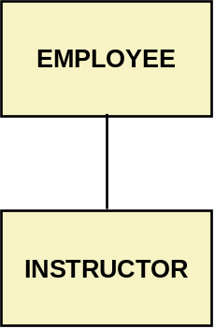
Fig. 5. Example of specialization or subtype relationship
- For primary entities, determine the cardinality of the relationship. For example, if a department can have many employees, you could say the relationship is 1 to many. In practice, this sort of information will be derived from business analysis as the subject areas and entities are discovered. For example, you may have learned that an EMPLOYEE could have appointments in more than one department. In that case, the relationship would be portrayed as many to many.
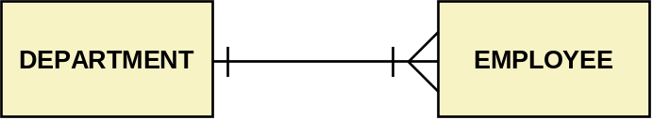
Fig. 6. Example of relationship cardinality
The example in figure 5 illustrates the case where a department can have anywhere from one to many employees. Conversely, the employee can only be associated with one department. The notation used in figure 5 is variously referred to as “crow’s feet”, Martin or IE notation and is used in (ART 0519) guidance. There are several other types of notation available. If you are using a tool such as System Architect, the notation may be prescribed for you. Figure 6 illustrates the fundamentals of this notation.

Notation | RELATIONSHIP interpretation (From Left to Right)
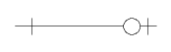 | Represents a “one to zero-or-one (minimum of zero and a maximum of one)” relationship between two entities
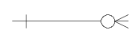 | Represents a “one to zero-or-many (minimum of zero and a maximum of many)” relationship between two entities
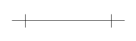 | Represents a “one to one (minimum of one and a maximum of one)” relationship between two entities
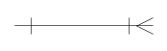 | Represents a “one to one-or-many (minimum of one and a maximum of many)” relationship between two entities
Fig. 7. ER notation (source: ART 0519 guideline)
This example is intended to provide very basic introductory guidance on Subject Area Model elaboration. Refer to associated guidance for a more complete example.

Appendix
The following is an example of a documented subject area model using System Architect (SA4TeamSD). The example is derived from The MyBank example encyclopedia.
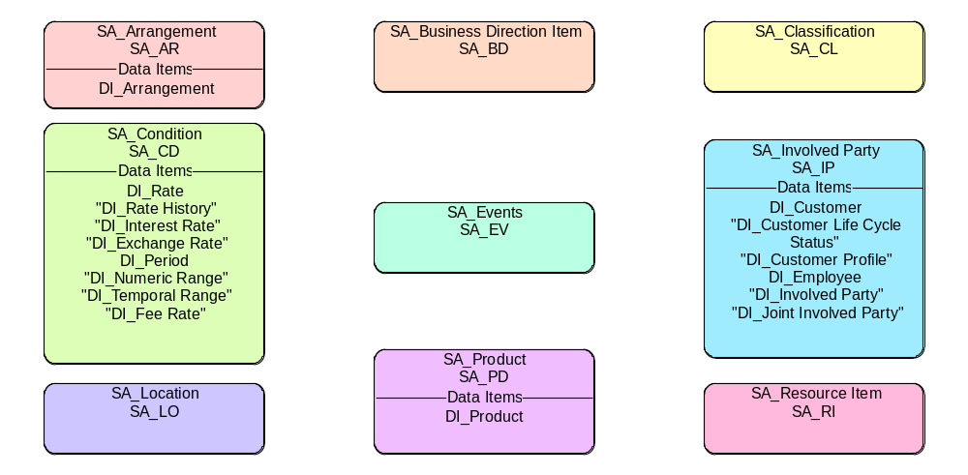
Fig. A.1 MyBank Subject Area Model
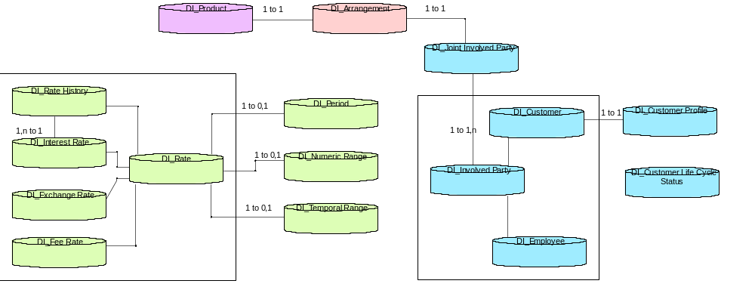
Fig. A.2 MyBank Data Elements and Relationships

Version Information

Revision Number | Revision Date | Summary of Changes | Author
1.0 | 05/31/2011 | Baseline version | Tom Seevers  [With valuable contributions from Ian Charters]

Data items may be thought of as entities in the early stages of development; in general, they will be less well defined, coarser grained and have fewer, higher level relationships.
While data items can be in many subject areas, therefore enabling data analysis from many viewpoints; it is more likely for entities to be in only one subject area, given the data model’s focus is usually specific to one viewpoint.
In SA4TeamSD, this is referred to as the “Data Item Relationship”
In SA4TeamSD, this is referred to as the “Data Item Super/Sub Rel [ationship]”.
See appendix for an example created using System Architect (SA4TeamSD).

