Service Model
Template
For Team Solution Design

Author: IBM
Owner: IBM

Contents
1. Introduction 3
2. Service Model for Team Solution Design 5
2.1 Service Portfolio 5
2.2 Service Hierarchy 6
2.3 Service Dependencies 7
2.4 Service Composition and Flow 8
2.5 Service Model Template Detail 9

Introduction
The Service Model augments other Work Products in Unified Method Framework by capturing information related to services that is not captured in other work products. Information documented in the Service Model is the result of work that spans the identification and specification of services as well the decision-making that is needed to support service realization.
This template is an abbreviated version of the Service Model templates associated with the Service Model artifact and its sub-artifacts in SOMA. In a typical pre-sale scenario, less detail is required. This template includes the typically required subset of content extracted from templates for the three sub-artifacts of the Service Model. In many cases, this template should be sufficient for pre-sale activity. For unusually complex situations requiring higher levels of elaboration, the Technical Solution Architect may wish to refer to the Service Model sub-artifacts and their associated templates. In such cases, also consider requesting assistance of a Subject Matter Expert.
The following table (Table 1: Service Model Detail) illustrates the subset of Service Model sections that are typically required in a pre-sale context. This template for Team Solution Design users contains information only on these sections.
- In a typical pre-sale environment, only the four sections outlined in red may be required. This template for Team Solution Design users contains information only on these sections.

Section | Description | Service Model Sub-Artifact
Service Portfolio (Required for this template) | List of candidate services discovered during SOMA service identification activities. | Service Portfolio
Service Hierarchy (Optional) | Candidate services organized using a business significant categorization scheme, making evaluation of candidate service more manageable. Domain Decomposition Functional Area Analysis typically provides the classification scheme. | Service Portfolio
Service Dependencies (Optional) | Documents dependencies between services in the model. | Service Dependencies
Service Composition and Flow (Optional) | Identifies which services are choreographed together to form a composite service. | Service Dependencies
Table 1: Service Model Detail
For additional detail on these or other sections of Service Model, refer to the full templates for the Service Model and each of its sub-artifacts.
See Guideline: SOA Architecture Design for Team Solution Design to understand how to use the standard Team Solution Design work products to capture:
- Service non-functional requirements in Non-Functional Requirements or Requirements Matrix
- Realization Decisions in Architectural Decisions and their impact on Architecture Overview, Component Model or Operational Model.

Service Model for Team Solution Design

Service Portfolio
There are three techniques available to identify these existing or potential new services:
1. Domain Decomposition: a top-down business-driven decomposition of a business domain, from the business aspect to IT aspect as shown in Figure 1. Note that when a Component Business Model exists, CBM competencies can be treated as domains.
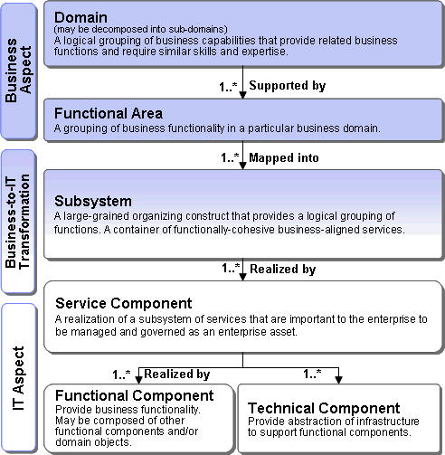
Figure 1: Domain Decomposition

2. Existing Asset Analysis: a bottom-up analysis that examines assets such as existing custom, packaged applications, and industry models, to determine what can be leveraged to realize service functionality. These existing assets might already contain existing services or might help us identify new services.
3. Goal-Service Modeling: an analysis that starts with Business goals that are decomposed into sub-goals and supporting services. Key performance indicators and associated metrics are identified to measure the attainment of sub-goals through the services identified. Goals, sub-goals, and key performance indicators may have already been captured in Project Definition.

For simplicity the Service Portfolio can initially be represented as a list of candidate services as shown in Figure 2.
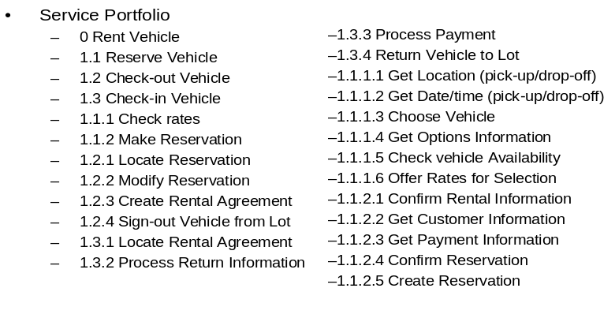
Figure 2: Service Portfolio - initial service list

Service Hierarchy
As the number of candidate services increases, an unstructured list can quickly become unmanageable. Therefore, a service classification scheme (hierarchy) should be identified so that candidate services can be organized into groups within the classification hierarchy. Although this is rarely the case in a pre-sale situation, even a few services might be benefit from being described using a hierarchy. Another situation might be when existing services must be analyzed to identify a few relevant services.
The Service Hierarchy organizes services in the service portfolio using a uniform classification scheme. The classification scheme is often based on the functional areas identified by Domain Decomposition, Existing Asset Analysis or Goal Service Modeling (as described above).
Notation for the Service Hierarchy is an outline format as shown in the example in Figure 3.

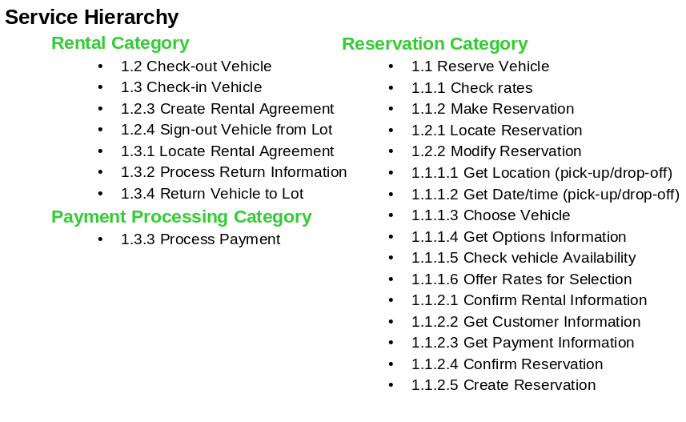
Figure 3: Service Portfolio organized using a classification hierarchy
While a simple list of service names can be a quick starting point, it will eventually be important to capture additional information about each service.

Service Dependencies
Since services are used in the context of business processes, the Project Definition work product is an important input to the understanding of dependencies, composition and flow. Analysis of how services are used in the context of business processes leads to the identification of how specific combinations of services are used.
Service dependencies describe the relationships between services that arise in the larger context of how they will be used. When a service is formed from a composition of other services, the composing service depends on the composed services. When services are used in the context of a business process, there is a process related dependency that arises from the inherent sequence of steps in the business process that dictates the order in which services will be used. These two types of dependency scenarios are shown in Figure 1:
- Functional dependencies (“Type 1”) that arise from composition of multiple services.
- Temporal dependency (“Type 2”) where there is some pre- or post- condition or processing requirement that will need to be accounted for in compositions or choreographies.
Dependencies can be represented visually with accompanying text that describes the nature of the dependencies. One style for diagramming dependencies is shown in Figure 4. For functional dependencies a UML component relationship diagram can also be used. For processing dependencies a UML sequence diagram can be used.

Service Dependency Type 1 | Service Dependency Type 2
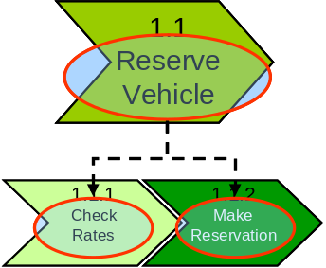 | 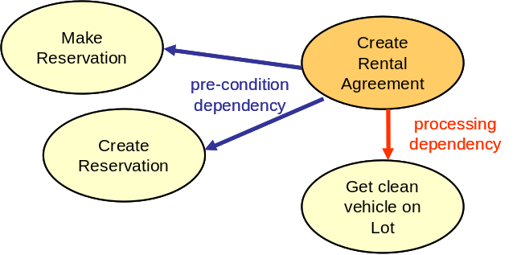
- Functional Dependency/Composite Dependency: Reserve Vehicle will depend on Check Rates and Make Reservation for its functionality | - Pre-condition dependency – i.e. another service invocation must have executed successfully before the current invocation can begin execution.  - Processing dependency – i.e. another service invocation is required to complete the successful execution of the current service.  - Post-condition dependency (not shown) – this appears in cases where a service requires another service invocation after its execution.
Figure 4: Types of Service Dependencies

Service Composition and Flow
Service composition can be used to support short running, non-interruptible, as well as long running interruptible processes. The flow of Service composition can be represented visually using the approach shown in Figure 5: Service Composition, with accompanying text that describes the composition. Each composition should be named so that it can be referred to in the State Management Decisions section.

A. Short running, non-interruptible process (micro-flow) | B. Long running , interruptible process  (macro-flow)
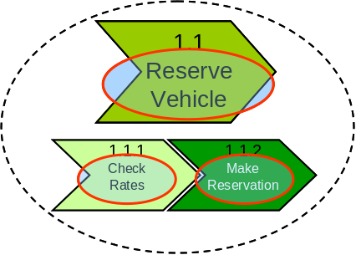 | 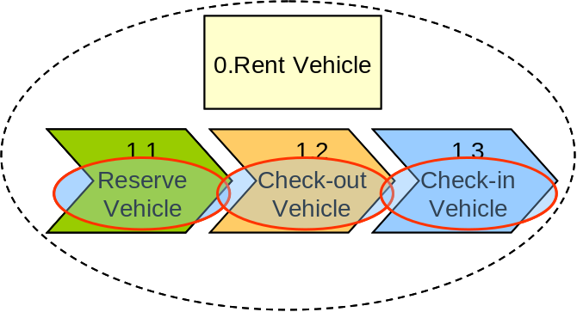
Reserve Vehicle is composed of:  - Check Rates  - Make Reservation | Rent Vehicle is composed of:  - Reserve Vehicle  - Check-out Vehicle  - Check-in Vehicle
Figure 5: Service Composition and Flow

Service Model Template Detail
The purpose of the Team Solution Design Task: Define Key Services is to identify relevant SOA services that contribute to infrastructure design and potentially enable a pre-sale demonstration or proof of concept. In some cases, it is necessary to be a bit more formal in capturing detailed information on these services.
The table shown in Table 2: Service Portfolio template is a template that can be used to document services at the level of detail needed in pre-sale solution design.

Functional Area | #.# | Service | Service Description | Service Owner | Source | Service Dependencies | Service Composition and Flow
Table 2 Service Portfolio Template

Functional Area: identified by Domain Decomposition, Existing Asset Analysis or Goal Service Modeling (as described above).
#.# : number of service - can indicate hierarchy as in 1.0, 1.1 etc. See example in in Figure 3.
Service: name of service
Service Description: short description of service.
Service Owner: owner of the service, for example, could be Business or IT owner
Source: examples might be a related business process, business function or goal (from the Project Definition).
Service Dependencies: text description such as “Functional Dependency: Reserve Vehicle will depend on Check Rates and Make Reservation for its functionality”. A visual representation may also be included or linked to.
Service Composition and Flow: text description such as “Macro-flow: Rent Vehicle is composed of: Reserve Vehicle, Check-out Vehicle and Check-in Vehicle”. A visual representation may also be included or linked to.

