Using StarUML to Create Team Solution Design
Work Product Diagrams

Introduction
This document will help you become familiar with StarUML and how to use this open source tool to assist in the creation of some of the diagrams needed as work products within Team Solution Design (formally called TeAMethod).

StarUML is an open source project to develop fast, flexible, extensible, featureful, and freely-available UML/MDA platform running on Win32 platform. The goal of the StarUML project is to build a software modeling tool and platform. StarUML is not as full function as the Rational tools but can be very useful when your purpose is to get a bit of help in drawing Team Solution Design diagrams.

Author: Bret Bailey – baileyba@us.ibm.com
Editor: Mark Palmer – palmer@us.ibm.com

Legal Stuff
The IBM internal use of the STARUML (as downloaded from http://staruml.sourceforge.net/en) is approved by IP Law with the following contingencies:

(1) your assurance that the open source code will neither:
(a) be used or distributed outside of IBM; nor
(b) leave any footprint on any code that IBM will use or distribute outside of IBM.

Background explanation: This approval extends only to the INTERNAL use of the open source code within IBM, and that code must not insert anything, whether code, text, images or otherwise, into any code that IBM will externally use or distribute. If the open source code, or any portion of it, is used or distributed outside of IBM, then such use or distribution must instead undergo an open source review as set forth at http://ltc.linux.ibm.com/open_source/index.html.

(2) your compliance with the terms of the license agreement found at the site, i.e.. GPL with the indicated two exceptions.

This tool contains open source code and is accordingly only authorized for INTERNAL USE ONLY on IBM internal systems by employees of IBM. The tool is not to be used on/with non IBM code and is not approved to be shipped to any teams outside of IBM. If there is a need to distribute this tool outside of IBM, you can direct the customer/partner to download their own copy of StarUML.

StarUML is an open source tool that uses the Gnu Public License. As IBM employees, you can not distribute the StarUML tool. However, diagrams generated by StarUML are not subject to the GNU license. The work products and UML created by StarUML can be distributed within IBM. In particular, work products generated with StarUML, especially pictures of the diagrams created with StarUML, may be distributed internally and externally if needed.

Installation
The StarUML modeling tool can be found at http://staruml.sourceforge.net/en. Click the StarUML Download link and then the StarUML 5.0 (Windows Installer) Stable 5.0….. link.

Once the tool has been downloaded, you can double click the icon to begin the installation process. Just follow the prompts; the defaults are acceptable unless you have a need to install the product in a non-default location.

General Use
StarUML is much like many other modeling tools. So, if you have experience with other tools, StarUML should be easy. If you are unfamiliar with modeling tools, be prepared to spend a little extra time figuring out how to use the tool. When you first start the tool, you are asked what “Approach” you want to use. It is strongly recommended that you use the “Rational Approach”, as this document is written with that assumption.

You are presented with several panes. The Tools pane, on the left side, contains the entities that are specific to the type of diagram you are currently creating. The Work Area is in the center and is the area where you will build your diagram. The Model Explorer pane, top right, gives you a convenient way to navigate to your various diagrams within StarUML. The Properties pane, bottom right, is where you can set values for certain parameters within certain entities in your diagrams.

When you drop an entity (Object, Component, Association, etc…) on the work area, you are given the opportunity to change the name of the entity. StarUML will assign a default name but this will most likely not fit your purposes. You can drop multiple instances of an entity by double clicking on the appropriate entity in the Tools pane (this will display a red lock next to the item in the Tools pane. While the lock is displayed, each time you click in the work area a new instance of that particular entity will appear. To remove the lock, just select any other entity in the Tools pane.

Once you have created your diagrams, they can be printed for future documentation purposes and filing. You can copy the documents from within StarUML as a Bitmap and paste them into Word documents, e-mail, Lotus Notes Databases, etc. This is done by right clicking in the Work Area of the appropriate diagram and selecting Edit/Copy Diagram as Bitmap. Then you can paste the resulting bitmap into the appropriate application.

Creating the Component Model Diagram
Once StarUML has been opened and the Rational Approach has been chosen, you can begin building your Component Model.
- Right click Component View in the Model Explorer pane.
- Select Add Diagram/Component Diagram this will bring up the appropriate tool set for building a component model diagram.
- Select Component in the Toolbox pane and click anywhere in the work area. Give your new component an appropriate name.
- Continue this activity until you have all of your components in the work area, you can click on Select and then click on a component in the work area to move it around in the work area.
- Select Association in the Tool pane. You make the association by left clicking in the middle of one component, hold the left mouse button down and drag the line to the associated component.
- Notice the Properties pane you can set the Multiplicity parameters for each end of the association.
- Repeat this activity until all associations have been defined.
- You can right click on a component or association in the work area and select Edit/Delete From Model to delete the selected entity.
- You can bend the association lines by clicking Select in the Tools pane and then clicking in the middle of the association line and dragging it to a better location.
- Here is an example based on the On Demand SOA Case Study in the Team Solution Design Team Room.

On Demand SOA Case Study – Component Model Diagram
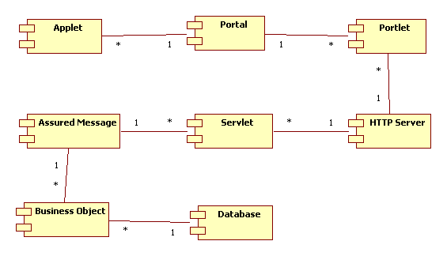

Creating the Interaction/Sequence Diagram
The Interaction Diagram or Sequence Diagram is the next diagram we will discuss.
- Right click Component View in the Model Explorer pane.
- Select Add Diagram/Sequence Diagram this will bring up the appropriate tool set for building an interaction or sequence diagram.
- You can drag an instance of a component from the Model Explorer pane and drop it onto the Work Area.
- If you do not have all of your components defined, you can add additional components by Right clicking on the Component View in the Model Explorer pane and select Add/Component. This will add a component that does not already reside on another diagram.
- Once all of the appropriate component instances have been added to your work area, you can select them and move them around by clicking Select in the Tools pane, clicking an Object or Component Instance, and then dragging it to an appropriate location.
- Select Stimulus in the Tools pane, then click the line extending down from your object or component instance (this is referred to as the object lifeline) and drag the resulting horizontal line to the lifeline of an appropriate object or component instance. Give your stilulus an appropriate name.
- You must set an appropriate ActionKind for each stimulus you add to the diagram. Note: Stimulus going from Left to Right should have an ActionKind of Call. Stimulus going from Right to Left should have an ActionKind of Return.
- The Method Invocation Boxes (the long skinny boxes on the lifelines) can be dragged to an appropriate length to denote transaction duration.
- Here is an example based on the On Demand SOA Case Study in the Team Solution Design Team Room.

On Demand SOA Case Study – Interaction/Sequence Diagram

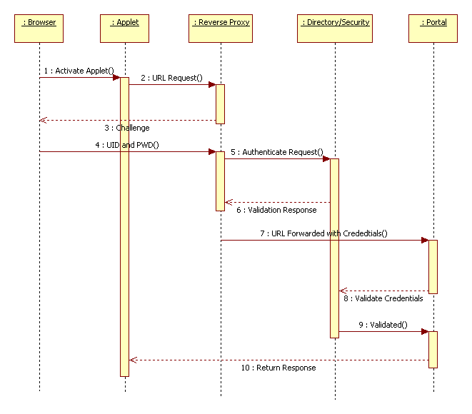

Creating the Use Case Model Diagram
- Right click Use Case View in the Model Explorer pane.
- Select Add Diagram/Use Case Diagram this will bring up the appropriate tool set for building a use case diagram.
- Select Actor in the Tools pane and click in the Work Area. Give your Actor an appropriate name.
- Select Use Case in the Tools pane and click in the Work Area. Give your Use Case an appropriate name.
- Select Package in the Tools pane and click in the Work Area. Give your Package an appropriate name.
- Connect the various components of your Use Case by selecting Generalization in the Tools pane, Right click on an entity and drag the resulting line to the next entity.
- Set an appropriate value for Discriminator in the Properties pane.
- Here is an example based on the On Demand SOA Case Study in the Team Solution Design Team Room.

On Demand SOA Case Study – Use Case Model Diagram
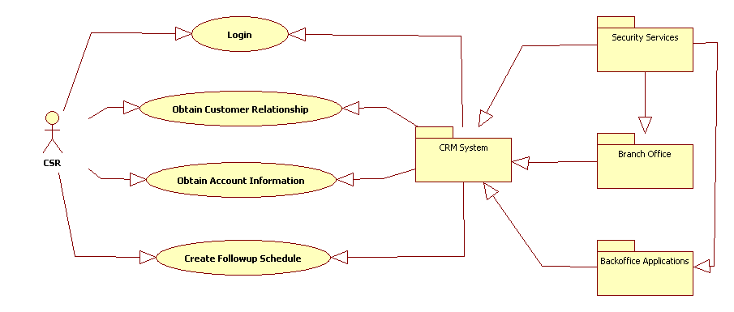

Additional Information
You can use the same techniques to create System Context Diagram(s), Architectural Overview Diagram(s), and any number of other diagrams. We suggest you try using the Case Diagram for the Architectural Overview.

There are many forums and other sources of help for StarUML on the web. You can see how other people are using this tool by browsing these sources.

