<Project Name/Subproject Name>
Business Scenario Template

Instructions for using this template to create “managed and controlled” documents or document templates:

Key to symbols used in this template:
[] indicates text to be replaced by the user of this template
<> indicates text that is updated as fields in the document properties, for example, <Project Name> above

Instructions for using this template to create your own document or document template:
Replace the default field values, including the < >,
Open the document properties by selecting File > Properties
On the Summary tab, update the following fields:
- Document Type/Title
- Author
On the Custom tab, update the following fields: (click Modify after updating the Value field for each item)
- Project Name
- Confidentiality (use appropriate confidentiality level if the document is confidential) – If none, delete text
- Copyright (update with the appropriate copyright statement(s))
- Issue Date
- Status (such as Draft or Approved)
Click OK to apply the property field updates
Select Edit > Select All, then press F9, select update entire table and click OK
Update the field properties in the header by selecting View > Header and Footer. Scroll down to page 2 or later. Press Ctrl+A to select the entire header and then press F9.
Replace blue (style=InfoBlue) text in square brackets, such as [project manager]. While working on a document, you may choose to leave some of this blue guidance. Note that a paragraph entered following this style will automatically be set to normal (style=Body Text). Remove it when the document is complete.
Replace the IBM logo with your company’s logo, as appropriate.
WHEN CREATING A TEMPLATE FROM THIS TEMPLATE, to provide instructions for the template users: Add, Delete or Update this instruction text as appropriate.
WHEN UPDATING A TEMPLATE CREATED FROM THIS TEMPLATE, maintain the ‘template version’ in the footer, by selecting View > Headers and Footers. This applies to updating the template version only; the document version is documented elsewhere (Summary of Changes).
TO REMOVE THESE INSTRUCTIONS: Click into THIS text box, click on the text box border, then press DELETE.

Template User’s Responsibility: Before using this template, verify it is the latest version.

Revision Status: <draft, approved, or obsolete>

Document Control Information

Document Author: <TomSeevers>
Document Owner: [owner]
Project Manager: [project manager]

Document Approver(s): (All Approvers are required. Records of each approver must be maintained.)

Approver Name | Role
[Name] | [Role]

Document Reviewers: (Records of each required reviewer must be maintained.)

Reviewer Name | Role
[Name] | [Role]

NOTE: All Reviewers in the list are considered required unless explicitly listed as Optional.

Summary of Changes:

The Document Author is authorized to make the following types of changes to the document without requiring that the document be re-approved:

- Editorial, formatting, and spelling
- Clarification

To request a change to this document, contact the Document Author or Owner.
Changes to this document are summarized in the following table in reverse chronological order (latest version first).

Revision | Date | Created by | Short Description of Changes
1.0 | 08/31/2012 | Tom Seevers | Initial Version

Document Source:

The latest version of this controlled document is stored in [this location].

Table of Contents
1. Introduction 4
1.1 Purpose 4
1.2 Scope 4
1.3 Intended Audience 4
1.4 Overview 4
2. Business Scenario < title> 4
2.1 Business Scenario Description 4
2.2 Business Outcomes, Benefits and KPIs 4
2.3 Business or External Capabilities 4
2.4 Technical or Supporting Capabilities 4
2.5 Business Scenario Scope and Context 5
2.6 Actors 5
2.7 Business Scenario Use Case 5
2.8 Information Sources 5
2.9 Business Scenario Maturity Assessment [optional] 5
2.10 Conceptual Architecture [optional] 5

Introduction

Purpose
[Describe the purpose or explanation for the origination of this business scenario. The typical purpose is to document business activities associated with a business component or process that an organization conducts within an industry or client imperative. Scenarios reflect the fundamental activities a business performs. Business Scenarios are an element of IBM’s Business Blueprint.]

Scope
[Provide a brief description of the scope of this business scenario. This could be expressed in terms of business activities, processes or industry / client imperatives. Include any aspects of the scenario that establish context.]

Intended Audience
[This document is normally intended for the use of the Technical Solution Architect and the client team supporting a Team Solution Design engagement as a basis for developing client recommendations. It may be especially helpful when developing a Client Imperative and/or Transformation Roadmap. If appropriate, this document may be written as a client deliverable.]

Overview
This document describes a business scenario for <industry or client imperative>. This document includes the following elements.
- Business Scenario Description
- Business Outcomes, Benefits and KPI’s
- Business or External Capabilities
- Technical or Supporting Capabilities
- Business Scenario Scope and Context
- Actors
- Business Scenario Use Case
- Information Sources
- Business Scenario Maturity Assessment (optional)
- Conceptual Architecture (optional)

Business Scenario < title>

Business Scenario Description
[A business scenario is defined in terms of business activities as part of a business process. For example, Loss Prevention might be defined as a typical business scenario.]

Business Outcomes, Benefits and KPIs
[Identify any current or expect business outcomes and benefits associated with this business scenario. Indentify key performance indicators that can be used to measure business outcomes and benefits derived from the realization of this business scenario. Consideration should be given to existing business objectives associated with the relevant business goals addressed by the scenario.]

Business or External Capabilities
[Identify the primary business or external capabilities necessary to realize this business scenario. Definition and elaboration of these business or external capabilities will be contained in a separate artifact.]

Technical or Supporting Capabilities
[Identify the technical or supporting capabilities necessary to enable the required business capabilities. Definition and elaboration of these technical capabilities will be contained in a separate artifact.]

Business Scenario Scope and Context
[Describe the positioning of this business scenario with regard to some common business process or activity. For example, a business scenario entitled Loss Prevention would be associated with the Underwriting portion of a broader claims process map. Identify business components (using an appropriate Component Business Model) impacted by this business scenario]

Actors
[An actor specifies a role that interacts with a target IT system and associated business processes. Actors may be realized as human or system. Identify any internal or external actors which interact with or are impacted by execution of the business process associated with this scenario.]

Business Scenario Use Case
[A high level business scenario use case depicts the workflow or flow of events resulting from the interaction of business actors with a business process. Alternatively, a high level process activity flow may be used. The process activity flow is similar except that it reveals specific activities within the business process. (see process activity flow example at the end of this document). There is not a single prescribed format for the Business Scenario Use Case. In the external literature, this may sometimes be described as a business use case or an essential use case.]

Information Sources
[Identify any enabling information sources necessary for the execution of business process associated with this scenario]

Business Scenario Maturity Assessment [optional]
[For an industry level business scenario, provide a definition for each level of maturity (Ad to Hoc, Foundational, Competitive, Differentiating, Breakaway (or similar progressive terms)). For use in a client engagement, provide assessment for the client’s current state.]

Conceptual Architecture [optional]
[Describe any important aspects of the conceptual architecture appropriate for use with the intended audience. Examples may include a Component Business Model, Application Function Model or Architecture Overview.]

Note: This template may be used to define a common business scenario at an industry level. A completed industry level template may be used in a client engagement as a starting reference to be tailored to the client’s actual or desired state.

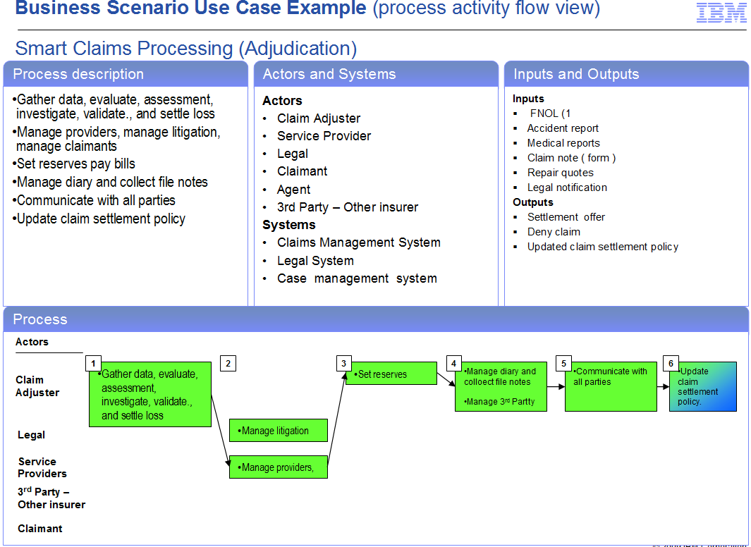

End of document–Business Scenario Template

