Team Solution Design Whitepaper
The Role of the IBM Business Blueprint in Solution Design

V1.1
06/30/2013

Document Control Information

Document Author: Tom Seevers
Document Owner: Tom Seevers

Revision | Date | Created by | Short Description of Changes
1.0 | 08/31/2012 | Tom Seevers | Initial version
1.1 | 06/30/2013 | Tom Seevers | Updated to conform to terminology changes and revised concept relationship model.

Document Source:

The latest version of this controlled document is stored in IBM MethodWeb.

Table of Contents
1. Introduction 4
1.1 Purpose 4
1.2 Scope 4
1.3 Intended Audience 4
1.4 Overview 4
2. IBM Blueprint Basics 5
2.1 Industry Imperative 5
2.2 Business Outcome 6
2.3 Transformational Stages 6
2.4 Solution Areas and Industry Solutions 7
2.5 IBM Capabilities 8
3. TeamSD and IBM Blueprint Conceptual Relationships 9
3.1 Capability 9
3.2 Client Imperative 9
3.3 Context (not illustrated in the model) 10
3.4 Industry Imperative 10
3.5 Offering 10
3.6 Assets 10
3.6.1 Intellectual Property 10
3.6.2 Service Offerings 11
3.6.3 Products 11
3.7 Transformation Roadmap 11
3.8 Value Proposition 11
4. IBM Blueprint Concepts in Practice 12

Introduction

Purpose
The purpose of this paper is to explain the basic concepts of the IBM Business Blueprint and how they relate to concepts employed in Team Solution Design.

Scope
This paper discusses the relationship of certain Team Solution Design and Business Blueprint concepts. It does not contain detailed solution design guidance.

Intended Audience
This paper is intended for solution architects supporting pre-sale engagements where the initial engagement is based on the client’s interest in one of IBM’s Industry Imperatives and there is a need to develop a Transformation Roadmap before proceeding with a specific solution design.

Overview
Recently IBM introduced the IBM Business Blueprint. The IBM Business Blueprint is a strategic initiative to implement a common go-to-market approach across IBM with a focus on solutions. The IBM Business Blueprint establishes a common set of concepts that enable clarity and cross brand integration in IBM’s capabilities and solution offerings. Several of these concepts have significant implications for pre-sale solution design. This paper is intended to integrate the Blueprint concepts with the concepts employed in Team Solution Design. This integration enables a logical progression from initial client discussions of Industry Imperatives through development of a Transformation Roadmap and finally, actual solution design. The paper is divided into the following sections.
- The first section is IBM Blueprint Basics. This section will provide a brief description of each of the main Blueprint concepts and relate them to appropriate work products in TeamSD.
- The second section is TeamSD and IBM Blueprint Conceptual Relationships. This section includes a conceptual relationship model and takes a more rigorous approach to exploring the relationships between TeamSD and Blueprint concepts that may impact solution design.
- The final section is IBM Blueprint Concepts in Practice. This section presents a basic scenario to illustrate key conceptual relationships in practice.

IBM Blueprint Basics
The main concepts of the Blueprint are illustrated in the following graphic.

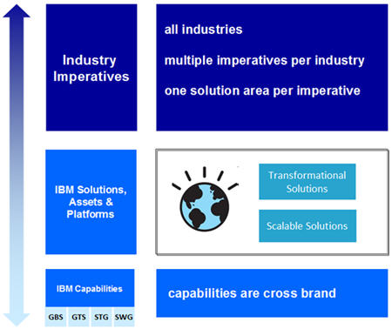

Industry Imperative
The highest level concept in the Blueprint is the Industry Imperative. The Blueprint defines it as:

The most pressing issues, concerns, opportunities C-suite client leaders face in an industry. They are:

- Transformational
- Attainable in the foreseeable future
- Aligned with IBM’s differentiated POV, where IBM has the ability to deliver value

In addition to the standard definition, Industry Imperatives have the following characteristics relevant to solution design.
- Industry Imperatives represent IBM’s opinion on a course of action that many clients in a particular industry would find appealing as a way to address some aspect of their business strategy. As this paper is published IBM has defined approximately 50 imperatives across all industries.
- IBM has defined a small number of imperatives for each industry. While they are intended to serve as a starting point in the discussion on what the client is trying to achieve, they will not address all types of opportunities. However, it is important to understand that IBM intends to align its capabilities and solutions to deliver value in the context of these imperatives. This means that at least initial aspects of solution design may be simplified in cases that are at least generally based on one of the defined Industry Imperatives.
- Even in cases where the Industry Imperative corresponds to the client’s needs, the fact that the Imperative is defined to address an entire industry means that as the opportunity progresses, it will be necessary to specialize or tailor the Imperative to what the specific client is trying to achieve. TeamSD provides support for doing so in a pre-sale context.

Industry Imperative example: Increase Flexibility and Streamline Operations

Relationship to Team Solution Design

- IBM identifies Industry Imperatives which are common across a specific industry. As an architect works with a client, the IBM-defined Industry Imperatives can be used to inform a discussion with the client regarding their client-specific imperatives and their corresponding goals and strategy. Business goals and strategy are defined in the Business Motivation Model (BMM) which is described in the Business Direction artifact.
- Industry Imperatives are typically associated with a transformational level of change. As such, it is likely that one cannot proceed directly from an industry imperative to a specific solution design. TeamSD provides a Transformation Roadmap Activity designed for such transformational opportunities. This activity offers guidance in developing a Transformation Roadmap which will document one or more Transformation Initiatives and associated Transformation Activities. The Transformation Activities will serve as a basis for understanding what solution design is required.
- The industry imperative is stated at a high level and will likely be specialized for an individual client’s needs. The Client Imperative artifact in TeamSD is intended for use in documenting how a particular imperative is specialized for a specific client opportunity.

Information on Industry Imperatives may be found at IBM’s System Support Information (SSI). (The prior link is a search of all Industry Imperatives.)

Business Outcome
The Business Outcome is an attribute of the Industry imperative. The Blueprint defines it as:

Quantifiable business impact that can be realized by implementing recommended solutions.

Business Outcome example: Time to market for new offerings accelerated

Relationship to Team Solution Design

- Each Industry Imperative also defines Business Outcomes which inform the discussion with the client regarding their Business Goals and Objectives. Business goals and objectives are defined in the Business Motivation Model (BMM) which is described in the Business Direction artifact.

- When using a particular Industry Imperative as a basis for client discussions, the associated Business Outcomes will certainly be an important part of the discussion. As the opportunity progresses, the Industry Imperative, including Business Outcomes, will be specialized to align with what the client is trying to achieve. The Client Imperative artifact is used to document this specialization of the business outcomes and other benefits that the client expects to achieve.

Transformational Stages
Transformational Stages are an attribute of the Industry Imperative. The Blueprint defines them as:

The steps an organization must take to achieve the desired outcomes and realize the benefits associated with an imperative. Ideally, the actions build on each other and reflect a natural progression.

Transformational Stages example:
- Streamlined operating environment: Align business, operations and technology using a common banking architecture and infrastructure platform that drives out complexity and cost while increasing flexibility.
- Business Process Standardization: Deliver business capabilities faster by introducing modular business services comprised of common data, business rules and processes that can be configured quickly to get new products and services to market with less risk and cost
- Operating Environment Automation: Monitor business activities and operations to improve back office performance
- Adaptable Core Banking System: Create a flexible and agile banking environment that is able to adapt to ongoing structural shifts

Relationship to Team Solution Design

- Each Industry Imperative also defines Transformational Stages. These stages inform the discussion with the client regarding the client imperative and associated solution strategy as documented in the Client Imperative artifact. They may also help identify Transformation Initiatives and associated Transformation Activities. Transformation Initiatives and Activities are Tactics. Tactics are defined in the Business Motivation Model (BMM) which is described in the Business Direction artifact.

- When using a particular Industry Imperative as a basis for client discussions, the associated Transformational Stages will certainly be an important part of the discussion. As the opportunity progresses, the Industry Imperative, including Transformational Stages, will be specialized to align with what the client is trying to achieve. The Transformation Roadmap artifact is used to document this specialization of the Transformational Stages. This is accomplished by defining one or more Transformation Initiatives and associated Transformation Activities. These initiatives and associated activities serve to realize one or more transformational stages. Transformational Stages as expressed in the Blueprint are not necessarily sequential as might be seen in various maturity models. The multiplicity relationship between Transformational Stages and Transformation Initiatives is an arbitrary choice, based on IBM and client preferences and granularity considerations.

Solution Areas and Industry Solutions

Each Industry Imperative is associated with a Solution Area and a set of Industry Solutions that address the Imperative. Solution Areas and Industry Solutions are attributes of the Industry imperative. The Blueprint defines them as:

Industry Solution Area: Group of industry solutions to address a particular industry imperative.

Industry Solution Area example: Core Banking Transformation

Industry Solutions: An offering made up of an integrated combination of IBM capabilities and assets that addresses a specific industry imperative and delivers a specific business outcome.

Industry Solution example: Core Banking Architecture Transformation

Relationship to Team Solution Design

- Industry Solutions represent candidate solutions that represent an asset to be used in solution design. As such, they do not represent a new concept with regard to solution design. What the Blueprint introduces however, is the relationship between industry solutions and the IBM Industry Imperatives. This relationship will likely be most helpful in developing a Transformation Roadmap.

IBM Capabilities
Underlying Industry Solutions is a set of IBM Capabilities. The Blueprint defines the IBM Capability as:

Represents the core client functions and value provided by a set of IBM products and offerings

In addition to the standard definition, IBM Capabilities have the following characteristics relevant to solution design.
- Capabilities may in some cases to be offered to a client independent of any Industry Solution.
- Capabilities may enable more than one Industry Solution.
- Capabilities represent an intermediate concept between the solution and individual products and services.
- Capabilities are enabled by assets such as products, service offerings and intellectual property. Assets consist of various combinations of process, organization, technology and information.
- IBM Capabilities are typically enabled by contributions from multiple IBM brands.

IBM Capability example: Information Integration and Governance - Information integration and governance solutions from IBM enable organizations to distribute trusted information to those who need it - when they need it.

Relationship to Team Solution Design

- During development of the Transformation Roadmap and specific solution design work products, specialization of IBM Industry Solutions will typically be required to adapt to the client’s needs. This specialization is potentially simplified by selecting from and specializing these higher level capabilities

- In some cases, IBM may be engaged with the client to perform enterprise architecture or strategy and transformation consulting. IBM methods employ the concept of Capability in work products such as Capability Description and Capability Model. Although these work products are not created in the base TeamSD, they should be considered as input when they exist in a specific client situation. These work products describe business or external capabilities that the client offers to the market. They also describe supporting capabilities necessary to establish the business capabilities. In this context, IBM Capabilities may be used to satisfy client need needs by offering IBM capability assets to create or improve necessary supporting capabilities for the client.

TeamSD and IBM Blueprint Conceptual Relationships
The following diagram is a concept relationship model that depicts various concepts and their relationship to the Capability concept. The purpose of the model is to provide a basis for understanding IBM Blueprint terms, underlying and related concepts and their relationships. For simplicity, not all possible concepts or concept relationships (Industry Imperative to Value Proposition) are shown. As such, the model focuses on Capability and does not intend to model all aspects of the IBM Blueprint. The Capability concept is emphasized because of its key role in solution design. Blueprint concepts from the prior section are repeated here in order to provide a more complete and rigorous understanding of conceptual relationships and solution design implications.
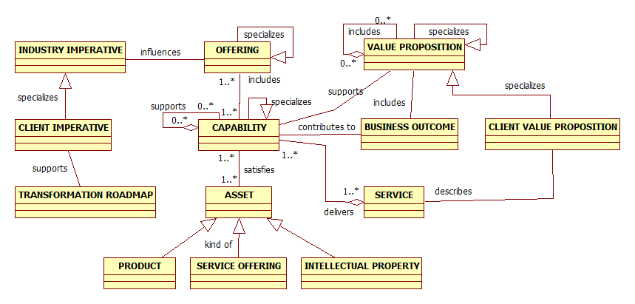

Capability
- Capabilities consist of various combinations of resources in the form of assets. Assets consist of various combinations of process, organization, technology and information.
- A capability is dependent on and influenced by industry or client context and must be aggregated or specialized as appropriate for the context.
- A capability may be specialized by modifying the assets or associated delivery methods in response to a specific context. General examples include specializing a generic capability to suit a particular industry or specializing an industry oriented capability to suit a particular client.
- Some capabilities are aggregated to support other capabilities. Supporting capabilities may also be referred to as internal or core capabilities. Supported capabilities are sometimes referred to as external capabilities. IBM capabilities would typically provide resources to improve or help create a client capability that directly or indirectly supports a client business or external capability.
- Capabilities are defined and implemented to offer a Service.
- Offerings consist of aggregations of one or more capabilities and are typically presented to the market as Industry Solutions.
- For additional information, see Guideline: The Role of Capabilities in Solution Design.

Client Imperative
- The Client Imperative serves to document the specialization of an Industry Imperative in the following ways.
  - The industry imperative is tailored to what the specific client is trying to achieve which becomes the client imperative.
  - The candidate business outcomes suggested in the industry imperative are evaluated and modified to suit the client’s business goals and objectives.
- The solution strategy developed as a part of the client imperative establishes scope, context and a basis for determining transformations initiatives and activities.
- The client imperative is both influenced by and contributes to context in the case of a specific client opportunity. This contribution to context influences further specialization of the capability and offering.
- Client imperative example: Enable the Bank’s Multichannel Delivery Strategy with an Optimal Architecture and Technology Platform

Context (not illustrated in the model)
- The concept of context is not represented in the model above. The selection and development of a capability is dependent on the context within which the capability will operate. For external capabilities, the target market segment provides context. Specialized capabilities may be developed for specialized market segments. Team Solution Design offers pre-sale guidance in the Transformation Roadmap activity on establishing the context and scope for a transformational opportunity. This is done by using appropriate high level organizing constructs such as the Transformation Framework. This enables identification of potentially relevant concerns at a domain level such as business information or user application function.
- The development of a value proposition will in part be dependent on context. If a standard offering is developed, it may be accompanied initially by a standard value proposition. Based on the influence of context, the standard value proposition may be modified to better resonate with the target market segment or even a specific client.
- Client context example: Factors such geography, size, current client capabilities, client size and preferences are all important factors on establishing client context.

Industry Imperative
- An industry imperative is the most fundamental Blueprint concept that contributes to context which in turn influences specialization of the capability and offering.
- Where an opportunity is at least initially based on the client’s interest in an industry imperative, the industry imperative influences the client imperative by providing the candidate imperative, motivation, business outcomes and stages of transformation, all of which will be specialized to suit the specific client situation.

Offering
- An offering consists of one or more capabilities which in turn consist of various assets such as products, service offerings and intellectual property.
- A capability is dependent on and influenced by context and must be aggregated or specialized as appropriate for the context.
- Optionally, an offering (Industry Solution) may contain finer grain offerings.
- An offering serves as the basis for the core attributes of a value proposition. The value proposition acts to elaborate on and specialize the offering, providing selective emphasis to those aspects of the offering that most resonate with the buyer’s needs. This is a mutual dependency.

Assets
- Assets enable IBM capabilities and include products, service offerings and intellectual property. Assets consist of various combinations of process, organization, technology and information.

Intellectual Property
Examples of Intellectual Property include:
- Consulting and Design Methods
- Industry Component Business Models
- Reference Architecture
- Industry Models such as IAA or IFW

Service Offerings
Examples of Service Offerings include:
- Customer Analytics Services
- Spend Analytics Services
- Workforce Analytics and Financial Analytics Services

Products
Examples of Products include:
- Cognos
- WebSphere
- Algorithmics]

Transformation Roadmap
- The Industry Imperative includes “stages of transformation”. These are more reflective of states and are not necessarily sequential. The Transformation Roadmap specializes these stages for the client and illustrates the transformation activities, sequence and dependencies necessary to achieve a desired state of transformation for the client.
- The transformation roadmap is dependent on documenting the solution strategy component of the client imperative.
- Client example (abbreviated): The client would like to transform their multichannel retail banking environment starting with the online banking channels. Later stages of the transformation would cover the call center and branch channels. The transformation will initially focus on the user experience and underlying user platforms along with key functional areas that would support a retail banking customer sales and service interactions.

Value Proposition
- The selection and development of the firm’s capabilities is guided by defined industry or client needs. A deployed capability fulfills or partially fulfills one or more needs.
- A base value proposition may be associated with a generic cross industry offering. That value proposition may be specialized for an industry, for a stage of transformation, or for a particular client opportunity in which case it is referred to in CVM as a Client Value Proposition.
- The offering constrains the value proposition in that it limits which client capabilities IBM offers to create or improve. The offering also constrains the value proposition in that the solution described is limited to the offering contents.
- Client example: see Client Value Proposition Example in UMF.

IBM Blueprint Concepts in Practice
This limited scenario models a generic example of how certain of the IBM Blueprint and related concepts would be realized in a context involving both IBM and the client. The primary emphasis of this scenario and walkthrough is the Capability concept.
The role of IBM is to help the client improve existing capabilities or create new capabilities. Figure 4 depicts the following general scenario.
- In response to general market segment needs, IBM develops a set of capabilities that are satisfied by assets such as Product, Service Offering and Intellectual Property. These capabilities support a value proposition.
- Based on the context provided by an industry imperative, IBM combines these capabilities to create an offering that addresses client needs and offers this as a service.
- The client fulfills their stated needs by requesting and contracting for service.
- In consuming the requested service, IBM assets are purveyed to the client to create resources necessary to satisfy their capabilities.
- The result is the creation or improvement of client capabilities that are in turn used to develop offerings for the market segment that they serve and produce a positive business outcome.
- These new or improved client capabilities may be internal or core capabilities that support externally offered capabilities.
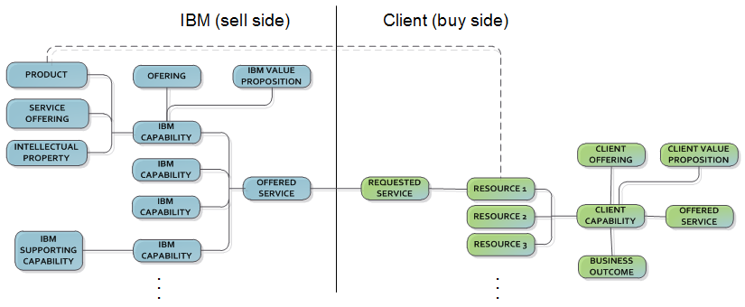

End of document–The Role of the IBM Business Blueprint in Solution Design

