Component Model for SOMA

Author: IBM
Owner: IBM

Document History
Document Location
This is a snapshot of an on-line document. Paper copies are valid only on the day they are printed. Refer to the author if you are in any doubt about the currency of this document.
The source of the document will be found in /tmp/lo/0000.doc
Revision History
Date of this revision: 10-14-2008 | Date of next revision (date)

Revision Number | Revision Date | Summary of Changes | Changes marked
3.2 | 10-14-08 | Template extracted out from WPD (Arun Thakore) | (N)
3.1.5 | Apr 2008 | Updated content to include both subsystem analysis and component specification (Shuvanker Ghosh, Victor Ramos)
2.2 | Sept 2005 | Consolidation of Service Component Model and Subsystem Analysis Document work products into an extension of ARC 108 Component model for SOMA. | (N)
2.1 | June 2005 | Subsystem Analysis WPD and Service Component Model - Version numbered to synchronize with TP
0.2 | May 2005 | Subsystem Analysis WPD and Service Component Model WPD - Revised for feedback
0.1 | April 2005 | Service Component Model WPD - Created based on previous enterprise component model
0.1 | Feb 2005 | Subsystem Analysis WPD - Initial draft to support SOMA 2.0 (David Janson)
 | May 2003 | Subsystem Analysis WPD - Reformatted into official GS Method format. (Ali Arsanjani)
Approvals
This document requires following approvals. Signed approval forms are filed in the Quality section of the PCB.
Name | Title
(name) | (title)
Distribution
This document has been distributed to
Name | Title
(name) | (title)
Contents
1. Introduction 4
1.1 Identification 5
2. Component Model for SOMA 6
2.1 Subsystem overview and relationships 6
2.2 Subsystem descriptions 7
2.2.1 Subsystem: <name> 7
2.3 Component Attributes 8
2.4 Component interfaces and interactions 9
2.5 Component allocation to architecture layers 10

Introduction
(Template GSA011uk.doc version 1.0 dated 11 June 2001 based on "APP 011 System Context” version 3.0)
Please note that:
- Text in the “Editor’s comments” style (such as this) provides guidance to the editor, in conjunction with the corresponding work product description, and should be removed from the published version of the document.
- The “Reader’s comments” style (in purple) provides guidance for the (client) reader and should be modified as appropriate by the editor to reflect any customization of the template.
- The “Normal” style (in black) should be used by the editor when adding the text describing the (sub)system appropriate for this work product.
When using this template, refer to the Unified Method Framework work product description “Component Model for SOMA”.
This is an extension of the existing ARC 108 Component Model work product to include output from SOMA activities such as Subsystem Analysis and Component Specification.
Subsystem Analysis describes subsystems in terms of responsibilities, composition, behavior, interfaces, and relationships between subsystems. The internal composition of subsystems is described in terms of identifying the Service Components, Functional Components, and Technical Components that each subsystem will contain. These elements are described in several ways using a combination of UML diagrams and textual descriptions. Subsystems provide bridge from a business function view to an IT function view.
The initial identification of subsystems takes place during Functional Area Analysis, where candidate subsystems are associated with functional areas (documented in the Functional Area Descriptions work product). Using the candidate subsystems as input, Subsystem Analysis describes subsystems in terms of responsibilities, composition, behavior, interfaces, and relationships between subsystems. The internal composition of subsystems is described in terms of identifying the service, functional and technical components that each subsystem will contain.
Service Components are associated with subsystems that are functionally aligned with business domain functional areas. This relationship provides traceability and justification for their inclusion in the solution, a key concept in the SOMA method. Figure 1 shows how Service Components are grouped within subsystems and are associated with functional and technical components

A service component is a realization of a subsystem, a logical grouping of functionally-cohesive business-aligned services, which is important enough to the enterprise to be managed and governed as an enterprise asset. These business-aligned services can be exposed at a variety of boundaries, including the edge of the enterprise or a business unit.

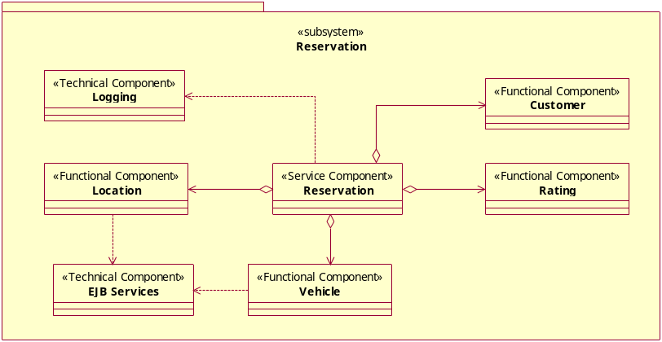
Figure 1: Service, Functional and Technical Components within a subsystem
The Component Model documents the Service Components, Functional Components, Technical Components and Subsystems that realize the functional aspects of an SOA based solution. Since the services exposed by an SOA based solution are realized through Service Components, this work product constitutes one of the most important work products for an SOA based initiative. The Service Component Model work product captures key IT aspects of an SOA based solution and is considered an essential work product in the Service-Oriented Modeling and Architecture (SOMA) method.

Identification
This document describes the Component Model for SOMA for .

Component Model for SOMA
Both Subsystem Analysis and Component Specification primarily use UML class and interaction diagrams along with textual descriptions to represent the following aspects of a SOA-based solution:
- Subsystems overview and relationships
- Subsystem descriptions, compositions, interfaces and behavior
- Attributes and messages related to Service Component, Functional components, and Technical components
- Component interfaces and interactions
- Component allocation to architectural layers

Subsystem overview and relationships
This provides an overview of the overall relationship among subsystems that pertain to the scope of analysis. A Subsystem Relationship Diagram and a Subsystem List table are used to describe the overall set of subsystems involved in the solution. This section is typically created in an incremental fashion, being revised and extended as each subsystem is analyzed and documented.
A Subsystem Relationship Diagram can be created by using UML class diagrams to represent subsystems as packages, showing relationships and dependencies among subsystems, as shown in Figure 2. There may be cases where the number of subsystems leads to the creation of more than one Subsystem Relationship Diagram.
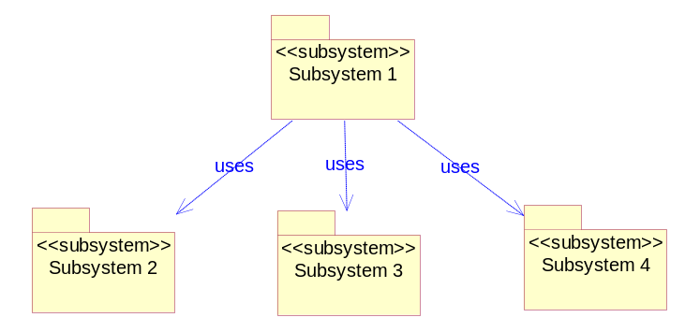
Figure 2: Subsystem relationship diagram example
Text should accompany the Subsystem Relationship Diagram to provide a high level description of the diagram and explain nature of the relationships and dependencies among subsystems.
Along with the Subsystem Relationship Diagram, a master Subsystem List should be maintained using the template shown in Table 1.

Subsystem name | Description
Name of subsystem | Brief overview description of the subsystem
Table 1: Subsystem list template

Subsystem descriptions
This uses a combination of text and UML class diagrams to capture the description of each subsystem. Complete one set of the documentation in this section for each subsystem being analyzed. An outline per subsystem is as follows:

Subsystem: <name>

Subsystem description
This section describes the functional responsibilities of the subsystem. Functional responsibilities are based on input from the Functional Area Descriptions work product and are further elaborated during Subsystem Analysis. This information can be captured using the template shown in Table 2.

Function | Description
Name of function | Summary of responsibilities of the function
Table 2: Subsystem description template

Subsystem composition and interfaces
A UML class diagram can be used to show the service, functional and technical components that a subsystem is composed of and the interfaces it exposes, as shown in Figure 1. It includes component relationships and dependencies. UML interaction diagrams can be used to represent interactions among components, and are important for documenting how service components use functional and technical components to provide various functions.

Function | Service | Interface | Service Component
Name of function | Name of service that exposes this function | Interface through which the function is exposed as a service | The service component that provides the realization of the function. Service components offer the interface that this table associates with a function and service. In many cases a single service component can be used to realize all functions for the subsystem.
Table 3: Subsystem composition template

Subsystem behavior
Text
Provide an overview of key factors that affect subsystem behavior. The following items should be analyzed and documented:
- Context: the context in which the expected behavior unfolds. This can involve security, transactional characteristics, valid states that need to be checked, line of business (e.g., retail versus institutional).
- Event: Business events related to the function. An event may trigger evaluation of business rules based on policies
- Policies: Policies associated with delivering functions the subsystem is responsible for in response to an event.
- Business Rules: Rules to be used when a policy has been selected.
- Data Elements: Data elements that are to be checked when the condition of the business rule is being checked.
- Meta-data: Identify things related to configurability and variations.

Component Attributes
Component attributes can be documented through a combination of UML class diagrams and the component attribute table in Table 4. Attributes can be listed in the table and added to the UML class representing the component. Policies and rules can be listed in the table. Variations can be listed in the table and reflected in a UML class diagram as additional classes representing variations and types. Services provided can be represented as operations exposed through the service component interface.

Component Type: Service | Functional | Technical Component name: <component name>
Attributes
Policies | - business policies (e.g. prioritization or service level commitment by class of consumer)  - IT policies (e.g. security, operational state monitoring and management, configuration and change management)
Rules | - constraint rules (stimulus and response rules, operation constraint rules, structure constraint rules)  - derivation rules (inference rules, computation rules)
Variations
Services provided | - (only for service components)
Services consumed | - (optional)
Table 4: Component attribute template

Attributes: Attributes that need to be defined for this component (alternatively these could be represented in a UML class diagram)
Policies: business or IT based policies that apply to this component. Business policies could reflect for example the business context within which the service should be used. IT policy could reflect things such as security and manageability.
Rules: rules that this component needs to enforce – rules can alternatively be captured in a UML model as stereotyped constraints using a declarative or Object Constraint Language (OCL).
Variations: variations from the Variations Model work product need to be realized by this component
Services provided: names of services that this service component is responsible for exposing
Services consumed: names of services that this service component consumes

Component interfaces and interactions
Component interfaces can be represented in a UML diagram consistent with the ADS standard.
Component interactions can be represented using UML sequence diagrams. Elaboration of the high level service, functional and technical components identified during Subsystem Analysis will typically add additional components to the model. Sequence diagrams should be created to represent stereotypical interactions between components in the model.

Component allocation to architecture layers
A key realization decision is to allocate components to architectural layers. Component allocation to layers can be represented using a diagram similar to Figure 3. A more detailed allocation of components to layers should also be performed based on the layers of the application architecture being used

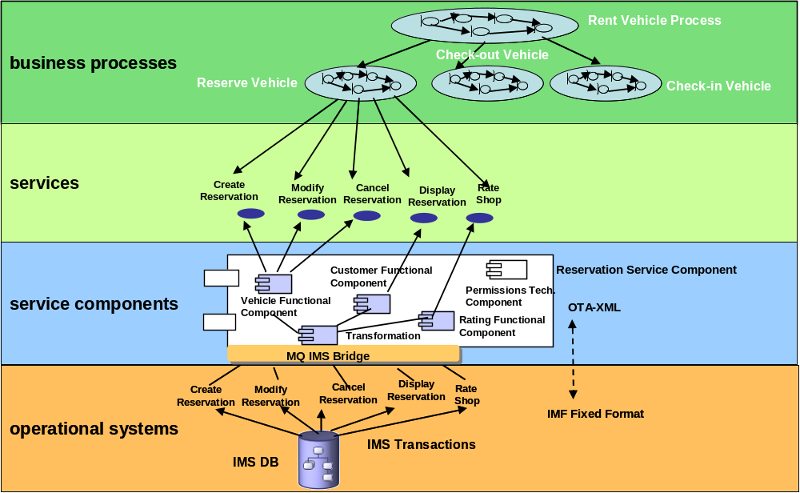
Figure 1: Allocating components to layers

A useful discussion of rules can be found in the Rational Unified Process content. Refer to Guidelines: Business Rules. The suggested categories of business rules shown in the template are summarized from that RUP content.

