Service Dependencies

Author: IBM
Owner: IBM

Document History
Document Location
This is a snapshot of an on-line document. Paper copies are valid only on the day they are printed. Refer to the author if you are in any doubt about the currency of this document.
The source of the document will be found in /tmp/lo/0000.doc
Revision History
Date of this revision: 10-15-2008 | Date of next revision (date)

Revision Number | Revision Date | Summary of Changes | Changes marked
3.2 | 10-15-08 | Template extracted out from WPD (Arun Thakore). Service Model is broken into one parent and three sub-artifacts, namely, Service Portfolio, Service Dependencies, Service Specification. | (N)
3.1 | August 2007 | Updated to include SOMA 3.1 concepts and additional details for the Service Model (Shuvanker Ghosh).
2.1 | June 2005 | Version numbered to synchronize with TP
0.5 | May 2005
0.4 | April 2005
0.3 | April 2005
0.2 | April 2005 | Revised after internal review
0.1 | March 2005 | Revised for SOMA 2 (David Janson)
New draft baseline | Sep 2004 | Added contents (Abdul Allam)
Approvals
This document requires following approvals. Signed approval forms are filed in the Quality section of the PCB.
Name | Title
(name) | (title)
Distribution
This document has been distributed to
Name | Title
(name) | (title)
Contents
1. Introduction 4
1.1 Identification 4
2. Service Dependencies 5
2.1 Service Dependencies 5
2.2 Service Composition and Flow 6

Introduction

Please note that:
- Text in the “Editor’s comments” style (such as this) provides guidance to the editor, in conjunction with the corresponding work product description, and should be removed from the published version of the document.
- The “Reader’s comments” style (in purple) provides guidance for the (client) reader and should be modified as appropriate by the editor to reflect any customization of the template.
- The “Normal” style (in black) should be used by the editor when adding the text describing the (sub)system appropriate for this work product.
When using this template, refer to the Unified Method Framework work product description “Service Dependencies”.
This chapter captures the dependencies among the services that were capture in the Service Portfolio artifact. The Service Dependencies is a part of the Service Model and consists of the various dependencies that exist among the services in the service model. In addition, it captures the compositions and flows among the services that constitute the composite services. This artifact is created during SOMA specification phase. This artifact is a sub-artifact of the Service Model artifact. In addition to the Service Dependencies, the Service Model consists of the Service Portfolio artifact and the Service Specification artifact. Table 1 shows the elements of the Service Model that are created in this artifact.

Section | Description | SOMA step where created
Service Dependencies | Documents dependencies between services in the model. | Service Specification:  - Model Service Dependencies
Service Composition and Flow | Identifies which services are choreographed together to form a composite service. | Service Specification:  - Identify Service Composition and Flow
Table 1: Service Dependencies Detail

Identification
This document describes the Service Dependencies system for .

Service Dependencies
This chapter describes the context of the system.

Service Dependencies
The Service Model documents three related aspects of the relationships among services that arise from the larger context that individual services are used in. Since services are used in the context of business processes, the Process Definition work products is an important input to the specification of dependencies, composition and flow. Analysis of how services are used in the context of business processes leads to the identification of how specific combinations of services are used.
Service dependencies describe the relationships between services that arise in the larger context of how they will be used. When a service is formed from a composition of other services the composing service depends on the composed services. When services are used in the context of a business process, there is a process related dependency that arises from the inherent sequence of steps in the business process that dictates the order in which services will be used. These two types of dependency scenarios are shown in Figure 1:
- Functional dependencies (“Type 1”) that arise from composition of multiple services
- Temporal dependency (“Type 2”) where there is some pre- or post- condition or processing requirement that will need to be accounted for in compositions or choreographies.
Service Dependency Type 1 | Service Dependency Type 2
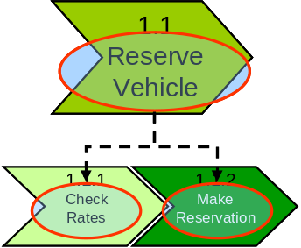 | 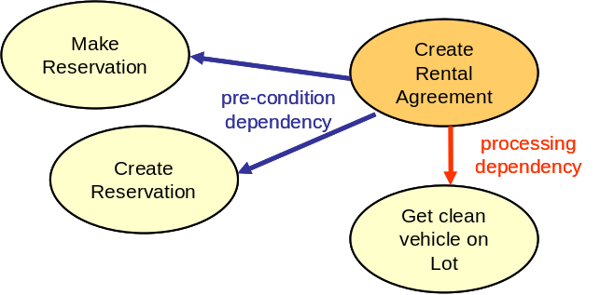
- Functional Dependency/Composite Dependency: Reserve Vehicle will depend on Check rates and Make Reservation for its functionality | - Pre-condition dependency – i.e. another service invocation must have executed successfully before the current invocation can begin execution.  - Processing dependency – i.e. another service invocation is required to complete the successful execution of the current service.  - Post-condition dependency (not shown) – this appears in cases where a service requires another service invocation after its execution.
Figure 4: Types of Service Dependencies
Dependencies should be represented visually with accompanying text that describes the nature of the dependencies. One style for diagramming dependencies is shown in Figure 1. For functional dependencies A UML component relationship diagram can also be used. For processing dependencies a UML sequence diagram can be used.

Service Composition and Flow
Service composition can be used to support short running, non-interruptible, as well as long running interruptible processes. The flow of Service composition can be represented visually using the approach shown in Figure 5: Service Composition, with accompanying text that describes the composition. Each composition should be named so that it can be referred to in the State Management Decisions section.
A. Short running, non-interruptible process (micro-flow) | B. Long running , interruptible process  (macro-flow)
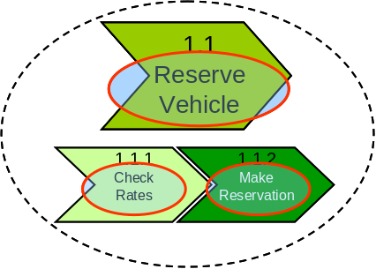 | 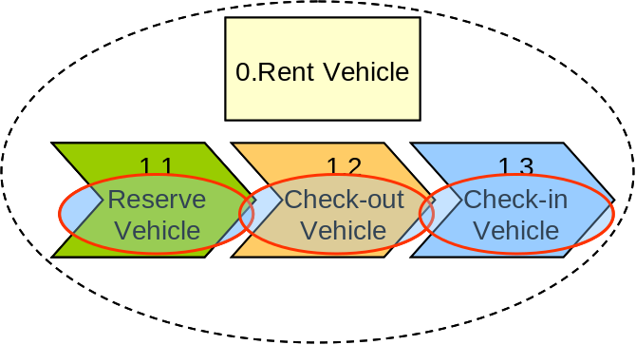
Reserve Vehicle is composed of:  - Check Rates  - Make Reservation | Rent Vehicle is composed of:  - Reserve Vehicle  - Check-out Vehicle  - Check-in Vehicle
Figure 5: Service Composition

